Applicant Evidence Studio Application Guide
Windows use and validation
By Jason Stys Version 0.3.1 11 November 2026
Review professional evidence in a user-controlled encrypted workspace, compare two exact records against one rubric, and prepare factual coaching and private exports. The installed app owns its local account service through readable Open, Help, Runtime notices and safe Quit controls.
The independently downloaded and installed application passed its real user workflows. Current main checks and processed CodeQL passed before publication. Icon targets were verified; normal default-profile shortcut activation is separately untested.

Capabilities and previous improvements
Retains criterion-level evidence comparison, exact record/rubric fingerprints, source warnings and browser-side WebCrypto. Version 0.3.1 adds patched runtime/resource verification and exclusive profile ownership without changing account paths or encrypted workspace formats.
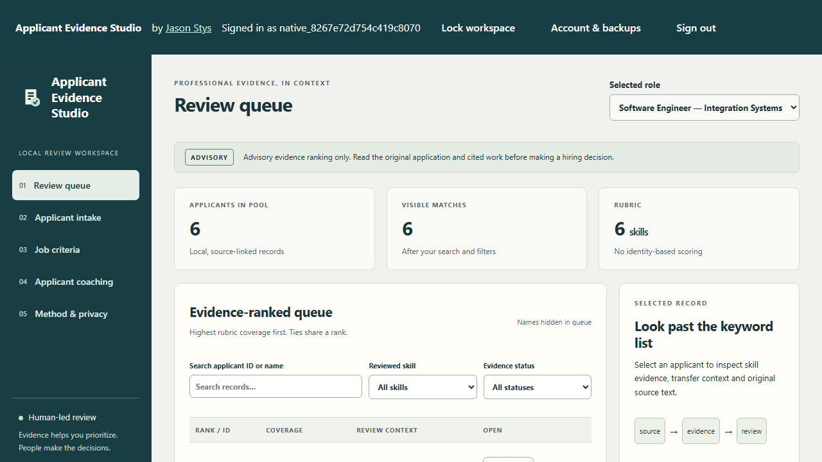
Figure 1 The installed app reopened a synthetic encrypted workspace after locking; its evidence queue is available again and the previous comparison selection is cleared.

A worked application journey
A reviewer opens a fictional software-role workspace, inspects two supplied records, captures their criterion evidence and downloads a private comparison before locking the workspace.
1. Open the app, create or sign into your local account and unlock with a separate private vault phrase.
2. Use fictional examples first. Review original sources and consent, then select exactly two records and Capture selected evidence.
3. Inspect the captured rubric, source warnings and criterion evidence. Refresh after edits; download before opening another record or locking.
4. Keep plaintext comparison downloads private. Lock when finished and use Quit application; closing the browser tab leaves the service running.
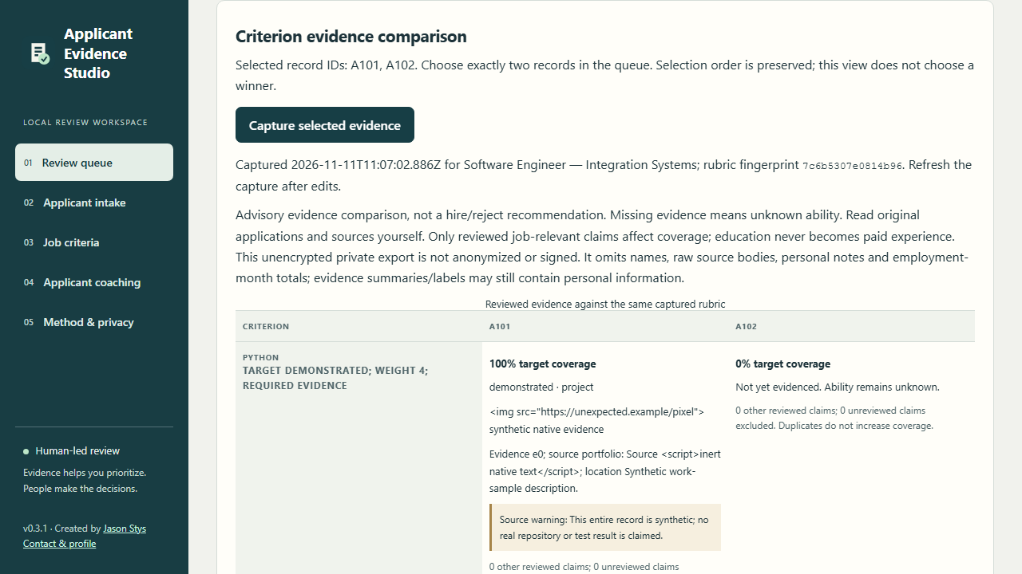
Figure 2 The visible comparison criteria retain literal synthetic evidence and source warnings. HTML-like record content is displayed as inert text; the complete private JSON is available separately.

Important implementation details

Use the same completion gate for every native close request
Quit, OS close and scoped synthetic acceptance all request ordinary service draining. The owner window continues polling actual completion before it releases the profile; there is no public HTTP shutdown route.
app/native_host.py lines 170 to 176
170 def request_close(self) -> None:
171 """Use the same completion gate for Quit, OS close and explicit synthetic acceptance input."""
172 self.closing = True
173 self.open_button.state(["disabled"])
174 self.quit_button.state(["disabled"])
175 self.status.set("Closing after active local requests finish. Saved accounts and vaults are retained.")
176 self.service.request_stop()
Source file SHA256 9cfbfb5c332dd91f3d8e64e0a9e6c99afe09fc56e15c5d3fdb5ca50033ffc206

Validation results and operating limits
Runtime source c3d44882ee39209b3a9fbbe884e1177cc78359e5
Check | Observed evidence | Result
Installed encrypted UI | Real WebCrypto, exact record hashes, Python parity, read-only comparison, accessibility, lock/reopen and unauthenticated refusal passed; zero outside requests and normal exit 0. | Passed
Old-to-new vault | An immutable 0.3.0 compatibility binary created and edited a synthetic encrypted vault. Installed 0.3.1 used the same login and phrase and retained its exact edited record hash. | Passed
Source and packages | Exact-main CI and processed three-language CodeQL passed. All three real native builds and final draft verification passed; all six independent asset downloads matched provider SHA-256. | Passed
Installation and icons | A fresh per-version Windows folder and individual Desktop/Start-menu targets were verified. Normal accounts and Docker were unchanged; default-profile shortcut activation remains separately untested. | Passed

Installation and private data
Download the matching archive and checksum from official Releases, extract it and launch the included application. Retain old versions and stopped-profile backups.
Open the individual Desktop icon, read Help and runtime notices, and use the application's own Quit controls. Prepared examples are inputs inside the actual app, never separate demo applications.

Limits and help
Advisory evidence comparison requires human source review; absent evidence is unknown ability, and education is not converted into paid employment. This app does not make a hiring decision.
Browser-side encryption protects stored workspace content; the trusted OS owner can still inspect the local machine. Exported comparison JSON is plaintext. Downloads are unsigned, with no notarized macOS bundle or public host provisioned.
The legacy 0.3.0 compatibility test required its explicitly recorded historical process cleanup; normal owned exit is proven for 0.3.1. No previously located user installation is claimed for that separately downloaded baseline.
Release and checksums | Runtime source | Usage and limits

