Applicant Evidence Studio Project Guide
  - By Jason Stys
Public source revision 2742474af850
This edition documents the cited source. Validation observations below identify their own tested revision and time; they are not a promise that an unrun later revision passed.
Published portable downloads are checked through a real extracted native
application and encrypted comparison/export journey. See the
portable acceptance guide and
current validation report.
Compare authorized evidence against one rubric with exact citations, unknowns and private exports. Actual published 0.3.0 archives now undergo encrypted UI, record-hash, assessment-parity, locking and access-isolation acceptance on three operating systems.
Checks the downloadable application's real privacy and review workflow, rather than inferring its behavior from source tests or bundled text.

Purpose operation and implementation
A private-account, source-linked applicant review and career-coaching application, created by Jason Stys. Reviewers can prioritize an authorized applicant pool using a transparent professional-skills rubric, inspect original evidence, and make their own decisions. Applicants can identify evidence gaps and download a factual, role-tailored resume draft.
Version 0.3.0 adds captured two-record criterion/evidence comparison, clarification prompts and private report export. Version 0.2 introduced real registration/login, encrypted private workspaces, local browser document processing, encrypted backup/restore, account recovery/deletion, help and portable desktop downloads. The host stores ciphertext, not readable resumes. Account aliases and operational metadata remain visible to the host. Encryption cannot protect against a malicious future host or compromised device; see the privacy model.
Use official downloads and installation/help. Contact Jason on LinkedIn or visit his GitHub profile. Never send private documents or credentials in an issue. Public account hosting requires a separate approved HTTPS provider/domain; no public backend URL is provisioned by committing this repo.

Private website or application
The one-file portable desktop build includes the Python service and browser UI: verify its SHA-256, extract, then launch it. No Python/Node setup is needed by end users. It opens your default browser and keeps a loopback-only service running. These are unsigned portable executables, not signed installers/notarized apps. Desktop OS/architecture support is identified in each release; mobile uses the website or installed web app, not a desktop executable.
For developers after the dependency/build steps below:
.\.venv\Scripts\python.exe -m app.cli accounts --data runtime/private --port 8054
Open http://127.0.0.1:8054/. Create an alias/login password and save the random login recovery code. Choose a different long vault phrase; it stays on your device and cannot be recovered by Jason or the server. New accounts are empty. Create a rubric or explicitly load fictional examples via Account & backups. Documents are parsed, reviewed and scored locally; only encrypted saves go to the account service. Private mode makes no external AI/GitHub/LinkedIn calls. Existing external AI adapters remain in the separate trusted developer mode below.
On supported browsers install via Install app, or iOS Share → Add to Home Screen. Connectivity to the account service is required; the service worker deliberately does not cache private responses. For real HTTPS hosting see deployment contract and operational gates. GitHub Pages alone cannot run the backend.
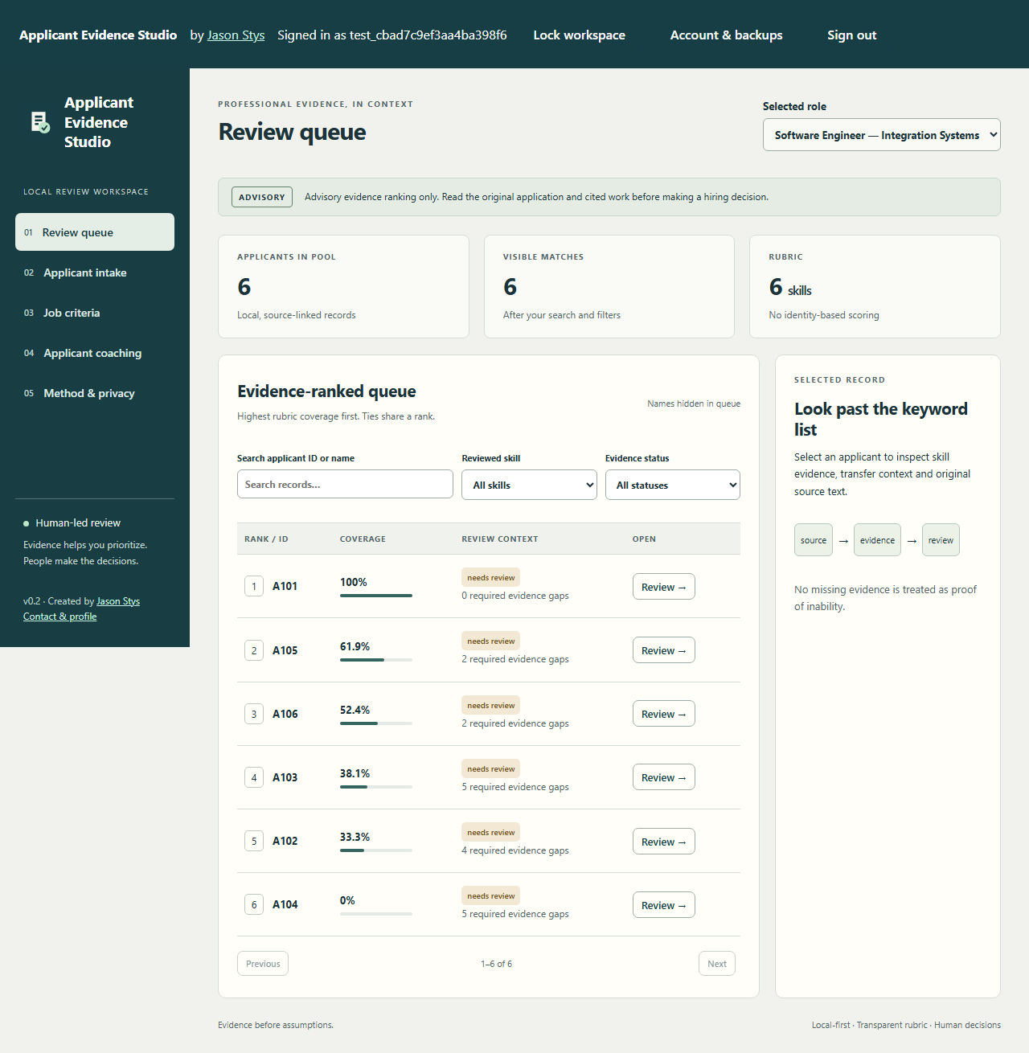
Synthetic private-account review workspace
Advisory only: scores describe reviewed evidence coverage, not a probability of job success or an automatic hire/reject decision. Read the application and cited work yourself. This portfolio prototype does not claim to be bias-free, legally compliant, or production-ready for real hiring.

What it does
Feature | Behavior
Ranked review queue | Weighted skill coverage, shared ranks for ties, search, skill/status filters and pagination. Repeated claims do not inflate scores.
Job configuration | Vetted professional skills, weights, target evidence strengths and required-evidence flags. Description-based suggestions are editable drafts requiring approval.
Consistent applicant records | Private sources, professional claims, explicit education outcomes/transfers, employment duration, review state and consent in a normalized JSON contract.
Resume intake | Bounded UTF-8 TXT/MD, text-based PDF and DOCX extraction. Unsupported, encrypted, scanned, damaged or ambiguous content is surfaced for review rather than guessed.
Professional sources | Private mode accepts applicant-provided professional exports/text. Legacy developer mode can import one explicitly authorized public GitHub README. No broad people search, login bypass or applicant-code execution.
Evidence quality | Reviewers check citations and choose declared, practiced, demonstrated or assessed strength. Coursework and projects can demonstrate skills without being relabeled as paid employment.
Applicant coaching | General/role-specific resume advice, LinkedIn presentation suggestions and practical portfolio-gap project plans.
Downloadable results | Escaped printable HTML resume draft, consistent applicant JSON and criterion-by-criterion advisory report with rubric fingerprint.
Optional AI | Legacy developer mode offers Ollama/compatible chat API citation-validated suggestions. Private accounts use deterministic local coaching and never send data to these providers. Scores remain deterministic in both modes.
Batched workflow | Atomic batches of up to 100 records. Private mode: up to 1,000 records within an 8 MiB workspace budget; legacy developer mode: 10,000 records. Optimistic revisions prevent stale-edit overwrites. Measurements are not production capacity claims.

Identity, protected traits, personal biography, school prestige, photos, follower counts and free-form source text are not ranking inputs. Raw source text is preserved privately for human review; it is not automatically sent to a model. Missing evidence is unknown, not proof of inability.

Legacy local developer mode
Requires Python 3.12+ and Node.js 24. No Docker or external AI service is needed for the normal workflow.
python -m venv .venv
.\.venv\Scripts\python.exe -m pip install --no-deps -r requirements.lock
.\.venv\Scripts\python.exe -m pip install --no-build-isolation --no-deps -e .
npm ci
npm run build
.\.venv\Scripts\python.exe -m app.cli seed --data runtime/demo
.\.venv\Scripts\python.exe -m app.cli serve --data runtime/demo --port 8014
On Linux/macOS use .venv/bin/python instead. Open the session link printed by the launcher. The token is per process and stored only in the browser tab's session storage; resume data is not cached there. Do not publish that link. The service binds to 127.0.0.1 only and accepts its configured Host/Origin.
seed is explicit and refuses duplicate IDs; it never silently replaces an existing database. For a clean private workspace, use a different --data directory, create a job in Job criteria, then import authorized records. The responsive UI is usable in a browser; it is not a signed native installer or a public mobile/cloud deployment.

Typical review
For a closer review, tick Compare ID beside exactly two queue records, then Capture selected evidence. The new criterion comparison uses one captured rubric and record revisions, shows strongest reviewed citations, excluded unreviewed/duplicate claims, unknown evidence and factual clarification prompts. It preserves selection order and never chooses a winner. Human observations can accompany a private JSON export; they do not change scores, records or hiring outcomes. Private accounts build this report entirely in the browser, with no plaintext request or workspace write.
- Read the job description and approve a relevant skill rubric. Avoid unnecessary requirements and unjustified weights.
- Import authorized resumes or a normalized JSON batch. Inspect parser warnings and original documents.
- Add source-linked claims and explicitly check evidence quality/ownership. Proposed keyword mentions stay unreviewed and score nothing until reviewed.
- Inspect the queue, score breakdown, required gaps, transfer chronology and uncertainty. Seek clarification or an accessible work sample where needed.
- Read the best-fit applications yourself. Make hiring decisions outside this advisory tool.
- Open Applicant coaching for practical improvements and a downloadable factual draft. Verify every fact before submitting it.
See docs/user-guide.md for a full walkthrough and examples for fictional cases and input schemas.

Why these languages
Python handles validated domain logic, safe document extraction, AI adapters and testing. TypeScript/React handles typed browser interaction. SQL provides transactional persistence; HTML/CSS provides portable accessible presentation. JavaScript handles compiler-AST documentation tooling. Languages are chosen for their jobs, not added as decorative demonstrations.

Files and responsibilities
The following entries identify the main responsibilities. The complete tracked-file catalog remains the source reference for the full inventory.
File / group | Purpose and main features
app/accounts.py | scrypt password hashes, random session/recovery digests, SQLite account ownership, expiry/throttling, ciphertext CAS and deletion.
app/private_api.py | Separate same-origin account service, strict security headers/input boundaries, encrypted envelopes only; no plaintext review/AI routes.
app/desktop.py, app/server.py | One-file per-user loopback launcher and explicit fail-closed HTTPS deployment factory.
web/PrivatePortal.tsx, web/vault.ts | Account forms, independent key derivation, AES-GCM backups, unlock/lock, help/recovery/deletion and author contact.
web/private-domain.ts | Browser-local validated evidence/ranking/coaching/export logic; serialized encrypted sync and stale-write protection.
web/private-ingest.ts, private-parser.worker.ts | Bounded local PDF.js/FFlate document extraction, timed workers and conservative unreviewed proposals.
web/validators.generated.js, .d.ts, scripts/compile_schemas.mjs | Build-time schema functions: strict CSP without runtime eval. Generated file is deliberately not hand-edited.
tests/test_accounts.py, tests/private.spec.ts, tests/fixtures/* | Synthetic auth/isolation/crypto/parser/backup/a11y regressions and Python/browser parity fixtures.
scripts/private_browser_server.py, private_fixtures.py | Disposable test account server and fictional reference/PDF fixture generation.
scripts/index_reader.mjs, tests/index-reader.mjs | Descriptor-bound, byte-limited strict UTF-8 source-index reads and actual path-replacement/growth/partial-read regressions.
scripts/build_desktop.py, smoke_desktop.py | Native binary/archive/checksum creation and packaged-service verification with disposable data.
public/manifest.webmanifest, sw.js | Installed-web-app metadata and network-only service worker; no private cache or offline sync claim.
playwright.private.config.ts | Private-account browser/device matrix, independent of existing local developer tests.
Dockerfile, .dockerignore | Non-root deployment build excluding runtime credentials/data. TLS/persistence/ingress remain host responsibilities.
.github/workflows/desktop-release.yml | Exact-commit CI gate, per-OS builds/smoke checks and publication only after all succeed.
docs/private-accounts.md, hosting.md, install.md, releases/v0.2.0.md | Privacy/threat model, deployment gates, user installation/help and honest release limitations.
docs/evidence-comparison.md, releases/v0.3.0.md | Capture/citation/unknown/privacy semantics and fresh version 0.3 release notes; published0.2 assets stay unchanged.
app/models.py | Closed professional-skill taxonomy, schema validation, source references, explicit education status, jobs, consent and bounded imports.

Limits and responsible extension
This version does not automatically infer protected traits, degrees, personality, employment-equivalent years or code ownership. It does not scrape LinkedIn, run applicant repositories, interpret images/equations or perform OCR. Text intake deliberately requires human evidence review. AI output is constrained coaching, not autonomous resume interpretation or a hidden selection score. Taxonomy additions require source/schema/test review.
Real organizational deployment requires authentication/authorization, encryption, retention policy, accessibility/user testing, relevant jurisdictional review, monitored bias/error evaluation, correction/appeal mechanisms and validated role-specific rubrics. Human involvement alone is not proof of fairness or legal compliance. See the documentation before using real applicant data.

CodeQL source security review
The CodeQL guide defines genuine Python, JavaScript/TypeScript and GitHub Actions security-extended analysis, review steps and unsupported scope. The dated scan report distinguishes actual results from pending/missing evidence. Static scanning supplements the existing runtime, dependency, privacy and isolation checks; it does not certify every input or platform. The subsequent full-main finding review records the actual three findings, a corrected development-tool read race and tested GitHub-request/dedicated-worker trust boundaries. The genuine read race auto-fixed on full main; two context-specific false positives received individual review. Zero open alerts is distinct from the two retained raw SARIF results. A passing CodeQL job alone is not security clearance.

Current scope and practical limits
- Evidence coverage is advisory, not applicant suitability, a hiring decision, fairness certification or legal-compliance assurance; original applications require human review.
- Comparison captures are unencrypted identifying files. Observations are transient and prior downloads cannot be revoked.
- The accepted public application remains 0.3.0 at its original release source; newer source adds acceptance and release guards without replacing those bytes.
- Unsigned portable applications trust the local OS and retained recovery material; extraction/UI tests do not certify signed installation, a clean-machine lifecycle or public hosting.
The accompanying Validation Review records the exact tested baseline, workflow evidence, test scope and known gaps. The Excel workbook provides filterable workflow and test-source inventories; neither substitutes for the actual execution logs.

Source references and maintenance
Maintain the editable Markdown and this Word edition together. Preserve dated execution reports and re-run the documented checks before release.
README.md · SECURITY.md · docs/architecture.md · docs/operations.md · docs/user-guide.md · docs/reports/portable-acceptance-2026-11-09.md · docs/reports/codeql-findings-2026-11-10.md · docs/codeql.md
Project source and current Actions · Contact Jason Stys

