Application Security Regression Workbench Application Guide
Windows use and validation
By Jason Stys Version 1.1.0 11 November 2026
Run genuine reference web-service security regressions across Java, C#, PHP and Node. Compare exact case outcomes over time, distinguish changed assertions and missing execution, and retain evidence for human review.
The independently downloaded installed application passed the recorded real workflows. All exact-main checks and processed CodeQL passed before publication. Icon targets were read-back verified; normal default-profile shortcut activation remains separately untested.

Capabilities and previous improvements
The original four-engine HTTP conformance and cohort tools now have a complete native review interface: explicit inputs, original case oracles, selected evidence, reasoned comparison, search, durable history and exact bundle export.
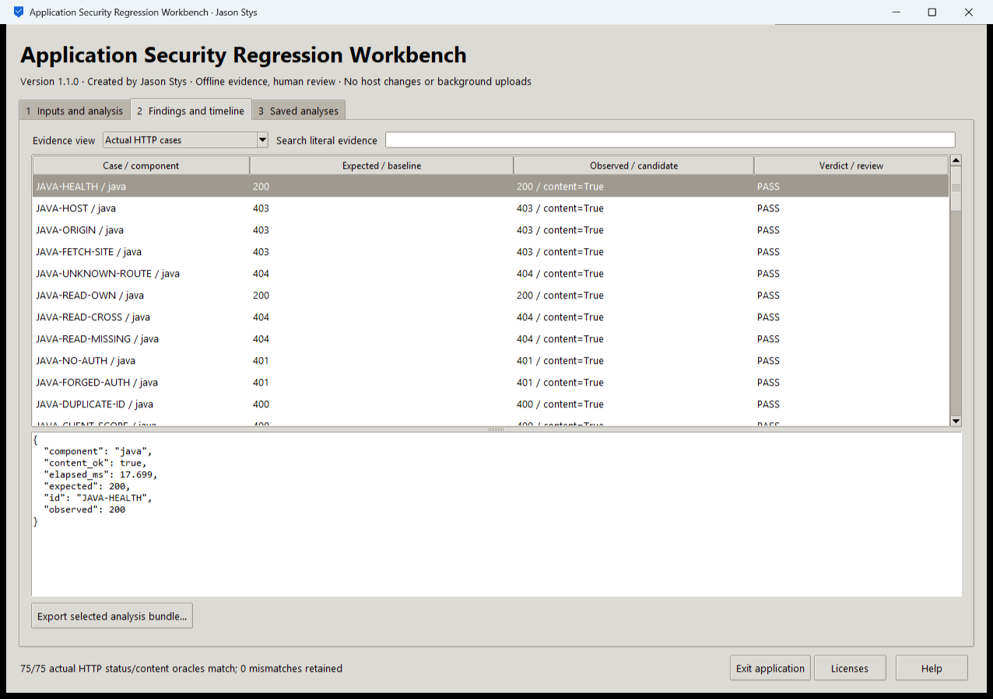
Figure 1 The installed app displays selected original reference-service evidence and its complete retained metadata.

A worked application journey
A security engineer reruns the authored four-service regression suite, then compares two synthetic historical cohorts to investigate changed behavior without hiding missing cases.
1. Select the reference components or authorized cohort data in Inputs and analysis. Prepared cases are ordinary editable inputs inside this app.
2. Run the actual fixed reference services. Inspect HTTP status and content assertions separately from labels; these checks do not execute uploaded source code.
3. Open Findings and timeline, select a case and inspect full source-bound details. Use literal search while keeping the full denominator visible.
4. Export the complete selected bundle, quit normally and reopen Saved analyses. Preserve original inputs and historical reports for independent review.
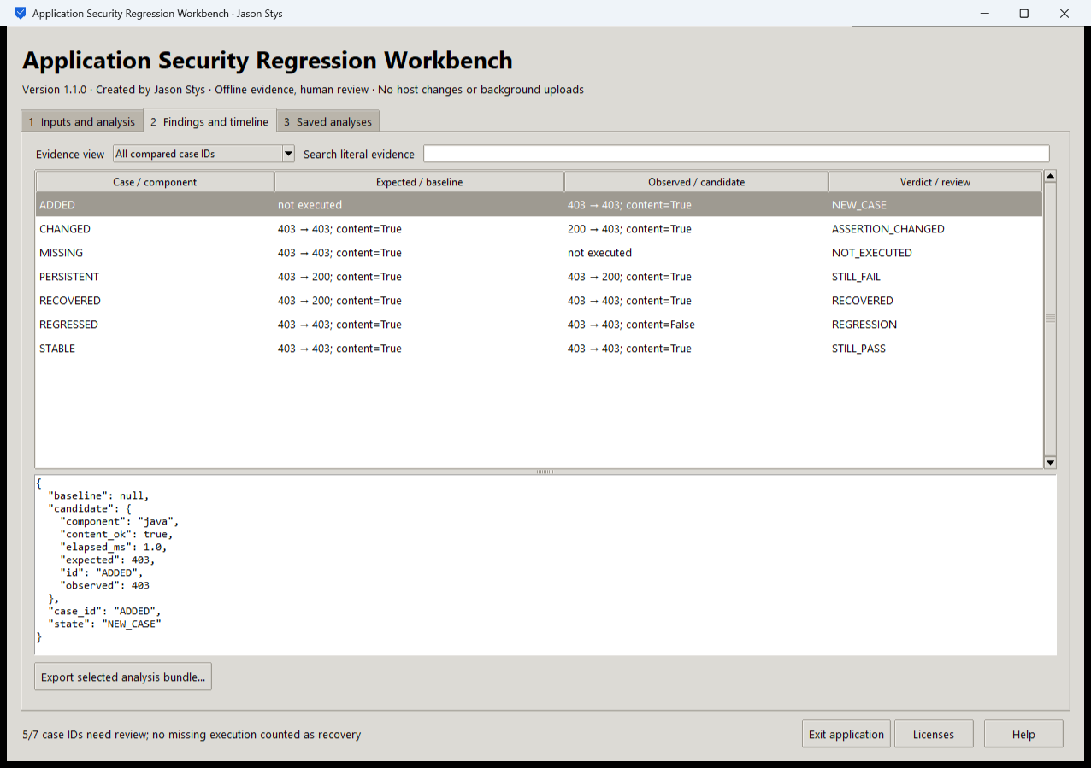
Figure 2 The real cohort view distinguishes new, missing, changed, recovered, persistent and regressed cases. Missing execution is not recovery.

Important implementation details

Execute only the authored component set
The native analysis selects a closed component list and calls the original real HTTP service/exercise functions. Uploaded cohort data is evidence to review, not executable code.
asrl/desktop_project.py lines 201 to 214
201 raise Rejected("unsupported_offline_operation")
202 if mode == MODES[0]:
203 component = parameters.get("component", "")
204 if component not in CHOICES["component"]:
205 raise Rejected("unknown_authored_component")
206 identity = package_identity(ROOT, PRODUCT, VERSION, RESOURCES, RESOURCE_LIMITS)
207 rows = []
208 for selected in (
209 sorted(evidence.COMPONENTS) if component == "all" else [component]
210 ):
211 try:
212 with service(selected, ROOT, stage) as port:
213 rows.extend(exercise(selected, port))
214 except evidence.LabError as error:
Source file SHA256 cd634e168e45d9735ea341dc1c0b731b5d85c03a5f085659b2f1cd1351ae7e15

Validation results and operating limits
Runtime source 34e40cf6657f3f1ddf8f9d059b5d09ab3c1b193c
Check | Observed evidence | Result
Actual installed workflows | Eight real installed workflows retained eight exact bundles; all 150 mandatory HTTP assertions across four actual services passed. Both installed launches ended normally. | Passed
Original core and source gates | 208 source tests and original Java/C#/PHP/Node cases, browser journeys, static types and dependency checks passed. The 95% source-coverage floor was retained; measured aggregate was 95.60%. | Passed
Assets and current security | Provider/download hashes, complete installed-byte identity, current exact-main workflows and processed raw CodeQL results passed with zero open main alerts. | Passed
Launch and data boundary | Individual Desktop and Start-menu targets verified. Only synthetic profiles were exercised; installed EXE tests are distinct from ordinary default-profile shortcut activation. | Passed

Installation and private data
Download the AppSec Windows EXE, its SHA-256 sidecar, runtime notices and project license. Verify the hash and launch the one-file EXE. Keep notices, stopped-profile backups and earlier app versions.
Use the individual Desktop icon and the app's Help. Quit through its owner controls. No Python setup or Docker change is required; examples are input data inside the full application.

Limits and help
This is an owner-local synthetic/reference regression workbench, not a general production scanner, identity service, ASVS certification or guarantee of secure third-party code.
Unsigned Windows x64 portable app; saved evidence is plaintext trusted-OS-owner data. JRE source/build references and original runtime terms are retained; no whole-JDK rebuild or legal-certification claim.
Release and checksums | Runtime source | Usage and limitations

