Business Knowledge Workbench Project Guide
  - By Jason Stys
Public source revision a25887ac0e54
This edition documents the cited source. Validation observations below identify their own tested revision and time; they are not a promise that an unrun later revision passed.
A private, local-first document and data standardization application by Jason Stys. Its main job is to turn supported business files from different sources into a consistent, inspectable representation: common measurement units, stable field names and order, a chosen document structure and layout, and a standard output file type. Search, product views and sales graphs make that standardized information useful; they are supporting features, not the main purpose.
Search standardized numeric table values with unit-aware ranges and same-cell correlation; download authorized bounded document bundles with checksummed manifests and saved standards. Fixed scientific notation normalization.
Makes standardized business records easier to investigate and hand off without mixing units or bypassing document access.

Purpose operation and implementation
Source and Actions · Downloads · Contact Jason on LinkedIn
Version 1.4.0 adds inclusive, unit-aware numeric searches and selection-based ZIP downloads with per-file integrity manifests. Search across saved standards without rewriting documents, then gather permitted standardized files using each document's saved output format. It preserves the visual field/layout editor, owner-controlled standards, original evidence and private local accounts. See the library guide, standards guide and workflow validation.
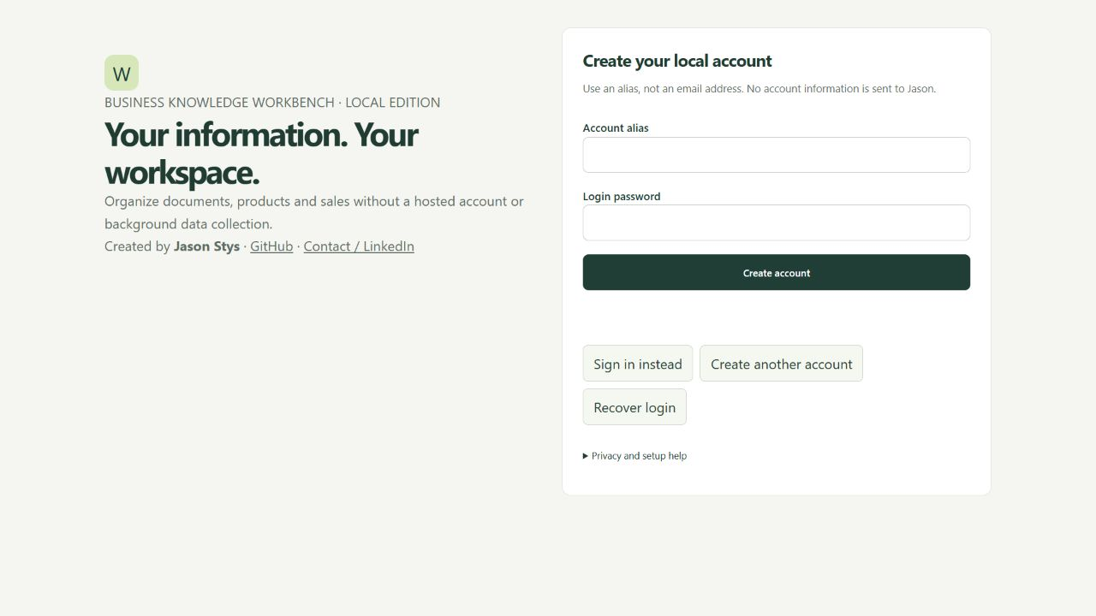
Installed private account website with blank credential fields

What standardize means
Suppose supplier A sends a CSV field length containing 4.25 in, supplier B sends JSON with Width: "8.2 cm", and a technician sends a DOCX table. The owner defines canonical fields item, width, their displayed headings, order and a millimeter target. Recognized tables then share the same schema and measurements (107.95 mm, 82 mm), even though the source files differ. Optional fields have explicit empty cells; missing required fields, incompatible dimensions and ambiguous duplicate headers are rejected. Extra columns can be preserved with a warning, rejected, or explicitly omitted from standardized output. Disabled fields are excluded even when present in a source. Original evidence remains available; field exclusion is a presentation choice, not redaction.
For documents, the selected standard controls section order and headings, font, heading color, margins, alignment, line/paragraph spacing, running headers/footers, DOCX/PDF page numbers, Letter/A4 paper, portrait/landscape orientation and preferred HTML/JSON/Markdown/CSV/DOCX/PDF delivery. An optional policy restricts document and report exports to that chosen type. Every conversion still goes through canonical HTML first. Original source bytes, pre-normalization blocks, warnings, the settings snapshot, revision and standard digest remain available for comparison.
This is normalization, not invention: the app does not guess units on arbitrary bare numbers, equate unrelated fields automatically, translate currencies or certify that extracted facts are true. A declared table field may specify a source unit for bare numbers. Graphs, images and equations can be retained without their meaning being understood. See format and fidelity limits.

Define your business standard
- Unlock your own private account and open Configuration studio.
- Set target units, document section order/headings, standard name, print layout
and default export type. Configure optional table keys, aliases and required fields in the visual editor; add, move, exclude or remove fields without writing JSON. The measurement-table example is an editable starting point.
- Use Preview draft standard with a CSV sample or a supported source file. This does not publish
anything, call an AI provider or alter stored documents.
- Save validated configuration publishes a new revision. A stale editor gets
a conflict instead of overwriting someone else's newer revision.
- Import supported files or combine authorized documents. Open the result and
choose Download standard…. Reports also have a standard-format download.
- For an older document, choose Create current-standard copy. Originals and
sales remain unchanged. Restore as new revision recovers a saved standard without rewriting its history or prior documents.

Browse search and download
Open Business workspace to see permitted standardized files, source types, extraction warnings, timestamps and standard revisions. Preview shows canonical HTML; Download in each row saves that document's standard format. The detail view also offers original source and permitted alternate exports.
Search standardized text and titles, then combine category, source format, content kind, measurement dimension, access scope and extraction-review filters. To locate a specific quantity, select a canonical Table field such as width and enter 107.95 mm in Field contains. The value must occur in that same table column. Results, counts and suggestions all obey the same permissions. Twenty-five files appear per page, up to the 200-document profile limit. See library examples and limits; images are not automatically OCR-searched.
For a range, choose width, Minimum 100, Maximum 110 and comparison unit mm: both 107.95 mm and 10.795 cm match, including files saved under older standard revisions. Text and numeric conditions must hold in the same cell. Unitless comparison never guesses units; incompatible, unknown and absent values do not match. Temperature bounds convert with offsets, not just scale factors.
Select up to twelve files across result pages and choose Download selected files (ZIP). Each export uses its own saved standard, even when current settings have changed. manifest.json records selection order, file sizes, SHA-256 hashes and standard revisions/digests. Authorization checks every selected document before generating anything. The ZIP contains plaintext standardized outputs, excludes original attachments, and is not an encrypted or digitally signed archive.
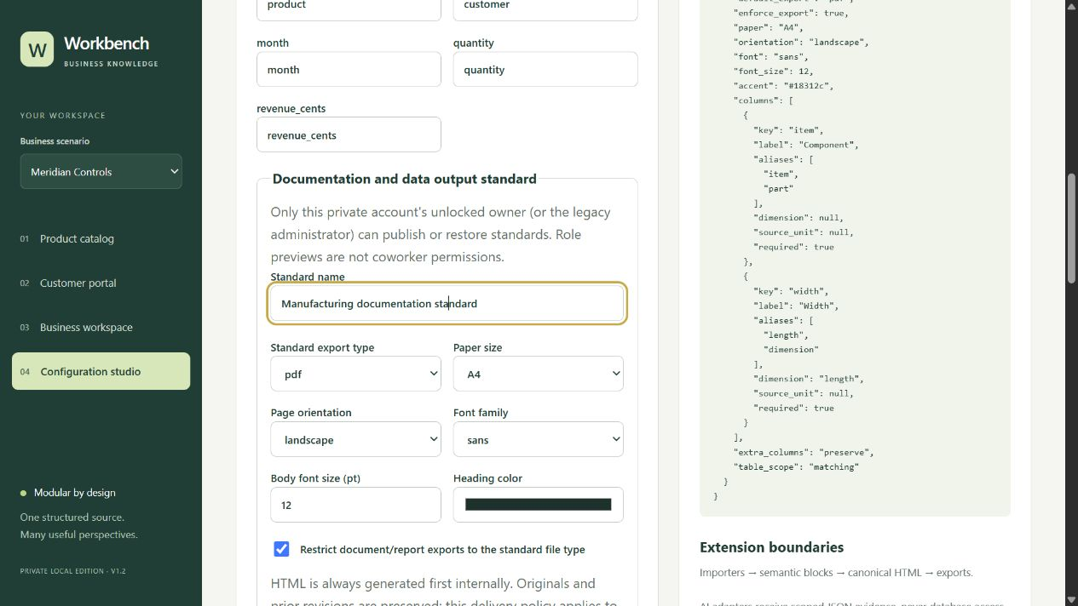
Owner-controlled output standard in a disposable fictional business account
The screenshot shows a published PDF/A4/landscape standard and its saved schema; no real account credentials, documents or provider keys are included.
Authority is enforced on the server, not just by hiding a button. In the installed private edition, the signed-in, vault-unlocked account owner is the standards authority for their own data. There are no shared-business invitations or delegated coworker roles yet. Customer/employee screens are own-account previews; in the separate legacy role demo, only the database-authenticated administrator may preview, publish, read history or restore standards. A client-supplied role header cannot promote a legacy employee or customer. A responsible standards manager would need a trusted shared-team authorization deployment, not a UI toggle.

Install and start
Download a release for your OS, verify its SHA-256 record and launch the app. The Windows per-user setup is one click; a portable ZIP is also provided. macOS arm64 and Linux x64 packages are available. Native packages include Python, the document service and the UI—no terminal setup is needed for normal use. Builds are unsigned / not notarized; no claim of store approval or universal hardware support.
Choose Open local website from the desktop menu to use the same app in a browser. The service binds only 127.0.0.1 on an automatically selected port. There is no public hosted website, paid hosting, telemetry or Jason-operated account server. A phone cannot connect to another device's loopback address; this release has responsive web layouts, not native mobile installers.
Create an alias and login password, privately save the once-shown login recovery code, then choose a different vault phrase. Forgotten vault phrases cannot be recovered or reset by Jason. See private accounts and user guide.

Main features
- Fifteen supported extensions: text, Markdown, sanitized HTML, CSV/TSV, JSON, XML, DOCX, XLSX, PDF and raster images. Original evidence, semantic blocks, extraction warnings and hashes are retained.
- Canonical HTML first, then HTML, JSON, Markdown, CSV tables, DOCX or PDF export. Graphs/images are preserved where supported, not universally understood; read the format limits.
- Decimal-based measurement normalization with dimension validation; 4.25 in → 107.95 mm, 104 F → 40 C. Configuration revisions preserve provenance.
- Bounded signed/scientific measurement notation is normalized as a complete number; an exponent suffix cannot be mistaken for a separate measurement (5e-3 V → 5 mV with a millivolt standard). Embedded identifiers and ambiguous hyphenated ranges are preserved for review.
- Numeric table-field range search across compatible units and saved revisions, plus bounded multi-file ZIP exports with independent per-file integrity records. Customer subsets obey the same server permissions as individual downloads.
- Named, data-only standards with visual field addition/removal/order/exclusion, optional/required columns, explicit measurement dimensions, real-file draft previews, immutable history and controlled export types. Bounded Word-like layout settings; no executable user templates or arbitrary CSS.
- Product catalog, customer subset preview, business reporting and administrator configuration views. These are previews within your own account, not a coworker invitation or shared-tenant permission system.
- Explicit opt-in fictional industrial equipment, renewable energy and laboratory supply scenarios. New accounts start with no products, sales, sources or demo users.
- Search, filtering, sort, ordered internal-only compilations, atomic sales imports with duplicate prevention, exact-cent reports, accessible graphs and labeled baseline forecasts.
- Optional read-only AI: offline extractive reference by default; explicitly connect an own local OpenAI-compatible server or the official HTTPS chat endpoint. Own keys are encrypted with documents when locked, never returned to the UI. External source transmission requires consent for the selected destination revision.
- Real local login, scrypt password hashes, expiring HttpOnly cookies, same-origin/custom-header request gates, separate session vault proof, human-idle locking, encrypted snapshots, login recovery and current-password-confirmed own-account deletion.
- Same-origin scripts, no third-party assets or ad integrations, scriptless document previews and sandboxed native renderer with no Node/preload privileges. These controls do not defeat malware or a compromised OS/browser extension.

Privacy and practical limits
Each account's locked document database and model settings are stored in an AES-256-GCM archive outside Git and installation files. While unlocked, the trusted local service temporarily uses plaintext files and an in-memory key. The OS owner/administrator or malware can inspect active data; this is not zero-knowledge or protection from a compromised device. Jason has no app backdoor or automatic remote data access.
Lock or sign out before switching accounts. Save an encrypted snapshot, then close the application before backing up the entire private account directory. A downloaded snapshot alone lacks account/key configuration. Plaintext exports and old developer/demo databases need separate protection. Existing demo/legacy data is neither imported nor erased.
Supported uploads are bounded to 4 MiB and 200 documents per business profile. Parsing uses timed credential-stripped child processes, not an antivirus or complete OS exploit sandbox. Do not upload files from untrusted attackers on a sensitive workstation; hostile-parser containment/CDR and shared business hosting need a separate deployment design. There is one unlocked account engine at a time. See architecture decision, security policy and release checklist.
Hosted model providers can retain deliberately transmitted content under their policies. Official chat requests set store: false; that is not a promise of zero provider retention. No live API keys or paid model calls are required by the test suite.

Run from source
Developer setup requires Node 24 and Python 3.12–3.14:
python -m venv .venv
.venv\Scripts\python.exe -m pip install -r requirements.lock -e .
npm ci
npm run build
.venv\Scripts\python.exe -m server.private_cli
The CLI opens the local account website. Keep its process running. A trusted operator can set KBW_ACCOUNT_DATA to a dedicated empty test directory; never point it at unrelated files. The legacy synthetic demo is separate and requires explicit KB_LEGACY_MODE=1 and KB_DEMO=1; never expose it to real records. Docker is optional for demo CI, not required by the installed app.

File responsibilities and language choices
Area | Responsibility
web/main.ts, types.ts, style.css, index.html | Typed document/product/reporting views, accessible HTML, responsive styling and escaped rendering.
web/private.ts | Account forms, browser key derivation, help, own AI settings, consent and human-activity signals.
server/accounts.py, permissions.py, vault.py | Local authentication/session/recovery hashes, dedicated OS-user permissions and streamed authenticated snapshots.
server/private_api.py, private_workspace.py, private_cli.py | Exact-loopback boundary, account-isolated document engine, serial lifecycle/idle recovery and local launch.
server/app.py, models.py, store.py, schema.sql | Preserved business API, validation, relational integrity, scoped searches and synthetic seeding.
server/conversion.py, worker.py, units.py | Supported rich-format parsers, bounded child conversion and exact normalization.
server/standards.py, web/standards.ts | Deterministic field/schema mapping, standard fingerprints and safe typed editor controls.
server/library.py, web/library.ts, web/standard-builder.ts | ACL-first filtered searches, bounded file pages and visual field-definition editing.
server/exports.py, analytics.py, ai.py | HTML-derived exports, explainable reporting and read-only model contracts.
desktop/main.cjs | Electron shell with an owned frozen service, denied external navigation/popups and graceful sealing.
scripts/ | Frozen entry, licenses/checksums, fixture/benchmark and exact line/file inventories.
tests/, playwright*.config.ts | Real parser/API/crypto/role regressions, browser journeys and native packaged-app tests.
public/, examples/ | Shell-only legacy PWA assets and clearly fictional sample evidence; no user data.
.github/workflows/, root configuration | Reproducible dependency/build/CI/package/release gates and optional legacy container.
docs/ | Usage, limits, architecture, contracts, validation/release evidence and per-file/source maps.

Python uses its mature document ecosystem, TypeScript provides typed browser interactions, SQL provides transactional business persistence, HTML/CSS keep outputs inspectable, and JavaScript powers the isolated desktop shell. The complete file catalog summarizes each tracked file; the generated code index maps every authored code file's functions/classes/variables to exact lines. Regenerate inventories after source edits.

Current scope and practical limits
- Local owner-account edition; no shared hosted-business identity, invitations or managed tenant deployment is supplied.
- Numeric range search covers standardized cells, not OCR or arbitrary source-blob search; unit conversion uses canonical six-place precision.
- Export ZIPs are plaintext integrity records, not encrypted or digitally signed; they omit originals and account secrets.
- Import and conversion support is adapter-specific; no universal file-format, image/equation understanding or AI-provider compatibility is promised.
The accompanying Validation Review records the exact tested baseline, workflow evidence, test scope and known gaps. The Excel workbook provides filterable workflow and test-source inventories; neither substitutes for the actual execution logs.

Source references and maintenance
Maintain the editable Markdown and this Word edition together. Preserve dated execution reports and re-run the documented checks before release.
README.md · SECURITY.md · docs/adr-private-local.md · docs/architecture.md · docs/operations.md · docs/reports/practical-workflows-2026-11-09.md
Project source and current Actions · Contact Jason Stys

