Synthetic controller commissioning pack
Invented source material for extraction testing. No real installation instructions or performance guarantees.
Product | Width | Input
MC-240 | 4.25 in | 24 V
IO-16 | 8.2 cm | 24000 mV
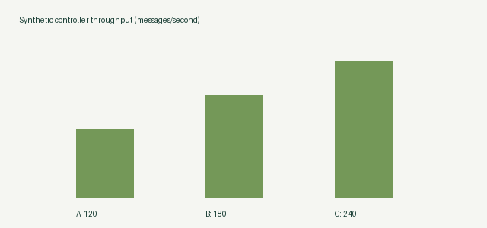
$V = raw / 65535 × 10$

