Business Knowledge Workbench Application Guide
Windows use and validation
By Jason Stys Version 1.4.1 10 November 2026
Normalize supported business files into a consistent HTML-first semantic representation with selected units, fields, columns, layout and export formats. An account owner configures their own private workspace standard, then searches, previews and downloads the standardized evidence.
The actual installed 1.4.1 app passed rich import, standard preview, library/search/export and encrypted same-account restart. A separate real 1.4.0 to 1.4.1 upgrade retained all 10 standardized documents with exact metadata and full semantic contents. Existing normal account and launcher files remained byte-for-byte unchanged.

Capabilities and previous improvements
Search standardized numeric table values with unit-aware ranges and same-cell correlation; download authorized bounded document bundles with checksummed manifests and saved standards. Fixed scientific notation normalization. Makes standardized business records easier to investigate and hand off without mixing units or bypassing document access. This release also corrects visible arrows and separators and bundles patched CPython 3.14.10 with Electron 44.11.
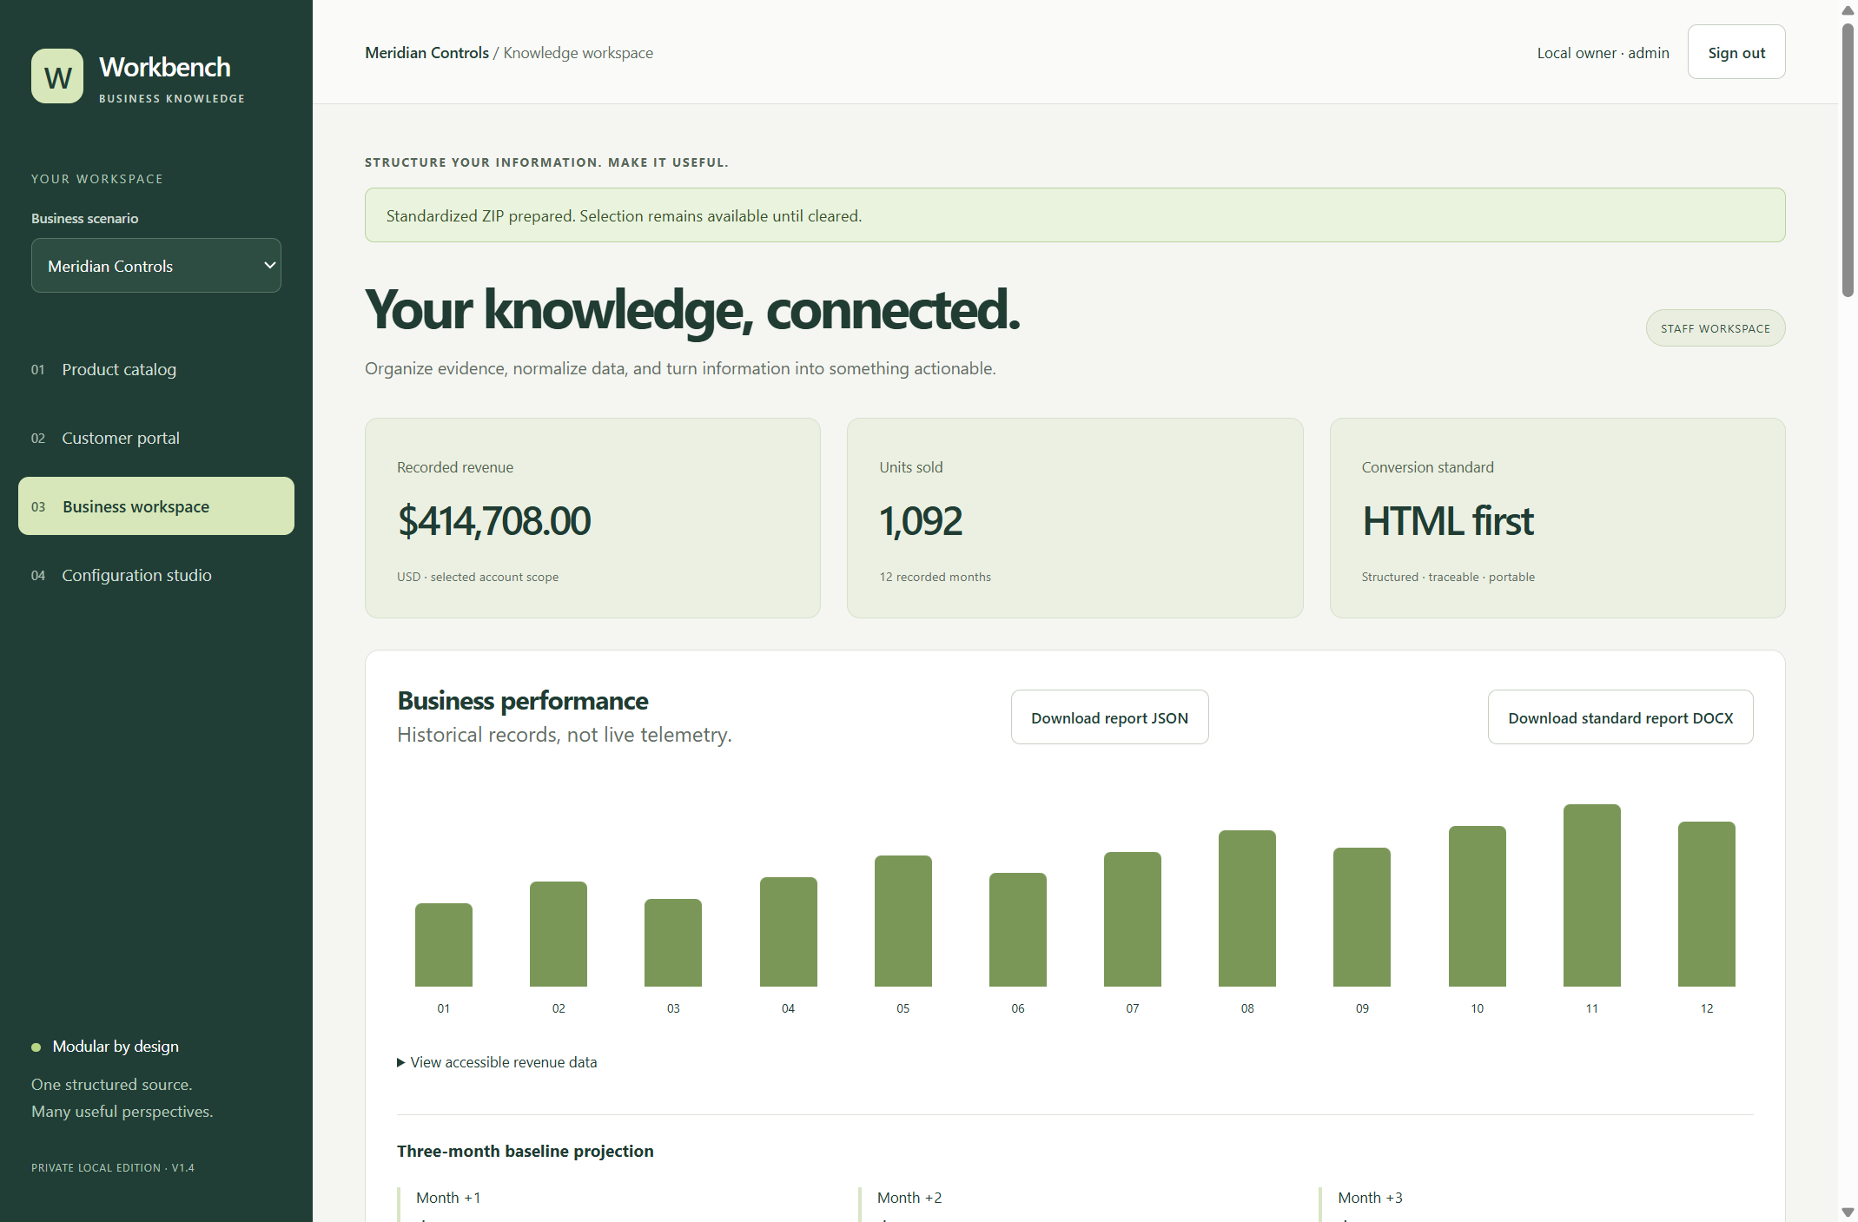
Figure 1 The actual installed app displays a private synthetic business workspace after rich import and library operations. Rows and standardized evidence remain within the authenticated account's unlocked vault.

A worked application journey
A fictional industrial supplier imports a commissioning DOCX containing a table, equation and figure. The owner customizes the output standard, reviews the formatted preview, searches the library and exports evidence before locking and reopening the same encrypted workspace.
1. Open the existing Desktop app, create or sign in to your local account, and unlock its separate vault phrase. Keep recovery material private.
2. Choose Configuration studio to set units, enabled fields, column aliases, layout and report sections. Preview the standard before saving it; private-edition views preview roles within your own account, not another user's data.
3. Use Business workspace to import supported files. Inspect conversion warnings and preview, then search/filter the library by content, type, classification or standardized numeric values.
4. Download authorized HTML-first outputs or a bounded checksummed bundle. Save the encrypted snapshot, lock the workspace and reopen it to verify the retained files.
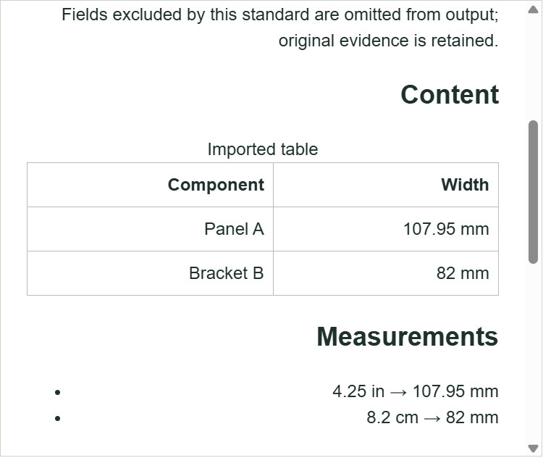
Figure 2 The actual installed preview viewport shows the selected manufacturing report standard and normalized table values. The full unchanged native workflow passed again; only the screenshot selects the visible iframe instead of its entire long document.

Important implementation details

Map selected columns with explicit aliases
The standard works on a deep copy, expands supported HTML tables and creates one alias lookup. Enabled and excluded columns are distinct; unknown data follows the configured explicit policy rather than disappearing silently. Header mapping scales linearly with cells and configured aliases.
server/standards.py lines 78 to 96
78 def prepare_tables(blocks: list[dict], config: WorkspaceConfig, warnings: list[str]) -> list[dict]:
79 """Map headers in O(cells + aliases), retaining unknown data or rejecting it explicitly."""
80 prepared = copy.deepcopy(blocks)
81 standard = config.output_standard
82 if not standard.columns:
83 return prepared
84 prepared = expand_html_tables(prepared)
85 enabled = [column for column in standard.columns if column.enabled]
86 excluded = {column.key for column in standard.columns if not column.enabled}
87 aliases = {
88 alias.strip().casefold(): column.key
89 for column in standard.columns
90 for alias in [column.key, column.label, *column.aliases]
91 }
92 for block in prepared:
93 if block["kind"] != "table" or not block["rows"]:
94 continue
95 rows = block["rows"]
96 headers = rows[0]
Source file SHA256 acba606eb5fe8867239a3c5712c0054cc4f050ec7c1024717841dcc7e7bbc8f5

Validation results and operating limits
Runtime source ba3cf3cfc6f2d443747f7350af06ca0329b1fcc4
Check | Observed evidence | Result
Native workflows | Full installed import/preview/custom-standard/library/export journey and same-account vault restart passed with synthetic rich documents. | Passed
Cross version upgrade | Real 1.4.0 and 1.4.1 apps reopened the same account; all 10 document metadata records and full semantic documents matched exactly. | Passed
Source and release | 327 tests at 89.79 percent coverage,18 private browser journeys, current main/CodeQL and all 3 OSnative release builds passed. All 12 downloaded assets matched provider/sidecar hashes. | Passed
PC preservation | Verified opaque account/launcher backup, installer exit 0 and unchanged normal profile bytes. Existing Desktop and extra demo links were preserved; the main link targets the accepted updated EXE. | Passed

Installation and private data
Use the matching 1.4.1 Windows installer and checksum sidecar from Releases. It upgrades the per-user app without requiring a system Python installation. Other OS packages are separate downloads.
Private account archives are outside the install/repository in BusinessKnowledgeWorkbenchAccounts. Back up the complete directory and preserve the independent vault phrase; login recovery cannot decrypt a lost vault phrase.

Limits and help
Supported formats are parsed with explicit fidelity warnings; there is no claim to understand every file, image, handwritten equation or arbitrary embedded object. External AI/provider use requires separate configuration and consent.
The native private edition isolates each authenticated owner's vault. Role previews are not an enterprise staff-directory authorization system. Packages are unsigned; the trusted OS/service can access active plaintext while the owner unlocks it. Docker and normal account credentials were not accessed by acceptance.
Release and checksums | Runtime source | Standards and search help

