CCSDS Telemetry Integrity Lab Project Guide
  - By Jason Stys
Public source revision 97f729a525aa
This edition documents the cited source. Validation observations below identify their own tested revision and time; they are not a promise that an unrun later revision passed.
The APID continuity review workflow groups records into conservative review segments, tracks compressed provisional gaps and recognizes uniquely matching late counters without rewriting original decisions. Ambiguity leaves unresolved values explicitly uncertain. The UI links each event to its original record; JSON/HTML and CLI history preserve the complete ledger. See the continuity guide.
The released 1.1.0 portable integrity lab includes per-APID continuity timelines: inspect provisional gaps and late recovery, follow ambiguity boundaries and retain every original parser decision in the downloaded evidence.
The safe Rust parser, independent Python reference and seeded fuzz checks remain unchanged. An extracted-app journey independently checks counters 50, 52, 51 and 53, a recovered provisional gap and unchanged late-or-reset review totals, then compares the real downloaded report with the API result. Coherent Cargo/Python/npm versions and runtime notices keep the new portable release aligned with its source.

Purpose operation and implementation
Read the bytes. Know the limits. An offline Rust/Python telemetry inspection workbench by Jason Stys.
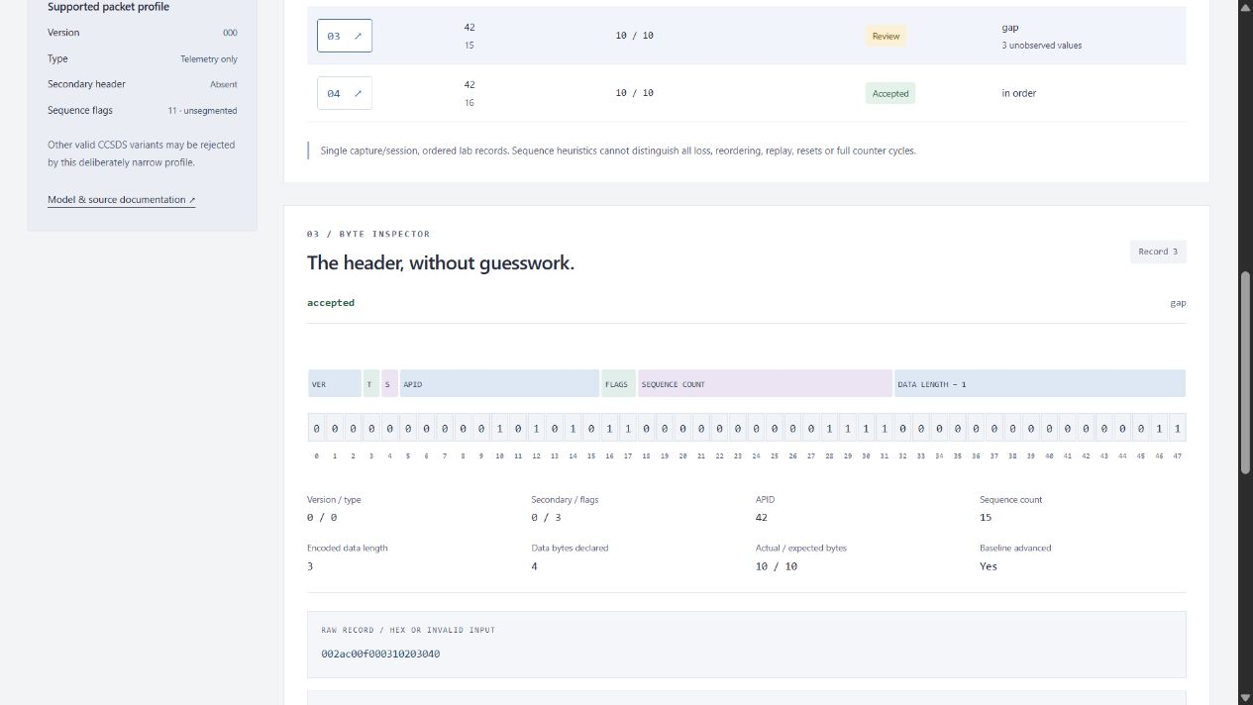
Actual local primary-header inspector
Decode a restricted CCSDS telemetry packet profile, inspect every primary-header bit, compare the actual native Rust parser against an independent Python implementation, and review sequence behavior without conflating gaps, reordering, resets, repeats and payload authenticity.
This is original educational software, not a complete CCSDS protocol entity, certified decoder, flight-qualified component or operational ground system. All built-in examples are invented. There is no live spacecraft/radio connection, command transmission, routing, targeting or hardware interface. Structurally accepted packets can still contain changed or unauthenticated data: this profile verifies no embedded payload checksum or sender identity. A report SHA identifies its contents; it is not an authenticated signature.

Demonstrated engineering
- Dependency-free Rust 1.98.1, forbidden unsafe code, bounded parsing and a borrowed accepted payload rather than a packed-struct cast.
- Checked network-byte-order primary header, exact length, payload cap and explicit unsupported-profile outcomes.
- Independent Python quotient/remainder reference, compared against every native result. Disagreement withholds evidence; Python never substitutes for a missing/broken native worker.
- Per-APID modulo continuity review with deliberate non-advancement on duplicate/reused/late/ambiguous records; idle packets do not contaminate application baselines.
- Twelve synthetic cases, 108 finite configurations, exhaustive native field/length tests, 50,000 seeded hostile-byte records and cross-language property tests.
- Accessible responsive TypeScript UI, proportional 48-bit header graphic, record filters, exact raw/declared sizes, opaque payload view and failure/retry behavior.
- JSON/CSV/inert HTML/input-capture exports, deterministic full evidence hashes and opt-in immutable local SQLite history.
- Cross-platform CI, locked dependencies, native packaged-app smoke tests and no Actions artifact/cache uploads.

Run the app
Download the Windows x64 ZIP or Linux x64/macOS ARM64 .tar.gz archive and matching .sha256 from the v1.1.0 release. Preserve POSIX links and executable permissions when extracting. Verify the digest, extract the whole directory, and launch TelemetryIntegrityLab (.exe on Windows). It starts a loopback service and opens your default browser. Stop its console with Ctrl-C. No global Rust/Python/Node installation, account, cloud API or administrator privileges are required for the portable app.
Bundles are unsigned/not notarized. Do not bypass OS warnings, disable protection, remove quarantine or run elevated. Use reviewed source if policy blocks unsigned binaries. Native releases target Windows x64, Linux x64 and macOS ARM64—not every OS release or mobile device. The website is a local browser application, not a publicly hosted multi-user service.

From source
Install Rust/rustup, CPython 3.12–3.14 and Node 24. The tracked Rust toolchain selects the reviewed compiler; packaging also needs its rust-docs component for redistribution notices.
python -m venv .venv
# Windows: .venv\Scripts\activate
# Linux/macOS: source .venv/bin/activate
python -m pip install --require-hashes -r requirements-dev.lock
cargo build --release --locked
npm ci
npm run build
python -m packetlab serve
The printed URL is http://127.0.0.1:<ephemeral-port>/. serve --no-browser --port 8825 selects a fixed port. The server never listens on a public interface. Rust is necessary to build from source; the Python reference is not a runtime fallback.
Try Missing sequence values, inspect record 3, then compare Delayed record after a gap, Half-range ambiguity, and Undetectable payload bit flip. The last one intentionally passes structural checks: the UI must not claim a check it never performed.

Capture and CLI
One ASCII hex packet per newline in a lab capture format. These trusted record boundaries are not a CCSDS framing or resynchronization mechanism. Example: 002ac0010002deadbe decodes to APID 42, sequence 1, unsegmented data and three opaque payload bytes. examples/nominal.hex is editable.
python -m packetlab export --scenario sequence-gap --output evidence.json
python -m packetlab export --scenario nominal --format input --output capture.hex
python -m packetlab export --input capture.hex --payload_limit 128 --forward_window 256 --output local-review.json --history local.sqlite3
Imports are CLI-only, capped at 128 KiB and 128 records; each decoded record is at most 4102 bytes. Unsupported or malformed records remain in the report, while an invalid capture envelope is rejected completely. Exports never overwrite. History is opt-in, plain local data and capped at 100 distinct reports; it is never exposed over HTTP. Use synthetic, non-sensitive captures. See API and user guide.

Verify
cargo fmt --check
cargo clippy --locked --all-targets -- -D warnings
cargo test --locked
python -m ruff check packetlab tests tools launcher.py
python -m ruff format --check packetlab tests tools launcher.py
python -m mypy packetlab
python -m pytest --cov=packetlab --cov-report=term-missing
python tools/benchmark.py
python tools/verify_repo.py
npm run format:check
npm test
npm run build
npx playwright install chromium firefox webkit
npm run test:e2e
Linux browser setup may need --with-deps. CI exercises the production handler/native worker/build in four OS/Python configurations, three browser engines and three frozen-app builds. CodeQL covers Python and TypeScript; Rust uses its compiler, forbidden-unsafe lint, strict Clippy and native tests, not an unsupported claim of Rust CodeQL scanning. See validation evidence.

Repository map
File/area | Responsibility
rust/lib.rs | Zero-copy byte inspection, bounded hex decode, fixed-key JSON and native exhaustive/fuzz tests
rust/main.rs | Bounded stdin-only native worker; validates complete capture envelope before any output
Cargo.toml, Cargo.lock, rust-toolchain.toml, .cargo/config.toml | Zero-crate compiler/build/lint contract; static Windows CRT linkage
packetlab/reference.py | Independent arithmetic reference and capture-envelope limits
packetlab/native.py | Fixed local/bundled worker bridge, timeout and response-contract checks
packetlab/engine.py | Invented captures, finite settings, continuity state, cross-language gate and canonical reports
packetlab/reports.py, resources/history.sql | Inert exports, verified hashes and immutable parameterized local history
packetlab/server.py, __main__.py, launcher.py | Read-only protected loopback service and source/portable CLI
web/ | Semantic interface, escaping/finite controls, bit graphic, responsive styles and unit tests
tests/ | Actual native/reference properties, sequence/state cases, HTTP/CLI/SQL and browser acceptance
tools/ | Benchmark contracts, exact-line/file inventory, native packaging/smoke and gated draft releases
examples/, docs/, licenses/ | Synthetic input, model/architecture/API/usage/security/evidence and redistribution notices
.github/workflows/ | Validation, CodeQL and manual three-platform release

Every individual file is summarized in FILE_CATALOG. CODE_INDEX provides generated exact definition/argument/variable/field locations; descriptive source headers and contracts reference this instead of duplicating fragile line numbers. CI rejects stale inventories or missing Python definition contracts/creator headers.

Author, sources and contact
Designed and engineered by Jason Stys. Portfolio, questions/issues. MIT original source. Normative field baseline: official CCSDS 133.0-B-2, June 2020, distributed EC2 PDF; the implementation claim remains deliberately restricted. See model, security and third-party notices. No government, military, NASA or contractor affiliation/endorsement is implied.

Current portable release
Version 1.1.0 includes the current practical workflow in Windows ZIP and Linux/macOS tar.gz portable folders, with OS/CPU/version labels and source-bound release metadata. Historical 1.0.0 downloads predate these improvements. These are unsigned portable applications, not installers; preserve the entire extracted folder and POSIX links. See release notes, local validation and release procedure for exact acceptance and publication boundaries.

Current scope and practical limits
- Restricted record-delimited educational CCSDS profile; no live radio/spacecraft integration, raw byte-stream resynchronization or payload authentication.
- Timeline segments are review boundaries, not proof of true sender sessions; provisional recovery does not establish permanent packet loss.
- Unsigned desktop portable folders, not system installers or clean-machine proof. Three-OS extracted-native checks drive an owned URL; default OS browser opening remains manual.
The accompanying Validation Review records the exact tested baseline, workflow evidence, test scope and known gaps. The Excel workbook provides filterable workflow and test-source inventories; neither substitutes for the actual execution logs.

Source references and maintenance
Maintain the editable Markdown and this Word edition together. Preserve dated execution reports and re-run the documented checks before release.
README.md · SECURITY.md · docs/ARCHITECTURE.md · docs/reports/PORTABLE_REFRESH_20261109.md
Project source and current Actions · Contact Jason Stys

