CCSDS Telemetry Integrity Lab Application Guide
Windows use and validation
By Jason Stys Version 1.1.0 10 November 2026
Reconcile per-APID provisional packet gaps without rewriting original parser decisions. Prepared scenarios use the full Windows application and its existing model and report exports.
The published Windows portable application was installed and tested using isolated synthetic inputs. Provider and sidecar digests, release metadata and installed resource identities were checked. The installed file set remained unchanged after testing.

Capabilities and previous improvements
Add a per-APID provisional gap and recovery ledger with compressed ranges and explicit ambiguous or censored sequence history. Explains packet continuity without turning reordering or incomplete captures into unsupported loss claims.
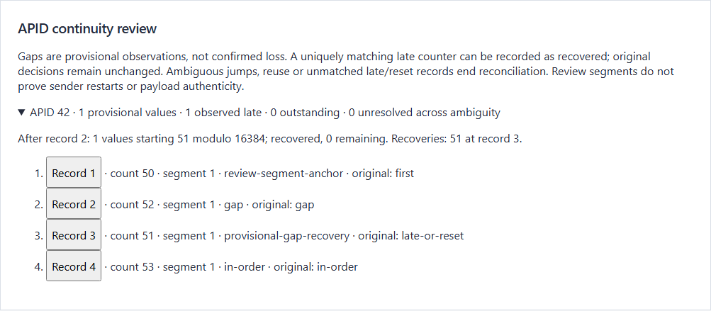
Figure 1 Actual installed application showing provisional sequence-gap recovery. Captured during the accepted native user journey with prepared synthetic inputs.

A worked application journey
The worked example compares provisional sequence-gap recovery with empty capture without invented apid. Interpret the results using the model assumptions and limits on the final page.
1. Open the application shortcut to start its local web interface and console. Select a prepared scenario or your own supported input; the examples require no external account or live hardware.
2. Inspect out-of-order packets, expand APID 42's timeline and select recovered sequence 51. Download the evidence and compare the empty-capture case.
3. Review the main case alongside the boundary case shown in Figure 2. APID 42 sequence 51 recovered a provisional gap at record 2. Its original late-or-reset disposition remained; an empty capture did not invent a stream.
4. Download the supported evidence report and retain the input/configuration with it. Recompute after an input change; do not reuse a result under a different configuration.
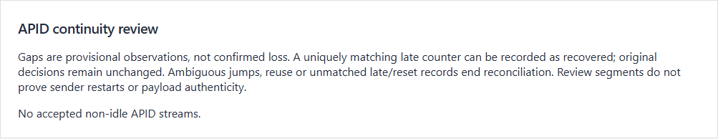
Figure 2 Actual installed application showing empty capture without invented apid. Captured during the accepted native user journey with prepared synthetic inputs.

Important implementation details

Timelines
A late counter recovers a provisional range only when exactly one current, unambiguous gap matches. Repeats and ambiguous observations remain distinct, and the original parser disposition is not rewritten.
packetlab/timeline.py lines 51 to 71
51 elif disposition == "late-or-reset":
52 matching = [
53 gap
54 for gap in stream["gaps"]
55 if gap["segment"] == stream["segment"]
56 and not gap["ambiguous"]
57 and (sequence - gap["first_sequence"]) % 16384 < gap["count"]
58 ]
59 pending = [
60 gap
61 for gap in matching
62 if sequence not in {entry["sequence"] for entry in gap["recoveries"]}
63 ]
64 if len(pending) == 1:
65 pending[0]["recoveries"].append({"sequence": sequence, "record": row["index"]})
66 event["kind"] = "provisional-gap-recovery"
67 event["gap_origin_record"] = pending[0]["origin_record"]
68 elif matching and not pending:
69 event["kind"] = "repeat-of-recovery"
70 else:
71 event["kind"] = "ambiguity-boundary"
Source file SHA256 cf9a1376e16127d113d0a6899961dc99c2f62400b16b9eef7d00ff738d596352

Validation results and operating limits
Runtime source 97f729a525aab8c9388c24db26748c475c88d82d
Check | Observed evidence | Result
Published package | Exact public release, provider/sidecar hashes and installed resources verified; installed bytes unchanged. | Passed
Actual native core | The existing packaged CLI/API and native feature acceptance helper passed on the installed executable. | Passed
Scenario evidence | APID 42 sequence 51 recovered a provisional gap at record 2. Its original late-or-reset disposition remained; an empty capture did not invent a stream. | Passed
UI and cleanup | Actual compiled-application browser journey passed. Both images were individually inspected; cleanup left no owned child process. | Passed

Installation and private data
Use the complete matching Windows portable folder from Releases, including all companion files; verify the SHA256 sidecar before extracting it. Keep application files separate from your inputs, downloaded reports and optional CLI history.
Return to this app's own console and press Ctrl+C. Closing its browser tab alone does not stop the service.

Limits and help
Restricted educational record-delimited profile; no live telemetry, radio, spacecraft control or payload authenticity proof.
These Windows portable checks used isolated synthetic inputs. System-wide installation, default-browser opening, desktop shortcuts and mobile installation were outside this test. Additional shortcut checks are recorded separately. No user data or Docker configuration changed.
Release and checksums | Runtime source | Project usage and limits

