Cloud Identity Access Workbench Application Guide
Windows use and validation
By Jason Stys Version 1.1.1 11 November 2026
Review signed fictional identities and closed-schema entitlement registries through the bundled OPA engine. Inspect request reasons, expiry and MFA contexts, and compare candidate permissions without applying them to a cloud service.
The installed 1.1.1 app passed its full native workflows and reopened the same synthetic profile created by 1.1.0 with exact saved evidence. Existing links were backed up and retargeted with read-back verification; default-profile shortcut activation was not independently exercised.

Capabilities and previous improvements
Retain individual Ed25519 signature verification while batching fixed OPA comparisons; the bounded batch preserves decisions and makes review practical. Actual custom inputs, saved history and exact evidence exports remain available.
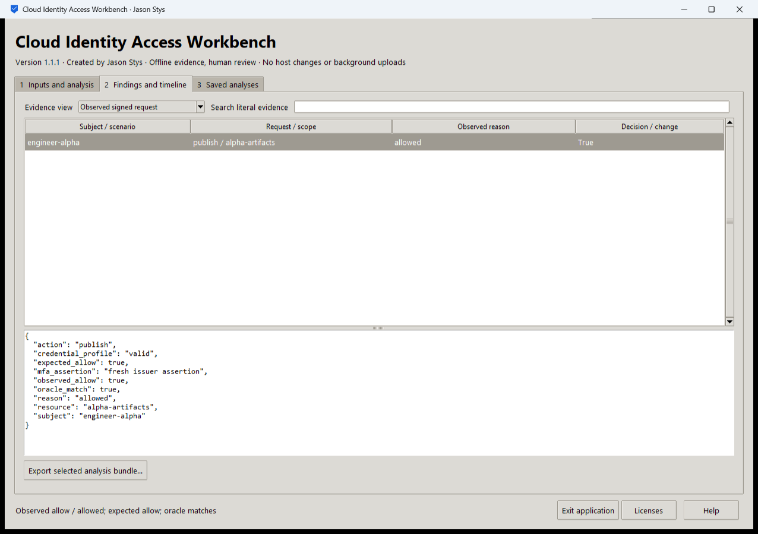
Figure 1 The actual installed workbench shows engineer-alpha's allowed publish request, fresh issuer MFA assertion and matching independent expectation.

A worked application journey
A security reviewer checks a signed synthetic publish request, then reviews a candidate registry's four permission gains and three losses across 128 signed contexts. The proposed registry is not applied.
1. Open Inputs and analysis, choose a prepared signed scenario or your supported authorized files, inspect parameters and Run selected analysis.
2. Inspect Findings and timeline, select an evidence view and search literal records. Read the original signature/expiry/MFA context before interpreting an allow result.
3. Run the candidate-registry comparison to inspect complete permission gains and losses; this review does not apply a registry or enforce access.
4. Export the selected exact bundle, close normally and reopen the same profile to inspect retained Saved analyses.
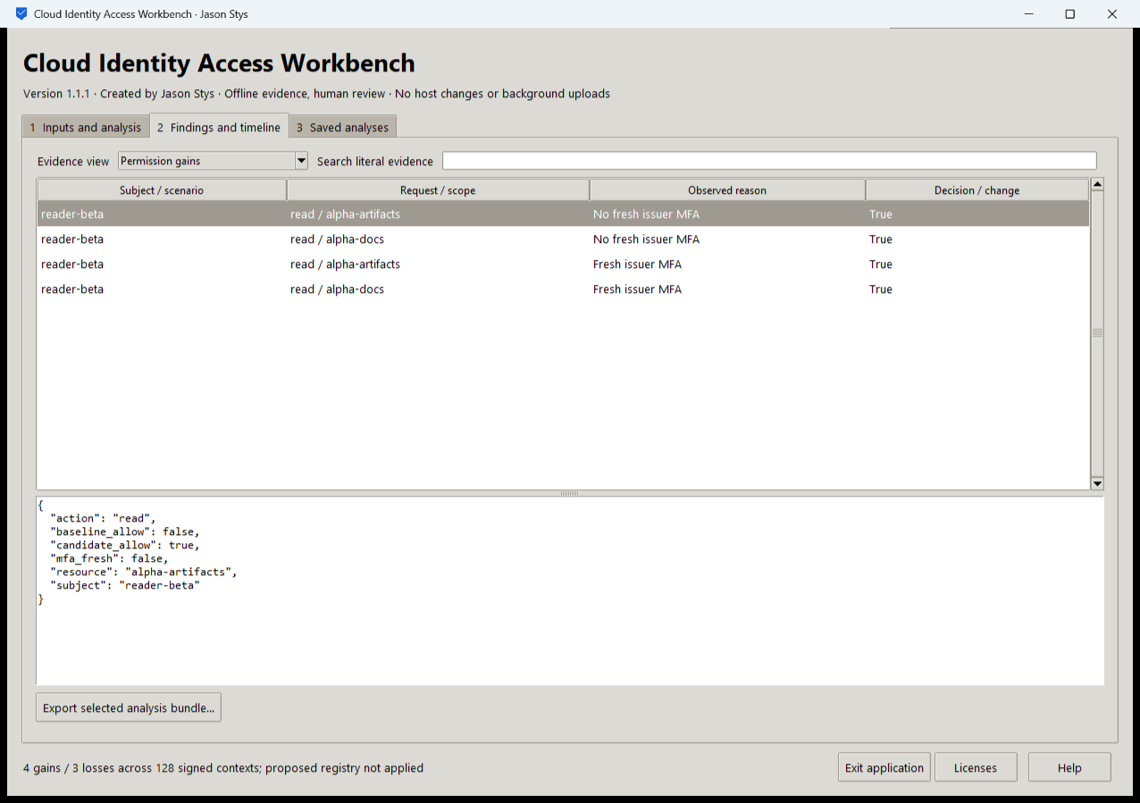
Figure 2 The same installed app retains four permission gains and three losses across 128 signed contexts; the selected gain preserves its original reason and the candidate is not applied.

Important implementation details

Check fixed state before a write can follow an alias
This pre-initialization check requires any existing fixed state member to be an ordinary single-link file without a Windows reparse attribute. Startup and connection admission apply it to the known marker/lock/SQLite recovery paths; ordinary recovery files are retained.
cial/desktop_state.py lines 233 to 245
233 def admit_existing(path: Path) -> None:
234 """Refuse pre-existing linked/nonregular fixed state before initialization can write through an alias."""
235 try:
236 info = path.lstat()
237 except FileNotFoundError:
238 return
239 if (
240 not stat.S_ISREG(info.st_mode)
241 or info.st_nlink != 1
242 or getattr(info, "st_file_attributes", 0)
243 & getattr(stat, "FILE_ATTRIBUTE_REPARSE_POINT", 0)
244 ):
245 raise Rejected("fixed workspace state must be unlinked one-link regular files")
Source file SHA256 4160443af1ead283829ef52661c960f04f8a3eb90cbff69fc38bda42e5aacb52

Validation results and operating limits
Runtime source 5f3b7c262174d814dcccdfe3c614c4aad74edc8f
Check | Observed evidence | Result
Actual installed workflows | Full original domain, review and export controls passed two normal native launches; all 9 saved bundles retained exact original bytes. | Passed
Old-to-new profile | The actual installed 1.1.0 app created a synthetic profile; installed 1.1.1 reopened it and retained all 9 exact bundles without reset. | Passed
Source and distribution | Exact-main workflows and processed CodeQL passed with zero open main alerts. Five downloaded assets and installed files matched their verified SHA-256 identities. | Verified
PC and links | Existing links were backed up and retargeted with settings retained. Normal profiles and Docker were unchanged; default-profile shortcut activation remains separately untested. | Verified

Installation and private data
Use the matching Windows EXE, checksum and notices from Releases; no system Python or terminal setup is needed.
Use the verified existing Desktop icon. Help explains formats and limits; Exit application closes the native owner. Back up the complete external profile after a normal exit.

Limits and help
Offline signed synthetic evidence and a fixed OPA query, not a cloud identity provider or enforcement service. Issuer MFA freshness is an assertion rather than live MFA verification. Bundled OPA module advisories retain their scoped nonreachability assessment; no scanner-wide clearance is claimed.
Prepared workflows used synthetic profiles only. Ordinary user profiles and Docker were unchanged; local plaintext remains accessible to the OS owner/administrator. Profile alias checks do not defend against malicious code with the same OS privileges.
Release and checksums | Runtime source | Usage and limits

