Cloud Job Orchestrator Application Guide
Windows use and validation
By Jason Stys Version 1.1.0 11 November 2026
Author bounded job workflows and run real local Rust workers against the bundled PostgreSQL database. Inspect dependencies, leases, captured results and durable work rather than relying on a simulated dashboard.
The independently downloaded installed application passed the recorded real workflows. All exact-main checks and processed CodeQL passed before publication. Icon targets were read-back verified; normal default-profile shortcut activation remains separately untested.

Capabilities and previous improvements
The original DAG, PostgreSQL lease/migration and recovery model now runs through a native operations workspace. Editable definitions, bounded import, explicit worker admission/pause, cancellation and literal result export preserve the original engine.
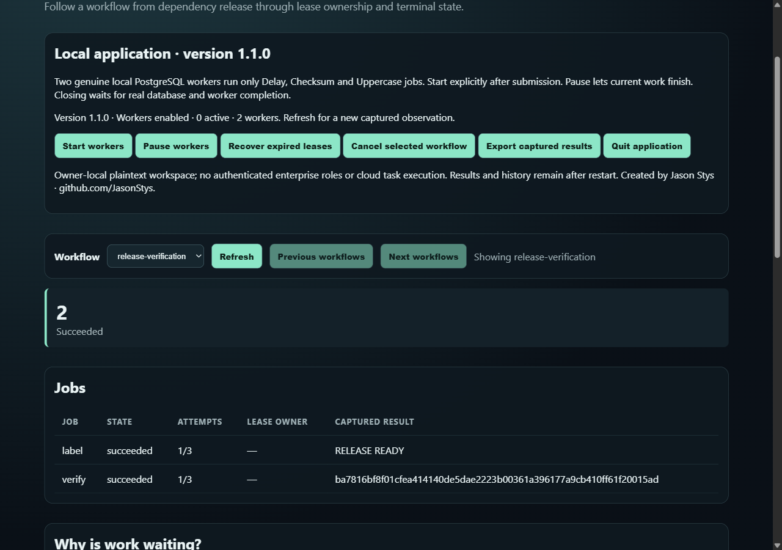
Figure 1 Actual installed workers completed the release-verification workflow and captured its literal checksum and label results.

A worked application journey
An operations developer previews a release-verification DAG, submits it, starts workers, reviews exact results, then pauses admission and verifies that accepted work finishes before shutdown.
1. Choose a prepared workflow as editable input, or import a bounded JSON definition. Change workflow identifiers before reuse; duplicates are refused.
2. Preview dependency waves, then explicitly submit and start the fixed local workers. Only Delay, Checksum and Uppercase jobs are supported; arbitrary commands are unavailable.
3. Refresh to capture actual database state. Inspect direct blockers, leases and recorded attempt events; snapshot countdowns are not a live clock.
4. Export captured results to a new file. Pause or quit to stop admission and retain accepted work, then reopen the same workspace to inspect durable state.
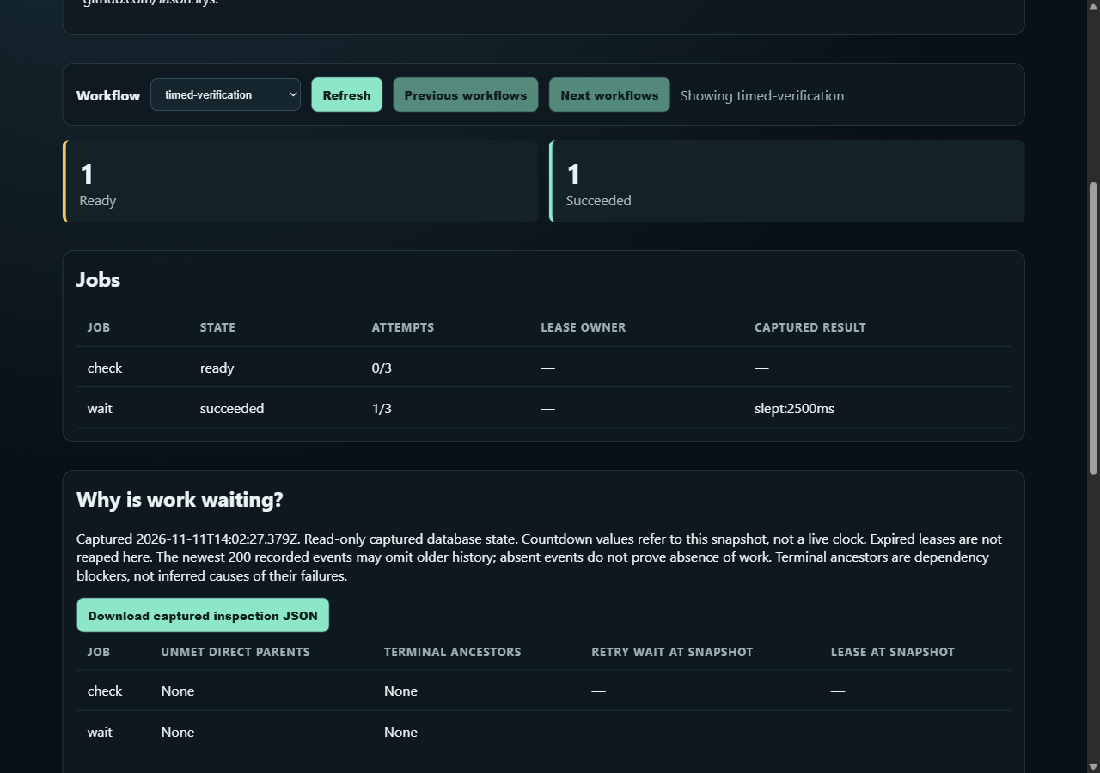
Figure 2 After reopening the same test workspace, the app shows the completed timed job and a dependent job still genuinely ready; Quit does not pretend that unclaimed work completed.

Important implementation details

Authenticate and identify the actual owned database
The connection verifies cluster name, exact PostgreSQL version and canonical data directory. A matching port alone cannot authorize adoption of another database.
src/native_database.rs lines 321 to 332
321 let actual: String = row.try_get("directory")?;
322 let cluster_matches =
323 row.try_get::<String, _>("cluster")? == cluster_name(&profile.identity.cluster);
324 let version_matches = row.try_get::<String, _>("version")? == "18.6";
325 let directory_matches = fs::canonicalize(actual)? == fs::canonicalize(&self.data)?;
326 eprintln!(
327 "Owned PostgreSQL identity: cluster={cluster_matches}, version={version_matches}, directory={directory_matches}"
328 );
329 let own = cluster_matches && version_matches && directory_matches;
330 pool.close().await;
331 if !own {
332 return Err(invalid("Authenticated native PostgreSQL identity differs").into());
Source file SHA256 416de5f2cbac573aaa72c8fb76398d17b8b0580a12f054c2fdda58790facd617

Validation results and operating limits
Runtime source 60a08d2d059dc4cf813e1b96029dd42ec76dc067
Check | Observed evidence | Result
Actual installed workflows | Two actual installed launches passed real PostgreSQL 18.6 worker outputs, import/export refusals, durable reopening, repeated Quit and retained-work completion. Outside and inherited-proxy requests were zero. | Passed
Original core and source gates | Original Rust tests, real hosted PostgreSQL migrations/leases, dashboard/browser, Terraform/Compose and recovery gates passed. The actual RustSec advisory was patched; fresh pinned audit reported zero vulnerabilities/warnings. | Passed
Assets and current security | Provider/download hashes, complete installed-byte identity, current exact-main workflows and processed raw CodeQL results passed with zero open main alerts. | Passed
Launch and data boundary | Individual Desktop and Start-menu targets verified. Only synthetic profiles were exercised; installed EXE tests are distinct from ordinary default-profile shortcut activation. | Passed

Installation and private data
Download the published Windows ZIP and checksum, verify SHA-256 and extract the complete bundle. Launch CloudJobOrchestrator.exe; retain the PostgreSQL tree and original notices. Keep old versions and stopped-workspace backups.
Use the individual Desktop icon and the app's Help. Quit through its owner controls. No Python setup or Docker change is required; examples are input data inside the full application.

Limits and help
Only the closed authored job set executes. Workspace/history data is trusted-owner plaintext; no enterprise account isolation, cloud execution or production authorization/TLS boundary is supplied by this local app.
Unsigned Windows x64 portable bundle. PostgreSQL is app-local; no global service, Docker setting, normal profile or real credentials were changed. Keep the complete companion tree and runtime notices.
Release and checksums | Runtime source | Usage and limitations

