Code Flow Studio Application Guide
Windows use and validation
By Jason Stys Version 0.4.4 10 November 2026
Code Flow Studio is a local development workbench for reviewing source, running approved tests inside isolated workers and comparing versioned evidence. This guide explains its Windows application, a reproducible synthetic workflow and the implementation behind its source and coverage checks.
The published and installed 0.4.4 application passed its full native journey on patched CPython 3.14.10 and Electron 44.11. The actual 0.4.3 and 0.4.4 apps also reopened the same disposable encrypted account with both saved revisions intact. Existing normal account and launcher files remained byte-for-byte unchanged after the backed-up installer upgrade.

Capabilities and previous improvements
The earlier portfolio work added exact file and line evidence, unused candidates, hash verified source inspection, guarded draft navigation, encrypted history and cancellation safe shutdown. Release 0.4.3 also preserves actual CSharp target exits independently from Coverlet, so approved nonzero exits can have measured coverage while collector failures remain blocked.
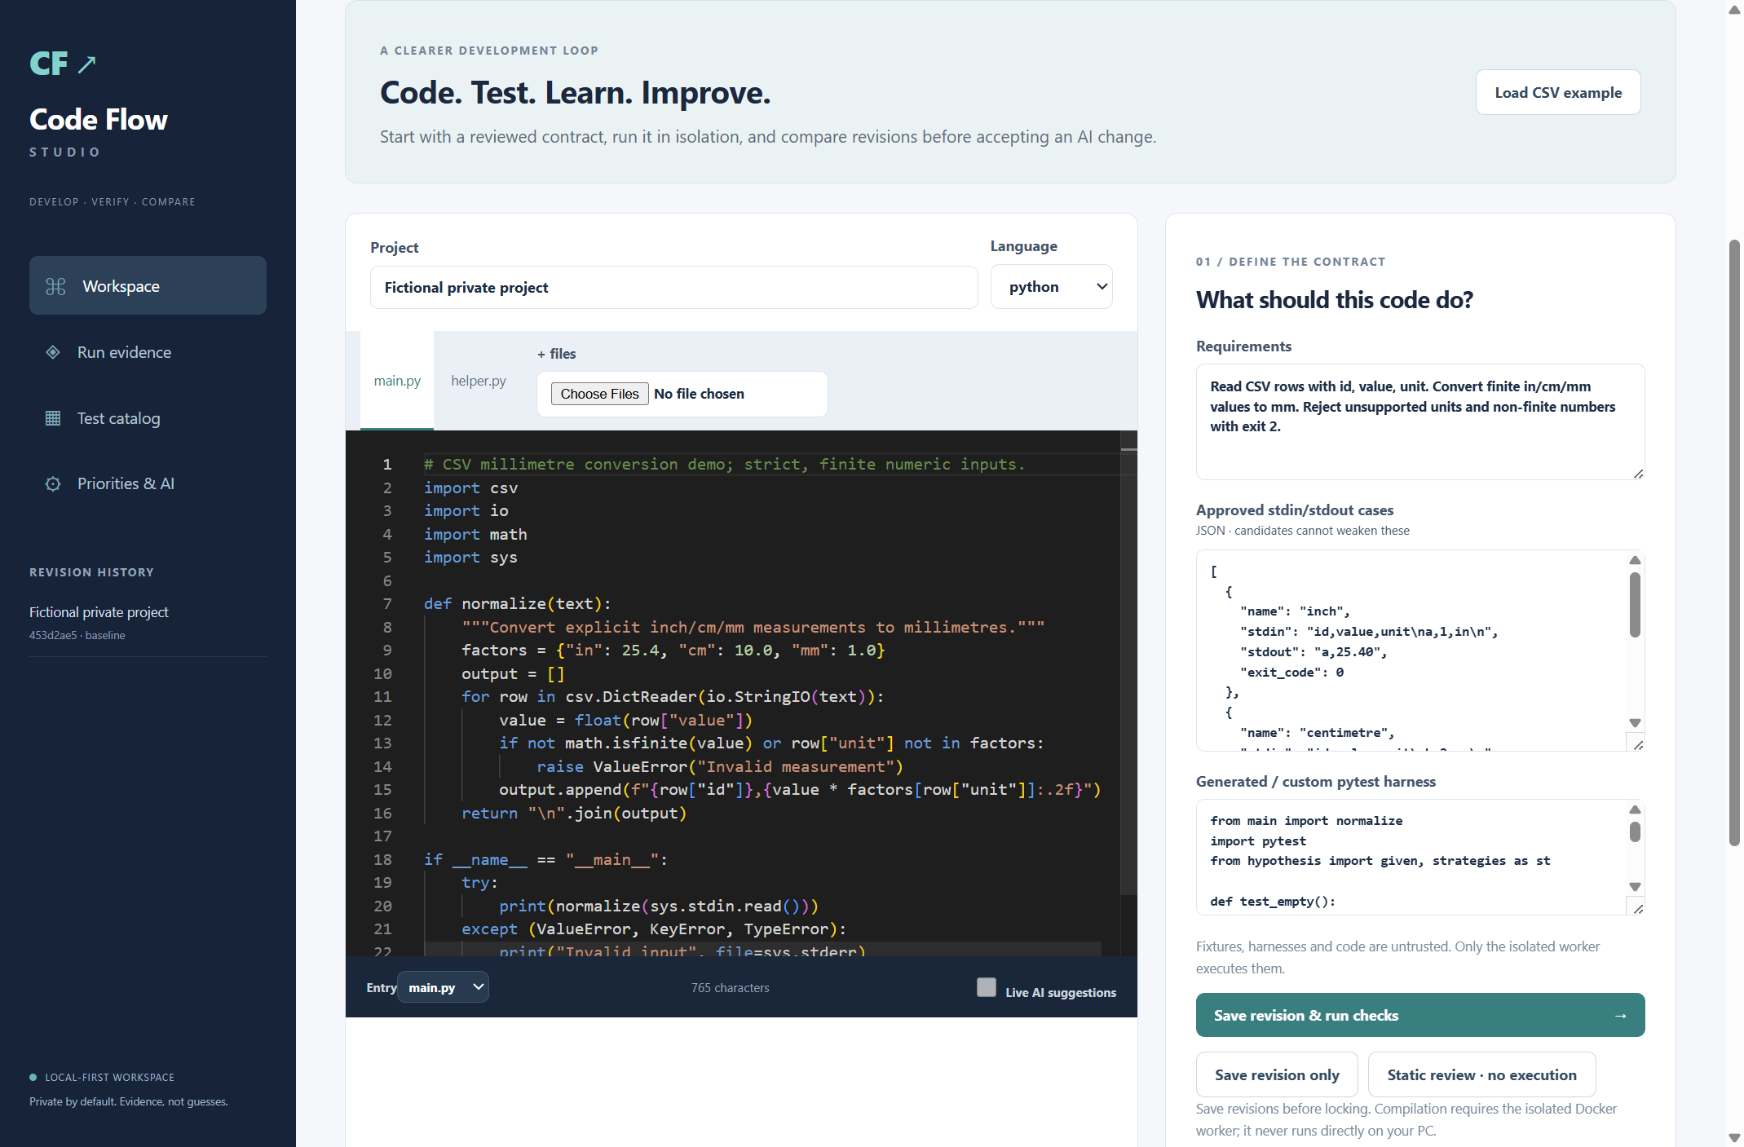
Figure 1 The actual installed workspace with a synthetic project after revision save and static review. This overview illustrates the interface; the native journey independently verified real account creation, vault unlock, editing and history.

A worked application journey
A developer reviews a small synthetic Python helper containing an unreachable print after a return. The reviewer must identify the original file and line, inspect the retained bytes and open only a matching draft. This scenario works without configuring a paid model or running a compiler container.
1. Open the application from its desktop or Start menu shortcut. Sign in to your own local account and unlock the separate vault phrase; create a new account if this is your first use.
2. Create a project, enter or upload flat source files and save a revision. Use Static review to collect nonexecuting findings. AI suggestions remain optional unverified proposals.
3. In Evidence, filter by file or category and select helper.py line 6. The source inspector verifies the retained source fingerprint and highlights the complete physical line.
4. Use Edit matching draft only when the current bytes still match. After edits, save a new revision and compare evidence. Lock the workspace when finished; retain your independent recovery material privately.
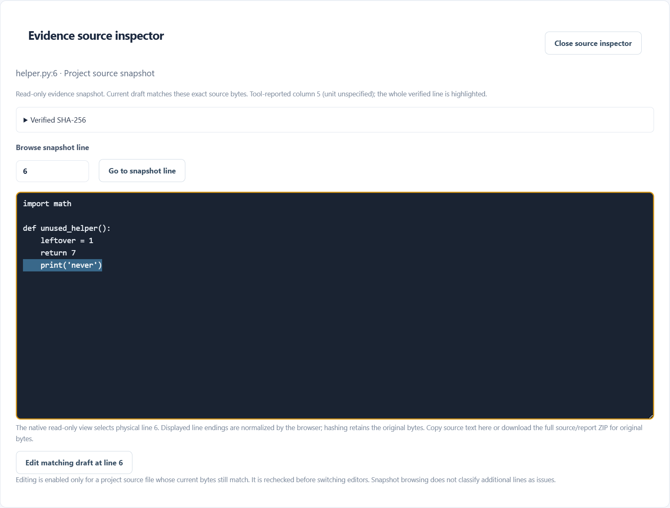
Figure 2 The installed application highlights physical line 6 of helper.py in its immutable evidence snapshot. The current draft matches the verified source bytes. This is static evidence from a synthetic example, not a local compiler execution claim.

Important implementation details

Validate the observed target result
The worker accepts only the fixed assembly, an actual integer target exit and its own bridge digest. The surrounding protocol also binds source, case and stdin. These checks prevent stale or inconsistent records from becoming measured coverage.
runner/csharp_coverage_bridge.py lines 239 to 250
239 _require(
240 type(value["target"]) is str and value["target"] == str(ASSEMBLY),
241 "Bridge observation target mismatch",
242 )
243 _require(
244 type(value["target_exit_code"]) is int and -128 <= value["target_exit_code"] <= 255,
245 "Invalid observed target exit",
246 )
247 _require(
248 _hex(value["bridge_sha256"], 64) and value["bridge_sha256"] == _bridge_hash(),
249 "Bridge source hash mismatch",
250 )
Source file SHA256 64e1d4e2dfca531b58e595945e937b41de1334eaba71b729e85794f8ff4fcc41

Ignore stale source verification
The renderer verifies the evidence snapshot and current draft asynchronously. A generation counter discards a completion from an older view, and editing remains tied to the matching context. Hashing scales with source bytes; it is not a measurement of the submitted program complexity.
ui/SourceInspector.tsx lines 60 to 79
60 setNotice("");
61 void Promise.all([
62 verifySourceLocation(location, snapshot),
63 verifySourceLocation(location, draft),
64 ]).then(([evidence, current]) => {
65 if (generation.current !== request) return;
66 setVerification({
67 location,
68 snapshot,
69 draft,
70 result: evidence,
71 draftMatches: current.ok && location.artifact === "source",
72 });
73 heading.current?.focus({ preventScroll: true });
74 heading.current?.scrollIntoView({ block: "start", behavior: "instant" });
75 });
76 return () => {
77 ++generation.current;
78 };
79 }, [location, snapshot, draft]);
Source file SHA256 2413783242d19c11b1eab25dddb7a4985aec247689df7980ebe2ee2933797a73

Validation results and operating limits
Runtime source 8a533a0b9838b994c18ec0475d91a4f8db1be6fa
Check | Observed evidence | Result
Installed identity | All 12 downloaded assets matched provider/sidecar hashes; all 3 archives carried the exact 0.4.4 source manifest. Actual installed runtime is CPython 3.14.10/Electron 44.11. | Passed
Native user journey | The full installed registration, WebCrypto unlock, editor, source inspection and 48-category journey passed. Both complete saved revisions also survived a real 0.4.3 to 0.4.4 same-account vault upgrade. | Passed
Lock and shutdown | The journey checked vault lock, owned service drain, sealing and actual service and bootloader exit. | Passed
Source release tests | 422 source tests,2 Windows platform skips and 28 subtests passed, with 85.13 percent coverage at the unchanged 80 percent controller/training floor. Current main/compiler/package/CodeQL workflows passed. | Passed
Hosted CSharp controls | Actual target exits 0, 1, 2, 7, 255 and malformed input 2 were measured; argument rejection, report write failure and timeout were blocked. | Passed

Installation and private data
Use the matching versioned Windows installer and its SHA256 sidecar from Releases. The existing per user installation and shortcut are retained; no IntelliJ, system Python or package manager setup is needed to open the app.
Account archives live separately in the OS user application data directory named CodeFlowStudioAccounts. Preserve the complete directory and your private vault phrase before a later upgrade. Login recovery does not imply recovery of a lost encryption phrase.

Limits and help
Local compilation needs a working isolated engine and matching 0.4.4 worker image. Hosted compiler checks passed; Docker on this PC was unchanged.
Measured instrumentation does not mean 100 percent line coverage or proven correctness. Same identity file bindings check consistency and are not tamper proof attestation of a malicious worker target. Unused candidates require developer review.
Unsigned packages trust the local OS and service while unlocked. Synthetic upgrade records matched exactly; normal archives were backed up and checksum-compared without decrypting them.
Release downloads and acceptance | Coverage protocol | Private account help

