Container Runtime Security Workbench Application Guide
Windows use and validation
By Jason Stys Version 1.1.0 11 November 2026
Review prepared container-security alerts and source-health evidence, inspect exact normalized snapshots and grouped episodes, and retain reasoned dispositions without hiding visibility gaps.
The independently downloaded and installed application passed its real user workflows. Current main checks and processed CodeQL passed before publication. Icon targets were verified; normal default-profile shortcut activation is separately untested.

Capabilities and previous improvements
Adds editable alert/policy/health inputs, captured source context, exact saved-review grouping, episode triage, literal search, no-overwrite exports and restart-persistent evidence. Raw workload identifiers are pseudonymized independently at ingestion.
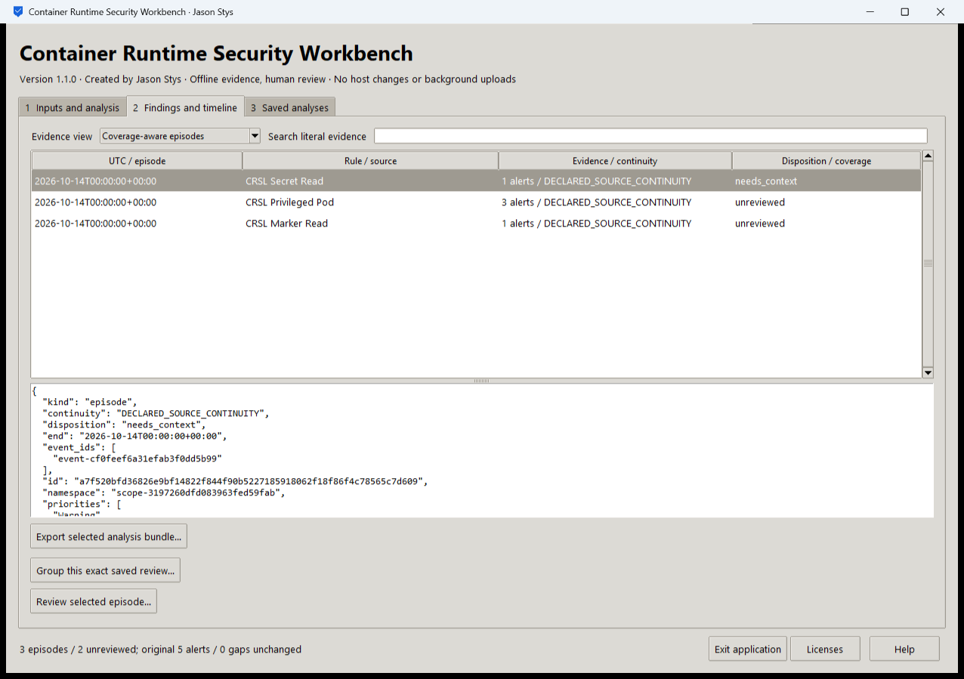
Figure 1 The installed app presents normalized source evidence and local review context while retaining original coverage limits.

A worked application journey
A security analyst imports fictional runtime and Kubernetes audit alerts, reviews duplicates and source continuity, groups the exact saved normalized review into episodes and records a disposition with a reason.
1. Select prepared or authorized alert, policy and source-health files. Review their declared scope and run the actual original analysis.
2. Inspect Original normalized alerts and source-health/coverage views. Missing visibility stays distinct from a negative security result.
3. Group this exact saved review, inspect episode evidence and record a reasoned local disposition. Do not replace the source snapshot or silently re-ingest raw identifiers.
4. Export the selected complete bundle. Reopen the same saved analysis after normal exit to compare exact review and provenance.
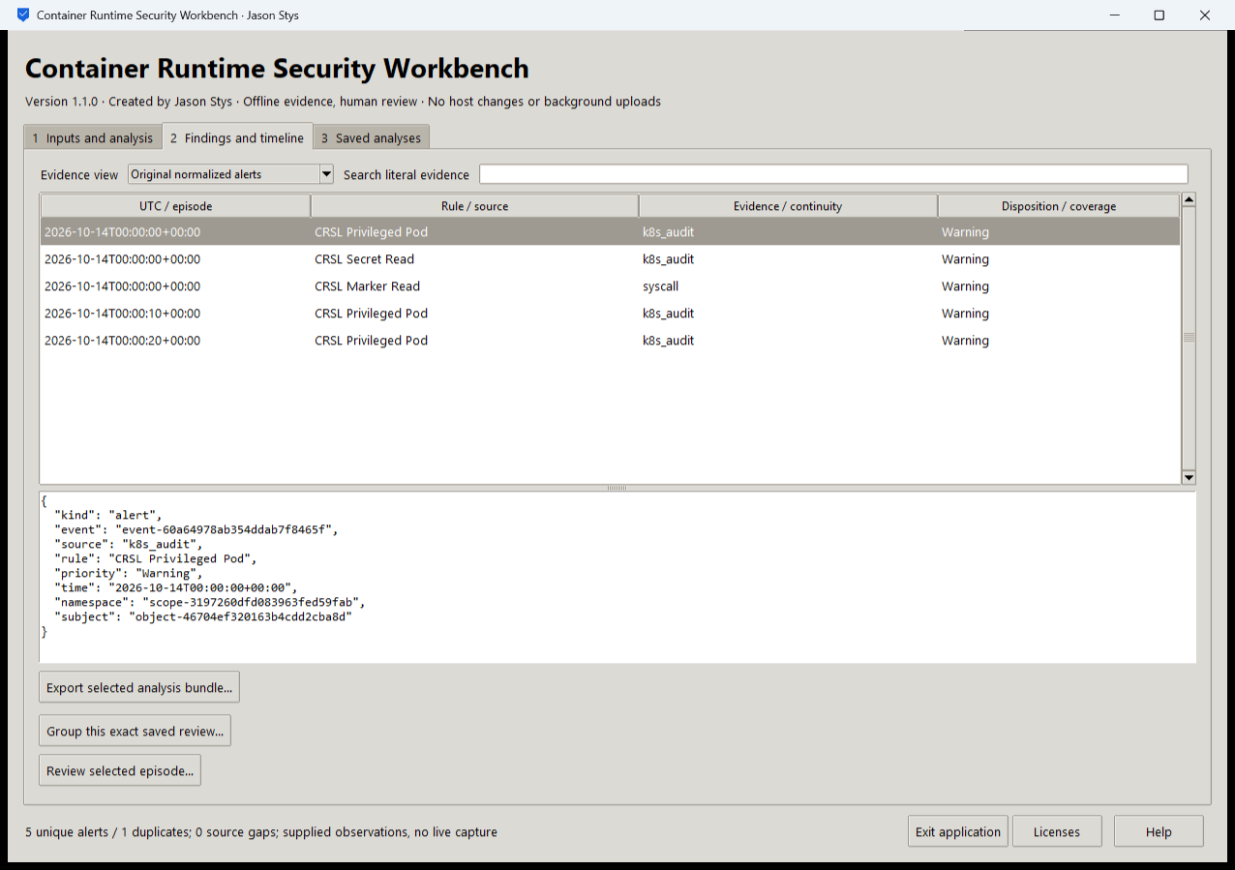
Figure 2 Original normalized alerts include source types and pseudonymous workload identities. The status distinguishes five unique alerts and one duplicate from the supplied observation scope.

Important implementation details

Restore one explicitly selected normalized review
Grouping restores the exact saved review from an explicit file or run ID. It does not silently re-ingest raw alerts or infer the latest matching record.
runtime_lab/desktop_project.py lines 248 to 258
248 def saved_review(
249 state: Workspace, parameters: dict[str, str]
250 ) -> tuple[Review, dict[str, bytes]]:
251 """Select one explicit normalized snapshot; never re-ingest raw alerts or infer a latest matching run."""
252 if parameters.get("saved_review", "").strip():
253 return restore(
254 json_value(read_source(Path(parameters["saved_review"]), 8 * 1024**2))
255 ), {}
256 selected = integer(parameters.get("saved_run", "").strip(), 2**63 - 1)
257 files = state.files(selected)
258 return restore(json_value(files["review.json"])), files
Source file SHA256 3896f5168eb8addae5d1f152e6e2ed4dcef92ffba0b4ab9b27e365763073424e

Validation results and operating limits
Runtime source 98ba4864a547428d7c41ba83a85e74a7a42bfd7b
Check | Observed evidence | Result
Actual installed native journeys | Two installed launches passed nine workflows, nine exact saved bundles, invalid-input preservation and normal exits. | Passed
Original engines and security | Original normalized-alert, source-health, grouping and triage tests, actual Falco/kernel integration on the disposable CI runner where configured, privacy checks and processed CodeQL passed on exact main. | Passed
Package and runtime identity | Five independently downloaded assets matched provider SHA-256. Actual installed bytes and source/runtime identities matched the reviewed clean-main proof. | Passed
Launch and privacy boundary | Individual Desktop and Start-menu link targets passed read-back. Installed EXEs were exercised separately with synthetic profiles; normal default-profile shortcut activation was not independently exercised. | Passed

Installation and private data
Download the Windows EXE, checksum sidecar and notices. Verify the hash and launch the EXE. Retain old versions and stopped-profile backups; no Python setup or Docker is required.
Open the individual Desktop icon and read Help/notices. Quit through the app; prepared examples are inputs in the real application, never separate demo apps.

Limits and help
Supplied logs and health snapshots do not prove that a live workload is safe or fully observed. Dispositions cannot erase independent coverage gaps. This GUI starts no Docker, driver, kernel sensor or enforcement.
Unsigned Windows portable EXE with plaintext owner-local evidence. No multiuser authentication or same-OS-user isolation is claimed. No ordinary profile or Docker setting was changed.
Release and checksums | Runtime source | Usage and limits

