Delay Tolerant Mission Network Lab Project Guide
  - By Jason Stys
Public source revision df32f632dc89
This edition documents the cited source. Validation observations below identify their own tested revision and time; they are not a promise that an unrun later revision passed.
Keep the message. Wait for the link. An offline, reproducible store-and-forward networking workbench by Jason Stys.
Replay delayed message delivery, inspect queue and hop waterfalls, and export evidence through versioned 1.1 portable applications.
Makes simulated recovery and latency investigation available without a developer setup, while checked extraction and release identity connect the download to reviewed source.

Purpose operation and implementation
The complete-run message waterfall now explains each message's queue waits, hop flight time, TTL boundary and actual congestion/integrity events. Queue plus flight time is checked against observed elapsed time. It distinguishes censored retained outcomes from delivery and keeps full-run explanations separate from causal tick replay. See the waterfall guide.
Explore what happens when a synthetic probe cannot immediately reach a relay or ground sink: limited storage, intermittent contacts, propagation delay, expiry, corrupt copies, duplicate arrivals, competing priorities, and a worker restart with messages in flight. A dependency-free Rust worker produces the results; a separately implemented Python model checks every event, queue sample, and final message before evidence is displayed. TypeScript, HTML, CSS, and SVG provide an accessible interactive replay; SQL provides optional immutable local evidence storage.
This is an educational three-node simulator, not BPv7 interoperability, a radio stack, BPSec, spacecraft software, or a flight-qualified system. All contacts and data are invented. No real equipment or network endpoints are contacted. See model assumptions.
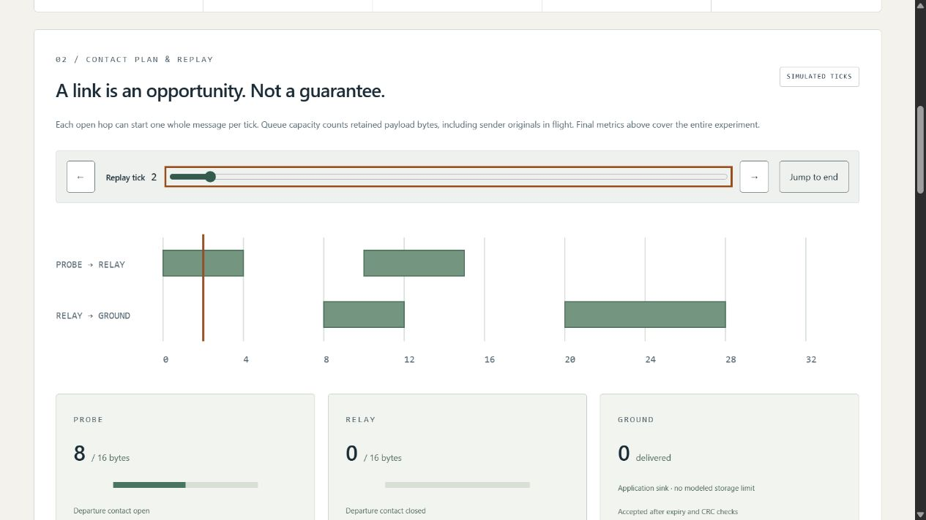
Actual local application with a verified synthetic contact plan

What it demonstrates
- Store/carry/forward behavior with one logical owner, bounded retained payload bytes, receiver backpressure, and retries.
- Nine experiments, including source-order FIFO versus earliest expiry, exact TTL boundaries, corruption, duplicate suppression, no contact, and an empty network.
- Tick-by-tick replay without exposing future message state; exact contact tables, queue occupancy, message outcomes, and a filterable full-run event ledger.
- A real two-process restart: serialize ownership and in-flight state, exit, validate a checkpoint, and resume in a fresh Rust process. The CLI can commit/reopen the handoff through SQLite first.
- Deterministic JSON/full HTML evidence, numeric queue CSV, editable input JSON, provenance, and SHA-256 identities. No automatic history collection.
- Strict bounds, malformed-input tests, independent differential verification across all 162 finite UI configurations, generated exact-line source documentation, and cross-platform portable builds.

Run the portable application
Download the versioned Windows ZIP or Linux/macOS .tar.gz archive and its matching .sha256 file from Releases. Verify its digest, then extract the entire archive to a user-owned folder. Never run from inside an archive or separate the executable from _internal.
- Windows x64: open MissionNetworkLab.exe.
- Linux x64: chmod +x MissionNetworkLab if extraction did not retain executable permissions, then ./MissionNetworkLab.
- macOS arm64: launch the corresponding MissionNetworkLab executable from Terminal.
The launcher opens a local browser on an ephemeral 127.0.0.1 port. Keep its console open; Ctrl+C stops it. No installer, administrator access, account, cloud service, Python, Node, or Rust installation is required for the portable app. Bundles are unsigned; do not bypass OS security warnings. Source builds are available if your policy disallows unsigned downloads. These are desktop bundles, not mobile installers or a public hosted service.

Run from source
Use Python 3.12–3.14, Node 24, and the pinned Rust 1.98.1 toolchain. Runtime Python and Rust have no third-party dependencies; development/browser/build dependencies are locked.
python -m venv .venv
.venv/Scripts/python -m pip install --require-hashes -r requirements-dev.lock
npm ci
rustup toolchain install 1.98.1 --profile minimal --component clippy,rustfmt,rust-docs
cargo build --release --locked
npm run build
.venv/Scripts/python -m dtnlab serve
On macOS/Linux use .venv/bin/python instead of .venv/Scripts/python. The native executable must exist: verification never silently substitutes the Python reference for a missing Rust worker.

Export and customize an experiment
The browser only accepts finite built-in settings. CLI input is an explicit local operation with a strict, bounded schema; it cannot execute payloads or select executable paths.
.venv/Scripts/python -m dtnlab export --scenario restart-inflight --format json --output result.json
.venv/Scripts/python -m dtnlab export --input examples/restart.json --format json --output imported.json --history history.sqlite3 --checkpoint-store checkpoints.sqlite3
Output destinations must not exist. SQLite files are optional, unencrypted local files, ignored by Git, capped at 100 distinct entries, and never automatically pruned. History and checkpoint stores are distinct. The second command uses persisted checkpoint bytes in a fresh worker; it does not simulate power loss during a write. Read the user guide and input/API contract before editing cases.

Repository map
Path | Responsibility
rust/lib.rs, rust/main.rs | Safe bounded network state machine, CRC/checkpoint validation, finite worker protocol
dtnlab/model.py, engine.py | Strict inputs, invented scenarios, independent-agreement gate, evidence identity
dtnlab/reference.py, native.py | Independent Python replay; fixed-path native subprocess and restart orchestration
dtnlab/reports.py, server.py, __main__.py | Inert exports, opt-in SQL history, protected loopback service and CLI
dtnlab/resources/ | SQL schemas with immutable-entry triggers
web/ | Typed replay/contracts, accessible responsive presentation, production build configuration
tests/ | Native differential/property/security/HTTP tests and browser/unit checks
tools/ | Exact-line inventory, deterministic benchmarks, portable build/smoke/release tooling
examples/, docs/ | Editable synthetic case, complete documentation, results and actual screenshots
.github/workflows/ | Least-privilege pinned validation, security analysis, manual draft packaging

Each source file has a responsibility/creator header and definition contracts. CODE_INDEX gives generated exact line locations for functions, classes, fields, and variables without brittle duplicate line numbers in comments. FILE_CATALOG summarizes every source-intent file; CI rejects stale indexes.

Documentation and contact
Architecture · Model · API · User guide · Validation · Release/runbook · Security · Third-party notices
Created by Jason Stys. Portfolio/contact profile · Project help/issues. MIT source license. No agency, employer, standards-body, or mission affiliation or endorsement.

Portable release identity
The 1.1 release contract keeps the software version consistent across Python, npm, the running service and the UI. Versioned archives include RELEASE.json with source commit, platform and clean/dirty build status. Packaging tests the freshly extracted application, including its new practical workflow, from an unrelated temporary working directory. Windows uses ZIP; Linux/macOS use .tar.gz to preserve required native links and permissions. Published 1.0 assets remain unchanged. Check the selected release's source and version rather than assuming an older download contains current source improvements. See the portable operation and release guide.
Observed local packaging checks and boundaries: portable 1.1 validation.
Draft discovery uses a bounded complete authenticated release listing and numeric-ID verification; a published-only tag lookup cannot prove that an untagged draft is absent. The release guide documents fail-closed ambiguity/history limits and the no-overwrite policy.

Current scope and practical limits
- Invented bounded topology and logical ticks; no real radios, BPv7/BPSec interoperability or exactly-once networking.
- Waterfalls explain a complete simulated experiment; causal replay separately hides future outcomes. Neither diagnoses actual radio faults.
- Unsigned portable files for documented desktop OS/CPU targets; no system installer, native mobile app, production host or operational assurance.
The accompanying Validation Review records the exact tested baseline, workflow evidence, test scope and known gaps. The Excel workbook provides filterable workflow and test-source inventories; neither substitutes for the actual execution logs.

Source references and maintenance
Maintain the editable Markdown and this Word edition together. Preserve dated execution reports and re-run the documented checks before release.
README.md · SECURITY.md · docs/ARCHITECTURE.md · docs/reports/PORTABLE_RELEASE_20261109.md
Project source and current Actions · Contact Jason Stys

