Delay Tolerant Mission Network Lab Application Guide
Windows use and validation
By Jason Stys Version 1.1.0 10 November 2026
Explain per-message queue/hop/TTL timing and bottlenecks from retained simulation events. Prepared scenarios use the full Windows application and its existing model and report exports.
The published Windows portable application was installed and tested using isolated synthetic inputs. Provider and sidecar digests, release metadata and installed resource identities were checked. The installed file set remained unchanged after testing.

Capabilities and previous improvements
Inspect per-message queue, hop, in-flight, expiry and bottleneck waterfalls tied to recorded replay evidence. Connects end-to-end delivery outcomes to the actual delays and contact constraints that produced them.
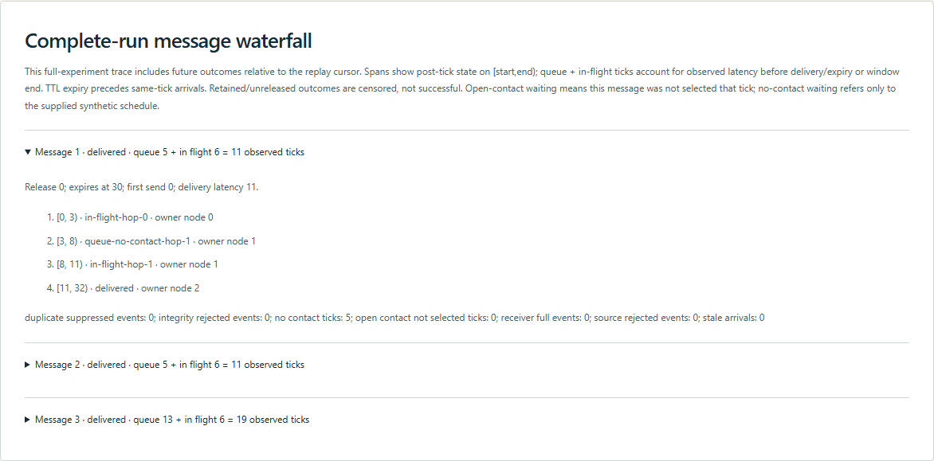
Figure 1 Actual installed application showing nominal queue/hop delivery. Captured during the accepted native user journey with prepared synthetic inputs.

A worked application journey
The worked example compares nominal queue/hop delivery with corrupt-first integrity rejection. Interpret the results using the model assumptions and limits on the final page.
1. Open the application shortcut to start its local web interface and console. Select a prepared scenario or your own supported input; the examples require no external account or live hardware.
2. Expand a nominal delivery waterfall and inspect its queue and two in-flight intervals. Export JSON, then compare corrupt-first and empty-network cases.
3. Review the main case alongside the boundary case shown in Figure 2. Three nominal messages delivered; queued plus in-flight ticks equaled elapsed latency. Corruption and an empty network remained explicit causal cases.
4. Download the supported evidence report and retain the input/configuration with it. Recompute after an input change; do not reuse a result under a different configuration.
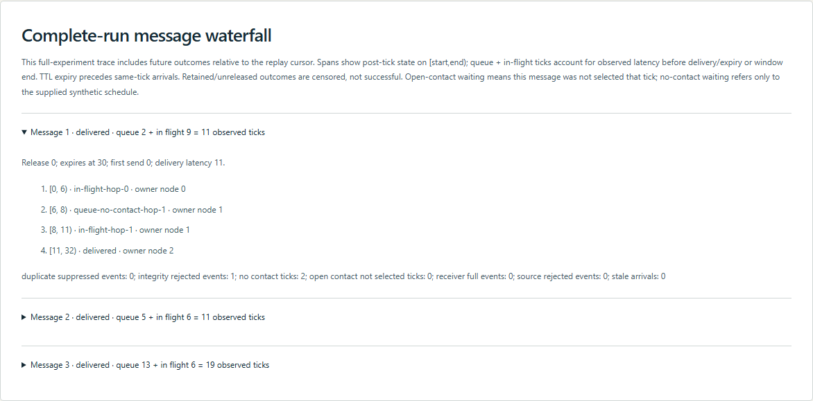
Figure 2 Actual installed application showing corrupt-first integrity rejection. Captured during the accepted native user journey with prepared synthetic inputs.

Important implementation details

Waterfalls
Post-tick retained state is split into in-flight, waiting with contact and waiting without contact. The final state and counted latency must match the verified trace or the derived waterfall is rejected.
dtnlab/waterfall.py lines 51 to 76
51 if status == "retained":
52 if busy:
53 phase = f"in-flight-hop-{node}"
54 elif any(c.hop == node and c.start <= tick < c.end for c in case.contacts):
55 phase = f"queue-open-contact-hop-{node}"
56 else:
57 phase = f"queue-no-contact-hop-{node}"
58 counts[phase] += 1
59 else:
60 phase = status
61 if spans and spans[-1]["phase"] == phase and spans[-1]["node"] == node:
62 spans[-1]["end"] = tick + 1
63 else:
64 spans.append({"start": tick, "end": tick + 1, "phase": phase, "node": node})
65 actual = final[message.id]
66 terminal = next(
67 (
68 event["tick"]
69 for event in events
70 if event["kind"] in {"delivered", "expired", "source-rejected"}
71 ),
72 case.horizon,
73 )
74 elapsed = max(0, terminal - message.release)
75 if status != actual["status"] or node != actual["node"] or sum(counts.values()) != elapsed:
76 raise RuntimeError("Waterfall trace inconsistent with verified final accounting")
Source file SHA256 f9bc6cfbf2d7732dfffdbb55f1adca58c46c4d68747ae801bb3cf5ef1582e34f

Validation results and operating limits
Runtime source df32f632dc89a329cfdd4eaf9c9f7b7248f8f5ac
Check | Observed evidence | Result
Published package | Exact public release, provider/sidecar hashes and installed resources verified; installed bytes unchanged. | Passed
Actual native core | The existing packaged CLI/API and native feature acceptance helper passed on the installed executable. | Passed
Scenario evidence | Three nominal messages delivered; queued plus in-flight ticks equaled elapsed latency. Corruption and an empty network remained explicit causal cases. | Passed
UI and cleanup | Actual compiled-application browser journey passed. Both images were individually inspected; cleanup left no owned child process. | Passed

Installation and private data
Use the complete matching Windows portable folder from Releases, including all companion files; verify the SHA256 sidecar before extracting it. Keep application files separate from your inputs, downloaded reports and optional CLI history.
Return to this app's own console and press Ctrl+C. Closing its browser tab alone does not stop the service.

Limits and help
Fixed invented logical topology, not real radios, BPv7/BPSec interoperability or exactly-once networking.
These Windows portable checks used isolated synthetic inputs. System-wide installation, default-browser opening, desktop shortcuts and mobile installation were outside this test. Additional shortcut checks are recorded separately. No user data or Docker configuration changed.
Release and checksums | Runtime source | Project usage and limits

