Detection Engineering Lab Application Guide
Windows use and validation
By Jason Stys Version 1.1.0 10 November 2026
Investigate supplied security events using actual detection rules, labeled replay, correlations and timeline evidence. The Windows application retains original detections alongside reasoned analyst decisions and exact exported evidence.
The published Windows portable app passed independent download/installed-byte acceptance, two real compiled launches, exact saved evidence comparisons and normal exits. The figures show the installed app with fictional supplied records.

Capabilities and previous improvements
Add hash-bound analyst dispositions and same-event rule/label comparisons with immutable alert evidence and inert HTML review. Connects rule changes to reviewable outcomes without rewriting original detections or hiding uncertainty.
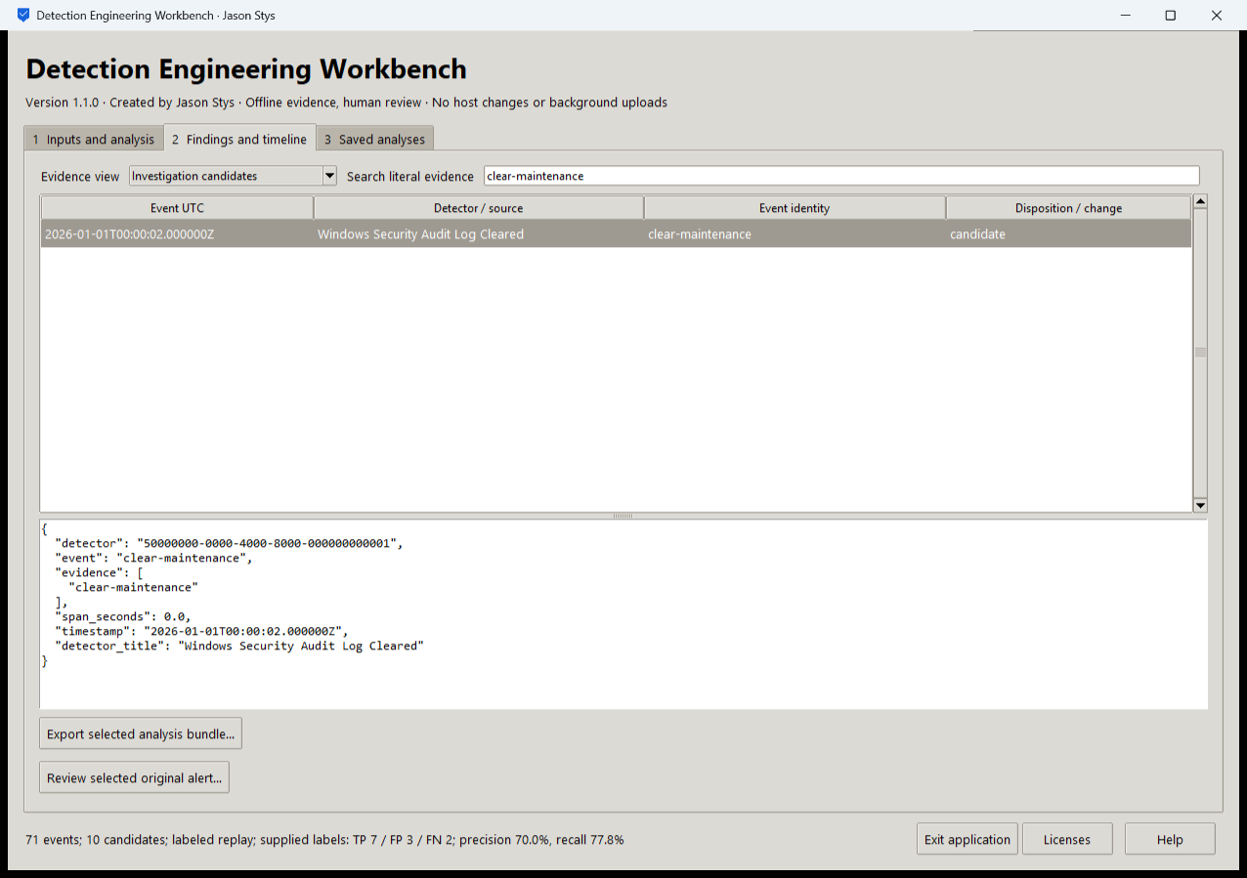
Figure 1 The installed application filters the supplied clear maintenance event and displays its original detector and timestamp. The summary reports 71 events and 10 candidates with supplied-label precision 70 percent and recall 77.8 percent.

A worked application journey
A detection engineer investigates a Windows audit-log-clearing candidate, records why a synthetic maintenance event was expected, and exports both the original evidence and the analyst review. A malformed input must leave the last accepted evidence intact.
1. Choose prepared labeled replay or select your own supported event, rule and optional label files in Inputs and analysis.
2. Run the real engine, open Findings and timeline, select Investigation candidates and search for clear-maintenance. Inspect the original JSON before deciding.
3. Use Review selected original alert to enter a disposition, reviewer assertion and rationale. Inspect the separate saved review rather than treating it as a changed detector result.
4. Export the selected analysis bundle. Reopen the same local profile and verify that Saved analyses retains the original and review bundles.
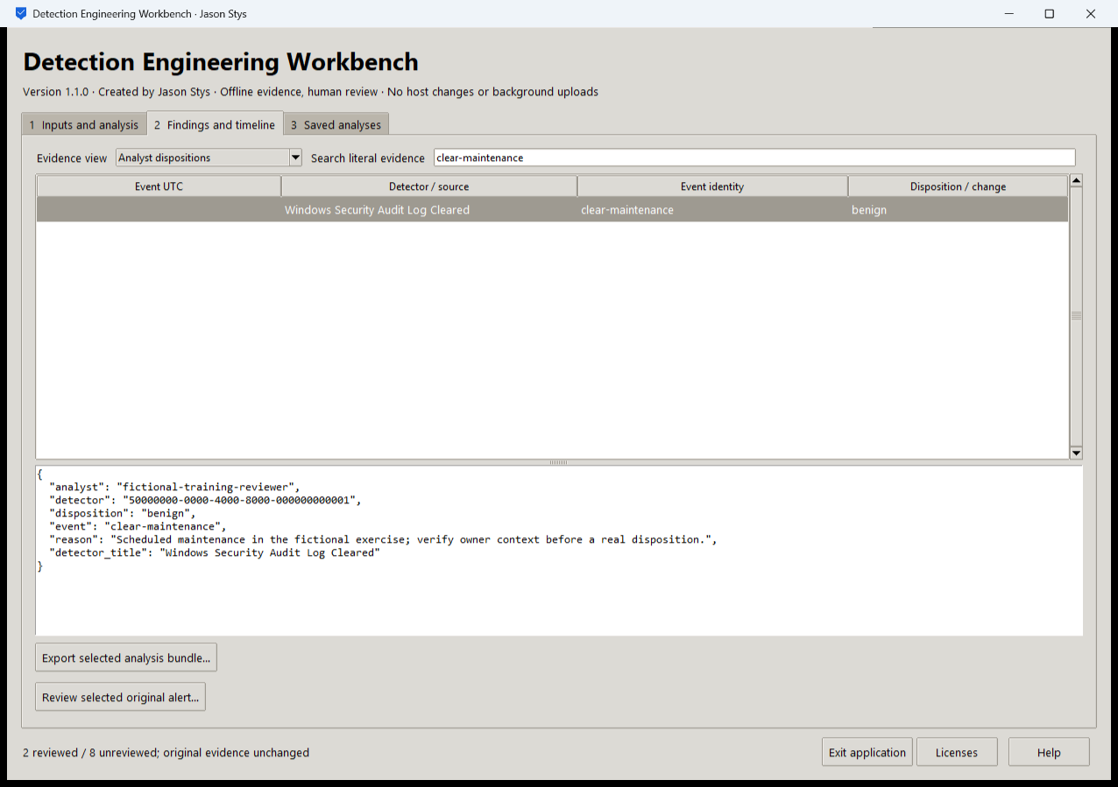
Figure 2 The installed application records a reasoned analyst disposition while retaining the original alert evidence. A review is a human assertion and does not rewrite detector accuracy.

Important implementation details

Retain an identified exclusive workspace
The workspace refuses an unknown nonempty directory and keeps data outside the application installation. A profile marker identifies the product; a nonblocking exclusive OS lock prevents two owners from mutating the same history.
detection/desktop_state.py lines 203 to 225
203 class Workspace:
204 """One-owner plaintext history; preserving evidence does not authenticate its publisher or analyst."""
205
206 def __init__(
207 self, path: Path, product: str, resources: Path, *, synthetic: bool = False
208 ) -> None:
209 """Open only a new or explicitly marked profile and take an exclusive nonblocking OS lock."""
210 self.path = unlinked(path)
211 if self.path.is_relative_to(resources.resolve()) or self.path.is_relative_to(
212 Path(sys.executable).parent.resolve()
213 ):
214 raise Rejected("workspace must be outside the application installation")
215 self.path.mkdir(parents=True, exist_ok=True, mode=0o700)
216 marker = self.path / "profile.json"
217 expected = {"schema": 1, "product": product, "synthetic_acceptance": synthetic}
218 if not marker.exists():
219 if any(self.path.iterdir()):
220 raise Rejected("unknown nonempty workspace; no files were reset")
221 with marker.open("xb") as stream:
222 os.chmod(marker, 0o600)
223 stream.write(canonical(expected))
224 actual = json_value(read_bytes(marker, 4096))
225 if (
Source file SHA256 385fc77cde7c768f36b2048ca8e8eaf4e42996da930122a1ff6fb0ce5c6acde9

Validation results and operating limits
Runtime source f70eecac9fcc511ea74ff7ab88b9c5a27f24732f
Check | Observed evidence | Result
Release and runtime | All 5 downloaded assets matched provider/sidecar hashes. Actual frozen CPython 3.14.10 and Tcl/Tk 9.0.4 matched their recorded runtime identities. | Passed
Real user workflow | Three exact saved bundles survived a second compiled launch. Real timeline/filter/review/export controls and malformed-input retention passed; all lifecycle buttons remained visible at 980 by 700 with a long status. | Passed
Source and security | All current main workflows passed. Exact-source CodeQL analyses processed with zero open main alerts before publication. | Passed
Desktop delivery | New individual Desktop and Start-menu links target the installed accepted EXE. Shortcut metadata was read back; normal shortcut activation was not independently exercised. | Verified

Installation and private data
Download the matching Windows EXE and SHA256 sidecar from Releases. This is an unsigned portable app, not an MSI; Python installation and terminal commands are unnecessary. Keep the distribution and runtime notices together.
Open your own new or identified profile outside the installation. History is local plaintext protected by OS-owner access and an exclusive instance lock. Use Help for formats and limits; Exit application closes the owned workbench.

Limits and help
Offline supplied evidence and analyst assertions only. This is not a host collector, intrusion-prevention agent or proof of detector effectiveness on an unknown production population.
Reviewer names are assertions, not authenticated identities. These tests used isolated synthetic profiles and did not access existing user data, call external services or change Docker. Back up your complete profile before moving it.
Release and checksums | Runtime source | Usage and limits

