Detection Engineering Lab Application Guide
Windows use and validation
By Jason Stys Version 1.1.1 11 November 2026
Investigate supplied security events using actual detection rules, labeled replay, correlations and timeline evidence. The Windows application retains original detections alongside reasoned analyst decisions and exact exported evidence.
The installed 1.1.1 app passed its full native workflows and reopened the same synthetic profile created by 1.1.0 with exact saved evidence. Existing links were backed up and retargeted with read-back verification; default-profile shortcut activation was not independently exercised.

Capabilities and previous improvements
Add hash-bound analyst dispositions and same-event rule/label comparisons with immutable alert evidence and inert HTML review. Connects rule changes to reviewable outcomes without rewriting original detections or hiding uncertainty.
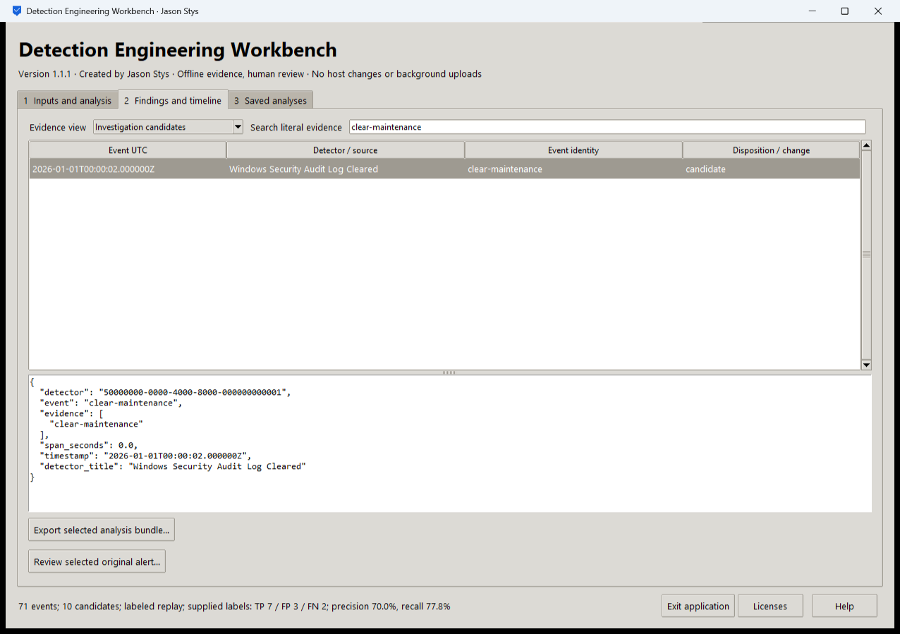
Figure 1 The installed application filters the supplied clear maintenance event and displays its original detector and timestamp. The summary reports 71 events and 10 candidates with supplied-label precision 70 percent and recall 77.8 percent.

A worked application journey
A detection engineer investigates a Windows audit-log-clearing candidate, records why a synthetic maintenance event was expected, and exports both the original evidence and the analyst review. A malformed input must leave the last accepted evidence intact.
1. Choose prepared labeled replay or select your own supported event, rule and optional label files in Inputs and analysis.
2. Run the real engine, open Findings and timeline, select Investigation candidates and search for clear-maintenance. Inspect the original JSON before deciding.
3. Use Review selected original alert to enter a disposition, reviewer assertion and rationale. Inspect the separate saved review rather than treating it as a changed detector result.
4. Export the selected analysis bundle. Reopen the same local profile and verify that Saved analyses retains the original and review bundles.
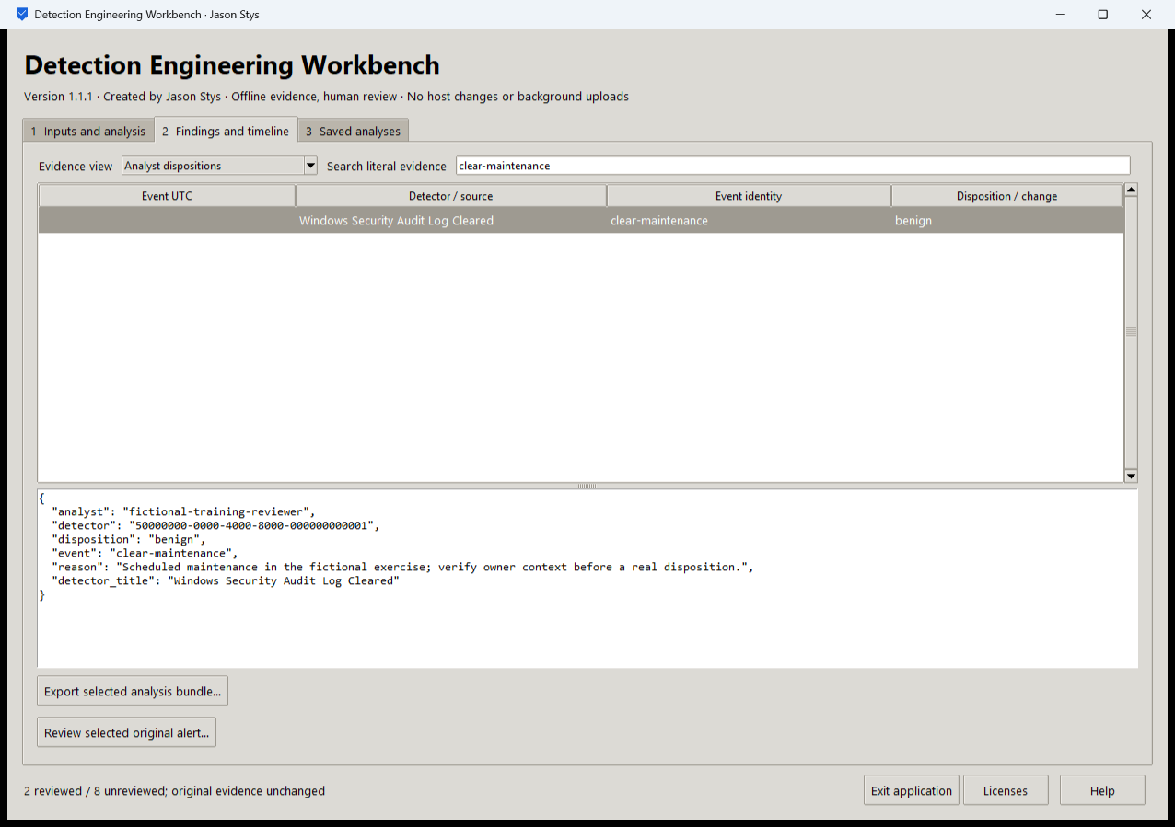
Figure 2 The installed application records a reasoned analyst disposition while retaining the original alert evidence. A review is a human assertion and does not rewrite detector accuracy.

Important implementation details

Check fixed state before a write can follow an alias
This pre-initialization check requires any existing fixed state member to be an ordinary single-link file without a Windows reparse attribute. Startup and connection admission apply it to the known marker/lock/SQLite recovery paths; ordinary recovery files are retained.
detection/desktop_state.py lines 208 to 219
208 def admit_existing(path: Path) -> None:
209 """Refuse pre-existing linked/nonregular fixed state before initialization can write through an alias."""
210 try:
211 info = path.lstat()
212 except FileNotFoundError:
213 return
214 if (
215 not stat.S_ISREG(info.st_mode)
216 or info.st_nlink != 1
217 or getattr(info, "st_file_attributes", 0) & getattr(stat, "FILE_ATTRIBUTE_REPARSE_POINT", 0)
218 ):
219 raise Rejected("fixed workspace state must be unlinked one-link regular files")
Source file SHA256 5cd749a383ce48c87d8e5c58182332bdacce5cc7c5547763a0fd9f7ca524c858

Validation results and operating limits
Runtime source 5d68b39e73ba0043f8b62892e7638928cf8be489
Check | Observed evidence | Result
Actual installed workflows | Full original domain, review and export controls passed two normal native launches; all 3 saved bundles retained exact original bytes. | Passed
Old-to-new profile | The actual installed 1.1.0 app created a synthetic profile; installed 1.1.1 reopened it and retained all 3 exact bundles without reset. | Passed
Source and distribution | Exact-main workflows and processed CodeQL passed with zero open main alerts. Five downloaded assets and installed files matched their verified SHA-256 identities. | Verified
PC and links | Existing links were backed up and retargeted with settings retained. Normal profiles and Docker were unchanged; default-profile shortcut activation remains separately untested. | Verified

Installation and private data
Download the matching Windows EXE and SHA256 sidecar from Releases. This is an unsigned portable app, not an MSI; Python installation and terminal commands are unnecessary. Keep the distribution and runtime notices together.
Open your own new or identified profile outside the installation. History is local plaintext protected by OS-owner access and an exclusive instance lock. Use Help for formats and limits; Exit application closes the owned workbench.

Limits and help
Offline supplied evidence and analyst assertions only. This is not a host collector, intrusion-prevention agent or proof of detector effectiveness on an unknown production population.
Reviewer names are assertions, not authenticated identities. These tests used isolated synthetic profiles and did not access existing user data, call external services or change Docker. Back up your complete profile before moving it.
Release and checksums | Runtime source | Usage and limits

