Disaster Recovery Drill Lab Application Guide
Windows use and validation
By Jason Stys Version 1.1.0 11 November 2026
Review captured restore ledgers and recovery-point catalogs against explicit recovery objectives. Compare lost orders, exact snapshot identity and supplied recovery timing before changing a review policy or recommending a recovery point.
The published Windows application passed its unchanged full consumer after independent download and installation. Exact source workflows and processed security analyses passed before publication. Individual shortcut targets were read back separately.

Capabilities and previous improvements
The original encrypted restic backup and isolated PostgreSQL recovery drills remain separate CLI and hosted tests. The desktop workbench adds authorized JSON imports, editable review objectives and as-of time, original and effective results, searchable evidence, retained history and exact export. Prepared cases run inside this same app.
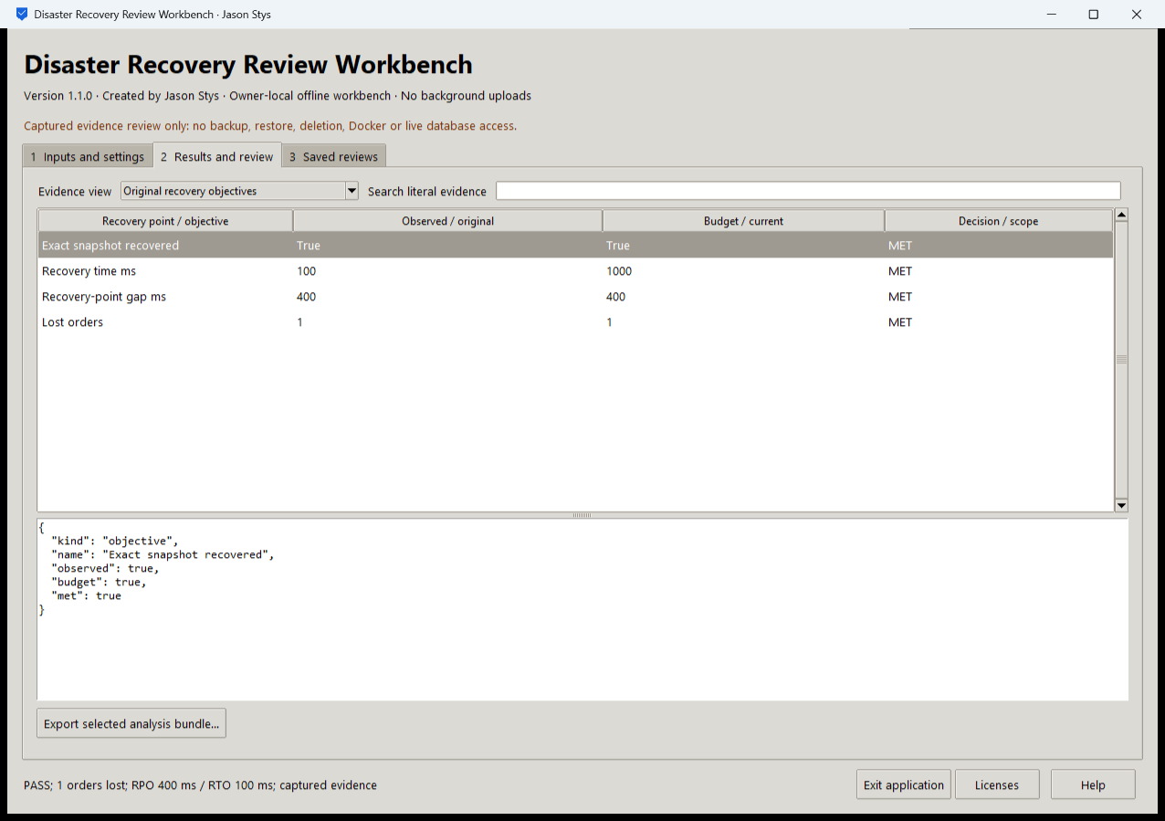
Figure 1 The installed app compares supplied recovery time, recovery-point gap and lost orders with their limits. These displayed times are captured input values, not a new measured restore.

A worked application journey
A continuity analyst compares a supplied restore evaluation with a four-point recovery catalog. One point has no tested timing. The analyst checks separate provenance groups and conservative retention recommendations without executing a restore or deleting a backup.
1. Choose a captured restore evaluation, a recovery catalog or a prepared exercise in Inputs and settings. Select only an authorized file with the documented JSON schema.
2. Review the original objectives before setting optional RPO, RTO or lost-order limits. Catalog reviews also accept an explicit as-of time and retention minimum.
3. Run the analysis. Inspect each objective, untested timing and provenance group in Results and review. Search filters the view while preserving the complete saved evidence.
4. Export the selected analysis bundle to a new destination. Reopen Saved reviews to compare exact retained results, then close with Exit application.
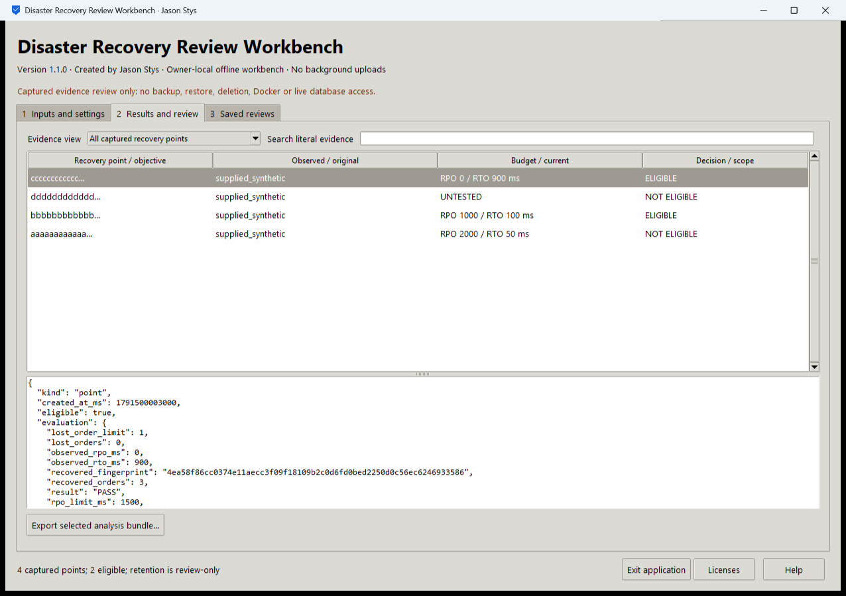
Figure 2 All four captured points remain visible. Two meet the selected objectives; one is untested. Eligibility and retention are review results, not live recovery or deletion.

Important implementation details

Preserve original objectives before applying review changes
The adapter evaluates the original captured data before changing any permitted policy field. It then calls the same planning or ledger engine for the effective review. Catalog-only controls cannot silently alter a restore evaluation.
dr/desktop_project.py lines 265 to 283
265 original = copy.deepcopy(data)
266 if not catalog:
267 record(
268 data, {"snapshot", "source_head", "restored", "elapsed_ms", "objectives"}
269 )
270 original_result = plan(original) if catalog else evaluate(**original)
271 for name, low, high in (
272 ("rto_ms", 1, 1800000),
273 ("rpo_ms", 0, 1800000),
274 ("max_lost_orders", 0, 10000),
275 ):
276 if parameters.get(name):
277 data["objectives"][name] = control(parameters[name], low, high)
278 for name, low, high in (("as_of_ms", 1, 2**53 - 1), ("retention_minimum", 1, 20)):
279 if parameters.get(name):
280 if not catalog:
281 raise Rejected("catalog-only control cannot change an evaluation")
282 data[name] = control(parameters[name], low, high)
283 result = plan(data) if catalog else evaluate(**data)
Source file SHA256 f743c9520f03d17d338c3d664a616a638887f1e7dfc8a620a74ab22842eab1a2

Validation results and operating limits
Runtime source a9b1347466f3301ed138e63a2a545d94c81eafb4
Check | Observed evidence | Result
Independent distribution | All five downloaded release files matched provider hashes. The executable also matched its checksum sidecar. Installed resources remained byte-identical after actual use. | Passed
Actual use and restart | All 10 installed workflows and 10 exact evidence bundles passed the original full assertions. Both launches exited normally; reopening retained every saved bundle. | Passed
Source and security | All exact-source main workflows passed before publication. Configured processed CodeQL analysis had zero raw findings and zero open main alerts. | Passed
Individual shortcut | Desktop and Start-menu targets were read back. Full installed executable acceptance is distinct from activating a normal default-profile shortcut. | Verified

Installation and private data
Download DisasterRecoveryDrillLab-1.1.0-windows-x64.exe and its checksum from Releases. This unsigned portable Windows x64 executable bundles Python 3.14.10 and Tcl and Tk 9.0.4; no Python setup or Docker change is required.
Use the individual Desktop icon and in-app Help. The owner profile stores selected paths and evidence as plaintext outside the installation. Protect exports and use nonidentifying inputs. Tests used separate synthetic profiles; normal user data was not opened.

Limits and help
Timing and provenance labels are supplied assertions. Local review does not authenticate a capture, establish a live RPO or RTO, or prove that a production backup can restore.
The GUI performs no backup, restore, SQL, Docker, prune or deletion. Real restic and PostgreSQL drills remain separate scoped tests. The profile trusts the OS owner and is not encrypted multiuser storage.
Release and checksums | Exact runtime source | Usage and limits

