Disconnected Release Kit Application Guide
Windows use and validation
By Jason Stys Version 1.1.0 11 November 2026
Review signed offline release bundles using an independently supplied Ed25519 public key, explicit product and target identity, assessment time and sequence policy. Inspect a candidate against retained deployment evidence without activating it.
The independently downloaded installed application passed its original full native acceptance and retained-file checks. Current main source workflows and processed security analyses passed before publication; shortcut targets were verified separately.

Capabilities and previous improvements
The original kit retains layered bundle signature, inventory, identity, expiration and rollback protections. The new GUI calls the same verifier, compares exact candidate and active bytes, records high-water and expected-current decisions, and supports complete no-overwrite exports and durable local history.
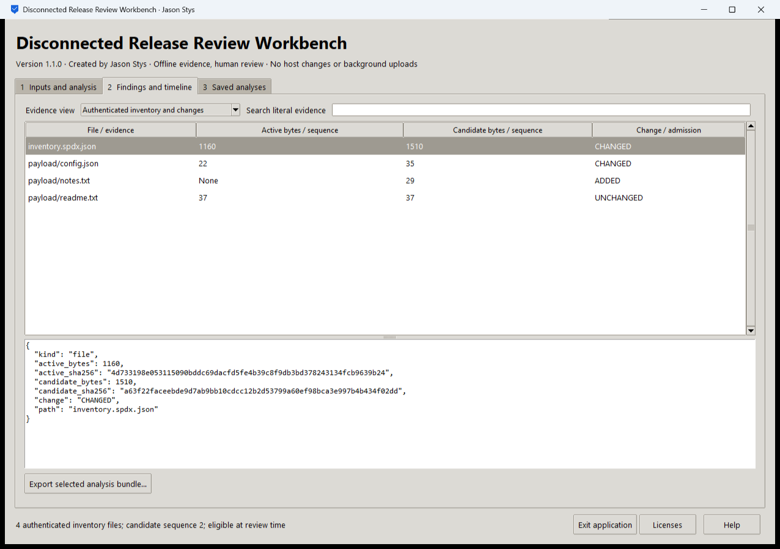
Figure 1 The actual installed application presents independently authenticated bundle inventory and retained policy evidence.

A worked application journey
A disconnected-site release reviewer receives a candidate bundle and a separately trusted public key. The reviewer verifies it, compares it with an owned deployment record and investigates an expired or stale candidate before exporting the evidence.
1. Select a prepared case or supported bundle, independently obtained raw public key and exact product/target policy.
2. Set the explicit assessment time and sequence floor. Run the original signature/inventory verification and inspect accepted or rejected details.
3. For deployment review, supply the owned deployment directory and exact expected-current digest. Inspect candidate and active identities and all retained policy reasons.
4. Export the complete selected record to a fresh destination, reopen its saved history and use the native Exit application control.
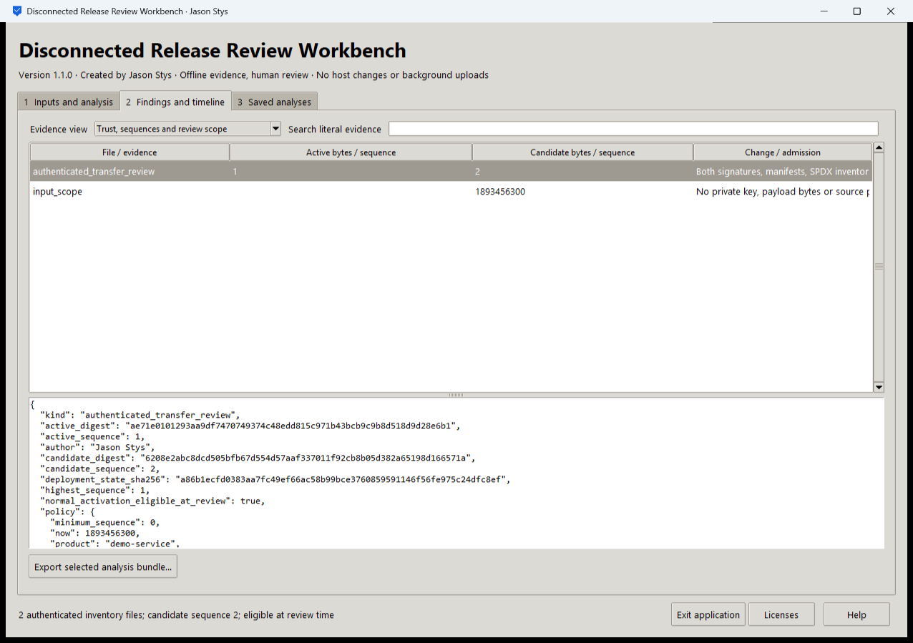
Figure 2 The installed review view keeps candidate eligibility and deployment context separate from activation; complete signed evidence remains downloadable.

Important implementation details

Separate supplied trust from bundle data
The desktop operation constructs explicit policy and reads the selected bundle and separate fixed-length trust key. Actual verification occurs in the original core, rather than trusting bundled metadata alone.
drkit/desktop_project.py lines 303 to 318
303 def analyze(
304 workspace: Workspace, parameters: dict[str, str], stage: Path
305 ) -> tuple[str, str, dict[str, bytes]]:
306 """Verify actual signatures/inventories or reauthenticate candidate/active bytes; never mutate the selected deployment pointer."""
307 del workspace
308 mode = parameters.get("mode", "")
309 if mode not in MODES:
310 raise Rejected("unsupported transfer operation")
311 trusted_policy = policy(parameters)
312 if mode == MODES[0]:
313 root, raw, trusted, expected = prepared(
314 stage, parameters.get("transfer_case", ""), trusted_policy
315 )
316 else:
317 raw = read_source(Path(parameters.get("bundle", "")), MAX_BUNDLE)
318 trusted = read_source(Path(parameters.get("trusted_key", "")), 32)
Source file SHA256 954bd2712fa838af29ad62616e064614ea474084e8233ef2574d1c2a24ea162d

Validation results and operating limits
Runtime source 22ba6c0b6ff464624f8b56ab1d9a19737cef6408
Check | Observed evidence | Result
Independent distribution | Downloaded provider assets, sidecar and installed file identities matched. The complete installed app was used; installation resources remained byte-identical. | Passed
Actual app use and restart | Ten actual workflows and ten complete evidence bundles passed the original installed consumer, including negative cases, no-overwrite export and two normal exits with exact retained history. | Passed
Source and security | All current main workflows passed before publication. All configured exact-source processed CodeQL categories had zero raw findings and zero open alerts. | Passed
Individual shortcut | Desktop and Start-menu targets were read back against the installed version. Normal default-profile shortcut activation is separate from full installed executable acceptance. | Verified

Installation and private data
Download the matching version and checksum from Releases. This is an unsigned per-user portable Windows x64 app; keep its complete accompanying files together. No system Python installation or Docker change is needed.
Use the individual Desktop icon and in-app help. Inputs, saved evidence and exports stay outside the installation. Preserve older versions and your own profiles; tests used only separate synthetic inputs.

Limits and help
The trust key must be established independently by the operator. A matching signature does not independently establish that a publisher or payload is safe.
The GUI does not sign, execute, activate or roll back payloads. These are separately controlled original CLI operations, not a claim made by a successful candidate review.
Release and checksums | Exact runtime source | Usage and limits

