Documentation Quality Workbench Application Guide
Windows use and validation
By Jason Stys Version 1.1.1 11 November 2026
Edit Markdown and HTML, configure documentation policy, inspect exact source locations and review accepted debt in the Windows application. It uses the same parsers, rules and reporting engine as the original CLI and GitHub Action.
All five assets were independently downloaded and the installed 1.1.1 app passed the complete native consumer with two normal exits and all 90 program files unchanged. A separate real 1.1.0-to-1.1.1 workspace test preserved document, attachment, policy, accepted-debt, current/previous-save and owner bytes through two further normal exits.

Capabilities and previous improvements
The original rule IDs, metadata and link checks, reasoned baseline review and JSON, SARIF and HTML reports remain. The graphical app adds an editable local corpus, inert reference assets, saved-source inspection, durable current and previous saves, explicit imports and exports, and completion-aware Exit. Version 1.1.1 adds main-owned Keep editing/Discard choices before whole-corpus replacement and failure exit status only after accepted startup work settles. Ordinary successful Quit and existing profile schemas remain.
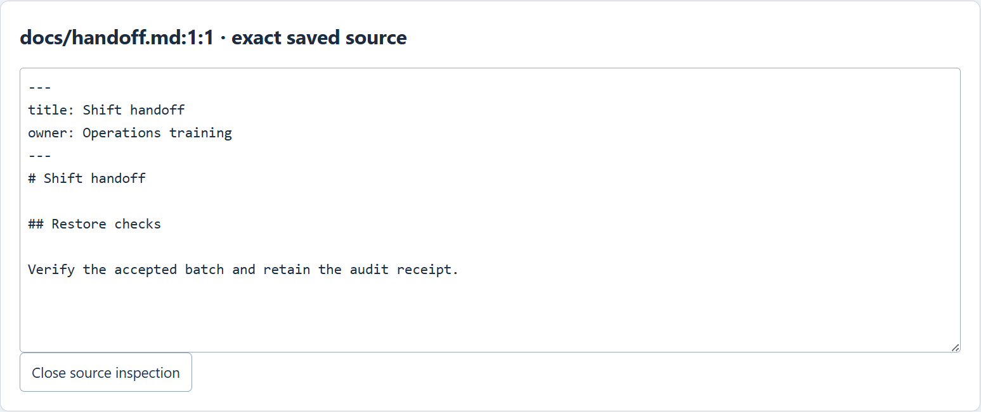
Figure 1 Installed 1.1.1 opens docs/handoff.md at line 1, column 1 for its missing reviewed metadata. The earlier heading repair remains in the saved text; navigation is bound to the analyzed corpus fingerprint.

A worked application journey
A documentation owner corrects a handoff heading, requires a reviewed metadata field and records a reasoned temporary debt decision. The same saved corpus, inert calibration reference and previous checkpoint must survive updating the installed application.
1. Open the prepared handoff corpus inside the full app. Select an approved Markdown or HTML document, edit its literal source and save before analyzing. The scanner uses the exact saved project.
2. Inspect a finding at its exact file, line and column. Correct the heading, save and analyze again. Add the reviewed policy field; record a meaningful reason if its missing metadata is temporarily accepted. Findings remain visible as debt.
3. When updating the application, keep the existing profile outside the program folder. The tested 1.1.0-to-1.1.1 synthetic workspace retained current and previous saves, policy, baseline decision, owner marker and attachment bytes. No normal profile was opened by these tests.
4. Use Keep editing or Discard before replacing a dirty corpus with prepared data, a previous save or imported project. Export JSON, HTML, active-only SARIF or corpus to a new selected file. Use Exit and wait for accepted workers and dialogs.
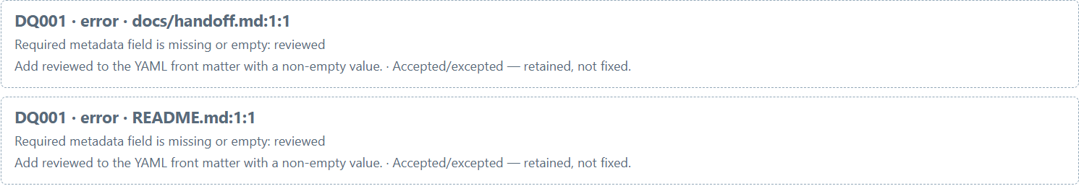
Figure 2 Both DQ001 findings remain at their exact file and line after the real 1.1.0-to-1.1.1 test. Accepted/excepted means retained debt; the metadata was not silently repaired or removed.

Important implementation details

Bind source navigation to the analyzed corpus
diagnosticSource recomputes the complete project fingerprint before reading the logical file. It rejects invalid line or column values and positions outside the saved text. An edited corpus cannot silently reuse a stale diagnostic location.
src/workbench/project.ts lines 256 to 276
256 export function diagnosticSource(
257 project: NativeProject,
258 analyzedFingerprint: string,
259 diagnostic: Diagnostic,
260 ): { text: string; line: number; column: number } | null {
261 if (projectFingerprint(project) !== analyzedFingerprint)
262 throw new Error('This result is stale; analyze the applied project again.');
263 const text = projectFiles(project).get(diagnostic.file);
264 if (typeof text !== 'string') return null;
265 if (
266 !Number.isSafeInteger(diagnostic.location.line) ||
267 diagnostic.location.line < 1 ||
268 !Number.isSafeInteger(diagnostic.location.column) ||
269 diagnostic.location.column < 1
270 )
271 throw new Error('Diagnostic location is not valid.');
272 const line = text.split(/\r?\n/u)[diagnostic.location.line - 1];
273 if (line === undefined || diagnostic.location.column > line.length + 1)
274 throw new Error('Diagnostic is outside the current source extent.');
275 return { text, line: diagnostic.location.line, column: diagnostic.location.column };
276 }
Source file SHA256 4ebcff346f0f2f6c7c6ccafc837c009f61377e4136b4b8fd33318ec7f2c462ba

Validation results and operating limits
Runtime source c44a4bd5f0252fb258ff20c2f1f311541b3de6e5
Check | Observed evidence | Result
Installed original workflows | Five downloaded assets matched provider identities and checksums. The full original consumer and three Keep/three Discard replacement cases passed, with two normal exits, actual scanner, held export, no page errors and all 90 files unchanged. | Passed
Cross-version preservation | Actual installed 1.1.0 and 1.1.1 opened the same fresh synthetic profile. Exact document, attachment, policy, debt, current/previous-save and owner bytes survived; both 90-file program inventories stayed unchanged. Two normal exits and no outside requests. | Passed
Source and hosted | 62 source plus 16 integration tests, 93.60% library lines; 26 native-helper and six archive controls passed at unchanged floors. All four main workflows and three processed CodeQL categories passed. Five actual Electron exit-status controls passed. | Passed

Installation and private data
Download DocumentationQuality-1.1.1-windows-x64.zip and its matching SHA256 sidecar from Releases. Extract the complete folder and launch DocumentationQuality.exe; keep every accompanying file together. No Node or Python setup is needed.
Use the individual desktop icon or in-app help. Corpus, debt and browser state are plaintext owner-local files outside the installation. Preserve existing profiles and old versions; do not delete a lock or sidecar to force startup. The two known Desktop/Start-menu icons now target 1.1.1; original shortcut bytes, the earlier installed version and its receipt were preserved.

Limits and help
Acceptance is a recorded debt decision, not a repair or authenticated approval. JSON and HTML retain accepted findings; SARIF contains active findings only. Unexamined debt does not prove that a finding was fixed.
One trusted OS owner and static filesystem admission are the boundary. The app is unsigned, has no reviewer login or encryption, and does not execute document code or fetch external links. Ordinary default-profile icon activation was not tested.
Release and checksum | Exact runtime source | Usage and limits

