Drone Airspace Awareness Studio Application Guide
Windows use and validation
By Jason Stys Version 0.2.0 10–11 November 2026
Inspect supported supplied track and airspace evidence using the actual bundled Rust kernel and full browser UI. Coverage, freshness, altitude-reference and observation limits remain explicit; no flight clearance or live surveillance is implied.
The downloaded Windows app passed its full workflow with synthetic data. Required main-branch checks and security scans passed for this source revision. Desktop and Start-menu shortcut targets were verified; the installed app was tested separately.

Capabilities and previous improvements
Show pair/zone coverage ledgers with stale tracks, datum mismatch, unknown intervals and exclusion reasons. Explains what an awareness result actually covers instead of implying empty or incomplete data means clear airspace.
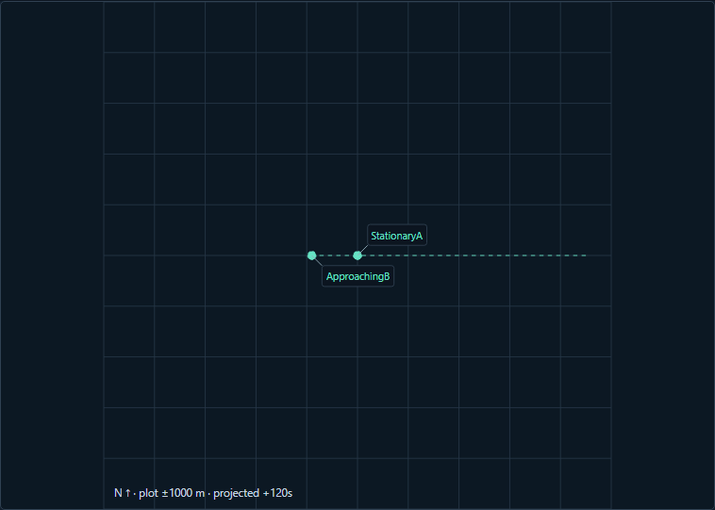
Figure 1 The selected 120-second snapshot of the actual synthetic traffic plot retains readable labels and a metre scale; it is advisory, not flight clearance.

A worked application journey
A reviewer uses supported fictional input files in the full app, inspects the original results and uncertainties, then exports exact evidence and quits normally.
1. Open the full desktop awareness app and import a supported bounded synthetic replay JSON, or edit the built-in input.
2. Set the analysis snapshot, projection horizon and margins; run the actual Rust assessment and move the path-time slider to inspect modeled positions.
3. Select tracks and inspect the named overlap-window and declared-pair coverage regions; distinguish stale, unknown-datum, inactive-zone and actually assessed pairs.
4. Export the reviewed evidence and retain its original replay input, then quit normally. Reopening starts a new in-memory review; reimport the supported input to continue.
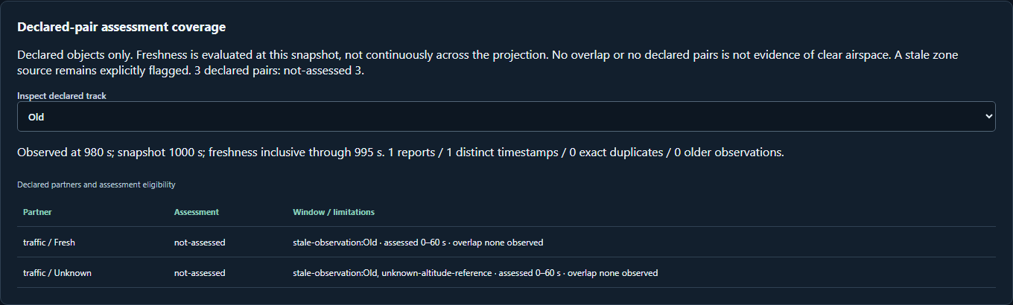
Figure 2 Coverage and unassessed pairs remain visible in the installed awareness viewer instead of being interpreted as safe traffic.

Important implementation details

Keep original evidence and decisions intact
Intersects independent horizontal and vertical time intervals inside the horizon; a 2D crossing alone does not become an overlap alert, and uncertainty remains a conservative advisory bound rather than a collision probability.
native/main.rs lines 48 to 68
48 fn overlap(a: State, b: State, h: f64, z: f64, horizon: f64) -> Option<(f64, f64)> {
49 let p = std::array::from_fn::<_, 3, _>(|i| a.p[i] - b.p[i]);
50 let v = std::array::from_fn::<_, 3, _>(|i| a.v[i] - b.v[i]);
51 intersect(
52 horizontal([p[0], p[1]], [v[0], v[1]], h + a.radius + b.radius, horizon)?,
53 vertical(p[2], v[2], z + a.height + b.height, horizon)?,
54 )
55 }
56
57 /// Strict native protocol validation, independent of API validation; no external dependencies.
58 fn calculate(text: &str) -> Result<String, &'static str> {
59 let mut tokens = text.split_whitespace();
60 let mut number = || {
61 tokens
62 .next()
63 .ok_or("missing value")?
64 .parse::<f64>()
65 .map_err(|_| "invalid number")
66 };
67 let count = number()?;
68 let horizon = number()?;
Source file SHA256 f1bb21346272cf86f1bc7c1bf51526e9dd155d471e1a02df3011225c8d7c3af8

Validation results and operating limits
Runtime source bd6ae7ed687290f03c73d8185427010167368785
Check | Observed evidence | Result
Real native workflows | The unchanged full installed-app consumer passed actual file import, original engine/results, role boundaries where applicable, exports, negative cases and normal owner Quit. | Passed
Source and security | All required main workflows for the runtime revision passed; processed CodeQL analyses reported zero open main alerts before release. | Passed
Distribution identity | All 2 assets matched provider/checksum identities; all 117 installed files remained unchanged during acceptance. | Verified
PC scope | New per-user version folder and individual links verified. Synthetic inputs and isolated outputs only; existing data and Docker were not used or changed. | Verified

Installation and private data
Keep the complete extracted ZIP together and launch AirspaceAwarenessStudio.exe. No system runtime or terminal setup is needed.
Open the verified Desktop icon. Save the original supported replay JSON and Export evidence before quitting; reopening resets in-memory state. The evidence export contains author, input and analysis, rather than a directly importable replay. Retain the original replay or extract its input object to reimport.

Limits and help
Synthetic local-frame advisory calculation; no live traffic, verified airspace clearance, remote feed, aircraft control or flight authorization.
Tests used synthetic offline inputs and isolated outputs. No aircraft, emergency dispatch or production data was accessed. This viewer keeps its active review in memory; save files explicitly before quitting.
Release and checksums | Runtime source | Usage and limits

