Drone Flight Policy Workbench Application Guide
Windows use and validation
By Jason Stys Version 0.2.1 11 November 2026
Use the full local staff policy-review app with actual official OPA evaluation, supported operation and policy JSON drafts, explicit no-write comparison, authenticated role views, durable review evidence and exact exports. Native OS-owner setup manages local accounts. Policy results are advisory and do not issue clearance or control an aircraft.
The independently downloaded installed app passed its full original workflows and an actual older-to-newer same-profile test. Current source checks and processed security analyses passed before publication. Individual shortcut targets were verified separately.

Capabilities and previous improvements
Compare active and draft policies using the same evidence and time, with exact native OPA inputs and failure states. Supports controlled policy review without publishing a draft or treating a comparison as flight authorization. The updated owner rejects aliased protected profile paths before access while admitting ordinary SQLite recovery files.
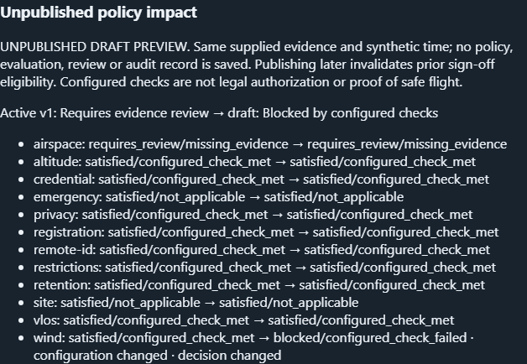
Figure 1 The installed policy app retains an unpublished draft and its original holds for review; no clearance or aircraft command is issued.

A worked application journey
A reviewer uses supported fictional input files in the full app, inspects the original results and uncertainties, then exports exact evidence and quits normally.
1. Open the native owner window, choose an identified private workspace and provision separate administrator/operator/reviewer accounts; Open full application.
2. Import or edit supported operation JSON, preserve unknown/stale/conflicting evidence, and Evaluate evidence using the actual checksum-verified bundled OPA.
3. As administrator, import/edit a policy draft and Preview draft impact against the same operation; inspect old/new check decisions and download the exact unpublished comparison before choosing any separate publication.
4. As a different reviewer, acknowledge only eligible current satisfied evidence or record rejection; export the source-bound report and Quit the owner window.
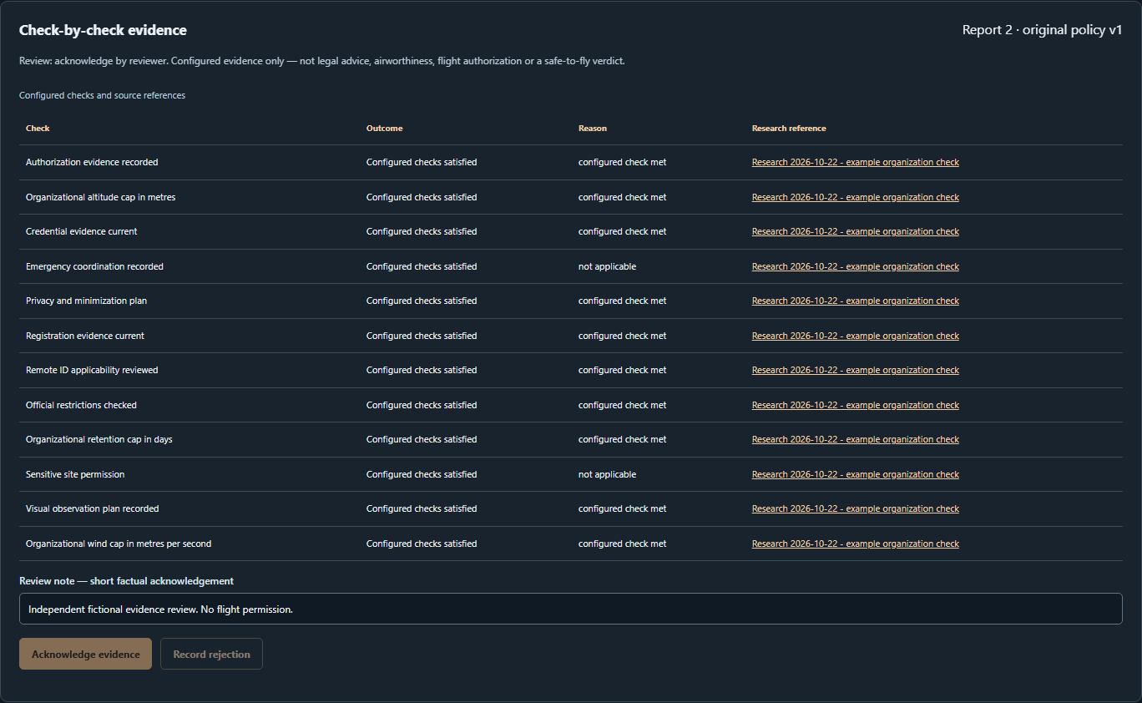
Figure 2 A separate staff reviewer inspects the retained policy evidence and its revision within the same full application.

Important implementation details

Keep original evidence and decisions intact
Requires exactly one valid result per configured rule and independently recomputes blocked/requires-review precedence before accepting OPA output; missing or malformed rule evidence cannot become a satisfied report.
workbench/engine.py lines 33 to 53
33 def validate_result(value, policy):
34 """Verify complete unique rule coverage and independently recompute overall hold precedence."""
35 if (
36 not isinstance(value, dict)
37 or set(value) != {"status", "checks"}
38 or not isinstance(value["checks"], list)
39 ):
40 raise ValueError("Malformed policy result")
41 expected = {r.id for r in policy.rules}
42 seen = set()
43 for row in value["checks"]:
44 if (
45 not isinstance(row, dict)
46 or set(row) != {"id", "status", "reason"}
47 or row["id"] not in expected
48 or row["id"] in seen
49 or row["status"] not in STATUSES
50 or row["reason"] not in REASONS
51 ):
52 raise ValueError("Incomplete or invalid rule evidence")
53 seen.add(row["id"])
Source file SHA256 d7b3b3ca1be19849fbed0f16799a141a39b36b26212a9d8c3847bf1854cab5b1

Validation results and operating limits
Runtime source 177e0abf205e3496241719813d6d3432c8e7ba2c
Check | Observed evidence | Result
Real native workflows | The complete original installed consumer passed domain inputs, real results, refusal, role boundaries and exact exports. Both launches exited normally. | Passed
Actual same-profile upgrade | Installed 0.2.0 created and edited the fixture; 0.2.1 reopened the same profile/password across all 3 roles, with retained records and normal exits. | Passed
Distribution identity | Both downloaded assets matched provider hashes; all 123 installed files stayed unchanged. Exact-main workflows and processed raw CodeQL passed. | Verified
PC scope | New per-user version folder and individual links verified. Synthetic profiles only; existing data and Docker were not used or changed. | Verified

Installation and private data
Download 0.2.1 and its checksum, extract the entire ZIP and launch DroneFlightPolicyWorkbench.exe. Use its own Desktop icon; no Python setup or Docker change is needed.
Keep older binaries and a stopped-profile backup. Reopen the existing profile with the same account; never initialize a replacement over retained data. Use Help and Quit through the owner window.

Limits and help
Organizational synthetic evidence checklist, not legal clearance, FAA service, airworthiness judgement, live credential verification or launch authorization.
Prepared inputs and tests were synthetic/offline; no aircraft, emergency dispatch or production data was accessed. Native owner access is trusted; retain the complete local profile privately.
Release and checksums | Exact runtime source | Usage and limitations

