Drone Maintenance Readiness Studio Application Guide
Windows use and validation
By Jason Stys Version 0.2.1 11 November 2026
Use the full maintenance ledger/readiness/standards application with authenticated staff roles, real JSON-file workflows, same-ledger draft-standard comparisons and durable evidence export. Startup inputs wait for authentication bootstrap readiness.
The independently downloaded installed app passed its full original workflows and an actual older-to-newer same-profile test. Current source checks and processed security analyses passed before publication. Individual shortcut targets were verified separately.

Capabilities and previous improvements
Compare unpublished maintenance standards against the same ledger, time and workload, exposing component findings and deadline deltas. Lets authorized reviewers assess standards changes before altering maintenance records or policy. The updated owner rejects aliased protected profile paths before access while admitting ordinary SQLite recovery files.
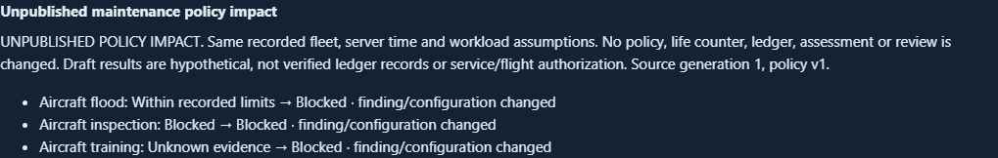
Figure 1 Complete aircraft-level summary of the unpublished policy comparison: its heading, source-generation notice and three aircraft results. Component details remain in the full app and evidence download.

A worked application journey
A reviewer uses supported fictional input files in the full app, inspects the original results and uncertainties, then exports exact evidence and quits normally.
1. Open native owner setup and an identified private workspace; provision admin, technician, reviewer and operator roles as needed, then open the full app.
2. Inspect a fictional aircraft and its serialized component usage, inspections and defects; record permitted new work instead of editing away lifetime history.
3. As administrator, import/edit policy JSON and Preview policy impact before publication; compare exact current and draft findings, then download the unpublished comparison.
4. Have a different reviewer verify recorded corrective work, inspect remaining warnings/unknowns, and export current evidence. Quit the owner window; reopening preserves the ledger.
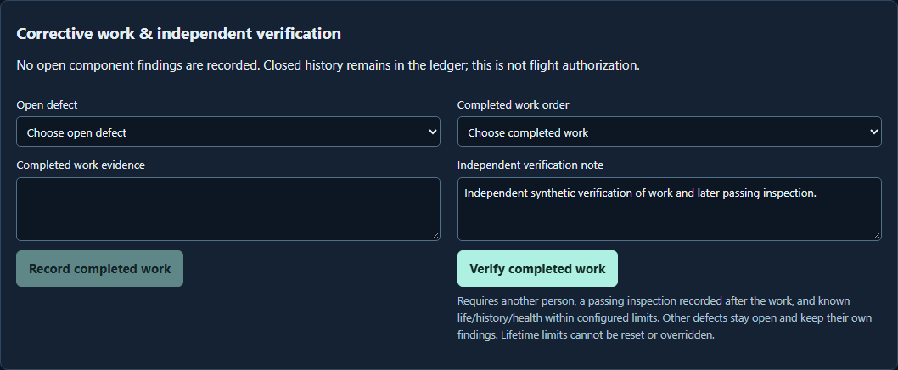
Figure 2 The installed maintenance app displays retained corrective-work evidence and the separate review workflow.

Important implementation details

Keep original evidence and decisions intact
Evaluates one serialized component without changing its counters: missing lifetime history stays unknown, retired/limit-reached records block, and all underlying reasons survive aggregate status precedence.
workbench/engine.py lines 40 to 60
40 def component_result(part, limit, inspection, defects, policy, at, assumptions):
41 """Evaluate one serialized identity without changing counters or assuming missing evidence passed."""
42 findings = []
43
44 def add(code, status, message):
45 """Retain every reason even when a higher-precedence finding sets aggregate status."""
46 findings.append({"code": code, "status": status, "message": message})
47
48 if part["retired"]:
49 add("retired", "blocked", "Part is permanently retired in this workspace")
50 if not part["history_complete"]:
51 add("history_incomplete", "unknown", "Opening lifetime history is not attested complete")
52 remaining_seconds = remaining_cycles = None
53 due = None
54 if limit is None:
55 add("limit_missing", "unknown", "No configured limits for this component kind")
56 else:
57 remaining_seconds = max(0, limit.seconds - part["seconds"])
58 remaining_cycles = max(0, limit.cycles - part["cycles"])
59 for key, used, maximum in [
60 ("time", part["seconds"], limit.seconds),
Source file SHA256 4b13a7501d50680e8667dde77edf21e40cd38185b685203a6863a55e2051f476

Validation results and operating limits
Runtime source f11c4bd4cbd0f2c9177b9cc1778aa6de9123582a
Check | Observed evidence | Result
Real native workflows | The complete original installed consumer passed domain inputs, real results, refusal, role boundaries and exact exports. Both launches exited normally. | Passed
Actual same-profile upgrade | Same-profile 0.2.0 to 0.2.1 retained stored policy, ledger and exports across four roles. Time-derived readiness was recomputed; both observations were retained. | Passed
Distribution identity | Both downloaded assets matched provider hashes; all 120 installed files stayed unchanged. Exact-main workflows and processed raw CodeQL passed. | Verified
PC scope | New per-user version folder and individual links verified. Synthetic profiles only; existing data and Docker were not used or changed. | Verified

Installation and private data
Download 0.2.1 and its checksum, extract the entire ZIP and launch DroneMaintenanceStudio.exe. Use its own Desktop icon; no Python setup or Docker change is needed.
Keep older binaries and a stopped-profile backup. Reopen the existing profile with the same account; never initialize a replacement over retained data. Use Help and Quit through the owner window.

Limits and help
Fictional record-based exercise, not airworthiness certification, manufacturer maintenance approval, empirical failure prediction or flight permission.
Prepared inputs and tests were synthetic/offline; no aircraft, emergency dispatch or production data was accessed. Native owner access is trusted; retain the complete local profile privately.
Release and checksums | Exact runtime source | Usage and limitations

