Drone Operations Console Application Guide
Windows use and validation
By Jason Stys Version 0.3.2 11 November 2026
Review and rehearse fictional local-grid flight plans with authenticated local accounts, projected animated paths, editable obstacles and explicit evidence. Preserve plans and local data when updating the real desktop application.
The independently downloaded installed application passed the recorded real workflows. All exact-main checks and processed CodeQL passed before publication. Icon targets were read-back verified; normal default-profile shortcut activation remains separately untested.

Capabilities and previous improvements
Earlier authenticated planning, route projection, obstacle avoidance, cooperative rendezvous and reusable scene inputs remain available. The app now has patched bundled runtime checks, completion-aware shutdown and version-specific UI/service resources that cannot adopt stale upgrade files.
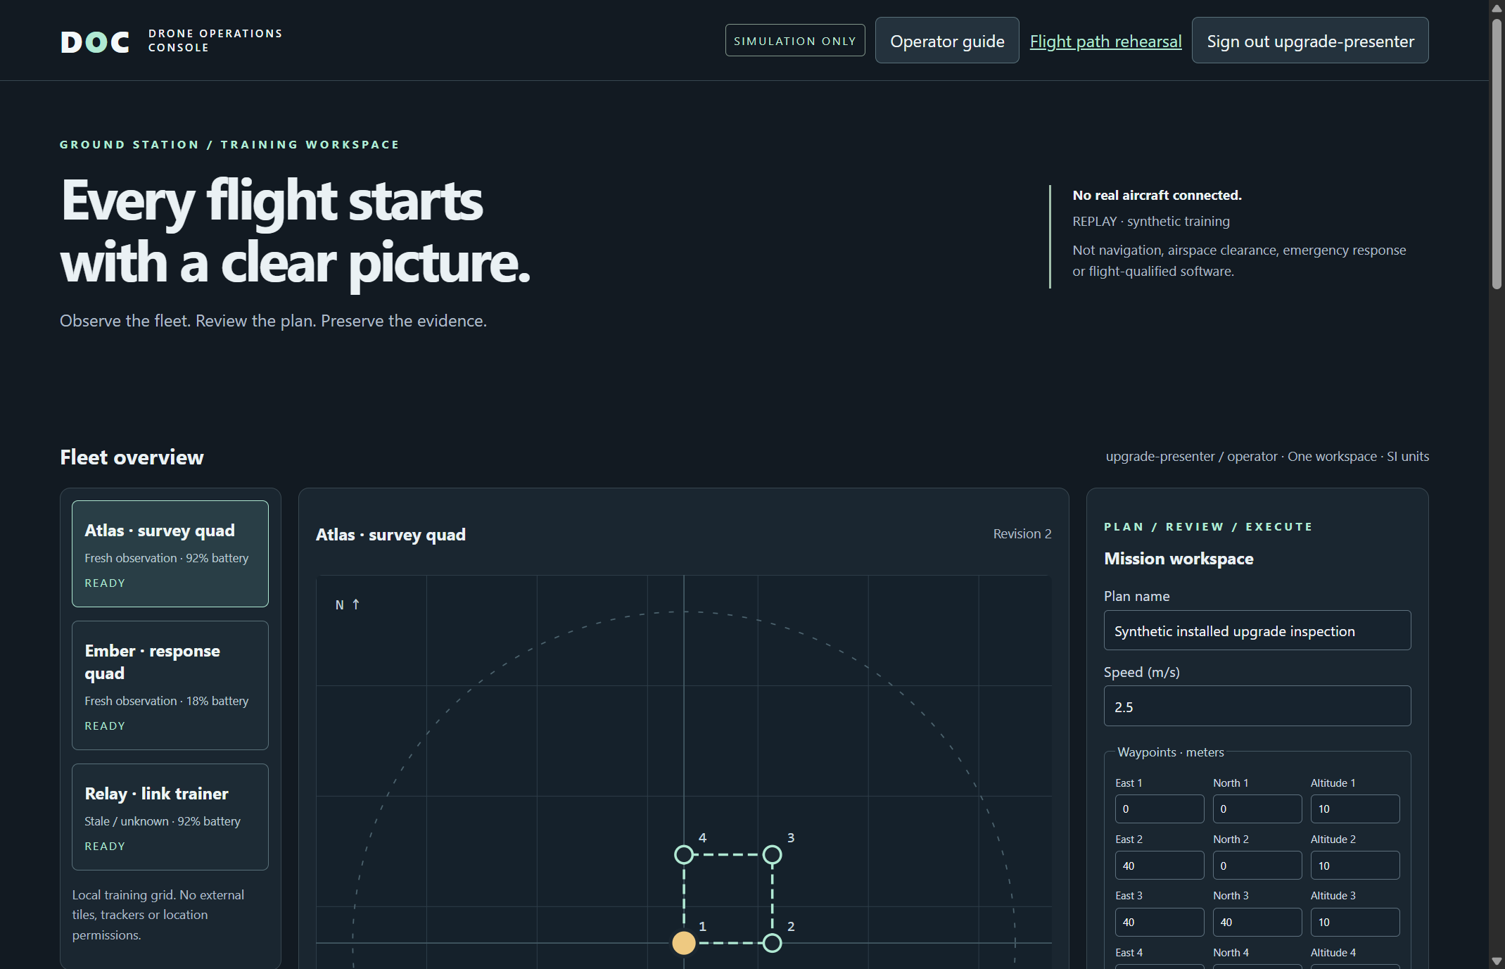
Figure 1 The actual 0.3.2 installation reopened the same synthetic operator and revision 2 inspection plan created by the preserved installed 0.3.0 app.

A worked application journey
A presenter creates and saves a fictional inspection plan in installed 0.3.0, updates through the actual NSIS installer, then signs in to 0.3.2 with the same password and reviews the unchanged plan and original audit rows.
1. Launch the desktop app and create a local operator or sign in. Review the simulation notice, selected aircraft, route revision and freshness separately.
2. Edit and save a bounded plan; changes invalidate old approval. The animated rehearsal is a separate input-driven cooperative simulation, with explicit obstacle and projection controls.
3. Save reusable scene inputs or export evidence. A projected path is a model preview, not operational navigation or a flight authorization.
4. Quit through the app or native window. Accepted work finishes before profile/service ownership is released. Preserve stopped-profile backups when upgrading and sign in to the same account afterward.
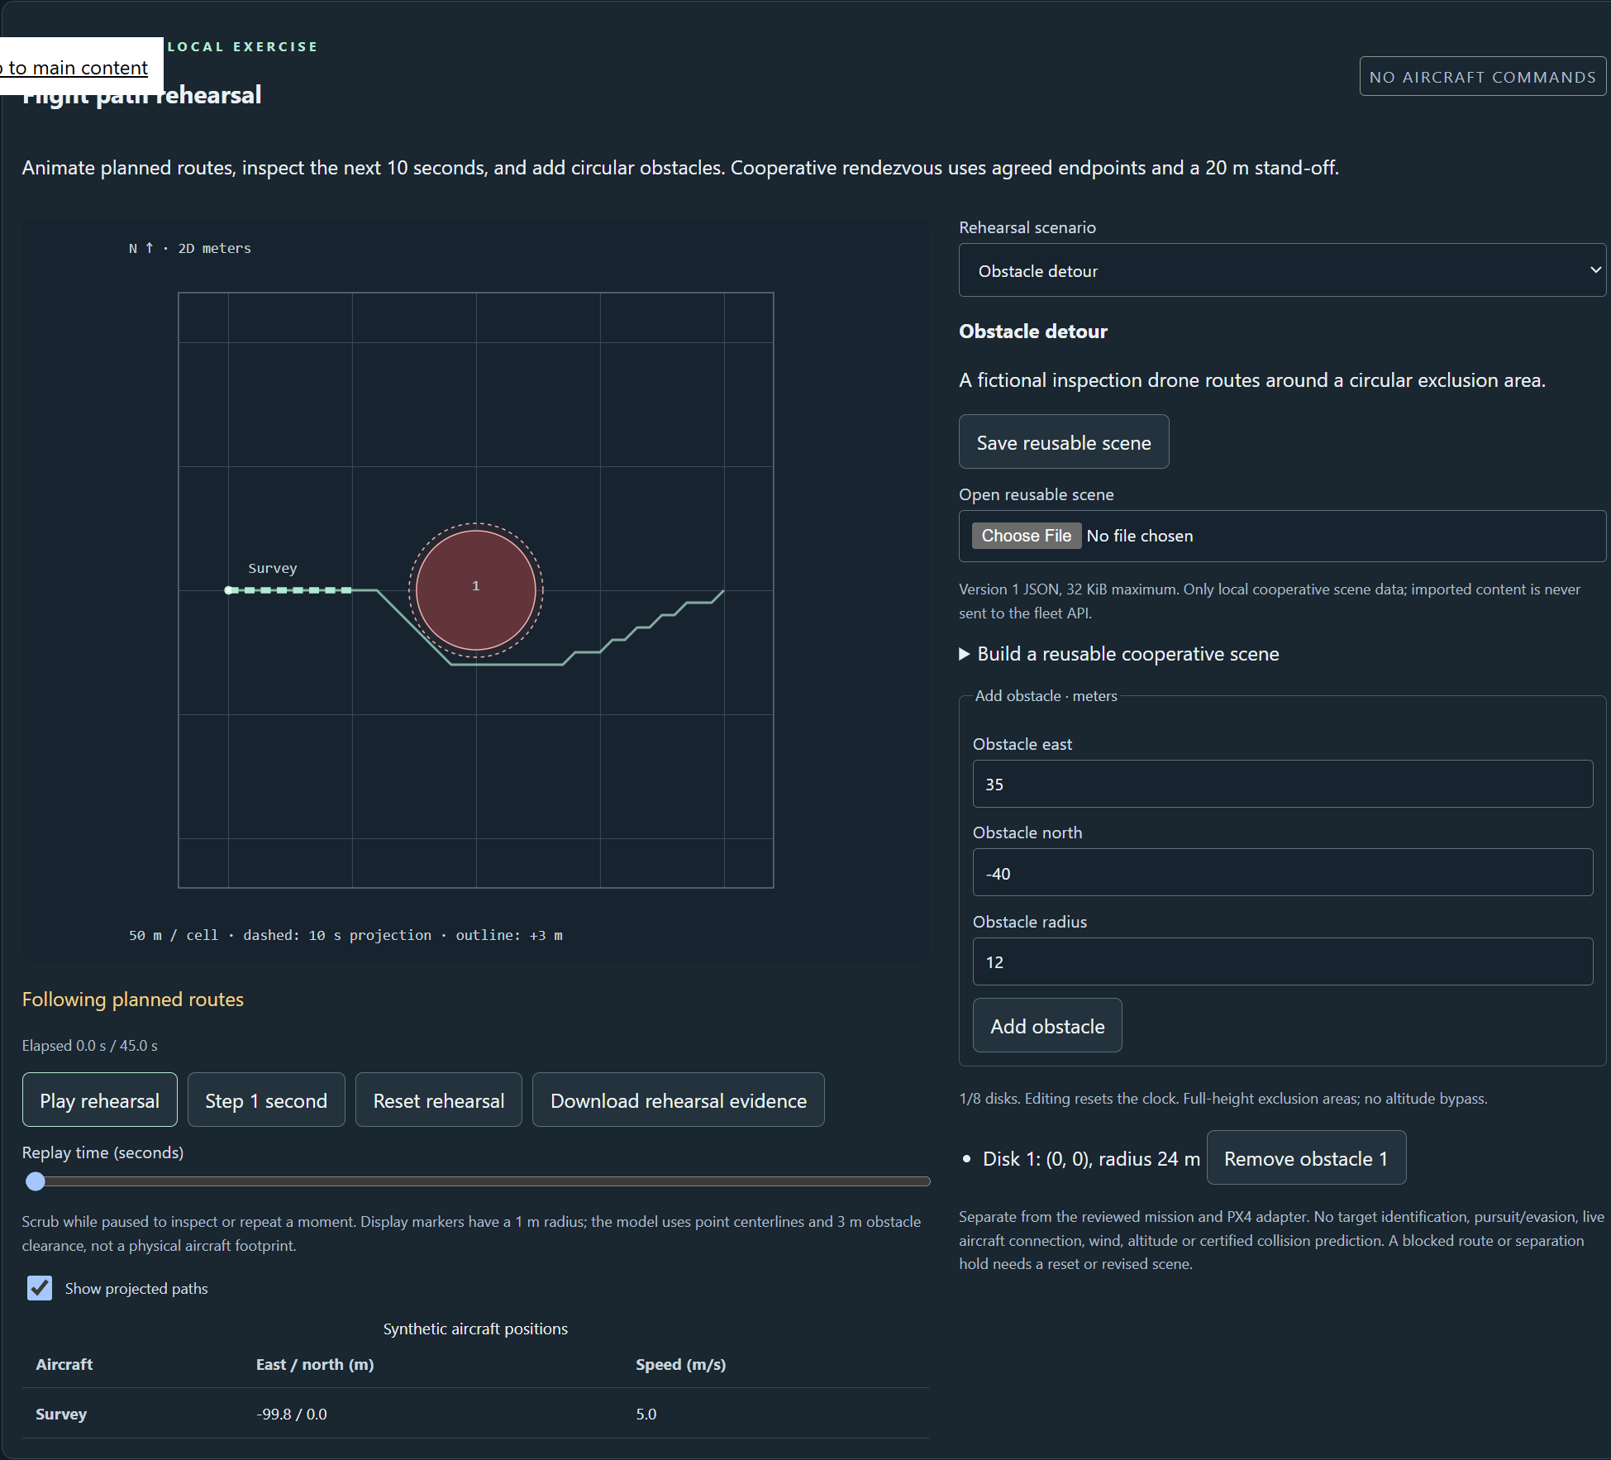
Figure 2 The actual installed rehearsal shows the complete projected route, circular obstacle, moving marker and playback controls. Movement was observed before pausing for this screenshot; the rehearsal sends no aircraft commands.

Important implementation details

Select resources for the exact installed app version
Validated version-specific directories select UI and service together. Legacy files cannot be adopted as current resources; current directory inventory remains strict.
desktop/resources.cjs lines 7 to 20
7 function resourceDirectories(resources, developmentRoot, packaged, version) {
8 const match =
9 typeof version === "string" &&
10 /^(?:0|[1-9]\d*)\.(?:0|[1-9]\d*)\.(?:0|[1-9]\d*)$/.exec(version);
11 if (!match || match[0] !== version)
12 throw new Error("Invalid application resource version");
13 if (packaged) {
14 const root = join(resources, "runtime", version);
15 return { serviceRoot: join(root, "service"), uiRoot: join(root, "ui") };
16 }
17 return {
18 serviceRoot: join(developmentRoot, "release", "drone-console-service"),
19 uiRoot: join(developmentRoot, "dist"),
20 };
Source file SHA256 5703e9a0b3e11809befaa2e5964e896fa121e4c63f63fb9665b78f2dc96a8d0f

Validation results and operating limits
Runtime source 97f595f1f3afbe612350018fc0bd7df68ebe633a
Check | Observed evidence | Result
Actual installed workflows | The independently downloaded NSIS update passed. Actual installed 0.3.0 created the account/plan, then 0.3.2 retained exact identity, plans and original audit rows. Both closed normally; normal account directories stayed unchanged. | Passed
Original core and source gates | All three original current-main native tests passed: installed account/animation/restart, installed-bundle retained-old-layout proof, and a separate same-source frozen held-work/repeated-Quit fixture. Original Python/Node/UI/browser/PostgreSQL/PX4/container gates also passed. | Passed
Assets and current security | Provider/download hashes, complete installed-byte identity, current exact-main workflows and processed raw CodeQL results passed with zero open main alerts. | Passed
Launch and data boundary | Individual Desktop and Start-menu targets verified. Only synthetic profiles were exercised; installed EXE tests are distinct from ordinary default-profile shortcut activation. | Passed

Installation and private data
Download the published Drone Operations Console Setup 0.3.2 EXE and SHA256SUMS file. Verify the hash, then run the per-user NSIS installer. Retain old versions and stopped-profile backups before updating.
Use the individual Desktop icon and the app's Help. Quit through its owner controls. No Python setup or Docker change is required; examples are input data inside the full application.

Limits and help
Simulation and cooperative rehearsal only; no target identification, weapon guidance, pursuit, real aircraft link, aviation clearance or certified collision prediction. Obstacles are full-height model exclusions with documented simplifications.
Unsigned per-user Windows installer. Both entire old installations and earlier link copies remain backed up; failed 0.3.1 stays unpublished. NSIS removed legacy files in this real update; a separate unchanged native fixture verified safe operation when extra old files remain.
Release and checksums | Runtime source | Usage and limitations

