Drone Video Privacy Studio Application Guide
Windows use and validation
By Jason Stys Version 0.2.1 11 November 2026
Review authorized short local clips, define frame-bounded region masks, verify processed pixels and require a separate reviewer before sharing a video-only export. Preserve original revisions, roles and evidence inside a complete desktop workflow.
The independently downloaded installed app passed its full original workflows and an actual older-to-newer same-profile test. Current source checks and processed security analyses passed before publication. Individual shortcut targets were verified separately.

Capabilities and previous improvements
The full authenticated app retains independent review, moving-mask editing, bounded media processing and minimal exports. Its updated native owner rejects profile aliases before access and supports ordinary SQLite recovery without losing retained data.
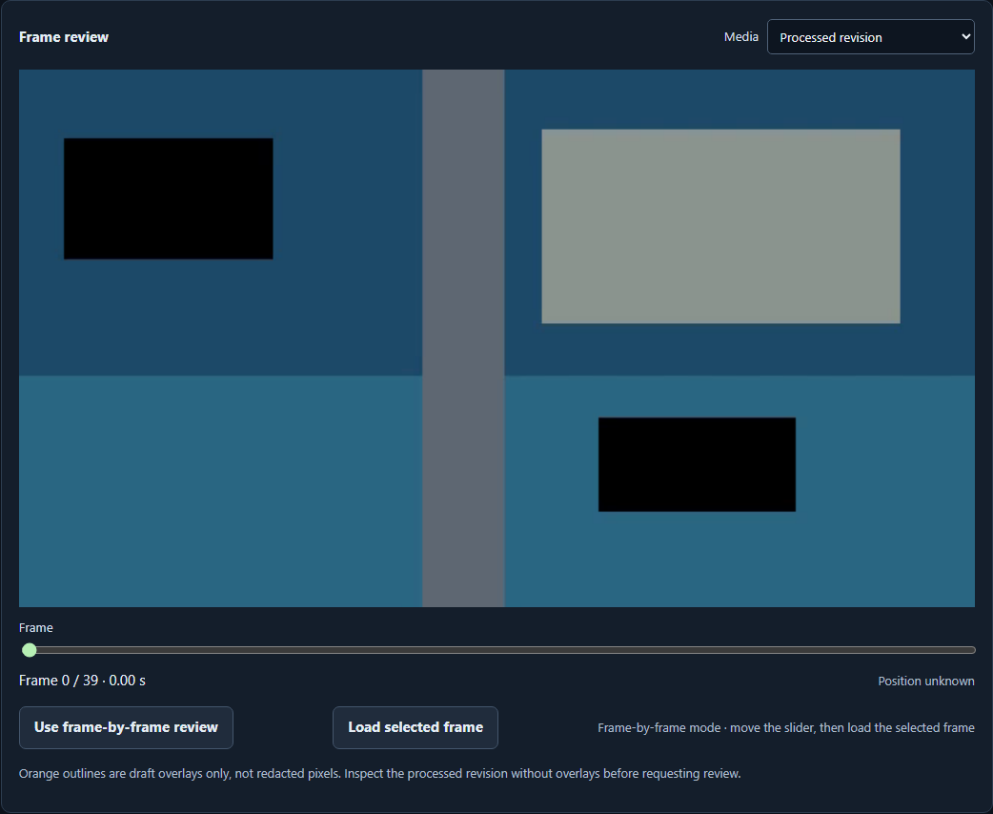
Figure 1 The actual installed app shows two black regions in a processed synthetic frame, separately from draft overlays.

A worked application journey
An operator imports a fictional coastal clip, masks two explicit regions and processes a revision. A separate reviewer inspects the result and context before exporting the reviewed MP4 and minimal receipt.
1. On first use, choose Install or Cancel for the pinned official codec dependency. Provision local roles through the owner controls and sign in to the full app.
2. Import authorized supported media or create an ordinary synthetic input. Set region/frame bounds, process a revision and inspect the resulting pixels frame by frame. Draft overlays are separate from redacted output.
3. Sign in as a separate reviewer, inspect the whole clip and context, then approve or reject that exact revision with a reason. A changed revision requires fresh review.
4. Download only the reviewed video and minimal receipt. Retain the private evidence trail and profile backup; use the owner window to quit normally.
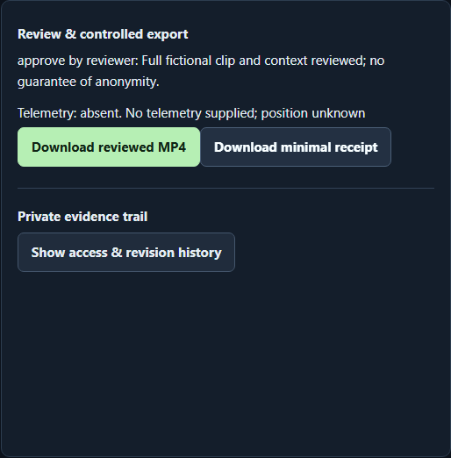
Figure 2 A different reviewer approved the retained fictional revision; the app permits the reviewed MP4 and minimal receipt exports.

Important implementation details

Apply explicit frame-bounded masks
The original media engine paints only the user-selected regions and frame interval. This deterministic edit does not recognize identity or certify anonymity; a person reviews the complete processed clip.
workbench/media.py lines 41 to 48
41 def paint(array, masks: list[Mask], index: int):
42 """Replace pixels in place; inclusive frame endpoints and overlapping masks form a union."""
43 height, width = array.shape[:2]
44 for mask in masks:
45 if mask.first <= index <= mask.last:
46 x0, y0, x1, y1 = rectangle(mask, width, height)
47 array[y0:y1, x0:x1] = 0
48
Source file SHA256 df89605222713ecf62dbc427b4544f1dd6c27ff0fa7b19e540afc340fc62d1dc

Validation results and operating limits
Runtime source 7062adeee5f7c2476086b0143b31c156941fa06f
Check | Observed evidence | Result
Original installed workflow | Actual import, moving-mask processing, independent review, metadata-minimized export and negative cases passed. Installed resources stayed unchanged. | Passed
Same-profile upgrade | Actual 0.2.0 to 0.2.1 retained revisions, media, reviews and every original audit event across three roles. New read/export events appended; both exits were normal. | Passed
Distribution and security | Both provider-hash-verified downloads, all 163 installed file hashes, current main workflows and two processed raw CodeQL analyses passed. | Passed
Local boundary | Only synthetic media/accounts were used. Desktop/Start-menu targets were verified; ordinary profile activation and clean-machine installation are separate untested scopes. | Verified

Installation and private data
Verify the 0.2.1 ZIP and checksum, extract it completely and launch DroneVideoPrivacyStudio.exe. First-run consent installs one verified official PyAV wheel; later use rechecks and reuses it offline.
The app archive contains no PyAV/FFmpeg. Keep its companion notices, older version and stopped-profile backup. Help documents supported formats, roles, retention and export behavior. Local Docker is unchanged.

Limits and help
Use authorized media only. Region masks, video-only output and metadata minimization do not guarantee anonymity; audio and unsupported streams are excluded. No identity recognition, live surveillance or aircraft control is present.
The local OS owner can access stored files; app roles do not isolate records from that owner. Codec notices are not legal/patent clearance. The older 0.2.0 draft remains unpublished.
Release and checksums | Exact runtime source | Usage and limitations

