Earth Observation Change Studio Project Guide
  - By Jason Stys
Public source revision e63d4d111512
This edition documents the cited source. Validation observations below identify their own tested revision and time; they are not a promise that an unrun later revision passed.
Notice the change. Question the cause. An offline environmental imagery review application by Jason Stys.
Inspect environmental change candidates, review immediate neighboring context and export GeoJSON in the 1.1 portable workflow.
Carries the frozen geospatial runtime and source identity with the reviewer, so region context and actual exports remain inspectable after downloading and extracting the app.

Purpose operation and implementation
Review candidate-region neighborhood context, including excluded fringe pixels, crop-edge contact and nearby unchanged/filtered/other candidate pixels. The same context travels in JSON, GeoJSON and human review exports; it is an availability cue, not a confirmed environmental label.
FIELDNOTE compares two dates on one geospatial grid, masks poor-quality pixels, calculates NDVI or green/NIR NDWI differences, and extracts connected candidate regions for human review. Python, NumPy and Rasterio/GDAL handle array computation, GeoTIFFs, alignment and geometry. TypeScript, HTML, CSS and Canvas present real raster evidence in a responsive browser. SQL/SQLite provides optional immutable local evidence history.
The repository includes two small, attributed public Sentinel-2 observations of Central Valley agricultural land and seven synthetic known-answer cases. It never presents a spectral threshold as a confirmed flood, damage or vegetation-loss label. Seasonal crop management, illumination, atmosphere, residual clouds and registration error can explain differences. No operational surveillance, targeting, private imagery collection, remote accounts or telemetry is included.
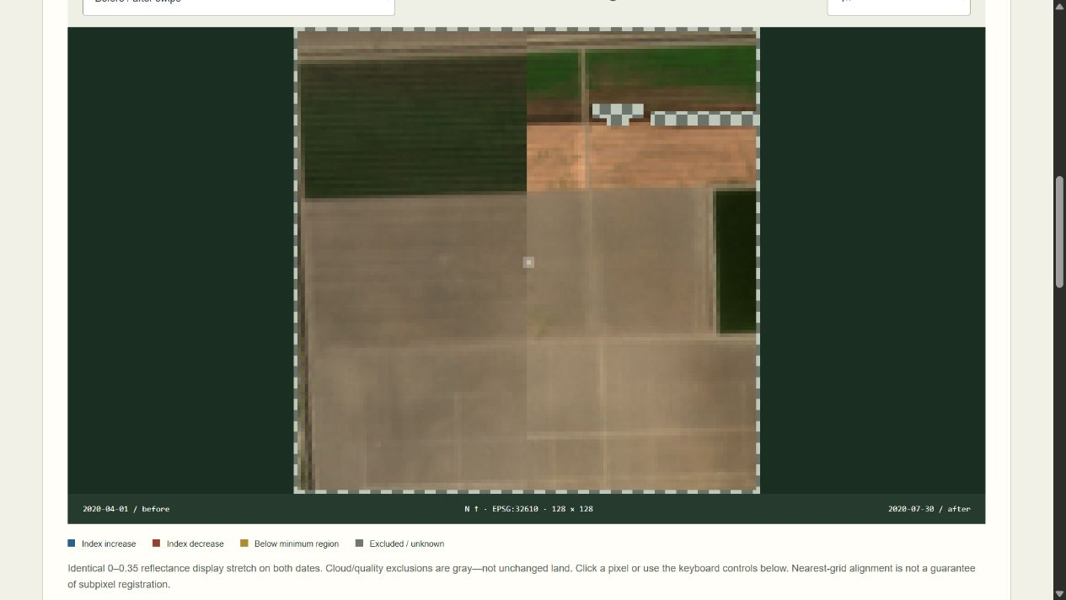
Actual FIELDNOTE imagery review

What works
- Compare April and July 2020 public imagery offline, with original STAC metadata, exact crop hashes and pinned radiometric conversion retained.
- Align the second date to the first WGS84 UTM metre grid. Use nearest neighbour for reflectance, coverage and categorical quality data; do not blend cloud classes or silently assume equal array positions mean equal geography.
- Compute NDVI (NIR-red)/(NIR+red) or green/NIR NDWI (green-NIR)/(green+NIR). Reject small denominators, invalid reflectance, nodata and unsupported quality classes.
- Apply explicit quality margins, thresholds and four-connected same-direction minimum-region filters. Excluded is not unchanged; no comparable pixels produces unavailable rates, not a misleading zero-change percentage.
- Verify every ratio and raw classification against an independently structured scalar implementation. Audit disjoint pixel accounting and retained-region membership.
- Explore before/after swipe, individual dates, candidate overlay, zoom, exact pixel coordinates/indices and quality breakdown. View threshold sensitivity without calling it statistical confidence.
- Review candidate regions in tab-local memory and download review JSON bound to the exact report identity. No automatic acceptance, server-side review storage or ground-truth claim.
- Export full JSON, dimensioned pixel CSV, inert HTML, actual GeoTIFF class/region rasters and WGS84 GeoJSON candidate footprints. Optionally retain hash-verified evidence in local SQLite.
- Exercise all 864 finite control combinations, analytical grid/ratio/region oracles, generated spectra, actual browser workflows and cross-platform portable apps.

Download a portable app
Open Releases. Download the Windows x64 ZIP or Linux x64/macOS Apple Silicon .tar.gz archive and its matching .sha256 file. Verify the digest; extract the entire EarthObservationStudio folder, including _internal and licenses.
- Windows: open EarthObservationStudio.exe.
- Linux/macOS: run ./EarthObservationStudio. The .tar.gz preserves required internal links and executable permissions; keep the whole extracted directory.
The application opens your normal browser on an ephemeral 127.0.0.1 port. Keep its console open; Ctrl+C stops it. No Python/Node installation, account, administrator access or internet connection is required for a bundle. These are unsigned/unnotarized portable desktop applications, not mobile installers or a public hosted multiuser service. Follow OS policy; do not bypass security warnings.

Source setup
Requires Python 3.12–3.14, Node 24 and supported prebuilt Rasterio/NumPy wheels. No Docker, external account or database server is needed.
python -m venv .venv
.venv/Scripts/python -m pip install --require-hashes -r requirements-dev.lock
npm ci
npm run build
.venv/Scripts/python -m eostudio serve
Use .venv/bin/python on Linux/macOS. In a restricted execution environment, select a task-owned writable TEMP/TMP directory for development tests rather than changing OS protections. Production packages use the locked geospatial native wheels, not a pretend pure-Python TIFF parser.

Export or use your own supported local pair
.venv/Scripts/python -m eostudio export --scenario vegetation-loss --format geojson --output candidates.geojson
.venv/Scripts/python -m eostudio export --input eostudio/resources/sentinel/central-valley.json --format tif --output classes.tif --history private.sqlite3
Existing export files are never overwritten. Input/API documentation defines the deliberately narrow manifest and five-band float32 GeoTIFF contract. Inputs must be local, bounded, chronological and hash-matched; arbitrary remote URLs, scripts, unconstrained rasters and browser uploads are not supported. Review third-party local TIFFs before processing them: this is not a malicious-file sandbox.
SQLite is optional, local and unencrypted. Hash checks and immutable-record triggers do not protect it from an OS user with file access. It caps at 100 distinct reports without automatic pruning; entry-count limits are not a tiny byte-size guarantee. Exported review notes remain user-owned local files. Do not commit private histories, input imagery, notes or credentials.

File and feature map
Path | Responsibility
eostudio/raster.py | Bounded local GeoTIFF contracts, UTM grids and nearest-neighbour alignment
eostudio/model.py | Strict manifest/control schemas, source hashes/dates and synthetic fixtures
eostudio/engine.py, reference.py | Vectorized indices, scalar oracle, quality margins, connected regions, accounting and evidence identity
eostudio/reports.py, resources/history.sql | GeoJSON/GeoTIFF/CSV/HTML exports and optional immutable SQLite history
eostudio/server.py, __main__.py, launcher.py | Protected read-only loopback service, explicit CLI and portable launcher
eostudio/resources/sentinel/ | Attributed public crops, original STAC responses and acquisition provenance
web/ | Typed defensive UI, actual raster rendering, pixel inspection and human review
tests/ | Analytical/property/schema/geospatial/HTTP/SQL/CLI and three-browser regressions
tools/ | Explicit public-data acquisition, benchmarks, exact-line inventory, packaging/smoke and draft release gates
.github/workflows/ | Pinned least-privilege cross-platform Validation, CodeQL and manual release workflows
docs/, licenses/ | Scientific model, user/API/data guides, validation evidence, screenshots and notices

Every code file has a creator/responsibility header; functions/classes have contracts. CODE_INDEX provides generated exact definition/variable line locations without fragile duplicated numbers in comments. FILE_CATALOG summarizes every source-intent file. CI rejects stale inventories.

Documentation and contact
Architecture · Scientific model · Data/provenance · Input/API · User guide · Validation · Release runbook · Security · Notices
Created by Jason Stys. Portfolio/contact · Help/issues. MIT project source; public Sentinel data retains its own terms and attribution. Contains modified Copernicus Sentinel data (2020). No agency, provider, employer or mission endorsement is implied.
Contribute with a small synthetic reproduction, an independent expected answer, a regression test and updated documentation/inventory. New environmental-accuracy claims need appropriate labeled observations and independent evaluation, not just a refreshed snapshot.

Portable release identity
The 1.1 release contract keeps the software version consistent across Python, npm, the running service and the UI. Versioned archives include RELEASE.json with source commit, platform and clean/dirty build status. Packaging tests the freshly extracted application, including its new practical workflow, from an unrelated temporary working directory. Windows uses ZIP; Linux/macOS use .tar.gz to preserve required native links and permissions. Published 1.0 assets remain unchanged. Check the selected release's source and version rather than assuming an older download contains current source improvements. See the portable operation and release guide.
Observed local packaging checks and boundaries: portable 1.1 validation.
Draft discovery uses a bounded complete authenticated release listing and numeric-ID verification; a published-only tag lookup cannot prove that an untagged draft is absent. The release guide documents fail-closed ambiguity/history limits and the no-overwrite policy.

Current scope and practical limits
- Four-neighbor availability describes local raster context, not environmental cause, registration accuracy or verified ground truth.
- Uses bounded synthetic/frozen public environmental imagery; no identifying surveillance or targeting capability.
- Unsigned portable desktop packages; no signed installer, public accounts, native mobile installation or environmental certification.
The accompanying Validation Review records the exact tested baseline, workflow evidence, test scope and known gaps. The Excel workbook provides filterable workflow and test-source inventories; neither substitutes for the actual execution logs.

Source references and maintenance
Maintain the editable Markdown and this Word edition together. Preserve dated execution reports and re-run the documented checks before release.
README.md · SECURITY.md · docs/ARCHITECTURE.md · docs/reports/PORTABLE_RELEASE_20261109.md
Project source and current Actions · Contact Jason Stys

