Earth Observation Change Studio Application Guide
Windows use and validation
By Jason Stys Version 1.1.0 10 November 2026
Review a change candidate's four-neighbor context and export matching geospatial evidence. Prepared scenarios use the full Windows application and its existing model and report exports.
The published Windows portable application was installed and tested using isolated synthetic inputs. Provider and sidecar digests, release metadata and installed resource identities were checked. The installed file set remained unchanged after testing.

Capabilities and previous improvements
Add region fringe, crop-edge, excluded and unknown context to change-region GeoJSON review after quality gating. Helps analysts distinguish plausible mapped changes from missing context and image-boundary artifacts.
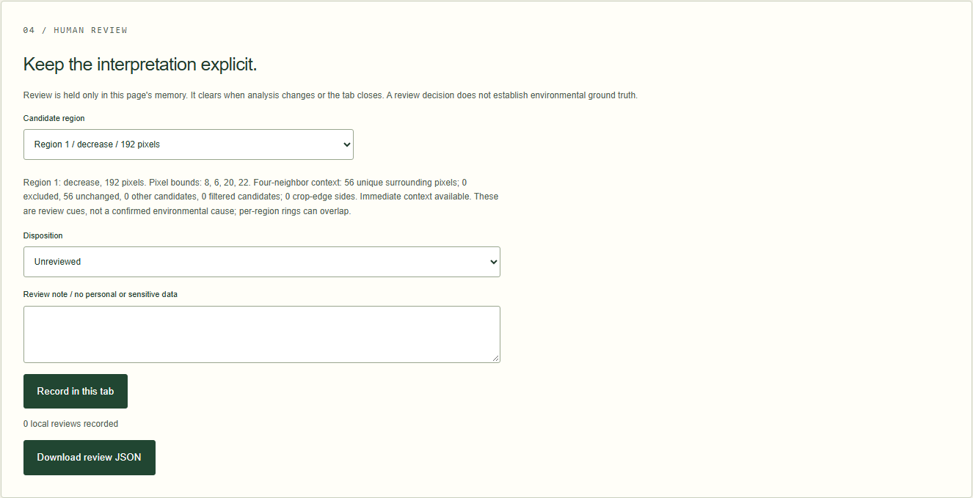
Figure 1 Actual installed application showing vegetation-loss region context. Captured during the accepted native user journey with prepared synthetic inputs.

A worked application journey
The worked example compares vegetation-loss region context with all pixels masked and unknown. Interpret the results using the model assumptions and limits on the final page.
1. Open the application shortcut to start its local web interface and console. Select a prepared scenario or your own supported input; the examples require no external account or live hardware.
2. Choose vegetation-loss and select region 1. Inspect the known and missing fringe context, export GeoJSON and compare its properties with JSON. Repeat with all pixels masked.
3. Review the main case alongside the boundary case shown in Figure 2. The synthetic region contained 192 pixels with 56 distinct fringe neighbors. GeoJSON context matched JSON; all-masked input produced no inferred regions.
4. Download the supported evidence report and retain the input/configuration with it. Recompute after an input change; do not reuse a result under a different configuration.
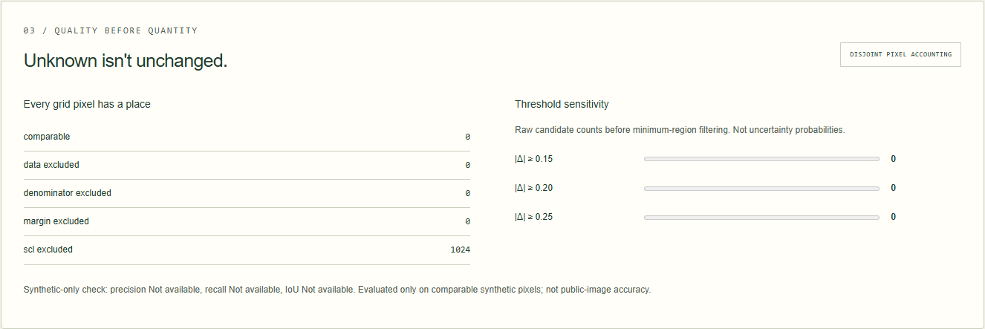
Figure 2 Actual installed application showing all pixels masked and unknown. Captured during the accepted native user journey with prepared synthetic inputs.

Important implementation details

Region context
Each retained region collects distinct four-neighbor fringe coordinates, counts crop-edge sides separately and records excluded context. Complete context requires no missing neighbors or crop edge; it does not infer a cause of change.
eostudio/context.py lines 25 to 51
25 for y in range(height):
26 for x in range(width):
27 identity = int(labels[y, x])
28 if identity == 0:
29 continue
30 if identity not in fringe:
31 raise RuntimeError("Region context accounting mismatch")
32 for dy, dx in ((-1, 0), (1, 0), (0, -1), (0, 1)):
33 ny, nx = y + dy, x + dx
34 if not (0 <= ny < height and 0 <= nx < width):
35 edges[identity] += 1
36 elif labels[ny, nx] != identity:
37 fringe[identity].add((ny, nx))
38 for region in regions:
39 identity = region["id"]
40 counts = {
41 code: sum(classes[y, x] == code for y, x in fringe[identity]) for code in range(5)
42 }
43 region["context"] = {
44 "neighbor_pixels": len(fringe[identity]),
45 "excluded_neighbors": int(counts[0]),
46 "unchanged_neighbors": int(counts[1]),
47 "other_candidate_neighbors": int(counts[2] + counts[3]),
48 "filtered_candidate_neighbors": int(counts[4]),
49 "crop_edge_sides": edges[identity],
50 "touches_crop_edge": edges[identity] > 0,
51 "complete_four_neighbor_context": bool(edges[identity] == 0 and counts[0] == 0),
Source file SHA256 baa480b4098e531b2f88cf9b2c96d0a67d0cca5de46e1a1e29a8fe7f5630e8ad

Validation results and operating limits
Runtime source e63d4d111512a36d1ffb19a04059b4d8965ac5d2
Check | Observed evidence | Result
Published package | Exact public release, provider/sidecar hashes and installed resources verified; installed bytes unchanged. | Passed
Actual native core | The existing packaged CLI/API and native feature acceptance helper passed on the installed executable. | Passed
Scenario evidence | The synthetic region contained 192 pixels with 56 distinct fringe neighbors. GeoJSON context matched JSON; all-masked input produced no inferred regions. | Passed
UI and cleanup | Actual compiled-application browser journey passed. Both images were individually inspected; cleanup left no owned child process. | Passed

Installation and private data
Use the complete matching Windows portable folder from Releases, including all companion files; verify the SHA256 sidecar before extracting it. Keep application files separate from your inputs, downloaded reports and optional CLI history.
Return to this app's own console and press Ctrl+C. Closing its browser tab alone does not stop the service.

Limits and help
Synthetic/frozen environmental imagery only; no identifying surveillance, person inference or targeting.
These Windows portable checks used isolated synthetic inputs. System-wide installation, default-browser opening, desktop shortcuts and mobile installation were outside this test. Additional shortcut checks are recorded separately. No user data or Docker configuration changed.
Release and checksums | Runtime source | Project usage and limits

