Edge Vision Workbench Application Guide
Windows use and validation
By Jason Stys Version 1.1.0 11 November 2026
Author numeric synthetic sensor vectors, train a reproducible compact classifier, compare five actual inference engines, and inspect quality/calibration/reference-agreement tradeoffs on shared held-out conditions.
The independently downloaded and installed application passed its real user workflows. Current main checks and processed CodeQL passed before publication. Icon targets were verified; normal default-profile shortcut activation is separately untested.

Capabilities and previous improvements
Adds editable CSV and drawing inputs, exact finite input validation, real five-engine comparison, all twelve deployment-review rows, configurable review limits, captured reports, reproducible rebuild and restart-persistent state. Original training/export/accuracy thresholds remain unchanged.
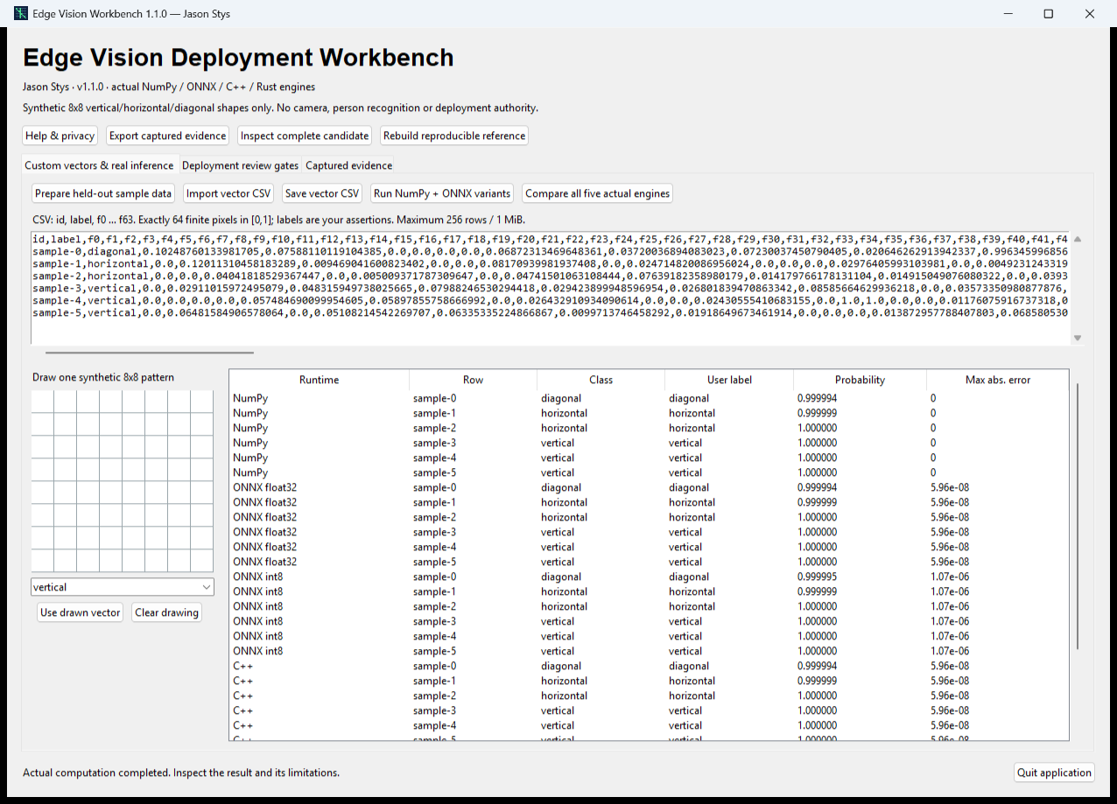
Figure 1 The installed app runs the real numeric engines and displays per-row class probabilities and reference error. The table scrolls to additional engine results.

A worked application journey
A software engineer compares NumPy, ONNX float/int8, C++ and Rust on identical synthetic 8-by-8 patterns. They inspect every clean/corrupted condition and deliberately strict review limits before exporting captured evidence.
1. Prepare held-out sample vectors, draw a synthetic pattern or import a bounded finite CSV. Inspect labels as your assertions, then compare all five real engines.
2. Open Deployment review gates. Set finite thresholds and inspect every candidate/condition row, including accuracy, worst-class recall, calibration and reference error.
3. Export the captured immutable evidence. An invalid import or cancelled rebuild retains prior data; rebuilding explicitly produces a new verified generation.
4. Quit normally. If a real write is pending, keep the visible owner open until completion. Reopen the retained data and generation before continuing.
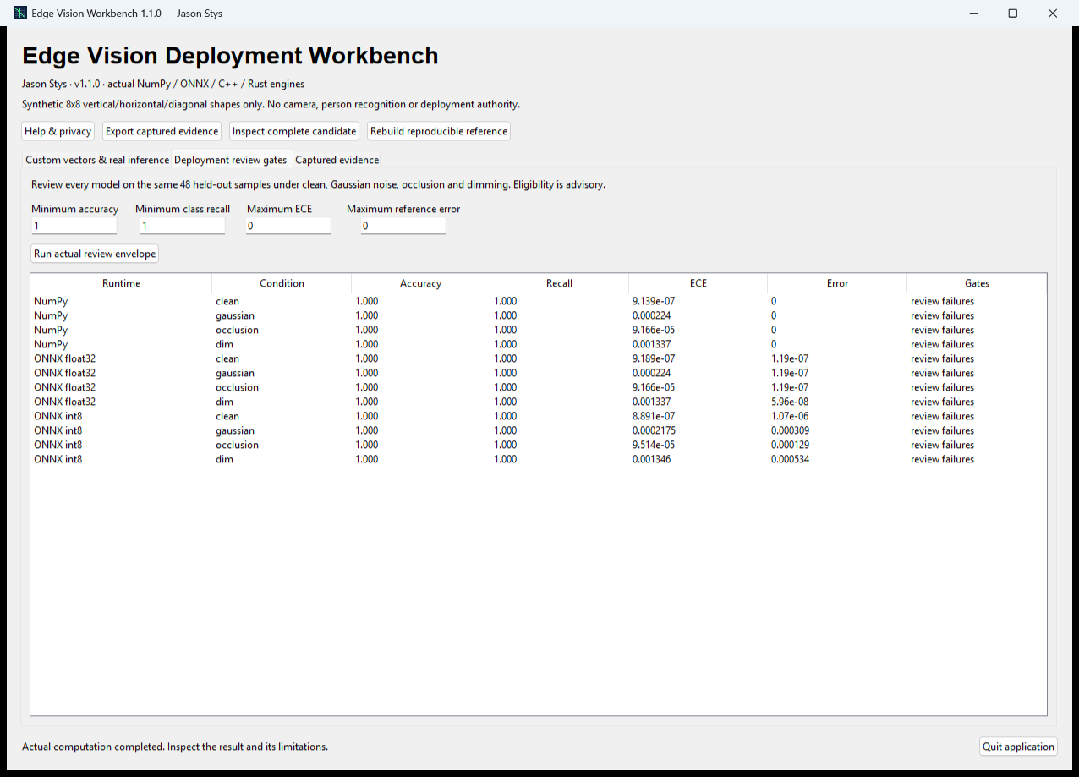
Figure 2 All twelve candidate/condition rows remain visible. Deliberately zero calibration/reference-error limits produce review failures despite perfect accuracy, demonstrating the separate gates.

Important implementation details

Evaluate worst-class recall and every review gate
The review compares each condition against independent accuracy, class-recall, calibration and runtime-agreement limits, and retains all failed gate names. A strong average cannot conceal the weakest class.
src/edgevision/review.py lines 60 to 74
60 probabilities = predictor(inputs)
61 metrics = classification_metrics(labels, probabilities)
62 error = maximum_absolute_error(expected, probabilities)
63 per_class = metrics["per_class"]
64 assert isinstance(per_class, dict)
65 worst_recall = min(float(value["recall"]) for value in per_class.values())
66 gates = {
67 "accuracy": float(str(metrics["accuracy"])) >= limits.minimum_accuracy,
68 "class_recall": worst_recall >= limits.minimum_class_recall,
69 "calibration": float(str(metrics["ece_10_bin"])) <= limits.maximum_ece,
70 "runtime_agreement": error <= limits.maximum_runtime_error,
71 }
72 reasons.extend(f"{condition}/{gate}" for gate, passed in gates.items() if not passed)
73 results[condition] = {"metrics": metrics, "reference_max_abs": error, "gates": gates}
74 return {"eligible": not reasons, "failed_gates": reasons, "conditions": results}
Source file SHA256 3eebcf365e3bfdfac4d1b36ef74b3cbc2b0b96c6bc0b3015a4bd2c5f42d59da7

Validation results and operating limits
Runtime source 5d1727699d9707cda117091f76fe59d8e9e25864
Check | Observed evidence | Result
Actual installed native journeys | Two installed launches passed editable vectors, five actual engines, all review rows, exact exports, real rebuild, pending-write ownership and retained state with normal exits 0/0. | Passed
Original engines and security | Original scientific thresholds, training/export tests, genuine CTest and Rust kernel cases, all-engine numerical agreement, source boundary controls and three-language processed CodeQL passed on exact main. | Passed
Package and runtime identity | Five independently downloaded assets matched provider SHA-256. Actual installed bytes and source/runtime identities matched the reviewed clean-main proof. | Passed
Launch and privacy boundary | Individual Desktop and Start-menu link targets passed read-back. Installed EXEs were exercised separately with synthetic profiles; normal default-profile shortcut activation was not independently exercised. | Passed

Installation and private data
Download the Windows ZIP and sidecar, verify the hash, extract into a fresh directory and run EdgeVisionWorkbench.exe. Retain old versions and stopped-profile backups; no Python setup or Docker is required.
Open the individual Desktop icon and read Help/notices. Quit through the app; prepared examples are inputs in the real application, never separate demo apps.

Limits and help
The compact model uses synthetic 8-by-8 shape patterns. It does not identify people, operate a camera, authorize deployment or establish production robustness. Labels and laboratory thresholds are operator choices.
Unsigned Windows portable ZIP with app-local runtimes; no clean-machine certification or other native-platform installer is claimed. Saved state is plaintext under a trusted OS owner.
Release and checksums | Runtime source | Usage and limits

