Engineering Documentation Foundry Application Guide
Windows use and validation
By Jason Stys Version 0.2.0 11 November 2026
Turn authorized PDF sources into a traceable documentation corpus, author its source registry, publish exact saved revisions and compare their cited content through a usable local application.
The independently downloaded Windows application passed the complete installed workflow with three normal exits. Four builds and two projects survived, including work accepted before Quit. All 114 installed files stayed unchanged. The native Open, Help and Exit controls passed a separate direct Windows inspection.

Capabilities and previous improvements
The original deterministic PDF extraction, canonical topics, publication checks, citations and safety-change comparator remain. The native application adds an upload library, editable projects, searchable immutable builds, original artifact previews, complete project exports and durable SQLite history. Prepared manuals are inputs inside the actual application.
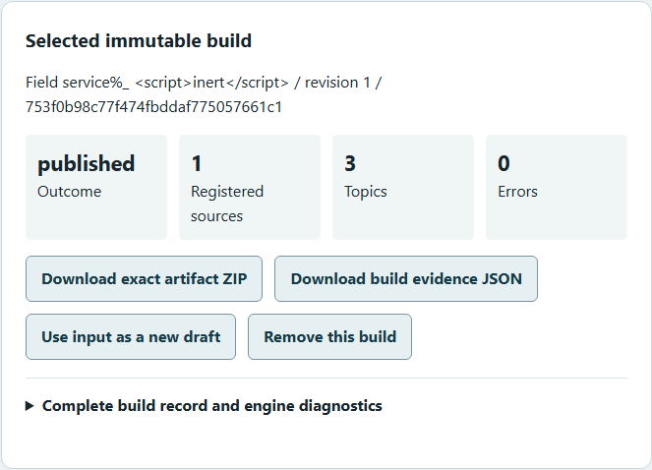
Figure 1 A synthetic field-service PDF produced three canonical topics with zero errors. This actual installed build card retains its revision and evidence downloads. The negative-test markup in its title is displayed literally.

A worked application journey
A service-documentation author uploads an original calibration manual and a revised manual, declares their provenance, publishes each saved registry and reviews changes before sharing the exact artifacts.
1. Open the native application. First use offers an explicit PDF-engine Install or Cancel choice. Read the exact dependency and terms; setup opens no source document. Choose an empty or existing Foundry workspace, then Open workspace.
2. Upload an authorized PDF, add its source declaration and edit the registry/settings. Validate and save the draft before building. A build captures its exact saved revision; conflicting or invalid edits preserve the saved project.
3. Inspect the publication decision, canonical topics, citations and original preview. Filter by literal text, topic kind or source. Download the source, selected artifact, complete build ZIP or evidence JSON. A wrong pinned checksum blocks publication.
4. Select before/after builds and generate the cited revision review. Inspect complete warnings and source evidence. Export projects before explicitly removing records. Quit through the browser or native Exit and wait for actual accepted work to finish.
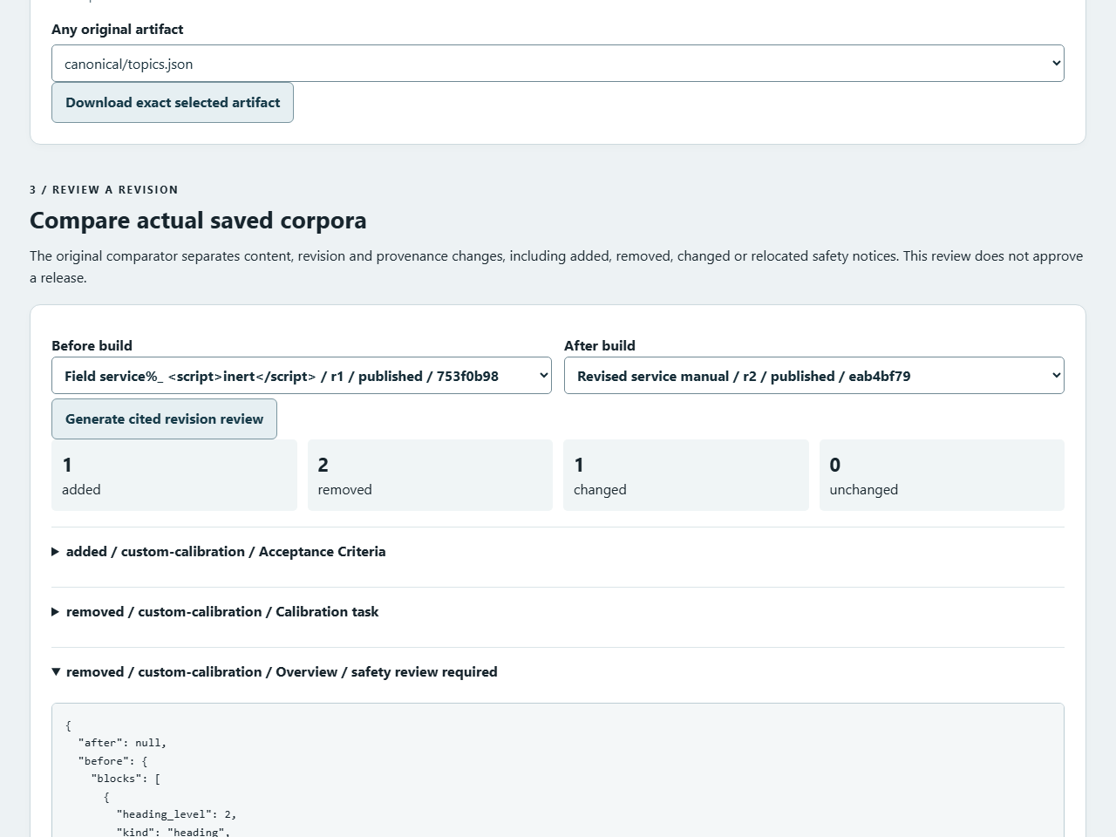
Figure 2 The actual comparator reports one added, two removed and one changed topic. Removing an overview that contains a safety notice requires human review. Expand the evidence or download its JSON to inspect all details; these counts do not approve a release.

Important implementation details

Read a saved publication by content identity
The store retrieves and rehashes the selected immutable build before lookup. Only one bounded unpacked build is cached. A different identity replaces that cache; results retain the original report and exact artifact bytes. These hashes detect changes and do not authenticate an author.
src/foundry_desktop/service.py lines 81 to 93
81 def publication(self, identifier: Any) -> tuple[JSON, dict[str, bytes]]:
82 """Use one bounded immutable build cache, rehashing its stored ZIP before every
83 selected lookup.
84 """
85 identifier = opaque(identifier)
86 record = self.store.build(identifier, with_bundle=True)
87 archive = record.pop("bundle")
88 with self.cache_lock:
89 if self.cache_id != identifier:
90 self.cache_files = unpack(archive)
91 self.cache_id = identifier
92 return record, self.cache_files
93
Source file SHA256 14b5d0becc2b9dcc03ec0279be05791d607ebf998aec6ef9d3e8827902c4d1f9

Validation results and operating limits
Runtime source fa0cf1a0132e56e2b0016207b3d5aecd08a29c2a
Check | Observed evidence | Result
Installed original workflows | Real PDFs, citations, publication blocks, revised safety content, exact downloads, literal search, editing races, mobile layout and accessibility passed. Four builds/two projects survived three normal exits, including work accepted before Quit. | Passed
Source and hosted gates | 290 source cases plus 13 isolated Tk/notice cases; 91.24% combined statement/branch coverage with the original 90% floor. Five editor model cases, strict types, audits, three OS native consumers and all three raw CodeQL categories passed. | Passed
Distribution and menu | Both downloaded assets matched provider identities and checksums. All 114 installed files stayed unchanged. Native Open/Help/Exit and owned HTTP readiness passed, followed by another normal exit and closed listener; individual icon targets were verified. | Passed

Installation and private data
Verify SHA256 and extract the complete Windows x64 ZIP. Keep all files and notices together. Open EngineeringDocumentationFoundry.exe or the Desktop icon; the native menu provides Open workspace, Browser, Help and Exit. A supported Microsoft Visual C++ runtime is required.
Initial setup separately downloads the pinned official PyMuPDF 1.28.2 wheel after explicit consent under GNU AGPL or Artifex commercial terms. The app bundles no parser and sends no documents to its provider. Workspace and exports are local plaintext; test profiles were isolated from normal data.

Limits and help
Text PDF and ruled-table heuristics have bounds; images remain placeholders. This is not OCR, universal file understanding, unit normalization, technical approval or a hostile-PDF sandbox. Inspect warnings and original source evidence.
One trusted OS owner; no hosted accounts or encryption. The unsigned Windows portable release is not a signed installer or clean-machine certification. Linux/macOS packages passed hosted tests but are not downloadable release assets here. Default-profile icon activation and the OS browser opener were not independently exercised.
Release and checksum | Exact runtime source | Setup and license scope

