Firmware Recovery Workbench Application Guide
Windows use and validation
By Jason Stys Version 0.2.1 11 November 2026
Rehearse signed inert firmware packages, A and B slot transitions, durable recovery and staged fleet decisions. Preserve exact input and state evidence so rejected, interrupted and unattempted actions remain distinguishable.
The published 0.2.1 app passed the full installed seven-record consumer and the actual import-race regression. A real 0.2.0 to 0.2.1 synthetic-workspace upgrade preserved every old record, added a new campaign and reopened all eight records with three normal exits.

Capabilities and previous improvements
The original Rust package, durable-store, lifecycle and fault engines remain. The native app adds editable images, devices, actions and cohorts, bounded interruption campaigns, retained searchable evidence and exact exports. Version 0.2.1 explicitly refuses an imported input that has not run while another rehearsal is busy.
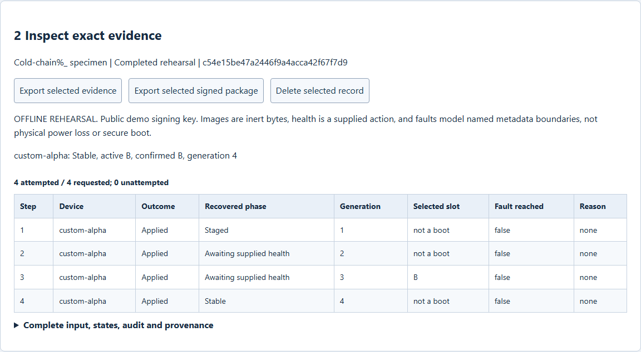
Figure 1 All four supplied actions completed for the custom fictional device. The final confirmed B slot and generation four come from the actual Rust simulation; no hardware was flashed.

A worked application journey
An embedded-software reviewer submits inert image bytes and a custom device, confirms the expected lifecycle, then compares a read-only fleet that stops after an assumed health failure. Imported evidence is rerun from input rather than accepted as a claimed result.
1. Choose lifecycle, fleet preflight or interruption campaign. Edit the fictional devices, inert image, package version, step sequence and supplied health outcomes.
2. Run the rehearsal and inspect attempted versus unattempted steps, recovered state, selected slot, generation, package evidence and exact input identity.
3. Select a saved record or import authorized evidence. Supplied result claims are ignored. If another rehearsal is active, the imported input is explicitly marked unexecuted; wait and Run it.
4. Export selected evidence or its inert signed package to a new destination. Search and reopen saved work, then use Exit application to let the owner close accepted work normally.
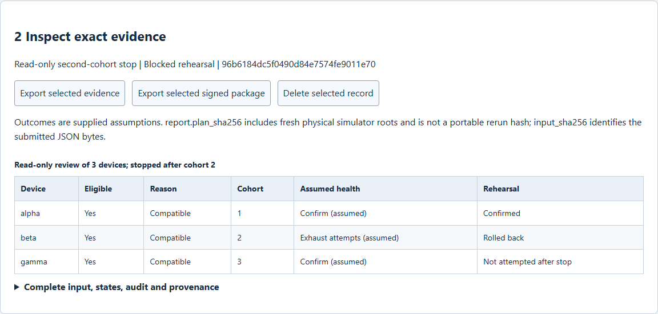
Figure 2 The second cohort rolls back under supplied exhausted-attempt health. The third device remains explicitly unattempted. The preflight is read only and does not deploy to a fleet.

Important implementation details

Refuse an unexecuted imported rehearsal
The UI rejects a busy run instead of silently returning and claiming that imported input was rerun. Successful executions still use the original API and Rust engine, with the captured revision controlling visible results.
web/src/app.ts lines 333 to 349
333 async function run(value: JsonObject = currentInput()): Promise<void> {
334 if (busy)
335 throw new Error(
336 "Another rehearsal is already running; this loaded input has not been run. Wait for completion, then Run.",
337 );
338 const captured = revision;
339 setBusy(true);
340 status("Running the original Rust engines in a fresh owned fictional lab…");
341 try {
342 const result = await api("/api/run", {
343 title: input("title").value,
344 input: value,
345 });
346 if (captured === revision) {
347 show(result);
348 status(
349 "Saved actual rehearsal evidence. Inspect its outcome; blocked/recovered states are not successful deployments.",
Source file SHA256 a7a85d4b0db38a02fb337bbc9269bddeeb2481796d466aefe36136c96a16425b

Validation results and operating limits
Runtime source 81658bc482aea93e7f7e32dabaacee64e7b5b958
Check | Observed evidence | Result
Installed domain workflows | The original seven retained workflows and exact downloads passed, including real selected-file and completed API-response scheduling. Both installed launches exited normally. | Passed
Actual retained workspace upgrade | Old 0.2.0 created seven real records. Version 0.2.1 retained their exact bodies, executed a new 12-case campaign and reopened all eight; previous capabilities were refused and all three owners exited zero. | Passed
Original source and security | 161 Python tests plus 13 Tcl cases, 30 Rust tests, five TypeScript tests and 1200 recovery cases passed. All four main workflows and four actual raw CodeQL categories passed. | Passed
Distribution and desktop icon | Five downloaded files matched provider hashes and all 242 files in each installed version stayed unchanged. Only the two known shortcut targets were updated after exact link backups; the old app and open old window were preserved. | Passed

Installation and private data
Extract the complete checksummed Windows x64 ZIP and retain the Python, Tcl, Tk, Rust and Cargo notices. Launch FirmwareRecoveryWorkbench.exe or the updated individual Desktop icon; no SDK, Python setup or Docker change is required.
Existing workspaces remain separate from the installation. The tested upgrade used a fresh synthetic workspace; ordinary profiles were not opened. Use Help for owner-local plaintext storage, explicit schemas and normal Exit.

Limits and help
The public demonstration signing key is not production trust. Images are inert bytes; health is a supplied action and faults model named metadata boundaries, not physical power loss or secure boot.
No hardware flashing, production deployment or payload execution occurs. Read-only fleet outcomes are assumptions. Automated compiled-app acceptance and shortcut readback do not establish a signed installer or manually verified default-browser opener.
Release and checksums | Exact runtime source | Current usage and limits

