First Response Drone Coordinator Application Guide
Windows use and validation
By Jason Stys Version 0.2.1 11 November 2026
Use the full offline incident/resource/staff planning app with real account provisioning, JSON-file import, aircraft/operator-loss contingency review and durable evidence export. Native owner controls manage only the chosen local profile.
The independently downloaded installed app passed its full original workflows and an actual older-to-newer same-profile test. Current source checks and processed security analyses passed before publication. Individual shortcut targets were verified separately.

Capabilities and previous improvements
Run hash-bound aircraft/operator-loss planning comparisons with planner/reviewer roles and stale-input protection. Adds a practical civilian contingency review while preserving the saved plan and explicit resource constraints. The updated owner rejects aliased protected profile paths before access while admitting ordinary SQLite recovery files.
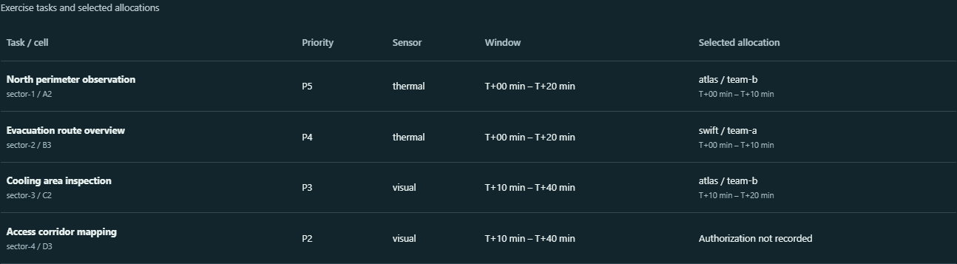
Figure 1 The installed coordinator's retained task-allocation table for the imported fictional scenario.

A worked application journey
A reviewer uses supported fictional input files in the full app, inspects the original results and uncertainties, then exports exact evidence and quits normally.
1. Open the native owner controls, choose the identified local workspace and provision separate planner/reviewer/observer accounts if needed. Open the full app.
2. As planner, import or edit a bounded synthetic incident JSON draft, save deliberately, then Generate alternatives and inspect qualification, time-window, reserve and uncovered-task reasons.
3. Preview one saved aircraft/operator loss and compare retained, reassigned and removed tasks; inspect search-completeness limits without changing the saved scenario.
4. Sign in as a different reviewer to record a planning judgement, then export revision-bound evidence; changed conditions make old reviews stale. Quit from the native owner window.

Figure 2 A separate reviewer inspects retained planning evidence in the same local staff application.

Important implementation details

Keep original evidence and decisions intact
Deep-copies the saved scenario, disables exactly one available resource and solves both copies under identical caps/objectives; it preserves the baseline and reports incomplete searches instead of claiming minimum-change or guaranteed optimal planning.
coordinator/contingency.py lines 11 to 31
11 def preview(scenario: Scenario, kind: str, resource: str, node_limit=NODE_LIMIT):
12 """Solve baseline and one unavailable-resource copy with identical search caps and assumptions."""
13 if kind not in {"aircraft", "operator"}:
14 raise ValueError("Unknown resource kind")
15 resources = scenario.aircraft if kind == "aircraft" else scenario.operators
16 selected = next((item for item in resources if item.id == resource), None)
17 if selected is None:
18 raise ValueError("Resource not in saved scenario")
19 if not selected.available:
20 raise ValueError("Resource is already unavailable")
21 changed = scenario.model_copy(deep=True)
22 copied = changed.aircraft if kind == "aircraft" else changed.operators
23 next(item for item in copied if item.id == resource).available = False
24 before, after = solve(scenario, node_limit), solve(changed, node_limit)
25 first = {row["task"]: row for row in before["alternatives"][0]["assignments"]}
26 second = {row["task"]: row for row in after["alternatives"][0]["assignments"]}
27 common = first.keys() & second.keys()
28 return {
29 "kind": kind,
30 "resource": resource,
31 "baseline_hash": digest(scenario.model_dump()),
Source file SHA256 e2353299319007e665a6d85376fd3dd0086746962d338afc211aba0042169876

Validation results and operating limits
Runtime source 1f520a511b6f539f2fd85df8c95042a42b1ced48
Check | Observed evidence | Result
Real native workflows | The complete original installed consumer passed domain inputs, real results, refusal, role boundaries and exact exports. Both launches exited normally. | Passed
Actual same-profile upgrade | Installed 0.2.0 created and edited the fixture; 0.2.1 reopened the same profile/password across all 3 roles, with retained records and normal exits. | Passed
Distribution identity | Both downloaded assets matched provider hashes; all 120 installed files stayed unchanged. Exact-main workflows and processed raw CodeQL passed. | Verified
PC scope | New per-user version folder and individual links verified. Synthetic profiles only; existing data and Docker were not used or changed. | Verified

Installation and private data
Download 0.2.1 and its checksum, extract the entire ZIP and launch FirstResponseCoordinator.exe. Use its own Desktop icon; no Python setup or Docker change is needed.
Keep older binaries and a stopped-profile backup. Reopen the existing profile with the same account; never initialize a replacement over retained data. Use Help and Quit through the owner window.

Limits and help
Fictional resource-planning exercise only; no dispatch, coordinates, emergency advice or flight authorization.
Prepared inputs and tests were synthetic/offline; no aircraft, emergency dispatch or production data was accessed. Native owner access is trusted; retain the complete local profile privately.
Release and checksums | Exact runtime source | Usage and limitations

