Forge2D Editor Application Guide
Windows use and validation
By Jason Stys Version 1.1.0 10–11 November 2026
Edit strict scene source and entity properties, run the actual deterministic engine with native play/pause/timer controls, record and replay inputs, and export scene/replay/render evidence with durable project recovery.
The downloaded Windows app passed its full workflow with synthetic data. Required main-branch checks and security scans passed for this source revision. Desktop and Start-menu shortcut targets were verified; the installed app was tested separately.

Capabilities and previous improvements
Added bidirectional collision category/mask filters, versioned scene migration, deterministic state hashes and initial/final overlap CSV inspection. Supports practical game-world collision layers and reproducible debugging against independent geometry oracles.
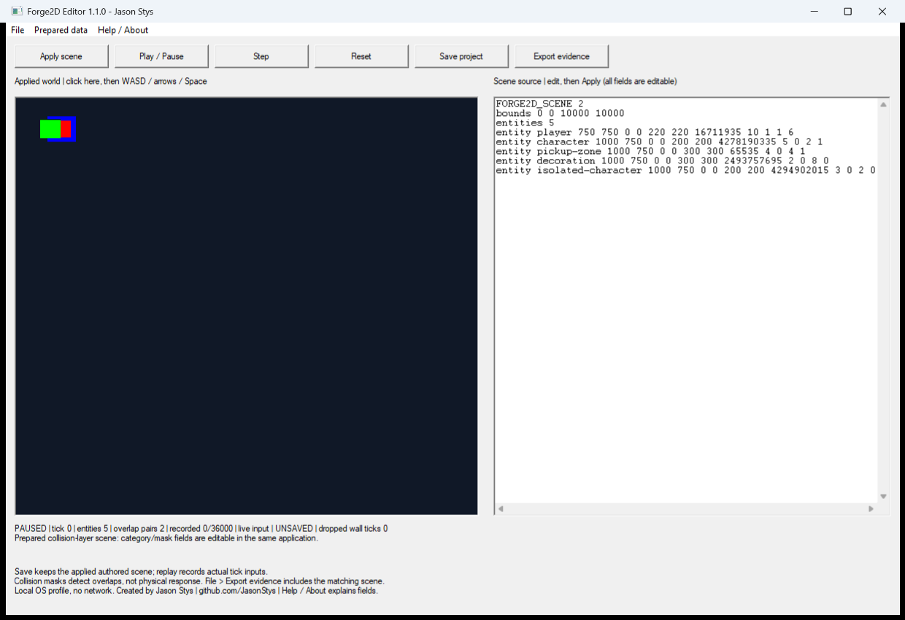
Figure 1 The installed editor applies the selected collision categories and masks to the authored scene. Overlap reporting is distinct from physical collision response.

A worked application journey
A game developer edits an authored scene, runs timer-driven play and replay, reviews collision layers, then saves the scene and verifies recovery on restart.
1. Open the complete installed editor and load an authored scene or a prepared scene in this same app.
2. Edit the scene text and apply it. Invalid scene input preserves the previously accepted engine state.
3. Use Play, Pause and Step, inspect collision layers, and record or replay inputs with the matching scene.
4. Save and export scene/replay/render evidence, then close normally and reopen the identified project.
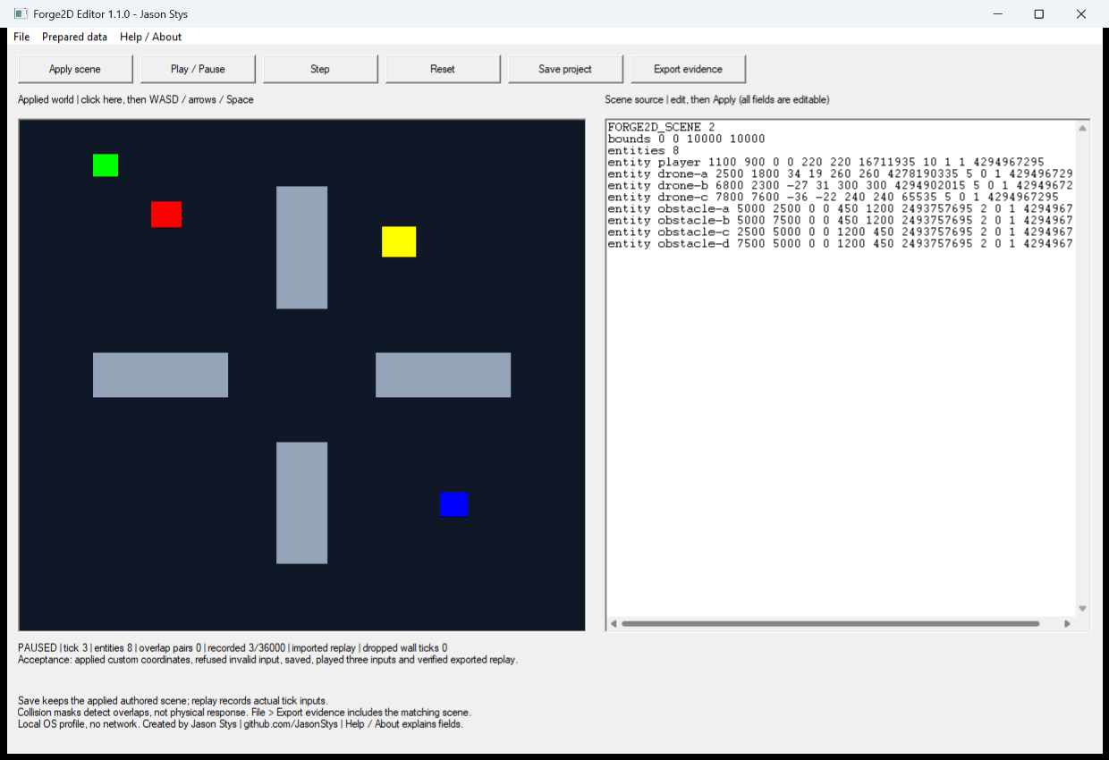
Figure 2 The same editor displays the actual engine scene and input replay, with the current tick, authored source and recording visible.

Important implementation details

Validate a new authored scene before replacing actual engine state
Validate a new authored scene before replacing actual engine state. The native controls call the real project implementation; the excerpt is bound to the exact installed runtime source.
src/editor.cpp lines 18 to 35
18 void EditorSession::apply_scene(std::string_view text) {
19 if (text.size() > maximum_input_bytes) {
20 throw std::invalid_argument("Editor scene input exceeds 1 MiB");
21 }
22 auto next_scene = parse_scene(text);
23 if (next_scene.entities.size() > maximum_entities) {
24 throw std::invalid_argument("Editor scenes are limited to 1000 entities");
25 }
26 auto next_world = World::from_scene(next_scene);
27 Replay next_recording;
28 next_recording.frames.reserve(maximum_frames);
29 scene_ = std::move(next_scene);
30 world_ = std::move(next_world);
31 recording_ = std::move(next_recording);
32 replay_.reset();
33 replay_index_ = 0U;
34 playing_ = false;
35 }
Source file SHA256 0a3ba9336ccce75dc424cef977bea511d4d33e3f7ae91fddfe93b8e0237a4bd0

Validation results and operating limits
Runtime source 4ba77538f5d3025677c51dc3948c1870d2aff963
Check | Observed evidence | Result
Real native workflows | The installed three-phase consumer verified actual play/timer inputs, replay/export, exact authored-scene restart and preserved corrupt-profile recovery. | Passed
Source and security | All required main workflows for the runtime revision passed; processed CodeQL analyses reported zero open main alerts before release. | Passed
Distribution identity | All 2 assets matched provider/checksum identities; all 6 installed files remained unchanged during acceptance. | Verified
PC scope | New per-user version folder and individual links verified. Synthetic profiles only; existing data and Docker were not used or changed. | Verified

Installation and private data
Keep the complete extracted ZIP together and launch Forge2DEditor.exe. No system runtime or terminal setup is needed.
Open the verified Desktop icon. Help describes supported inputs and workflow limits; close through the app's owner controls and back up its external data directory after a normal exit.

Limits and help
Unsigned Windows portable app; not an OS installer, signing proof or clean-machine certification. Only marked synthetic profiles and actual own-window handlers/timers tested; no normal AppData, populated-user upgrade or external OS input automation.
Prepared inputs and acceptance used synthetic data only; normal profiles were not opened and Docker was unchanged. Local plaintext is trusted-OS-owner data, not protection against that OS user or administrator.
Release and checksums | Runtime source | Usage and limits

