GitOps Platform Lab Application Guide
Windows use and validation
By Jason Stys Version 1.1.0 11 November 2026
Audit supplied Kubernetes manifests and captured controller snapshots using the original closed policy engine. Compare desired and observed revision/generation evidence while keeping local review separate from live cluster enforcement.
The independently downloaded installed application passed its original full native acceptance and retained-file checks. Current main source workflows and processed security analyses passed before publication; shortcut targets were verified separately.

Capabilities and previous improvements
The original project retains declarative GitOps configuration, Helm tests and policy/snapshot assessment. The new desktop GUI adds local manifest and snapshot selection, explicit original-versus-effective policy limits, exact comparisons, retained immutable history and complete evidence export.
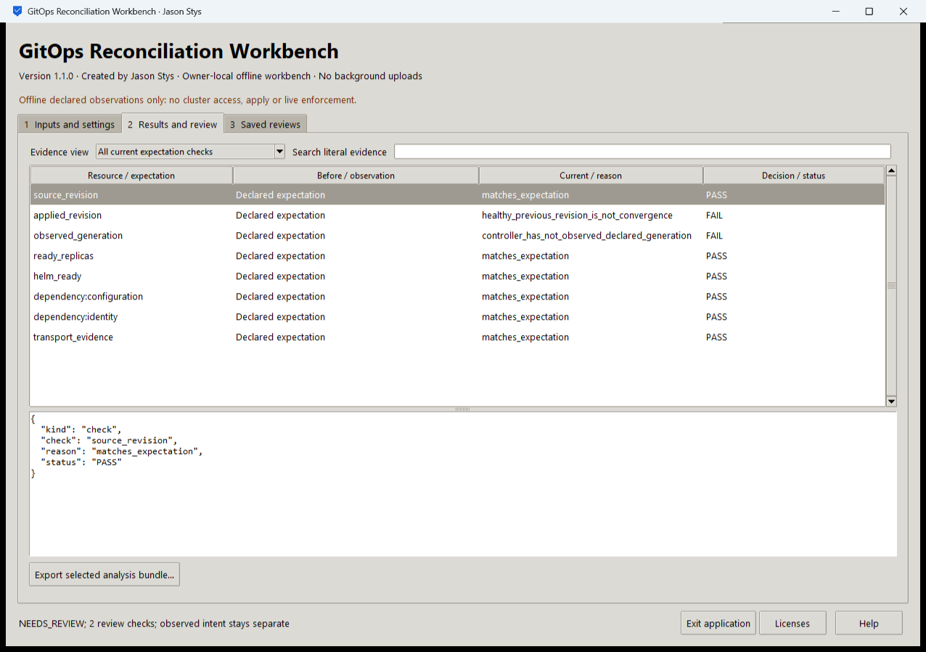
Figure 1 The installed snapshot review displays actual applied revision and generation checks over the supplied captured evidence.

A worked application journey
A platform engineer reviews a captured deployment snapshot, checks the applied revision and observed generation, then compares a revised capture. An override must not silently repair or discard invalid original input.
1. Choose a manifest audit, snapshot assessment or before/after comparison; select supported local captures or a prepared case.
2. Review original inputs first, then set any permitted effective policy overrides and run the original engine.
3. Inspect findings, explicit applied/observed revisions and generation status. Search the retained rows and view original/effective input identities.
4. Export the complete record without overwriting a prior result. Reopen its retained history and exit through the native owner control.
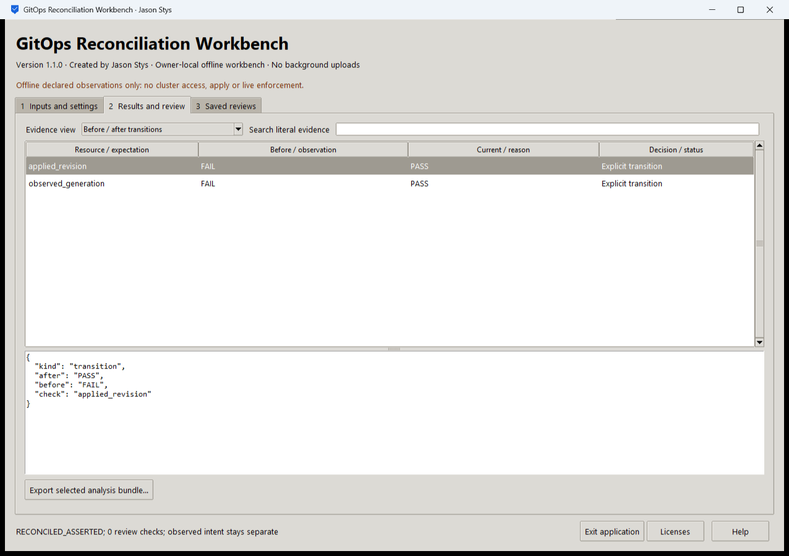
Figure 2 The installed evidence view retains original inputs and scope. Its result does not assert that a live controller enforced the policy.

Important implementation details

Retain source identity and explicit live access limits
The adapter reads bounded manifest or snapshot bytes, retains their digest and records that no live cluster or live enforcement was observed. Invalid parse errors remain visible.
lab/desktop_project.py lines 255 to 278
255 raw = read_source(
256 Path(parameters.get("manifest" if manifest else "snapshot", "")),
257 1024 * 1024,
258 )
259 raw_hash = hashlib.sha256(raw).hexdigest()
260 try:
261 data = (
262 (json_bytes(raw) if raw.lstrip().startswith(b"[") else yaml_bytes(raw))
263 if manifest
264 else json_bytes(raw)
265 )
266 except (yaml.YAMLError, UnicodeError, RecursionError):
267 raise Rejected("bounded manifest/snapshot parse failed") from None
268 if mode == MODES[2]:
269 before = json_bytes(
270 read_source(Path(parameters.get("before", "")), 1024 * 1024)
271 )
272 scope: dict[str, Any] = {
273 "schema": 1,
274 "mode": mode,
275 "source_bytes_sha256": raw_hash,
276 "live_cluster_accessed": False,
277 "live_enforcement_proven": False,
278 }
Source file SHA256 7a2343a727d01bc1f15632154f4109bf7accaef6cd7a238f53712724357046c7

Validation results and operating limits
Runtime source 89fffbae0bd2fe1f74e2954edb8b981be42e5b6f
Check | Observed evidence | Result
Independent distribution | Downloaded provider assets, sidecar and installed file identities matched. The complete installed app was used; installation resources remained byte-identical. | Passed
Actual app use and restart | Twelve real installed workflows and twelve reopened evidence bundles passed the original full native consumer, including original/effective policy checks and two normal exits. | Passed
Source and security | All current main workflows passed before publication. All configured exact-source processed CodeQL categories had zero raw findings and zero open alerts. | Passed
Individual shortcut | Desktop and Start-menu targets were read back against the installed version. Normal default-profile shortcut activation is separate from full installed executable acceptance. | Verified

Installation and private data
Download the matching version and checksum from Releases. This is an unsigned per-user portable Windows x64 app; keep its complete accompanying files together. No system Python installation or Docker change is needed.
Use the individual Desktop icon and in-app help. Inputs, saved evidence and exports stay outside the installation. Preserve older versions and your own profiles; tests used only separate synthetic inputs.

Limits and help
Assessment uses supplied files and captured snapshots; the GUI does not access a live cluster, install Helm, invoke Docker or perform policy enforcement.
An observed snapshot can be stale or unauthenticated. A local review preserves its exact supplied identity and limitations rather than proving current live-system state.
Release and checksums | Exact runtime source | Usage and limits

