Host Hardening Assurance Lab Application Guide
Windows use and validation
By Jason Stys Version 1.1.0 10 November 2026
Assess supplied host snapshots against explicit hardening policies and dated exceptions. The native workbench supports single-host review, drift and fleet refresh queues without collecting or changing the PC.
The published Windows portable app passed independent download/installed-byte acceptance, two real compiled launches, exact saved evidence comparisons and normal exits. The figures show the installed app with fictional supplied records.

Capabilities and previous improvements
Review expected host inventory, unknown missing evidence, policy/platform counts and owner refresh/deviation queues. Prevents absent hosts or stale observations from inflating assurance results.
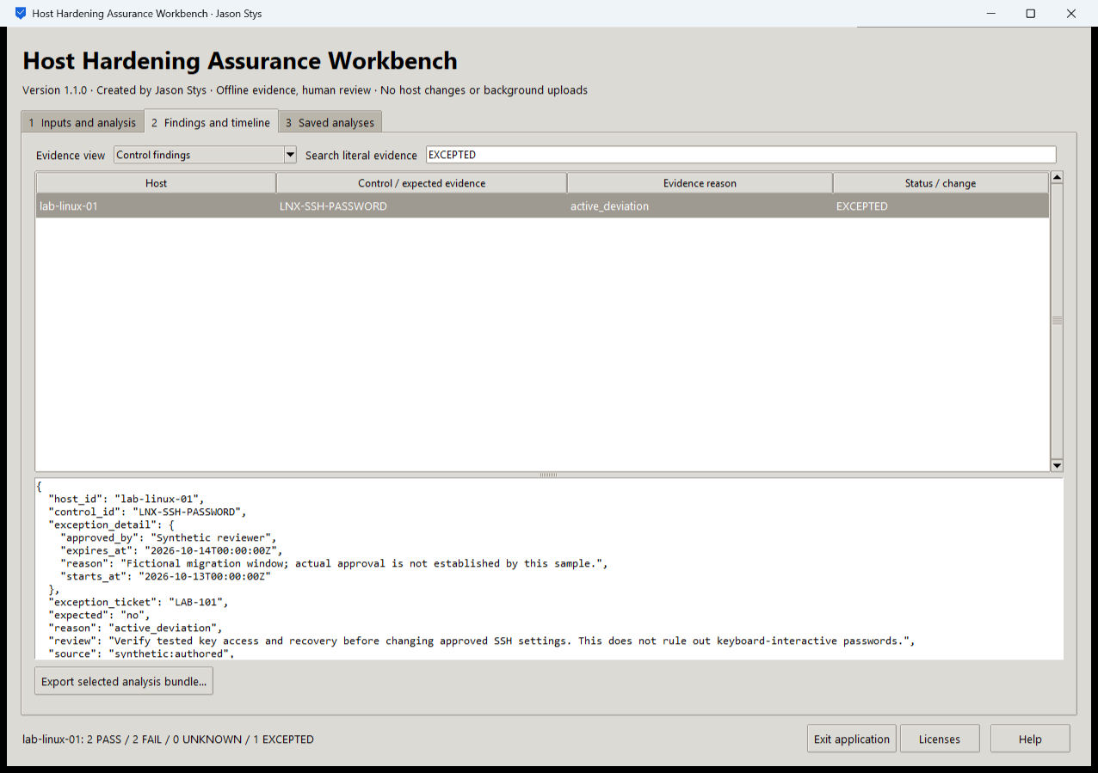
Figure 1 The installed workbench shows a supplied SSH-password deviation as EXCEPTED and retains the dated exception and evidence reason. Its displayed synthetic snapshot has 2 PASS,2 FAIL,0 UNKNOWN and 1 EXCEPTED.

A worked application journey
An infrastructure reviewer checks a fictional Linux snapshot against the baseline, reads its bounded SSH exception, then compares the fleet inventory with the available snapshots to identify a missing-host refresh request.
1. Select a prepared host or fleet case, or choose your supported policy, snapshots, expected inventory and optional exception file.
2. Set the explicit assessment time and run the real baseline or fleet engine. Review PASS, FAIL, UNKNOWN and EXCEPTED separately.
3. Filter the control findings, inspect the original evidence and exception dates, then open the fleet refresh queue to distinguish absent hosts from observed deviations.
4. Export the selected evidence bundle and reopen the same profile to inspect the unchanged saved analyses. Apply any host change separately through your own approved administration process.
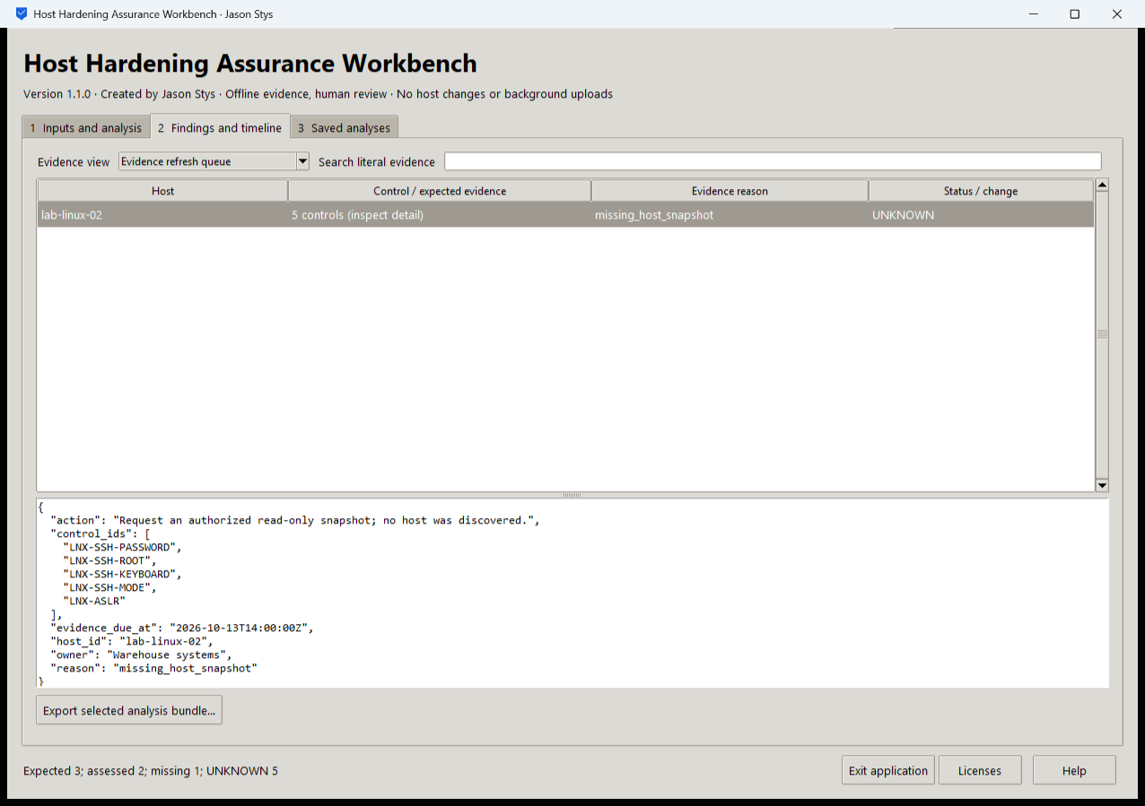
Figure 2 The installed application reviews expected-host and missing-evidence results. Missing or stale observations remain visible rather than increasing the assessed-host assurance count.

Important implementation details

Use the existing baseline and fleet engine
The GUI adapter validates the supplied policy, exceptions, assessment clock and snapshot list, then calls the existing fleet or host assessment. It never invokes the separate host collector or enforcement code.
hardening/desktop_project.py lines 150 to 174
150 def analyze(
151 state: Workspace, parameters: dict[str, str], stage: Path
152 ) -> tuple[str, str, dict[str, bytes]]:
153 """Invoke the real validated baseline/drift/fleet engine; no collector/enforcement module is called."""
154 mode = parameters["mode"]
155 policy = load_policy(Path(parameters["policy"]))
156 exceptions = load_exceptions(
157 Path(parameters["exceptions"]) if parameters["exceptions"].strip() else None, policy
158 )
159 clock = timestamp(parameters["as_of"])
160 paths = tuple(
161 Path(value.strip()) for value in parameters["snapshot"].splitlines() if value.strip()
162 )
163 if len(paths) > 500:
164 raise Rejected("too many supplied snapshots")
165 output = stage / "bundle"
166 if mode == MODES[2]:
167 result = assess_fleet(
168 inventory(Path(parameters["inventory"])),
169 tuple(load_snapshot(path) for path in paths),
170 policy,
171 clock,
172 exceptions,
173 )
174 publish(result, output)
Source file SHA256 1bb3cfd79793f483ab411d0ce07dbffb2a2c10d211ffc32460f274761cdde1e6

Validation results and operating limits
Runtime source fa1daf2af31dc76c0ade1069f6132071b888b3dc
Check | Observed evidence | Result
Release and runtime | All 5 downloaded assets matched provider/sidecar hashes. Actual frozen CPython 3.14.10 and Tcl/Tk 9.0.4 matched their recorded runtime identities. | Passed
Real user workflow | Three original and refresh-review bundles survived restart exactly. Single-host and fleet workflows, missing evidence, malformed input and long-status lifecycle layout passed. | Passed
Source and security | All current main workflows passed. Exact-source CodeQL analyses processed with zero open main alerts before publication. | Passed
Desktop delivery | New individual Desktop and Start-menu links target the installed accepted EXE. Shortcut metadata was read back; normal shortcut activation was not independently exercised. | Verified

Installation and private data
Download the matching Windows EXE and SHA256 sidecar from Releases. This is an unsigned portable app, not an MSI; Python installation and terminal commands are unnecessary. Keep the distribution and runtime notices together.
Open your own new or identified profile outside the installation. History is local plaintext protected by OS-owner access and an exclusive instance lock. Use Help for formats and limits; Exit application closes the owned workbench.

Limits and help
Only supplied snapshots are assessed. Local Windows acceptance is separate from genuine POSIX FIFO tests in hosted Linux/macOS checks. No host setting, credential or security policy was changed.
Reviewer names are assertions, not authenticated identities. These tests used isolated synthetic profiles and did not access existing user data, call external services or change Docker. Back up your complete profile before moving it.
Release and checksums | Runtime source | Usage and limits

