Host Hardening Assurance Lab Application Guide
Windows use and validation
By Jason Stys Version 1.1.1 11 November 2026
Assess supplied host snapshots against explicit hardening policies and dated exceptions. The native workbench supports single-host review, drift and fleet refresh queues without collecting or changing the PC.
The installed 1.1.1 app passed its full native workflows and reopened the same synthetic profile created by 1.1.0 with exact saved evidence. Existing links were backed up and retargeted with read-back verification; default-profile shortcut activation was not independently exercised.

Capabilities and previous improvements
Review expected host inventory, unknown missing evidence, policy/platform counts and owner refresh/deviation queues. Prevents absent hosts or stale observations from inflating assurance results.
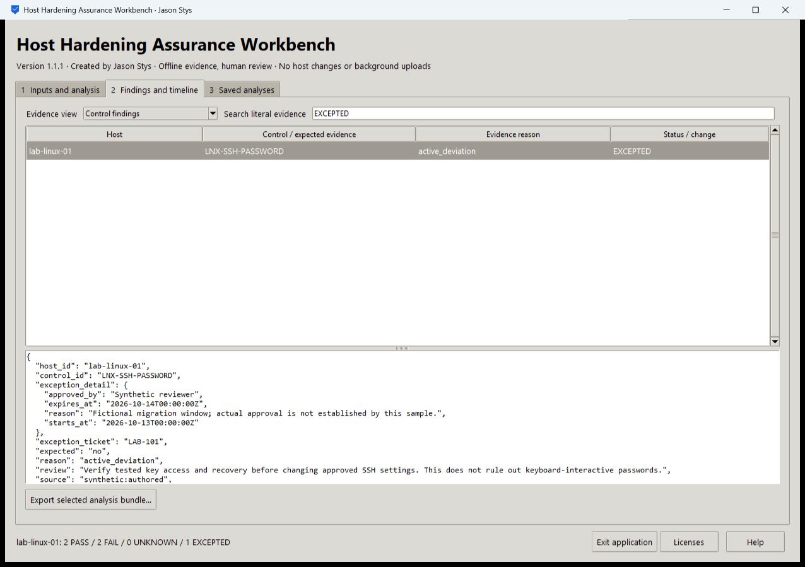
Figure 1 The installed workbench shows a supplied SSH-password deviation as EXCEPTED and retains the dated exception and evidence reason. Its displayed synthetic snapshot has 2 PASS, 2 FAIL, 0 UNKNOWN and 1 EXCEPTED.

A worked application journey
An infrastructure reviewer checks a fictional Linux snapshot against the baseline, reads its bounded SSH exception, then compares the fleet inventory with the available snapshots to identify a missing-host refresh request.
1. Select a prepared host or fleet case, or choose your supported policy, snapshots, expected inventory and optional exception file.
2. Set the explicit assessment time and run the real baseline or fleet engine. Review PASS, FAIL, UNKNOWN and EXCEPTED separately.
3. Filter the control findings, inspect the original evidence and exception dates, then open the fleet refresh queue to distinguish absent hosts from observed deviations.
4. Export the selected evidence bundle and reopen the same profile to inspect the unchanged saved analyses. Apply any host change separately through your own approved administration process.
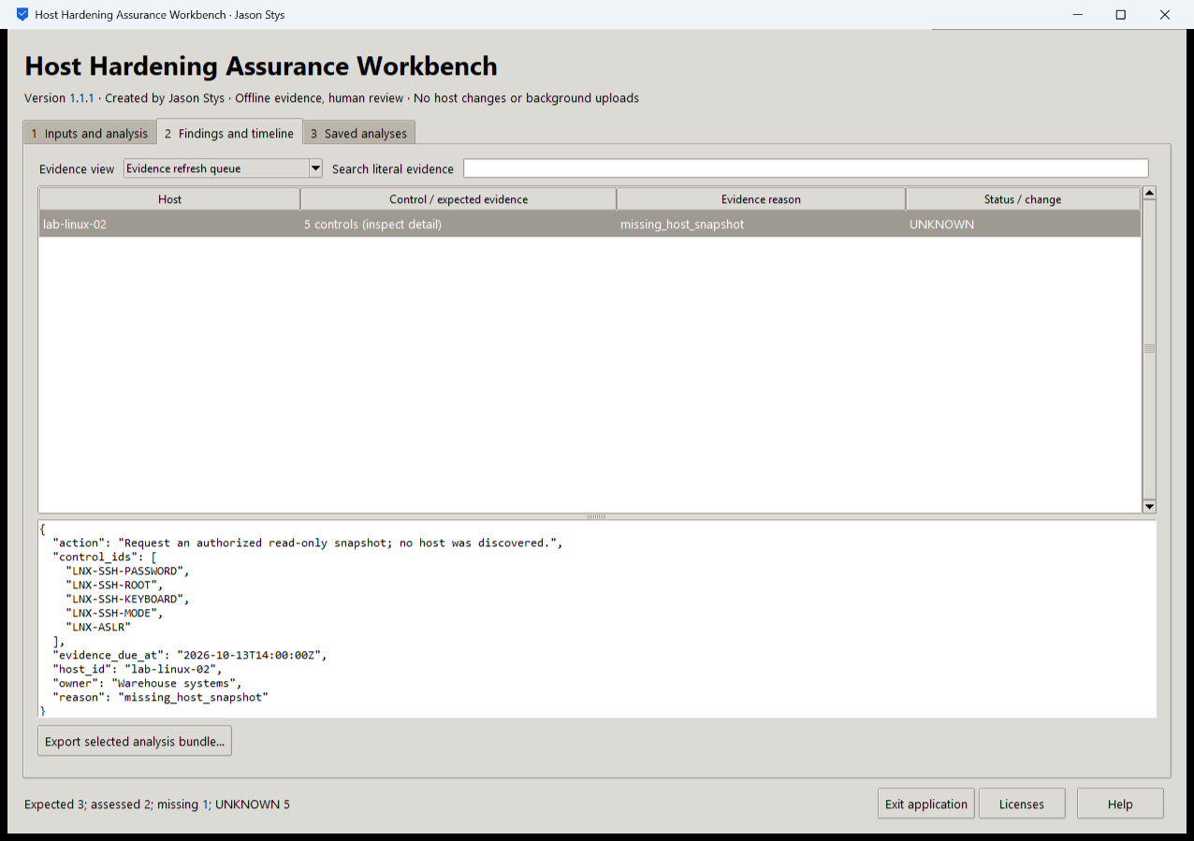
Figure 2 The installed application reviews expected-host and missing-evidence results. Missing or stale observations remain visible rather than increasing the assessed-host assurance count.

Important implementation details

Check fixed state before a write can follow an alias
This pre-initialization check requires any existing fixed state member to be an ordinary single-link file without a Windows reparse attribute. Startup and connection admission apply it to the known marker/lock/SQLite recovery paths; ordinary recovery files are retained.
hardening/desktop_state.py lines 208 to 219
208 def admit_existing(path: Path) -> None:
209 """Refuse pre-existing linked/nonregular fixed state before initialization can write through an alias."""
210 try:
211 info = path.lstat()
212 except FileNotFoundError:
213 return
214 if (
215 not stat.S_ISREG(info.st_mode)
216 or info.st_nlink != 1
217 or getattr(info, "st_file_attributes", 0) & getattr(stat, "FILE_ATTRIBUTE_REPARSE_POINT", 0)
218 ):
219 raise Rejected("fixed workspace state must be unlinked one-link regular files")
Source file SHA256 5cd749a383ce48c87d8e5c58182332bdacce5cc7c5547763a0fd9f7ca524c858

Validation results and operating limits
Runtime source 8c63f7b01b84b87fd02fa1c379cbf4ed908b7bc1
Check | Observed evidence | Result
Actual installed workflows | Full original domain, review and export controls passed two normal native launches; all 3 saved bundles retained exact original bytes. | Passed
Old-to-new profile | The actual installed 1.1.0 app created a synthetic profile; installed 1.1.1 reopened it and retained all 3 exact bundles without reset. | Passed
Source and distribution | Exact-main workflows and processed CodeQL passed with zero open main alerts. Five downloaded assets and installed files matched their verified SHA-256 identities. | Verified
PC and links | Existing links were backed up and retargeted with settings retained. Normal profiles and Docker were unchanged; default-profile shortcut activation remains separately untested. | Verified

Installation and private data
Download the matching Windows EXE and SHA256 sidecar from Releases. This is an unsigned portable app, not an MSI; Python installation and terminal commands are unnecessary. Keep the distribution and runtime notices together.
Open your own new or identified profile outside the installation. History is local plaintext protected by OS-owner access and an exclusive instance lock. Use Help for formats and limits; Exit application closes the owned workbench.

Limits and help
Only supplied snapshots are assessed. Local Windows acceptance is separate from genuine POSIX FIFO tests in hosted Linux/macOS checks. No host setting, credential or security policy was changed.
Reviewer names are assertions, not authenticated identities. These tests used isolated synthetic profiles and did not access existing user data, call external services or change Docker. Back up your complete profile before moving it.
Release and checksums | Runtime source | Usage and limits

