Incident Response Evidence Workbench Application Guide
Windows use and validation
By Jason Stys Version 1.1.1 11 November 2026
Preserve authorized original files in local cases, verify custody and independent checkpoints, page through UTC events and select exact source-line bookmarks. Private originals and checkpoints stay separate from deliberately minimized handoff exports.
The installed 1.1.1 app passed its full native workflows and reopened the same synthetic profile created by 1.1.0 with exact saved evidence. Existing links were backed up and retargeted with read-back verification; default-profile shortcut activation was not independently exercised.

Capabilities and previous improvements
Create exact-digest/line analyst bookmarks and minimized handoffs from one verified SQLite evidence snapshot. Lets analysts share necessary findings while retaining chain/checkpoint bindings and excluding raw originals and notes.
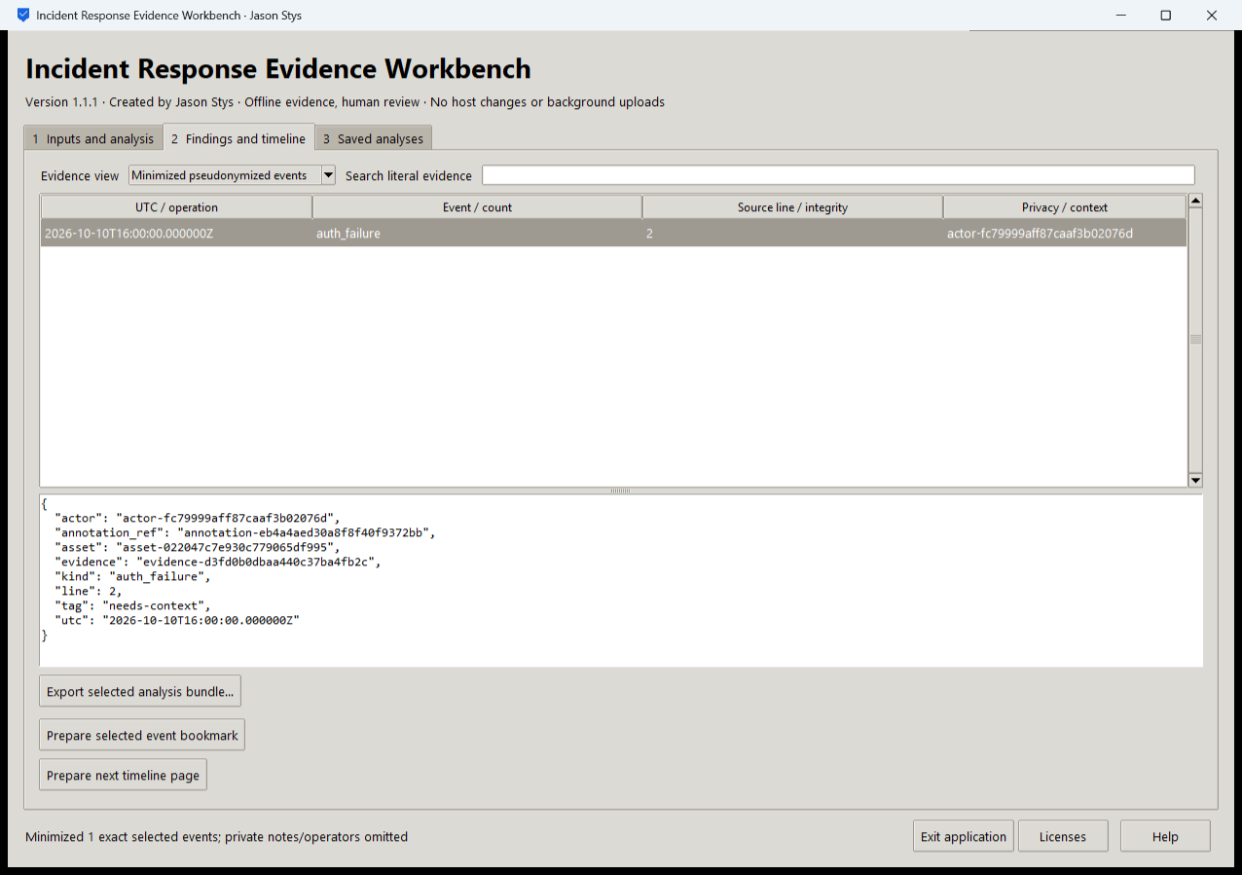
Figure 1 The installed app displays a minimized handoff containing one selected auth_failure event. Its source digest and line reference remain; the original actor and private notes are omitted.

A worked application journey
An authorized responder creates a fictional case, preserves original files, verifies custody/checkpoints, selects exact-line bookmarks and exports a minimized handoff.
1. Open the app and choose your supported authorized files or a prepared fictional scenario in Inputs and analysis.
2. Choose the required operation, inspect its actual parameters, acknowledge permission and Run selected analysis.
3. Verify case custody/checkpoints before paging the UTC timeline or selecting exact source-line bookmarks. Case commits are independent of GUI history; verify before retrying a reported save failure.
4. Export the selected bundle and reopen Saved analyses after a normal exit. Keep private evidence separate from any minimized handoff.
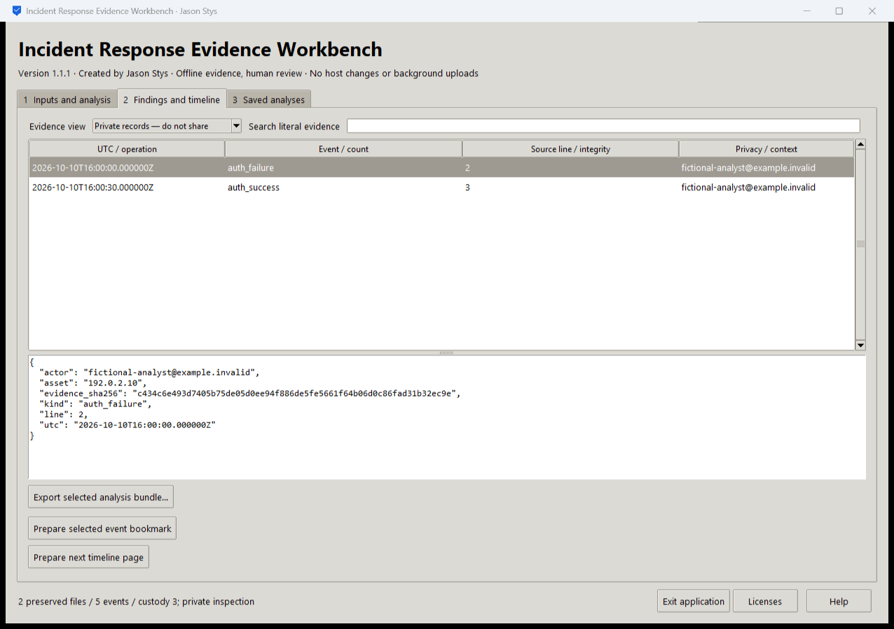
Figure 2 The original synthetic event view retains two preserved files and five timeline events. The selected auth_failure shows its original source line and fictional actor; originals stay separate from the minimized handoff.

Important implementation details

Check fixed state before a write can follow an alias
This pre-initialization check requires any existing fixed state member to be an ordinary single-link file without a Windows reparse attribute. Startup and connection admission apply it to the known marker/lock/SQLite recovery paths; ordinary recovery files are retained.
irkit/desktop_state.py lines 217 to 229
217 def admit_existing(path: Path) -> None:
218 """Refuse pre-existing linked/nonregular fixed state before initialization can write through an alias."""
219 try:
220 info = path.lstat()
221 except FileNotFoundError:
222 return
223 if (
224 not stat.S_ISREG(info.st_mode)
225 or info.st_nlink != 1
226 or getattr(info, "st_file_attributes", 0)
227 & getattr(stat, "FILE_ATTRIBUTE_REPARSE_POINT", 0)
228 ):
229 raise Rejected("fixed workspace state must be unlinked one-link regular files")
Source file SHA256 6ea8717ed3942a11931326a12a9040b4ee1702b56730deae9deb1a9069e58fad

Validation results and operating limits
Runtime source 6a751ebb9b0bc9d4f434b946d22b46cc3ffaf589
Check | Observed evidence | Result
Actual installed workflows | Full original domain, review and export controls passed two normal native launches; all 13 saved bundles retained exact original bytes. | Passed
Old-to-new profile | The actual installed 1.1.0 app created a synthetic profile; installed 1.1.1 reopened it and retained all 13 exact bundles without reset. | Passed
Source and distribution | Exact-main workflows and processed CodeQL passed with zero open main alerts. Five downloaded assets and installed files matched their verified SHA-256 identities. | Verified
PC and links | Existing links were backed up and retargeted with settings retained. Normal profiles and Docker were unchanged; default-profile shortcut activation remains separately untested. | Verified

Installation and private data
Use the matching Windows EXE, checksum and notices from Releases; no system Python or terminal setup is needed.
Open the verified Desktop icon. Help describes supported inputs and workflow limits; close through the app's owner controls and back up its external data directory after a normal exit.

Limits and help
Unsigned Windows portable app; no signed installer or macOS/Linux native acceptance. Owner-local plaintext cases and history do not provide multiuser authentication, encryption or legal forensic certification. Normal user profiles, accounts and installed apps were not used in acceptance.
Prepared inputs and acceptance used synthetic data only; normal profiles were not opened and Docker was unchanged. Local plaintext is trusted-OS-owner data, not protection against that OS user or administrator.
Release and checksums | Runtime source | Usage and limits

