Industrial Edge Digital Twin Application Guide
Windows use and validation
By Jason Stys Version 1.1.0 10–11 November 2026
Operate the actual bundled C++ process model through the sandboxed Electron interface, set targets, inject supported synthetic sensor faults, record bounded traces and reopen retained targets with the engine safely stopped.
The downloaded Windows app passed its full workflow with synthetic data. Required main-branch checks and security scans passed for this source revision. Desktop and Start-menu shortcut targets were verified; the installed app was tested separately.

Capabilities and previous improvements
Capture and replay synchronized signals, requested/actual outputs, quality, faults and alarms; import/export bounded traces and scrub time-aligned trends with commands blocked in review. Creates a practical simulated-process investigation workflow with recorded and live state clearly distinguished.
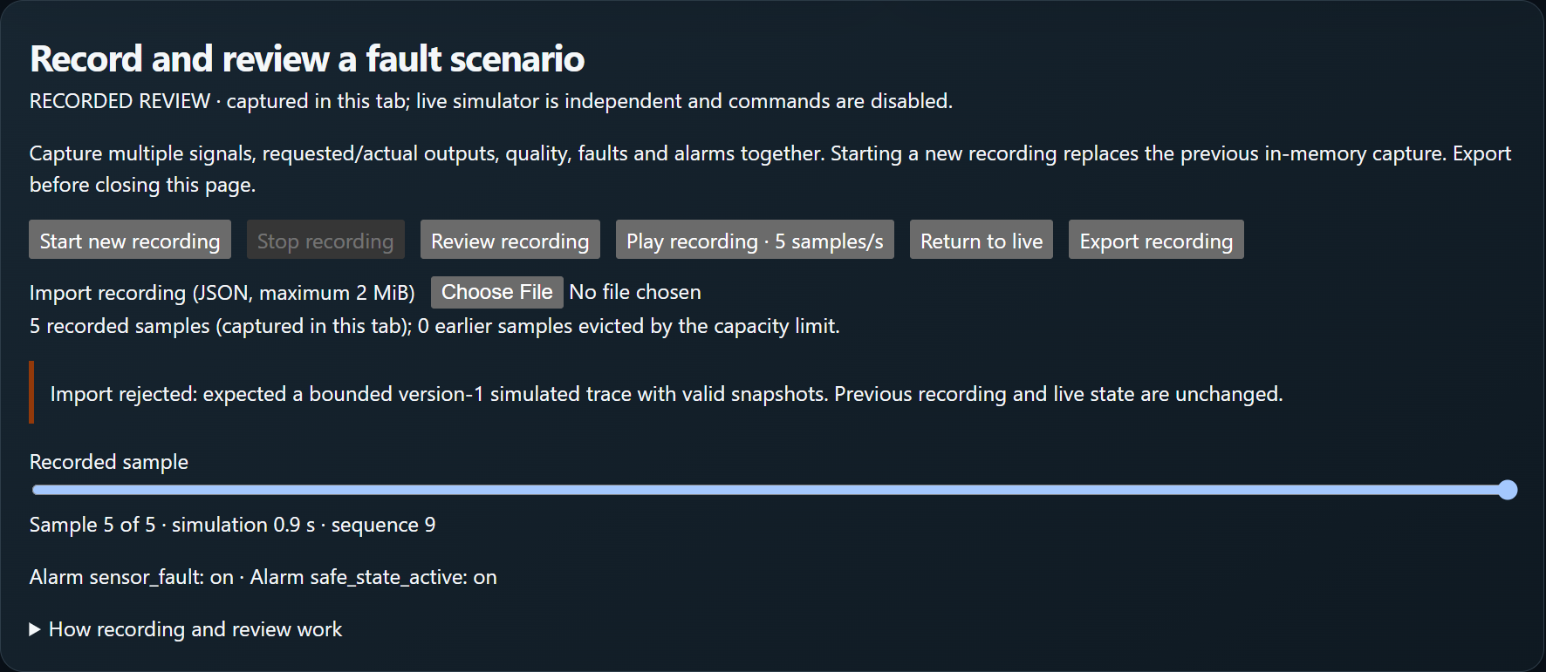
Figure 1 Recorded process samples are reviewed in the same installed digital-twin application; this is the output of the bundled C++ model.

A worked application journey
A fictional process engineer sets tank/temperature targets, observes the real bundled C++ model, reviews a sensor fault and retains bounded process traces.
1. Open the full app and inspect the explicit model state before starting its local engine.
2. Set supported targets and start the model; inspect levels, temperature, controller state and declared limits.
3. Inject a supported synthetic sensor fault and record a bounded trace for review and export.
4. Close normally and reopen: saved targets/traces remain, while the engine starts safely stopped.
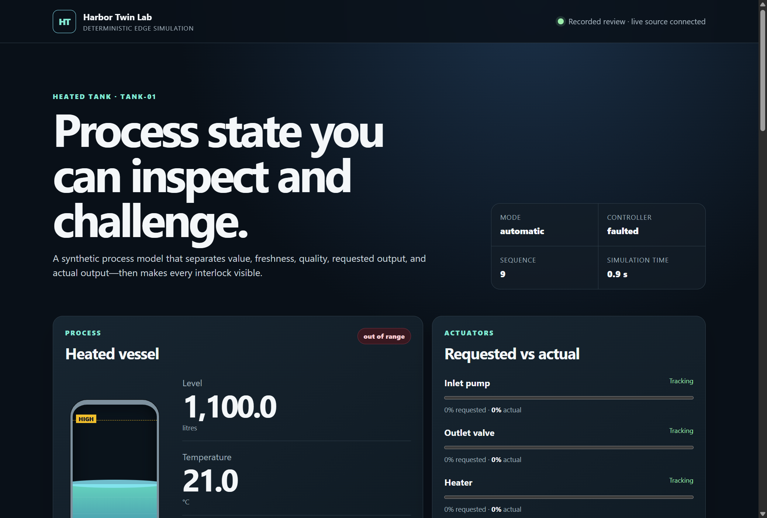
Figure 2 The installed application displays the accepted workspace and its original project results using synthetic data.

Important implementation details

Own the sandboxed native window and orderly engine/gateway lifecycle
Own the sandboxed native window and orderly engine/gateway lifecycle. The native controls call the real project implementation; the excerpt is bound to the exact installed runtime source.
desktop/main.mjs lines 22 to 42
22 async function stop() {
23 if (closing) return;
24 closing = true;
25 try {
26 await runtime?.close();
27 for (const name of ["desktop-ready.json"]) {
28 try {
29 unlinkSync(join(app.getPath("userData"), name));
30 } catch (error) {
31 if (error.code !== "ENOENT") throw error;
32 }
33 }
34 allowedQuit = true;
35 app.quit();
36 } catch {
37 closing = false;
38 if (!test)
39 dialog.showErrorBox(
40 "Workspace could not close",
41 "Saved review files were preserved. Use Quit again or review the application guide.",
42 );
Source file SHA256 74b40d97c66d96ec17d8c3a19a0b801a600ce09860b48f574c948f23e08b85c9

Validation results and operating limits
Runtime source b93914513ccf751eab2a2c0f7a5aa8225d9fe336
Check | Observed evidence | Result
Real native workflows | Actual installed Electron/C++ control, fault and trace workflows passed; four samples and 420 L / 55 °C targets persisted with the engine stopped on restart. | Passed
Source and security | All required main workflows for the runtime revision passed; processed CodeQL analyses reported zero open main alerts before release. | Passed
Distribution identity | All 2 assets matched provider/checksum identities; all 79 installed files remained unchanged during acceptance. | Verified
PC scope | New per-user version folder and individual links verified. Synthetic profiles only; existing data and Docker were not used or changed. | Verified

Installation and private data
Keep the complete extracted ZIP together and launch IndustrialEdgeDigitalTwin.exe. No system runtime or terminal setup is needed.
Open the verified Desktop icon. Help describes supported inputs and workflow limits; close through the app's owner controls and back up its external data directory after a normal exit.

Limits and help
Unsigned Windows portable folder; no signed installer or cross-OS native acceptance. This is an educational synthetic plant, with no hardware or MQTT connection and no production safety or control authorization.
Prepared inputs and acceptance used synthetic data only; normal profiles were not opened and Docker was unchanged. Local plaintext is trusted-OS-owner data, not protection against that OS user or administrator.
Release and checksums | Runtime source | Usage and limits

