Industrial Memory Workbench Application Guide
Windows use and validation
By Jason Stys Version 1.1.0 11 November 2026
Build and inspect synthetic memory-protocol frames, run ordered read and write sessions on one simulated memory server, and account for accepted frames, discarded bytes and incomplete input across arbitrary stream chunks.
The published Windows application passed its complete installed consumer after independent download. Ambiguous acknowledgments remain review outcomes, with actual before and after bytes visible. The simulated IMLP transport performs no hardware or network I/O; the desktop UI uses its owned loopback HTTP service.

Capabilities and previous improvements
The original C++20 codec, memory server, client and loopback transport remain the domain engine. The app adds editable sessions and streams, explicit write permission, real retry and fault evidence, exact frame exports, searchable retained history and completion-aware import handling.
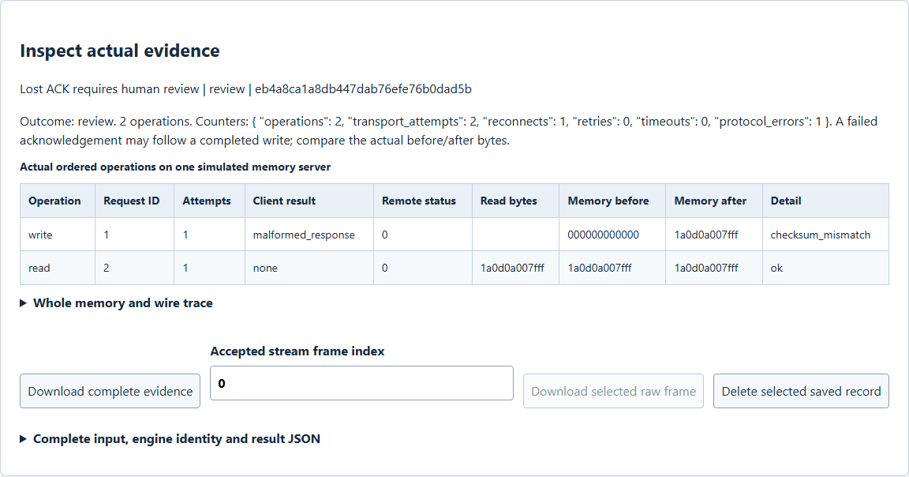
Figure 1 The checksum failure affects the acknowledgment, while actual memory already contains the new bytes. The following read confirms them; a failed client result is not proof of an unperformed write.

A worked application journey
A protocol developer deliberately corrupts a write acknowledgment, reads back the simulated memory, then parses a fragmented stream with noise and incomplete EOF data. Exact wire and state evidence explains both review outcomes.
1. Choose Session, Inspect frame, Compose frame or Parse stream in the same app. Edit bounded JSON or import an authorized input; select prepared cases only as editable starting data.
2. For sessions, specify the permitted write ranges and ordered operations. Review actual attempts, request IDs, remote status and memory before and after each operation.
3. For streams, supply chunks and EOF policy. Inspect every accepted frame and the complete byte accounting, including omitted diagnostic counts and pending data.
4. Save and search evidence, download the complete record or one selected raw frame, and reopen the workspace to compare retained results. Wait for accepted operations before Exit application.
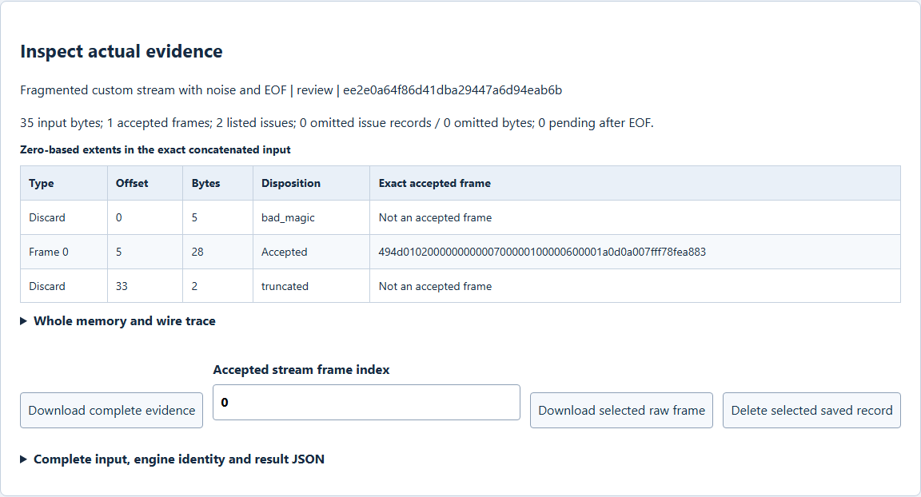
Figure 2 All 35 concatenated bytes are accounted for: five discarded bytes, one accepted 28-byte frame and two truncated final bytes. Offsets are zero based and the actual raw frame remains downloadable.

Important implementation details

Independently verify the wire frame
Python checks the exact network-order layout, magic, version, reserved byte, payload extent and CRC against the original C++ report. This independent relationship check prevents a child report from merely asserting success.
imlp_studio/engine.py lines 63 to 82
63 def wire_frame(raw: bytes) -> dict:
64 """Independently read the published wire layout and IEEE CRC without calling the C++ codec."""
65 require(22 <= len(raw) <= 278, "Accepted frame has invalid extent")
66 magic, version, opcode, flags, reserved, identity, address, size, status = struct.unpack(
67 ">2sBBBBIIHH", raw[:18]
68 )
69 require(
70 magic == b"IM" and version == 1 and reserved == 0 and len(raw) == size + 22,
71 "Accepted frame fields/length differ",
72 )
73 require(zlib.crc32(raw[:-4]) == struct.unpack(">I", raw[-4:])[0], "Accepted frame CRC differs")
74 return {
75 "version": version,
76 "opcode": opcode,
77 "flags": flags,
78 "request_id": identity,
79 "address": address,
80 "status": status,
81 "payload_hex": raw[18:-4].hex(),
82 }
Source file SHA256 0ec2dc59c7f1f02e4e0b20cb5dcd2a979c76140b5533db888c5bda84e42a8df3

Validation results and operating limits
Runtime source a70fe14ab0f94ce21e4b6f271be551a8618f8ffa
Check | Observed evidence | Result
Actual app and restart | Ten actual executions passed; eight records remained after two explicit test deletions. Exact evidence and raw-frame exports, two normal exits and restart were verified. | Passed
Original domain gates | 198 Python tests plus 13 isolated Tcl cases, 24 C++ tests, 22000 properties, three CTest groups and five TypeScript tests passed; original sanitizers, fuzzing and benchmarks remain separate hosted gates. | Passed
Distribution and security | All five release files matched provider hashes and all 82 installed files stayed unchanged. Three main workflows and four actual raw CodeQL categories passed before publication. | Passed

Installation and private data
Extract the complete checksummed Windows x64 archive and keep all original runtime notices. Launch IndustrialMemoryWorkbench.exe or the individual Desktop icon; Python 3.14.10, Tcl and Tk 9.0.4 and the fixed C++ engine are bundled.
The native owner window opens a separate local plaintext workspace. Use Help for the exact schemas and limits. Automated acceptance used separate synthetic profiles and does not prove a clean-machine installer transaction.

Limits and help
IMLP/1 is a synthetic protocol, with no commercial-device compatibility or physical I/O claim. CRC detects accidental corruption and is not authentication.
Write permission applies only to simulated memory. The simulated protocol has no hardware connections, external network transport, arbitrary submitted programs or production enforcement. The desktop browser uses an owned local HTTP service. Protect owner-local plaintext profiles and exports.
Release and checksums | Exact runtime source | Current usage and limits

