Infrastructure Policy Lab Application Guide
Windows use and validation
By Jason Stys Version 1.1.0 10 November 2026
Assess supplied infrastructure plans, explain resource drift and replacement risk, and compare exact-decimal cost evidence. The native app retains semantic-plan-bound human review receipts while keeping the policy gate authoritative.
The published Windows portable app passed independent download/installed-byte acceptance, two real compiled launches, exact saved evidence comparisons and normal exits. The figures show the installed app with fictional supplied records.

Capabilities and previous improvements
Build resource drift/replacement worklists and semantic-plan-bound reasoned review receipts. Makes proposed infrastructure changes easier to assess without letting review annotations override policy gates.
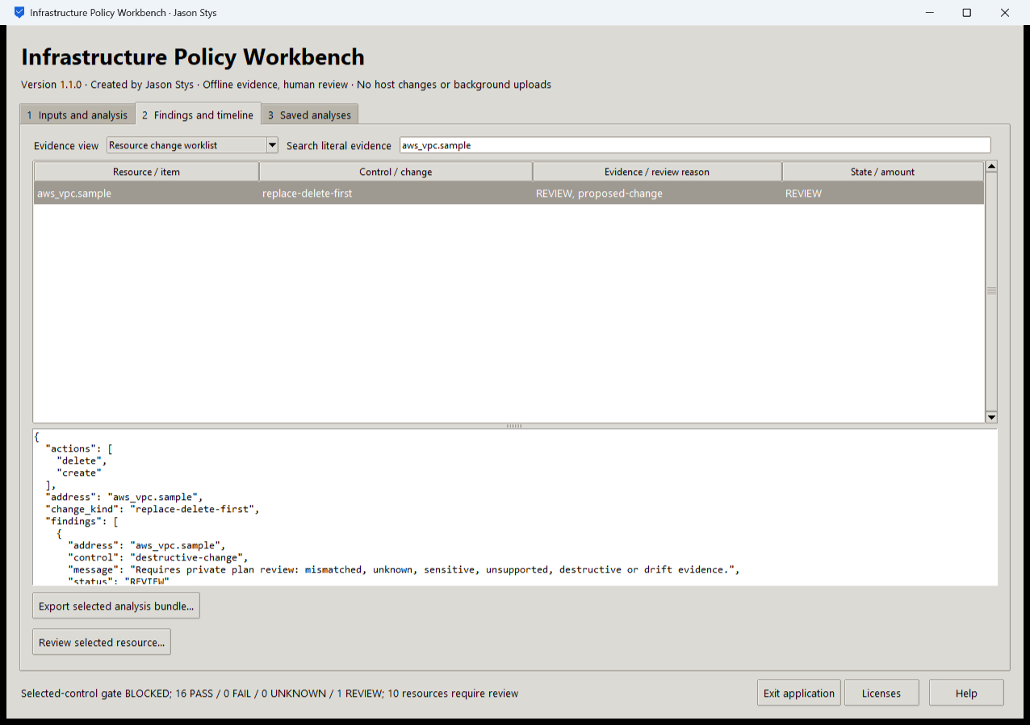
Figure 1 The installed app selects an aws_vpc.sample delete-before-create replacement and shows its original REVIEW evidence. The selected-control gate remains BLOCKED with 16 PASS and 1 REVIEW.

A worked application journey
A platform engineer assesses a synthetic plan, identifies a destructive replacement, compares a changed plan and exact costs, then records a rationale against the correct saved worklist. A stale or malformed receipt must not replace accepted evidence.
1. Choose a prepared case or browse to your supported offline plan and policy. Run assessment or the plan/cost comparison without applying infrastructure.
2. Open Resource change worklist, filter aws_vpc.sample and inspect the original action sequence, finding and proposed-change reason.
3. Select an actual required resource and record its reviewer, ticket, decision and reason. If the plan has changed, regenerate the worklist before reviewing it.
4. Inspect the unchanged policy gate, export the selected complete evidence and receipt, then reopen the same profile to verify saved history.
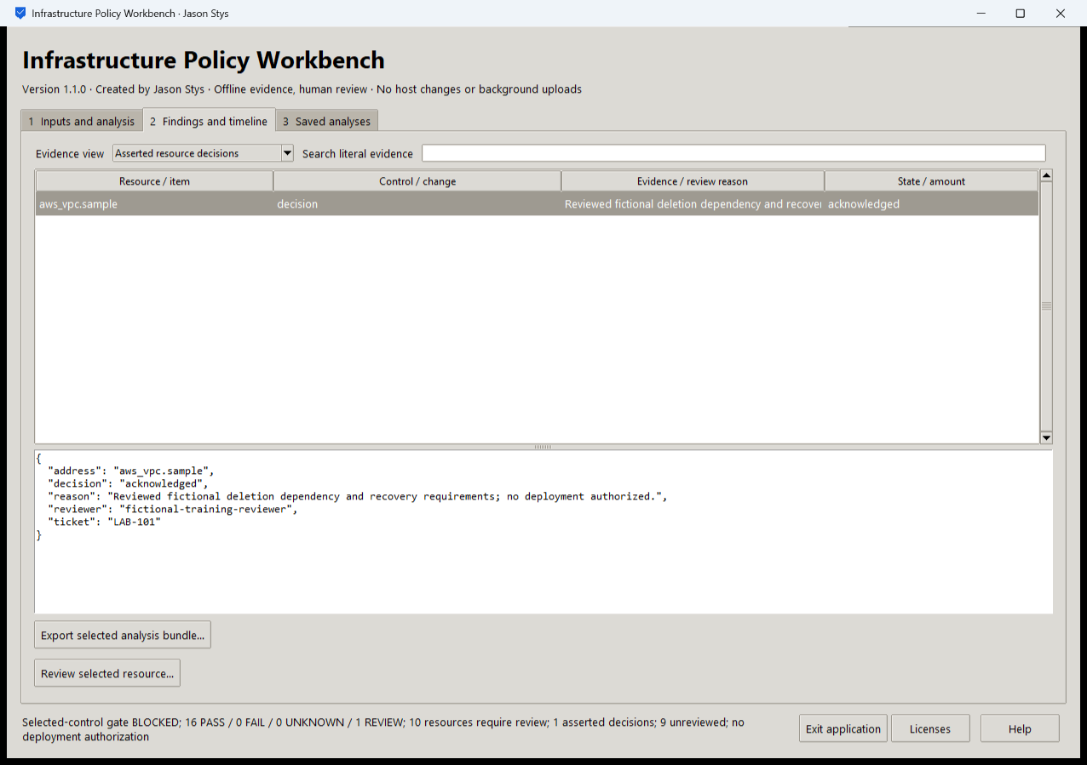
Figure 2 The actual installed review retains a reasoned resource disposition bound to the current semantic plan and worklist. The annotation does not turn the blocked policy result into approval.

Important implementation details

Reject a stale plan review
The receipt path reloads the current semantic plan and compares both plan and worklist digests. It carries forward matching decisions only; the separate policy assessment is not overwritten by reviewer annotations.
assurance/desktop_project.py lines 189 to 211
189 or not selected["review_required"]
190 ):
191 raise Rejected("select an actual required resource from the saved worklist")
192 plan = load(read(Path(parameters["plan"])))
193 current = review.worklist(plan)
194 if (
195 current["plan_digest"] != original["plan_digest"]
196 or current["worklist_digest"] != original["worklist_digest"]
197 ):
198 raise Rejected("selected worklist is stale for this plan")
199 decisions = []
200 for entry in state.history():
201 files = state.files(entry["id"])
202 if "review.json" in files:
203 prior = json_value(files["review.json"])
204 if (
205 prior.get("kind") == "asserted_change_review_receipt"
206 and prior.get("worklist_digest") == current["worklist_digest"]
207 ):
208 decisions = list(prior["decisions"])
209 break
210 decisions = [row for row in decisions if row["address"] != selected["address"]]
211 decisions.append(
Source file SHA256 7298d95494c8c1325bcbfbf4d483ed6b533fab851ea93691ff1cdcfac5518966

Validation results and operating limits
Runtime source 1d1e1085da02b1e9016c3e60b2a00555d03faef8
Check | Observed evidence | Result
Release and runtime | All 5 downloaded assets matched provider/sidecar hashes. Actual frozen CPython 3.14.10 and Tcl/Tk 9.0.4 matched their recorded runtime identities. | Passed
Real user workflow | Four exact bundles survived a second launch. Actual assessment, replacement review, plan comparison, exact-decimal cost and malformed-receipt retention passed; a reasoned receipt left the BLOCKED gate unchanged. | Passed
Source and security | All current main workflows passed. Exact-source CodeQL analyses processed with zero open main alerts before publication. | Passed
Desktop delivery | New individual Desktop and Start-menu links target the installed accepted EXE. Shortcut metadata was read back; normal shortcut activation was not independently exercised. | Verified

Installation and private data
Download the matching Windows EXE and SHA256 sidecar from Releases. This is an unsigned portable app, not an MSI; Python installation and terminal commands are unnecessary. Keep the distribution and runtime notices together.
Open your own new or identified profile outside the installation. History is local plaintext protected by OS-owner access and an exclusive instance lock. Use Help for formats and limits; Exit application closes the owned workbench.

Limits and help
No cloud credentials, Terraform apply, network deployment or provider account is used. The native GUI runs the Python policy engine; the repository's separate OPA/Terraform hosted controls remain independently tested.
Reviewer names are assertions, not authenticated identities. These tests used isolated synthetic profiles and did not access existing user data, call external services or change Docker. Back up your complete profile before moving it.
Release and checksums | Runtime source | Usage and limits

