Infrastructure Policy Lab Application Guide
Windows use and validation
By Jason Stys Version 1.1.1 11 November 2026
Assess supplied infrastructure plans, explain resource drift and replacement risk, and compare exact-decimal cost evidence. The native app retains semantic-plan-bound human review receipts while keeping the policy gate authoritative.
The installed 1.1.1 app passed its full native workflows and reopened the same synthetic profile created by 1.1.0 with exact saved evidence. Existing links were backed up and retargeted with read-back verification; default-profile shortcut activation was not independently exercised.

Capabilities and previous improvements
Build resource drift/replacement worklists and semantic-plan-bound reasoned review receipts. Makes proposed infrastructure changes easier to assess without letting review annotations override policy gates.
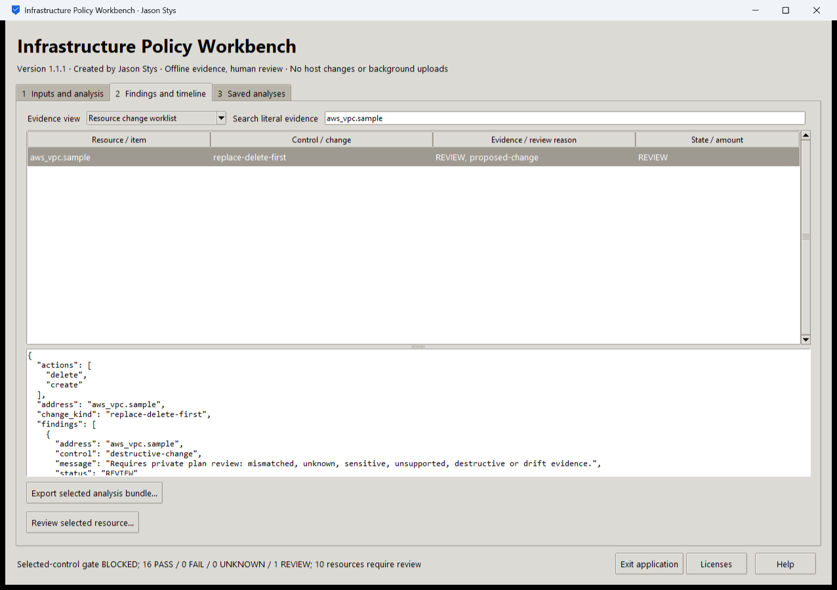
Figure 1 The installed app selects an aws_vpc.sample delete-before-create replacement and shows its original REVIEW evidence. The selected-control gate remains BLOCKED with 16 PASS and 1 REVIEW.

A worked application journey
A platform engineer assesses a synthetic plan, identifies a destructive replacement, compares a changed plan and exact costs, then records a rationale against the correct saved worklist. A stale or malformed receipt must not replace accepted evidence.
1. Choose a prepared case or browse to your supported offline plan and policy. Run assessment or the plan/cost comparison without applying infrastructure.
2. Open Resource change worklist, filter aws_vpc.sample and inspect the original action sequence, finding and proposed-change reason.
3. Select an actual required resource and record its reviewer, ticket, decision and reason. If the plan has changed, regenerate the worklist before reviewing it.
4. Inspect the unchanged policy gate, export the selected complete evidence and receipt, then reopen the same profile to verify saved history.
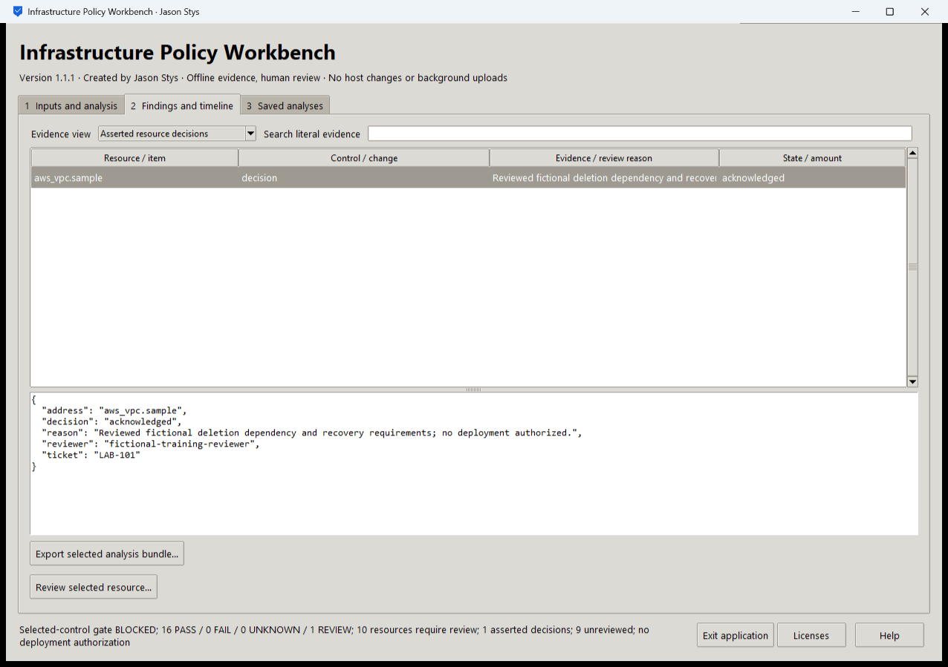
Figure 2 The actual installed review retains a reasoned resource disposition bound to the current semantic plan and worklist. The annotation does not turn the blocked policy result into approval.

Important implementation details

Check fixed state before a write can follow an alias
This pre-initialization check requires any existing fixed state member to be an ordinary single-link file without a Windows reparse attribute. Startup and connection admission apply it to the known marker/lock/SQLite recovery paths; ordinary recovery files are retained.
assurance/desktop_state.py lines 208 to 219
208 def admit_existing(path: Path) -> None:
209 """Refuse pre-existing linked/nonregular fixed state before initialization can write through an alias."""
210 try:
211 info = path.lstat()
212 except FileNotFoundError:
213 return
214 if (
215 not stat.S_ISREG(info.st_mode)
216 or info.st_nlink != 1
217 or getattr(info, "st_file_attributes", 0) & getattr(stat, "FILE_ATTRIBUTE_REPARSE_POINT", 0)
218 ):
219 raise Rejected("fixed workspace state must be unlinked one-link regular files")
Source file SHA256 86b27d4f873982a95a2b8f6de3bfd332da84b40550e52ac9b78675fe3b5daa41

Validation results and operating limits
Runtime source 9993424892243203dfc8e2ce88390e5000b35551
Check | Observed evidence | Result
Actual installed workflows | Full original domain, review and export controls passed two normal native launches; all 4 saved bundles retained exact original bytes. | Passed
Old-to-new profile | The actual installed 1.1.0 app created a synthetic profile; installed 1.1.1 reopened it and retained all 4 exact bundles without reset. | Passed
Source and distribution | Exact-main workflows and processed CodeQL passed with zero open main alerts. Five downloaded assets and installed files matched their verified SHA-256 identities. | Verified
PC and links | Existing links were backed up and retargeted with settings retained. Normal profiles and Docker were unchanged; default-profile shortcut activation remains separately untested. | Verified

Installation and private data
Download the matching Windows EXE and SHA256 sidecar from Releases. This is an unsigned portable app, not an MSI; Python installation and terminal commands are unnecessary. Keep the distribution and runtime notices together.
Open your own new or identified profile outside the installation. History is local plaintext protected by OS-owner access and an exclusive instance lock. Use Help for formats and limits; Exit application closes the owned workbench.

Limits and help
No cloud credentials, Terraform apply, network deployment or provider account is used. The native GUI runs the Python policy engine; the repository's separate OPA/Terraform hosted controls remain independently tested.
Reviewer names are assertions, not authenticated identities. These tests used isolated synthetic profiles and did not access existing user data, call external services or change Docker. Back up your complete profile before moving it.
Release and checksums | Runtime source | Usage and limits

