Integration Operations Console Application Guide
Windows use and validation
By Jason Stys Version 1.1.0 10–11 November 2026
Use the full Spring/React local application with private generated configuration, persistent H2 storage, real integration-job workflows, audit exports and preserved role/origin/session controls. Its Java21 runtime is bundled.
The downloaded Windows app passed its full workflow with synthetic data. Required main-branch checks and security scans passed for this source revision. Desktop and Start-menu shortcut targets were verified; the installed app was tested separately.

Capabilities and previous improvements
Search all jobs by account/state, page captured audit history and download exact reviews. Fixed request-key intent, real-client binding, timestamp precision, null wire fields and mobile overflow. Makes integration support usable beyond the recent-activity feed and catches defects through real API/browser workflows.
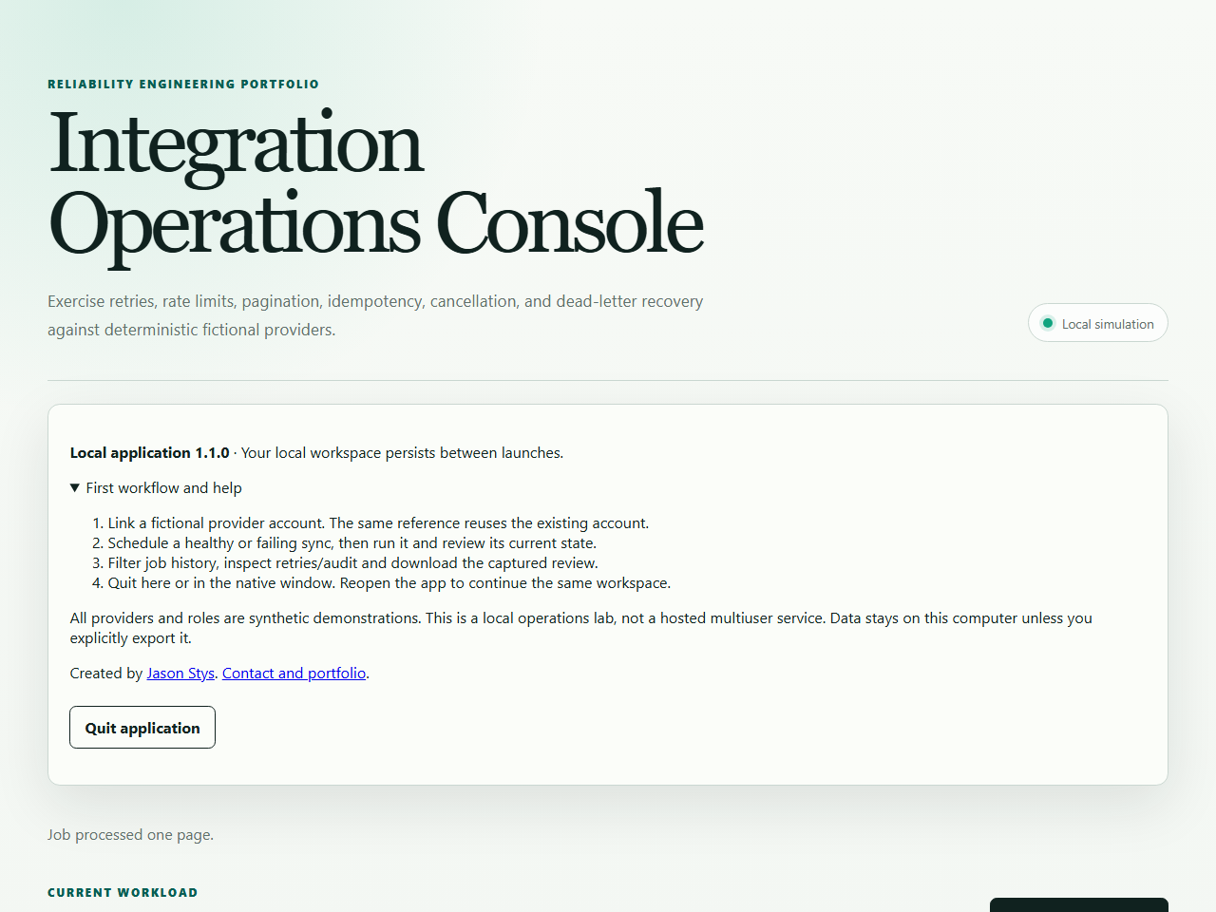
Figure 1 The complete installed integration console displays its real local job controls and fictional provider workflow.

A worked application journey
An integration operator runs a fictional paginated synchronization, investigates a permanent schema failure and reviews durable job/audit evidence.
1. Launch the complete Java app and use Open console; review the first-workflow help and local-session boundary.
2. Select a fictional account and run the healthy paginated synchronization. Inspect accepted records and idempotent replay.
3. Run the supported failing scenario, inspect its permanent error and deliberately cancel or replay the job.
4. Filter jobs, download captured audit evidence, quit through the owner window and reopen retained jobs/settings.
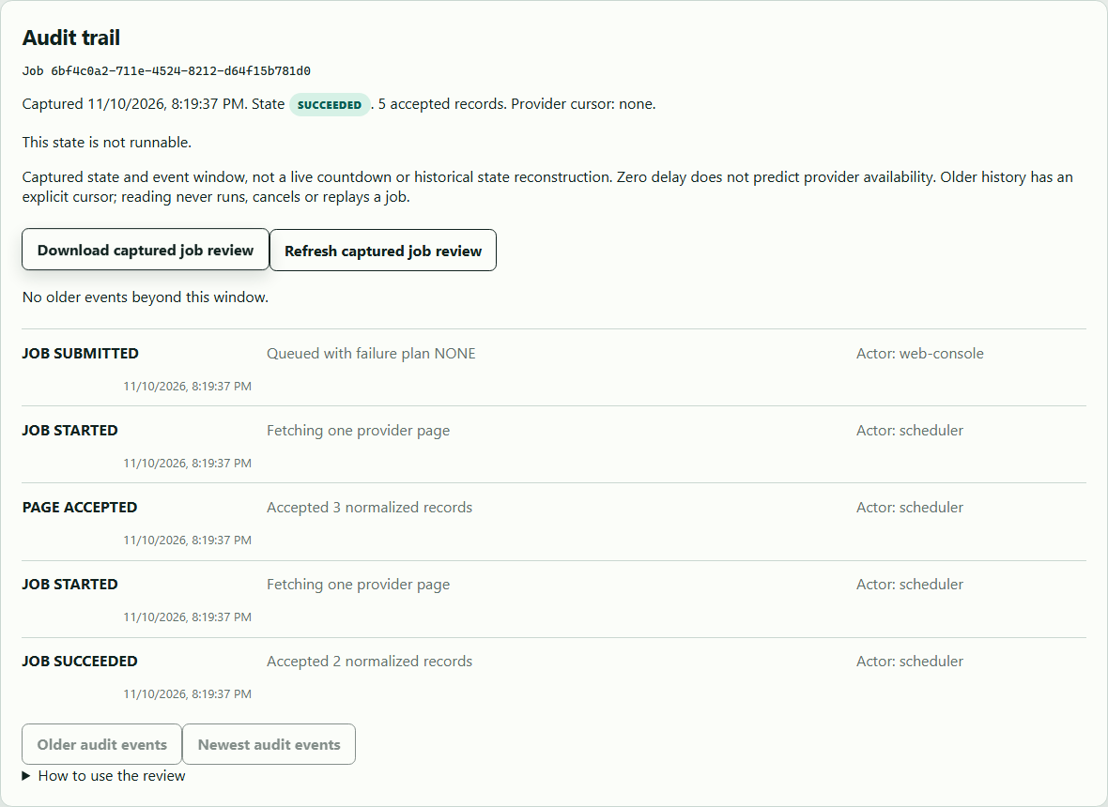
Figure 2 The installed console retains the original job and audit evidence after the supported synchronization workflow.

Important implementation details

Close Spring and the database before releasing profile ownership
The actual native shutdown first closes the Spring context and database, then disposes the window and releases the profile lock. A failed close does not admit another writer early; the caller reports that the existing data needs review.
backend/src/main/java/dev/jasonstys/operations/desktop/DesktopState.java lines 126 to 143
126 /** Close Spring/database first, then the window and ownership lock. No data is deleted. */
127 public synchronized void close() throws Exception {
128 if (!closed.compareAndSet(false, true)) {
129 return;
130 }
131 stopping.set(true);
132 if (context != null) {
133 context.close();
134 }
135 if (window != null) {
136 SwingUtilities.invokeAndWait(window::dispose);
137 }
138 // On failure retain ownership until this process exits, rather than admit another writer early.
139 Files.deleteIfExists(profile.root().resolve("desktop-ready.json"));
140 Files.deleteIfExists(profile.root().resolve("desktop-test-session.json"));
141 profile.close();
142 }
143 }
Source file SHA256 e3e4e608186bb497eed77239772f885edef37105a8e9aabc71da5650a9997446

Validation results and operating limits
Runtime source 8646ee63608448651beeaa734ff3a055d17149d7
Check | Observed evidence | Result
Real native workflows | The installed Java21/Spring/React app processed five records, exercised healthy and permanent-failure/replay/cancel paths, exported audit evidence and retained jobs/settings across two normal exits. | Passed
Source and security | All required main workflows for the runtime revision passed; processed CodeQL analyses reported zero open main alerts before release. | Passed
Distribution identity | All 2 assets matched provider/checksum identities; all 221 installed files remained unchanged during acceptance. | Verified
PC scope | New per-user version folder and individual links verified. Synthetic profiles only; existing data and Docker were not used or changed. | Verified

Installation and private data
Keep the complete extracted ZIP together and launch IntegrationOperationsConsole.exe. No system runtime or terminal setup is needed.
Open the verified Desktop icon. Help describes supported inputs and workflow limits; close through the app's owner controls and back up its external data directory after a normal exit.

Limits and help
Unsigned Windows jpackage app-image, not an installer, signed distribution or cross-OS native proof. Fictional providers and simulated actor roles; protected private-local session is not a production multiuser identity provider.
Prepared inputs and acceptance used synthetic data only; normal profiles were not opened and Docker was unchanged. Local plaintext is trusted-OS-owner data, not protection against that OS user or administrator.
Release and checksums | Runtime source | Usage and limits

