MAVLink Evidence Studio Application Guide
Windows use and validation
By Jason Stys Version 0.2.0 10–11 November 2026
Inspect imported offline MAVLink evidence, packet-local timing/drop/correlation results and ambiguous boundary states through the complete bundled viewer. No aircraft or live control connection is opened.
The downloaded Windows app passed its full workflow with synthetic data. Required main-branch checks and security scans passed for this source revision. Desktop and Start-menu shortcut targets were verified; the installed app was tested separately.

Capabilities and previous improvements
Review relay-local delay, drop, unobserved and ambiguous packet correlation with exact evidence boundaries. Helps diagnose simulated transport faults without claiming receiver acknowledgement or loss from incomplete observations.
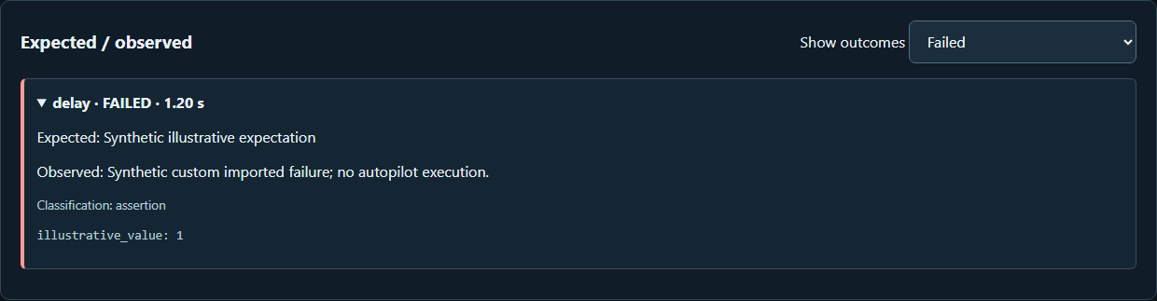
Figure 1 An expanded imported failed delay case retains its expected and observed evidence; this does not change the report outcome.

A worked application journey
A reviewer uses supported fictional input files in the full app, inspects the original results and uncertainties, then exports exact evidence and quits normally.
1. Open the desktop viewer; use a report produced by the supported Linux simulator suite, or explicitly choose its visibly labeled synthetic example.
2. Import an arbitrary valid supported report JSON and filter case outcomes; inspect expected/observed checks, compatibility identity and missing/truncated evidence.
3. Open retained packet delivery review to inspect receive/send correlation, intentional drops, duplicates and local delay while distinguishing absent metadata from actual loss.
4. Download the exact report and derived packet review, then Quit application. Separate Linux PX4/MAVSDK/relay execution is not bundled as Windows SITL.
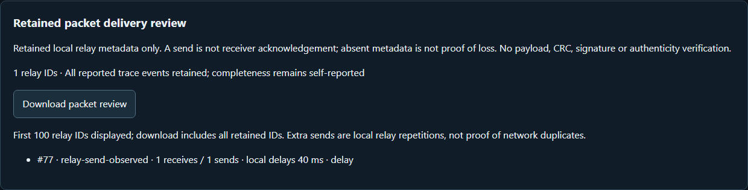
Figure 2 Retained packet observations are reviewed with their explicit correlation and local-delay limits; a send is not a receiver acknowledgement.

Important implementation details

Keep original evidence and decisions intact
Correlates retained relay events by local packet ID, discloses ambiguous/missing/inconsistent metadata and calculates local send delays without converting a send into a receiver acknowledgement or changing the original run outcome.
assurance/delivery.py lines 12 to 32
12 def delivery_review(report: Report) -> dict:
13 """Group bounded retained events by relay ID; disclose ambiguity and local timing only."""
14 groups = defaultdict(list)
15 for event in report.trace:
16 groups[event.packet_id].append(event)
17 packets = []
18 for identifier, events in sorted(groups.items()):
19 receives = [event for event in events if event.event == "receive"]
20 sends = [event for event in events if event.event == "send"]
21 delays = []
22 if not receives:
23 status = "receive-not-retained"
24 elif len(receives) != 1:
25 status = "ambiguous-receive"
26 else:
27 received = receives[0]
28 inconsistent = any(
29 sent.direction != received.direction
30 or sent.size != received.size
31 or sent.at_ms < received.at_ms
32 for sent in sends
Source file SHA256 9227f899781c755d0c45c3d02008b0a99e023ff519d448d28d987160730c6b56

Validation results and operating limits
Runtime source cd733ce544242a073cab60a3477df18d02558ed1
Check | Observed evidence | Result
Real native workflows | The unchanged full installed-app consumer passed actual file import, original engine/results, role boundaries where applicable, exports, negative cases and normal owner Quit. | Passed
Source and security | All required main workflows for the runtime revision passed; processed CodeQL analyses reported zero open main alerts before release. | Passed
Distribution identity | All 2 assets matched provider/checksum identities; all 72 installed files remained unchanged during acceptance. | Verified
PC scope | New per-user version folder and individual links verified. Synthetic inputs and isolated outputs only; existing data and Docker were not used or changed. | Verified

Installation and private data
Keep the complete extracted ZIP together and launch MavlinkEvidenceStudio.exe. No system runtime or terminal setup is needed.
Open the verified Desktop icon. Save the reviewed report JSON and derived packet-review export explicitly. Reopening starts an empty/example viewer; reimport your saved report to continue. The derived packet review is a separate export.

Limits and help
Offline evidence viewer on the PC; actual compatibility/SITL execution requires the separately documented Linux environment. No live-aircraft endpoint.
Tests used synthetic offline inputs and isolated outputs. No aircraft, emergency dispatch or production data was accessed. This viewer keeps its active review in memory; save files explicitly before quitting.
Release and checksums | Runtime source | Usage and limits

