Memory Safety Analysis Lab Application Guide
Windows use and validation
By Jason Stys Version 1.1.0 11 November 2026
Compare a fixed binary-record parser in independently built C++, Rust and Python implementations. Inspect malformed inputs, exact result disagreements, corpus construction and bounded reduction without compiling or executing submitted source files.
The independently downloaded installed application passed its original full native acceptance and retained-file checks. Current main source workflows and processed security analyses passed before publication; shortcut targets were verified separately.

Capabilities and previous improvements
The original lab retains safe cross-language parsers, differential checks, sanitizer/fuzzing evidence and repeatable malformed-input corpora. The new desktop workbench uses those real engines, supports bounded local data inputs, keeps immutable review history and exports complete evidence through normal GUI controls.
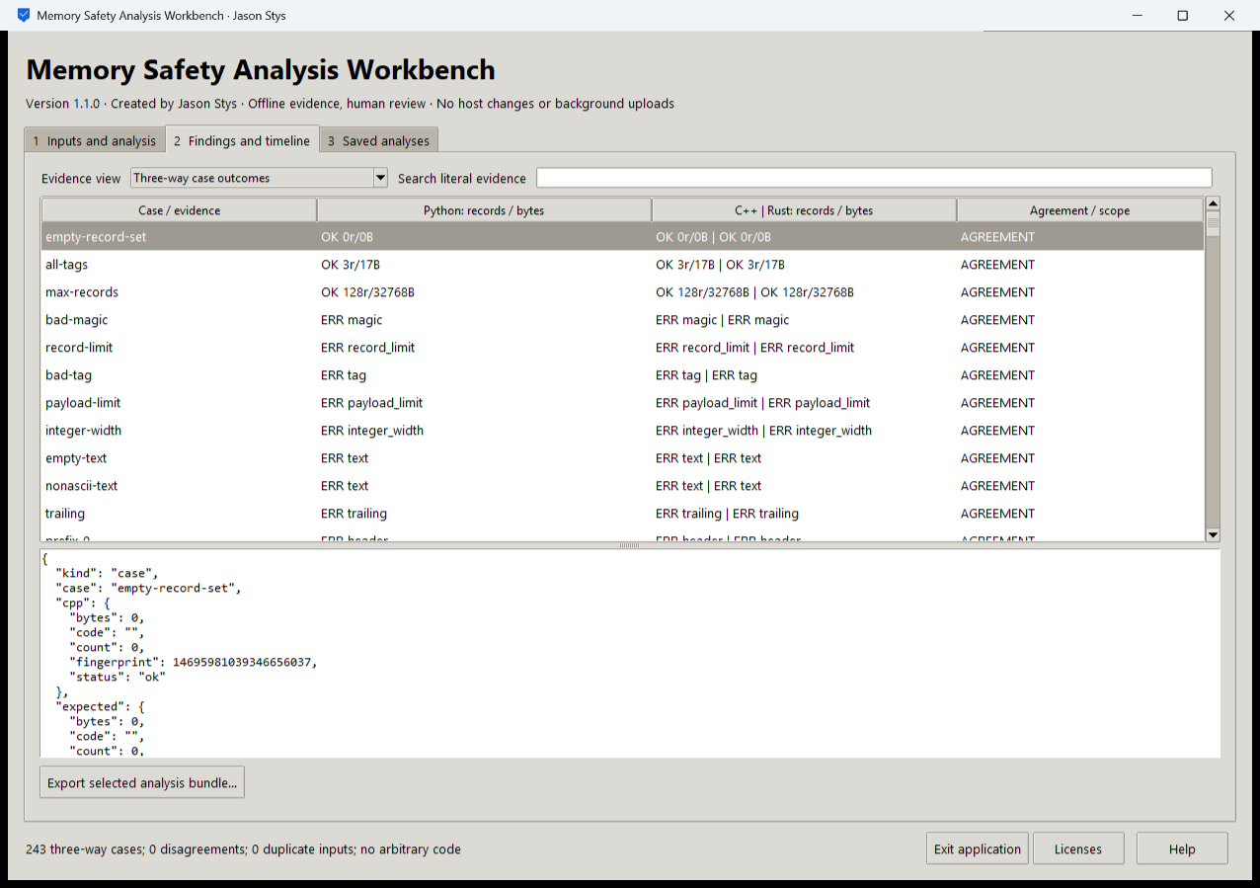
Figure 1 The installed app shows the actual 243-case three-language comparison with zero disagreements for this supplied corpus.

A worked application journey
An engineer reviews a binary sensor-record corpus, investigates a malformed record and compares an imported corpus against all three bundled implementations. The engineer retains the selected input identities, then closes and reopens the same synthetic workspace.
1. Choose the original parser comparison or an authorized local corpus operation; use a prepared input as an editable starting point.
2. Select the exact supported file and bounded reduction settings. Run the actual three-language comparison and inspect result rows and original detail.
3. Search the retained evidence and export the complete selected bundle to a new destination. Invalid inputs must leave earlier records intact.
4. Reopen the same owner workspace and compare the retained result and exports. Exit with the native owner control.
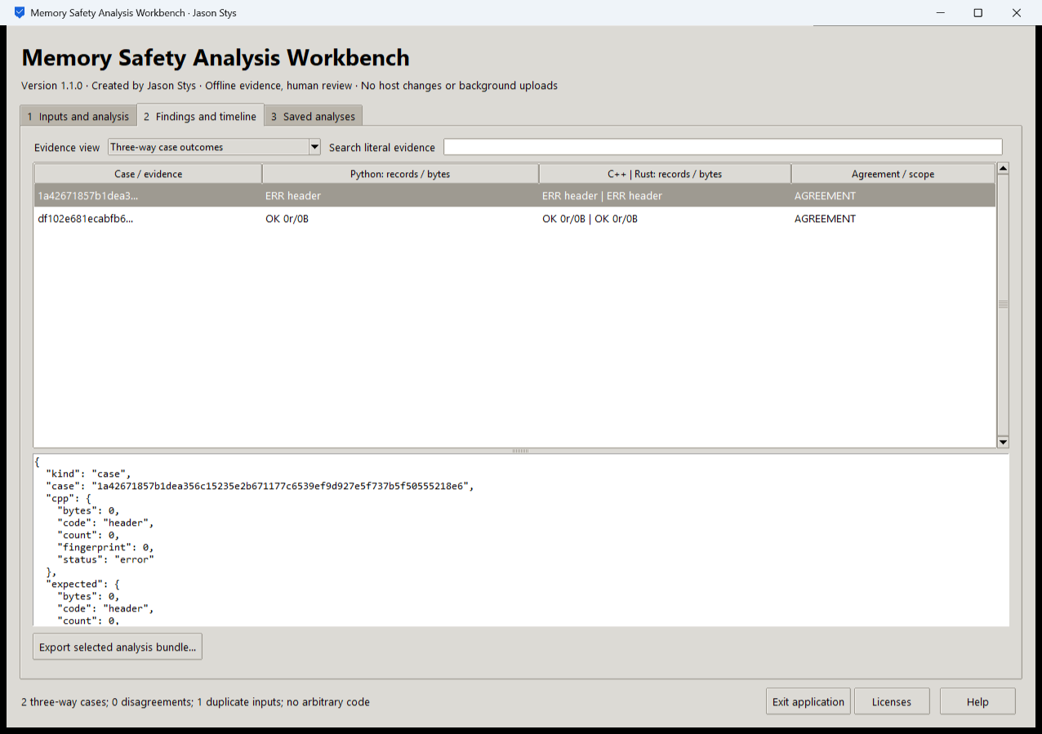
Figure 2 The second installed view keeps selected review evidence and scope visible; full result JSON is available in the exported bundle.

Important implementation details

Reuse the original comparison engine
The GUI selects a closed supported mode, computes the actual original corpus comparison and retains each input hash with its JSON and HTML results.
msal/desktop_project.py lines 191 to 207
191 def analyze(
192 state: Workspace, parameters: dict[str, str], stage: Path
193 ) -> tuple[str, str, dict[str, bytes]]:
194 """Reuse the original three-way comparison and corpus/reduction engines; never compile or execute submitted data."""
195 del state
196 mode = parameters.get("mode", "")
197 if mode not in MODES:
198 raise Rejected("unsupported data review")
199 if mode == MODES[0]:
200 cases = corpus()
201 result = cast(dict[str, Any], compare(cases))
202 result["input_sha256"] = {
203 name: hashlib.sha256(data).hexdigest() for name, data in cases
204 }
205 files = {
206 "report.json": canonical(result),
207 "report.html": render(result).encode(),
Source file SHA256 81d345e3099c3804ada8f69068734f081ed990fd3cc615d9365165374d2c520d

Validation results and operating limits
Runtime source 2526a32020cc7628e36e8931ef3be65eee2a0d5c
Check | Observed evidence | Result
Independent distribution | Downloaded provider assets, sidecar and installed file identities matched. The complete installed app was used; installation resources remained byte-identical. | Passed
Actual app use and restart | Nine actual workflows and nine retained bundles passed the complete original installed consumer; two launches exited normally and the exact history/export bytes reopened. | Passed
Source and security | All current main workflows passed before publication. All configured exact-source processed CodeQL categories had zero raw findings and zero open alerts. | Passed
Individual shortcut | Desktop and Start-menu targets were read back against the installed version. Normal default-profile shortcut activation is separate from full installed executable acceptance. | Verified

Installation and private data
Download the matching version and checksum from Releases. This is an unsigned per-user portable Windows x64 app; keep its complete accompanying files together. No system Python installation or Docker change is needed.
Use the individual Desktop icon and in-app help. Inputs, saved evidence and exports stay outside the installation. Preserve older versions and your own profiles; tests used only separate synthetic inputs.

Limits and help
Passing a finite corpus does not prove the absence of memory bugs. The bundled parsers and reducer have a fixed protocol and bounds; the GUI does not compile or run arbitrary supplied source.
This owner-local evidence tool does not authenticate another reviewer or encrypt data against the same Windows account. Original sanitizer and broader fuzzing jobs are separate CI evidence.
Release and checksums | Exact runtime source | Usage and limits

