MIPS Pipeline Workbench Application Guide
Windows use and validation
By Jason Stys Version 1.1.0 11 November 2026
Edit educational assembly, compare an actual Rust pipeline model with an independent reference model, and inspect cache experiments, cycle evidence and exact physical-line diagnostics through a usable native workspace.
The independently downloaded installed application passed the recorded real workflows. All exact-main checks and processed CodeQL passed before publication. Icon targets were read-back verified; normal default-profile shortcut activation remains separately untested.

Capabilities and previous improvements
The original simulator and static TypeScript explorer now accept custom bounded assembly/cache inputs, verify architectural results, search persistent experiment history, export exact evidence and rerun imported inputs. Architectural Halt PC reporting was corrected.
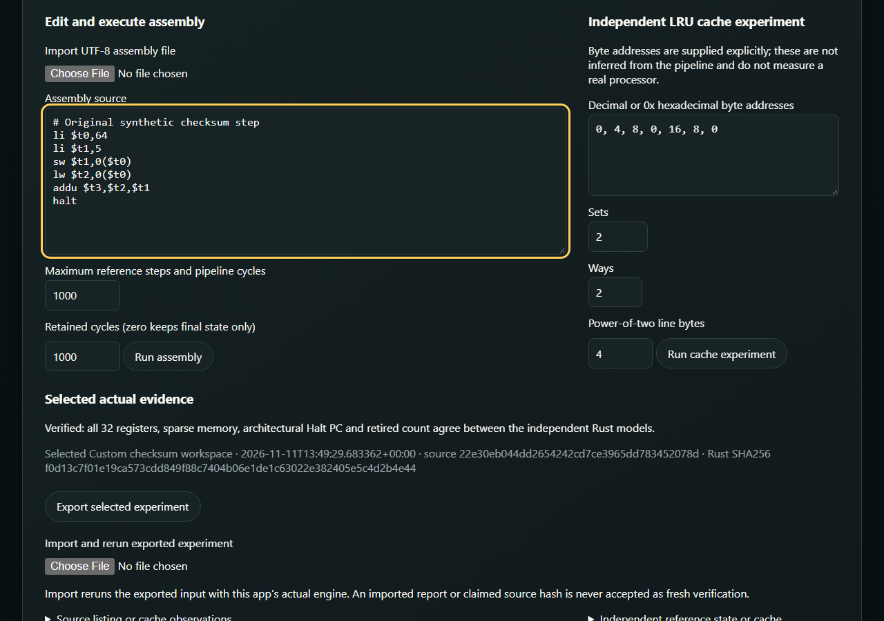
Figure 1 The installed app runs custom synthetic assembly and confirms that all registers, memory, retired count and architectural Halt PC agree between independent models.

A worked application journey
A computer-architecture developer edits a six-instruction checksum example, inspects a load-use stall, runs a separate explicit-address cache experiment and reopens its recorded history.
1. Enter or import bounded UTF-8 assembly. Select maximum cycles and retained trace length; zero retained cycles keeps final state without claiming a missing trace was executed.
2. Run the actual fixed Rust engine. Compare independent reference and pipeline register/memory/PC results and inspect physical-line errors without losing the previous saved experiment.
3. Enter explicit cache addresses and bounded sets, ways and line bytes. The cache experiment is separate from inferred processor memory traffic.
4. Export an experiment, reopen saved history and import the exact input to rerun it. Quit normally; local SQLite history remains available after restart.
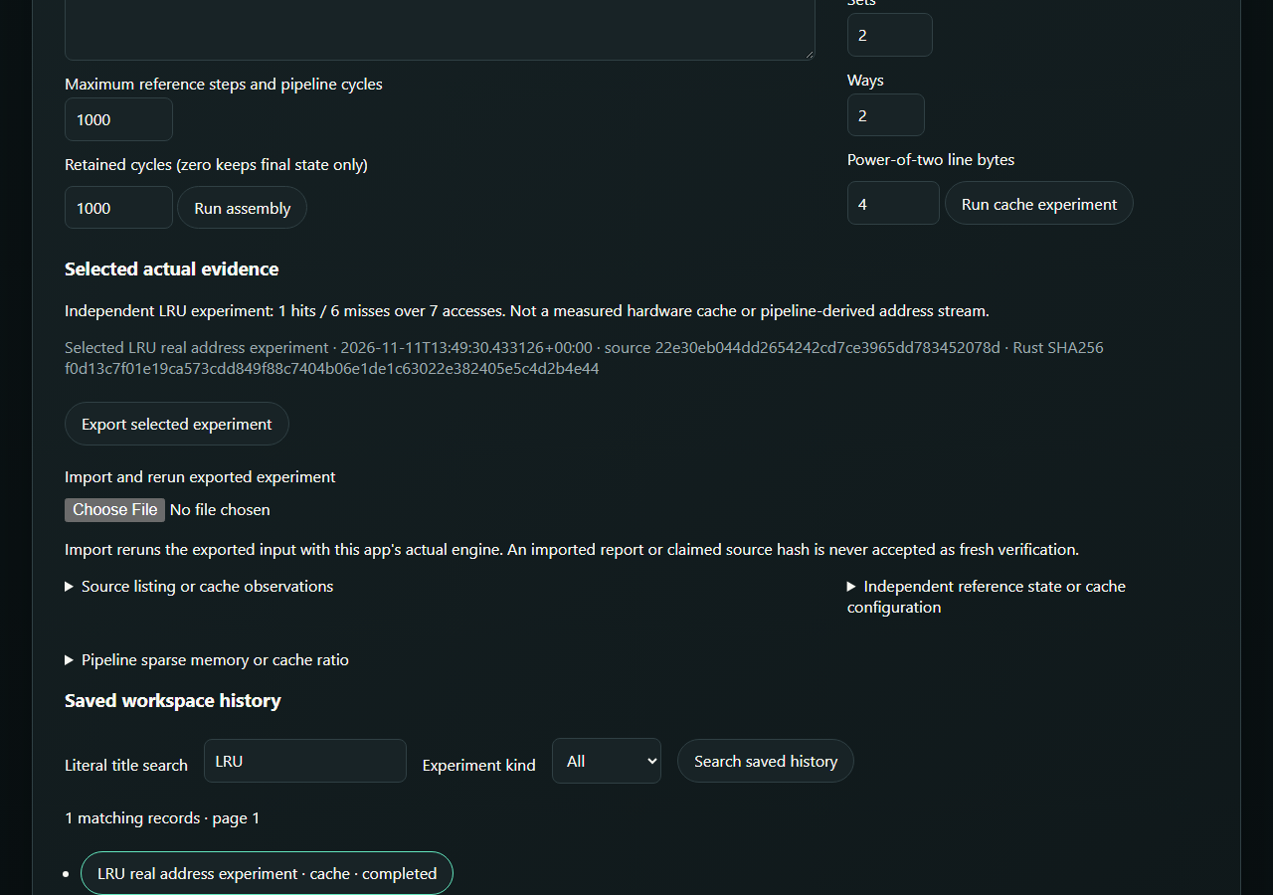
Figure 2 Actual selected cache/history evidence retains the input and source identity. Reimport reruns the input; a supplied report never becomes fresh verification by assertion alone.

Important implementation details

Retire the architectural Halt location
The final PC is Halt plus four, rather than a younger speculative fetch cursor. Independent tests compare registers, memory, retired instructions and PC across retained-trace settings.
src/pipeline.rs lines 195 to 207
195 let halt_next_pc = id_ex.and_then(|stage| {
196 matches!(stage.instruction, Instruction::Halt).then_some(stage.pc.wrapping_add(4))
197 });
198 let load_stall = has_load_use_hazard(id_ex, if_id);
199
200 let mut event = None;
201 let (next_if_id, next_id_ex, fetched) = if let Some(next_pc) = halt_next_pc {
202 halt_seen = true;
203 // Architectural completion belongs to Halt+4, not the prefetched younger cursor.
204 pc = next_pc;
205 let discarded = u64::from(if_id.is_some()) + 1;
206 flushes = flushes.saturating_add(discarded);
207 event = Some("halt: younger instructions flushed".to_owned());
Source file SHA256 fdd79f04f3eb23fb44879b693bf9880da8b850b44e6a3912da58f685a6c7b128

Validation results and operating limits
Runtime source 22e30eb044dd2654242cd7ce3965dd783452078d
Check | Observed evidence | Result
Actual installed workflows | Two actual installed launches passed custom assembly, cache/import/export/refusal/mobile workflows and reopened three retained records. An invalid instruction was reported on physical line 3; both processes exited normally. | Passed
Original core and source gates | 158 Python tests plus five subtests, 13 isolated GUI-notice cases, 28 Rust tests, 11 TypeScript tests and four original browsers passed; source coverage 94.55% at unchanged 90% floor. All 13 actual Rust runtime notice files were verified. | Passed
Assets and current security | Provider/download hashes, complete installed-byte identity, current exact-main workflows and processed raw CodeQL results passed with zero open main alerts. | Passed
Launch and data boundary | Individual Desktop and Start-menu targets verified. Only synthetic profiles were exercised; installed EXE tests are distinct from ordinary default-profile shortcut activation. | Passed

Installation and private data
Download the Windows ZIP and checksum, verify SHA-256 and extract the complete bundle. Open MipsPipelineWorkbench.exe inside its named folder; keep the _internal directory and notices. Retain old versions and stopped-profile backups.
Use the individual Desktop icon and the app's Help. Quit through its owner controls. No Python setup or Docker change is required; examples are input data inside the full application.

Limits and help
Educational instruction/cache subset only. User assembly is interpreted by the bounded simulator, never compiled into host code. Cycle counts are model observations, not measured processor timing or hardware validation.
Unsigned Windows portable bundle with Python 3.14.10 and Tcl/Tk 9.0.4 and original Rust terms. History is owner-local plaintext; default-browser opening and ordinary default-profile shortcut activation remain separate from automated installed-executable tests.
Release and checksums | Runtime source | Usage and limitations

