Mission Clock Integrity Lab Application Guide
Windows use and validation
By Jason Stys Version 1.1.0 10 November 2026
Distinguish qualified timestamp order from overlapping or unqualified intervals. Prepared scenarios use the full Windows application and its existing model and report exports.
The published Windows portable application was installed and tested using isolated synthetic inputs. Provider and sidecar digests, release metadata and installed resource identities were checked. The installed file set remained unchanged after testing.

Capabilities and previous improvements
Build interval partial-order frontiers and minimal precedence edges, preserving touching/ambiguous and unqualified observations. Shows which event orderings are supported by clock uncertainty instead of forcing a false total timeline.
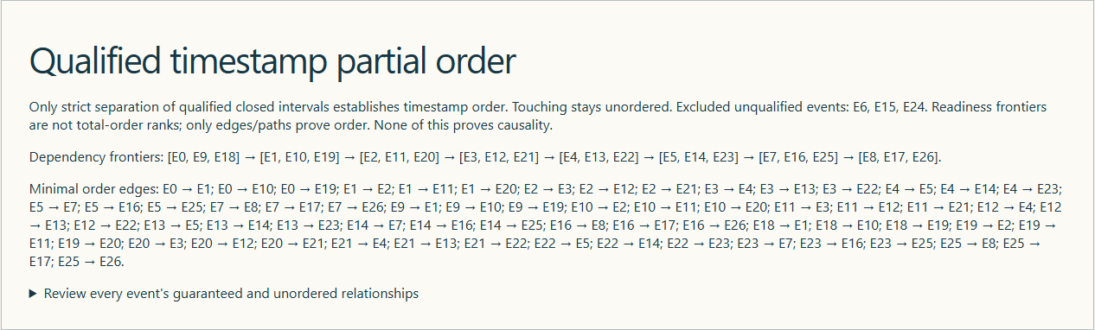
Figure 1 Actual installed application showing reference-loss partial ordering. Captured during the accepted native user journey with prepared synthetic inputs.

A worked application journey
The worked example compares reference-loss partial ordering with nominal qualified timestamp ordering. Interpret the results using the model assumptions and limits on the final page.
1. Open the application shortcut to start its local web interface and console. Select a prepared scenario or your own supported input; the examples require no external account or live hardware.
2. Open the timestamp-order review and inspect qualified frontiers and unqualified events. Compare touching uncertainty bounds, export the partial-order evidence and repeat with nominal input.
3. Review the main case alongside the boundary case shown in Figure 2. Reference loss left 24 qualified and three unqualified events; nominal qualified all 27. Strictly separated bounds permitted order; touching bounds did not.
4. Download the supported evidence report and retain the input/configuration with it. Recompute after an input change; do not reuse a result under a different configuration.
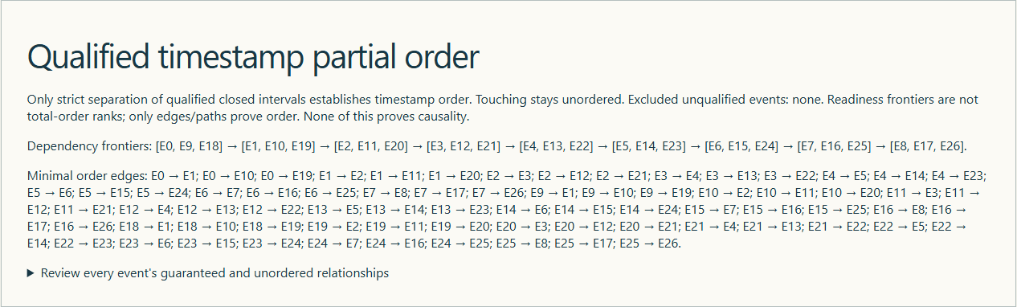
Figure 2 Actual installed application showing nominal qualified timestamp ordering. Captured during the accepted native user journey with prepared synthetic inputs.

Important implementation details

Order review
Only strictly separated qualified intervals can form ordering edges. Invalid edges and cycles fail closed; reduced edges and readiness frontiers preserve partial order instead of claiming causality or a total rank.
clocklab/ordering.py lines 19 to 39
19 for left, right, code in pairs:
20 if code not in (0, 1):
21 continue
22 before, after = (left, right) if code == 0 else (right, left)
23 a, b = records[before], records[after]
24 if before not in qualified or after not in qualified or a[3] + a[4] >= b[3] - b[4]:
25 raise RuntimeError("Invalid qualified ordering edge")
26 edges.add((before, after))
27 covers = sorted(
28 (a, b)
29 for a, b in edges
30 if not any((a, middle) in edges and (middle, b) in edges for middle in qualified)
31 )
32 remaining = set(qualified)
33 frontiers = []
34 while remaining:
35 ready = sorted(
36 node for node in remaining if not any((other, node) in edges for other in remaining)
37 )
38 if not ready:
39 raise RuntimeError("Qualified timestamp ordering cycle")
Source file SHA256 a6947fb4f3789076b63ca0de17e4e9d64a75635c910d2953cd41e49af8cfc980

Validation results and operating limits
Runtime source 1af9738149716f944cc74a3c577746bea35194db
Check | Observed evidence | Result
Published package | Exact public release, provider/sidecar hashes and installed resources verified; installed bytes unchanged. | Passed
Actual native core | The existing packaged CLI/API and native feature acceptance helper passed on the installed executable. | Passed
Scenario evidence | Reference loss left 24 qualified and three unqualified events; nominal qualified all 27. Strictly separated bounds permitted order; touching bounds did not. | Passed
UI and cleanup | Actual compiled-application browser journey passed. Both images were individually inspected; cleanup left no owned child process. | Passed

Installation and private data
Use the complete matching Windows portable folder from Releases, including all companion files; verify the SHA256 sidecar before extracting it. Keep application files separate from your inputs, downloaded reports and optional CLI history.
Return to this app's own console and press Ctrl+C. Closing its browser tab alone does not stop the service.

Limits and help
Synthetic logical interval analysis, not host-clock changes, time service, UTC certification or operational timing.
These Windows portable checks used isolated synthetic inputs. System-wide installation, default-browser opening, desktop shortcuts and mobile installation were outside this test. Additional shortcut checks are recorded separately. No user data or Docker configuration changed.
Release and checksums | Runtime source | Project usage and limits

