Mission Clock Integrity Lab Project Guide
  - By Jason Stys
Public source revision 1af973814971
This edition documents the cited source. Validation observations below identify their own tested revision and time; they are not a promise that an unrun later revision passed.
The qualified timestamp partial-order review now exposes minimal guaranteed-order edges, readiness frontiers and per-event unordered relationships. Unqualified evidence and touching intervals never become an invented total order; timestamp order is not causality.
Compare synthetic clock histories and qualified timestamp order, inspect uncertainty frontiers and export evidence from 1.1 portable apps.
Packages the native model, independent auditor and review interface together while keeping application/native product versions coherent and checking actual extracted execution.

Purpose operation and implementation
Same event. Different clocks. CHRONICLE is an offline synthetic timing instrument by Jason Stys. Explore clock drift, reference blackouts, path asymmetry, phase steps, rate-limited corrections and ambiguous telemetry order—without changing your computer clock or contacting a timing server.
C++20 evolves bounded integer-nanosecond clock states. A dependency-free Rust worker audits closed timestamp intervals and source sequences. Independent Python implementations must agree exactly with both workers before results are released. TypeScript/HTML/CSS/Canvas provide the accessible browser instrument; optional SQL/SQLite retains immutable local evidence.
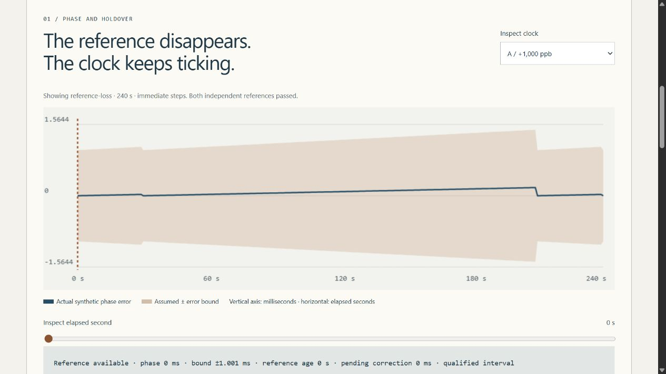
Actual CHRONICLE instrument

Features
- Six fictional cases: stable reference, blackout, asymmetric paths, backward clock step, out-of-envelope oscillator and reordered telemetry.
- Compare immediate phase steps with capped slewing. Inspect actual phase, assumed error envelope, reference age, pending correction, mode and qualification at every one-second tick.
- Distinguish reference loss from expired holdover and invalid bounds. Known simulation truth flags envelope violations; this is not a claim that real clocks can detect their own true error.
- Classify event pairs as strictly before, strictly after, ambiguous or unqualified. Touching is not strictly ordered; time order is not causality. Arrival order and source-sequence regressions remain separate.
- Export complete JSON, all sample rows as dimensioned CSV, escaped script-free HTML, and an editable strict input profile. Keep the exact report SHA-256 and model assumptions with the evidence.
- Test all 216 finite UI combinations, hand-derived drift and interval boundaries, generated models, hostile native-parser inputs and three real browser engines.

Download and run
Download a portable release for Windows x64, Linux x64 or macOS Apple Silicon and its matching .sha256. Verify the digest, then extract the entire MissionClockIntegrityLab directory. Open MissionClockIntegrityLab.exe on Windows or run ./MissionClockIntegrityLab on Linux/macOS; the .tar.gz preserves internal links and executable permissions.
The app opens your normal browser on an ephemeral 127.0.0.1 port. Keep its console open; Ctrl+C stops it. No account, Python/Node/compiler installation, internet connection, administrator access or Docker is required for a portable bundle. These are unsigned/unnotarized desktop applications, not mobile installers or a public hosted service. Respect OS policy; do not bypass warnings.

Source quick start
Requires Python 3.12–3.14, Node 24, a C++20 compiler/CMake, and the pinned Rust 1.98.1 toolchain with clippy/rustfmt. Windows needs Visual Studio 2022/2026 C++ tools; Linux/macOS use their installed compiler. Only development/build dependencies are installed: the Python and Rust runtimes have no third-party package/crate dependencies.
python -m venv .venv
.venv/Scripts/python -m pip install --require-hashes -r requirements-dev.lock
.venv/Scripts/python tools/build_native.py
.venv/Scripts/python tools/build_rust.py
npm ci
npm run build
.venv/Scripts/python -m clocklab serve
Use .venv/bin/python on Linux/macOS. Restricted development environments may need task-owned TEMP/TMP paths and ordinary permission to invoke their installed compiler; do not disable host protections.

CLI evidence and custom scenarios
.venv/Scripts/python -m clocklab export --scenario clock-step --output step.json
.venv/Scripts/python -m clocklab export --scenario clock-step `
--policy 1 --format csv --output slew.csv
.venv/Scripts/python -m clocklab export --input examples/blackout.json `
--format html --output blackout.html --history private.sqlite3
Exports refuse to overwrite existing files. Custom profiles are deliberately bounded, local JSON—not scripts, clock-control instructions, remote URLs or browser uploads. API/input documentation defines every field and protocol. SQLite history is unencrypted, optional, hash-verified and capped at 100 distinct reports with no automatic pruning. It is not protected from an OS user with file access. Keep your histories/exports outside Git.

File and feature map
Path | Purpose
native/core.hpp, core.cpp, cli.cpp, tests.cpp | Bounded integer clock model, strict numeric protocol and analytical C++ contracts
auditor/src/main.rs | Safe closed-interval audit, source/arrival disorder checks and Rust tests
clocklab/model.py | Strict profile validation, finite presets and wire serialization
clocklab/reference.py | Independently structured Python clock and interval implementations
clocklab/engine.py | Fixed native process orchestration, exact agreement/accounting gates and report identity
clocklab/reports.py, resources/history.sql | Full exports and optional immutable, idempotent local history
clocklab/server.py, __main__.py, launcher.py | Protected read-only loopback server, explicit CLI and portable launcher
web/ | Defensive typed UI, real evidence plots, inspector and pair interpretation
tests/ | Finite-space/property/analytical/schema/native-parser/HTTP/SQL/CLI/browser regressions
tools/ | Native builds, benchmarks, sanitizer requests, exact-line inventory and release gates
examples/, docs/, licenses/ | Editable profile, model/user/API/validation guides and runtime notices
.github/workflows/ | Pinned least-privilege Validation, CodeQL and manual draft-release pipelines

Every code file has a creator/responsibility header; major functions/classes describe their contracts. Generated CODE_INDEX records definition/variable line locations; FILE_CATALOG summarizes every tracked-intent file. CI rejects stale inventories, avoiding manually duplicated line numbers that drift after edits.

Limits, documentation and contact
This is synthetic civilian timing education, not an NTP/PTP implementation, calibrated oscillator model, authenticated time service, UTC certificate or flight-qualified system. No leap-second/time-scale conversion, stochastic clock noise, relativity, real GNSS, hardware interface, host-time adjustment, automatic operational decision or causal-order inference is implemented.
Model/research · Architecture · User guide · Input/API · Validation · Release/runbook · Security · Notices.
Created by Jason Stys. Portfolio/contact · Help/issues. MIT project source; runtime notices retain their own terms. No agency, employer or mission endorsement. Contributions should include a small synthetic reproduction, independent expected answer, regression and updated documentation—not refreshed baselines to silence failures.

Portable release identity
The 1.1 release contract keeps the software version consistent across Python, npm, the running service and the UI. Versioned archives include RELEASE.json with source commit, platform and clean/dirty build status. Packaging tests the freshly extracted application, including its new practical workflow, from an unrelated temporary working directory. Windows uses ZIP; Linux/macOS use .tar.gz to preserve required native links and permissions. Published 1.0 assets remain unchanged. Check the selected release's source and version rather than assuming an older download contains current source improvements. See the portable operation and release guide.
Observed local packaging checks and boundaries: portable 1.1 validation.
Draft discovery uses a bounded complete authenticated release listing and numeric-ID verification; a published-only tag lookup cannot prove that an untagged draft is absent. The release guide documents fail-closed ambiguity/history limits and the no-overwrite policy.

Current scope and practical limits
- Synthetic integer intervals and logical time do not establish real UTC accuracy, timing certification or host-clock control.
- Readiness frontiers are not total-order ranks; timestamp separation is not causality, and unqualified intervals remain unknown.
- Unsigned desktop portable files for specific OS/CPU targets; no system installer, public hosting or physical timing integration.
The accompanying Validation Review records the exact tested baseline, workflow evidence, test scope and known gaps. The Excel workbook provides filterable workflow and test-source inventories; neither substitutes for the actual execution logs.

Source references and maintenance
Maintain the editable Markdown and this Word edition together. Preserve dated execution reports and re-run the documented checks before release.
README.md · SECURITY.md · docs/ARCHITECTURE.md · docs/reports/PORTABLE_RELEASE_20261109.md
Project source and current Actions · Contact Jason Stys

