Mission Contact Resource Scheduler Project Guide
  - By Jason Stys
Public source revision 4e5c7ecf87d8
This edition documents the cited source. Validation observations below identify their own tested revision and time; they are not a promise that an unrun later revision passed.
An offline contact-planning workbench by Jason Stys. Allocate fixed synthetic contact windows across a shared ground network, inspect the constraints, and compare an exact optimum with a greedy baseline.
The released 1.1.0 portable scheduler includes station-loss contingency comparisons: inspect retained, removed and replacement contacts, per-request service changes and utility loss, then download complete planning evidence.
The existing exact finite-candidate solver and independent exhaustive oracle are preserved. The extracted application proves the hand-checkable 60 + 60 versus 100 greedy trap, a fully lost station and feasible empty service before comparing the actual UI download with its API result. Source-bound native packaging carries the practical replanning workflow into downloads.

Purpose operation and implementation
The single-station loss contingency workflow now reoptimizes each full-window station outage, showing retained/removed/added contacts, before/after request assignments and service/energy changes. Every alternative preserves the current case's budgets and remaining constraints and uses the same exact objective. This is a contingency comparison, not a minimum-change or operational dispatch optimizer. See the contingency guide.
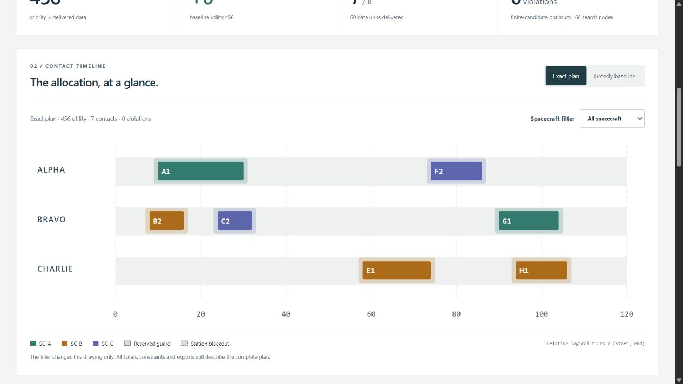
Local scheduling workspace

What it demonstrates
- An original, deterministic branch-and-bound optimizer, with a complete finite search and explicit objective tie breakers.
- Competing station and spacecraft reservations, per-side guard time, maintenance/outage blocks, deadlines, band compatibility, full-delivery capacity, station-time budgets and spacecraft-energy budgets.
- An inspectable TypeScript interface: proportional station timeline, exact/greedy switch, spacecraft filter, decision inspector, resource ledger and every request's outcome.
- Eight synthetic scenarios, 432 reviewed parameter combinations, an independent exhaustive oracle and property-based generated-case tests.
- Reproducible SHA-256 evidence; full JSON, candidate CSV, inert HTML and editable input JSON; optional immutable local SQLite history.
- Strict local JSON imports through the CLI, loopback-only read-only HTTP, zero third-party Python runtime dependencies, and portable native desktop bundles.
This is an educational allocation lab, not an operational scheduling product. No live spacecraft, ground station, radio, orbital propagation, targeting, command, account or external data connection exists. Times are relative logical ticks; energy/data are invented units. “Optimal” means best among the supplied fixed candidates for the documented finite objective, not best across every possible real contact. No mission assurance, certification or endorsement is claimed.

Try it
The v1.1.0 release supplies Windows x64 ZIP and Linux x64/macOS ARM64 .tar.gz archives, each with a matching .sha256 file. Verify the digest and extract the whole archive, preserving its _internal folder, licenses and POSIX links/permissions. Launch MissionContactScheduler (.exe on Windows). It starts a local service and opens your default browser. Keep its console open; Ctrl-C stops it. No installation, admin access, global Python or Node is needed for the bundled app.
Bundles are unsigned. Verify the checksum and trusted source; do not disable or bypass OS security warnings. Platform/architecture support is specific, not a promise to run on every device. See user guide and release procedure.
From source, use CPython 3.12–3.14 and Node 24:
python -m venv .venv
# Windows: .venv\Scripts\activate
# Linux/macOS: source .venv/bin/activate
python -m pip install --require-hashes -r requirements-dev.lock
npm ci
npm run build
python -m scheduler serve
The development tools are not needed by the stdlib runtime. serve --no-browser --port 8805 selects a fixed local port; otherwise an ephemeral port avoids conflicts. It never binds a public interface. GitHub contains source and downloads, not a publicly hosted multi-user service.
Start with Greedy trap, leave the defaults, and solve. The greedy baseline chooses one 100-utility contact; exact search chooses two compatible contacts totaling 120. Use the plan switch and inspect A1's obstacles. Try the all-stations-unavailable case: it produces a valid empty allocation, with all requests still visible.

Code and documentation map
Area | Responsibility
scheduler/model.py | Strict immutable request/window schema and bounded duplicate-safe local JSON parser
scheduler/solver.py | Constraint explanations, feasibility audit, greedy baseline, exact search and totals
scheduler/engine.py | Finite controls, invented cases, complete evidence, canonical SHA and catalog
scheduler/reports.py | JSON/CSV/HTML/input exports and explicit immutable SQL history
scheduler/server.py, __main__.py | Protected loopback HTTP and source/bundled CLI
scheduler/resources/history.sql | History schema and no-update/no-delete triggers
web/ | Semantic HTML, responsive CSS, typed rendering contracts and UI controller
tests/ | Independent exhaustive/property tests, malformed input, actual HTTP/SQL/CLI, browser acceptance
tools/ | Contract benchmark, exact-line indexes, verified portable packaging and gated draft releases
examples/nominal.json | Editable strict synthetic case
.github/workflows/ | Validation, CodeQL and manual three-platform release
docs/ | Model, architecture, API, usage, security, release, third-party notices and actual validation reports

Every file is summarized in FILE_CATALOG; CODE_INDEX supplies generated exact definition, argument and variable lines. File headers and function/class contracts describe responsibilities without duplicating brittle line numbers. CI rejects stale indexes and missing headers/docstrings.
Read MODEL for equations, assumptions, complexity and limitations; ARCHITECTURE for design decisions; API for exact contracts; SECURITY for trust boundaries.

Author and contact
Designed and engineered by Jason Stys. Portfolio: jasonstys.github.io/portfolio-case-study-site. Questions and reproducible non-sensitive issues: repository issues. MIT licensed. Research references inform the concepts only; the optimizer and synthetic cases are original.

Current portable release
Version 1.1.0 includes the current practical workflow in Windows ZIP and Linux/macOS tar.gz portable folders, with OS/CPU/version labels and source-bound release metadata. Historical 1.0.0 downloads predate these improvements. These are unsigned portable applications, not installers; preserve the entire extracted folder and POSIX links. See release notes, local validation and release procedure for exact acceptance and publication boundaries.

Current scope and practical limits
- Invented finite candidates and units; no real radio, ground-station dispatch or operational availability guarantee.
- Replanning optimizes the existing objective; it does not guarantee minimum changes to a previous plan.
- Unsigned desktop portable folders, not system installers or clean-machine proof. Three-OS extracted-native checks drive an owned URL; default OS browser opening remains manual.
The accompanying Validation Review records the exact tested baseline, workflow evidence, test scope and known gaps. The Excel workbook provides filterable workflow and test-source inventories; neither substitutes for the actual execution logs.

Source references and maintenance
Maintain the editable Markdown and this Word edition together. Preserve dated execution reports and re-run the documented checks before release.
README.md · SECURITY.md · docs/ARCHITECTURE.md · docs/reports/PORTABLE_REFRESH_20261109.md
Project source and current Actions · Contact Jason Stys

