Mission Contact Resource Scheduler Application Guide
Windows use and validation
By Jason Stys Version 1.1.0 10 November 2026
Explain exact contact allocation and station-outage changes against a saved baseline. Prepared scenarios use the full Windows application and its existing model and report exports.
The published Windows portable application was installed and tested using isolated synthetic inputs. Provider and sidecar digests, release metadata and installed resource identities were checked. The installed file set remained unchanged after testing.

Capabilities and previous improvements
Reoptimize a bounded contact plan under complete single-station loss and show retained, added and removed allocations. Provides a concrete contingency-planning workflow with independently verified feasibility and resource budgets.
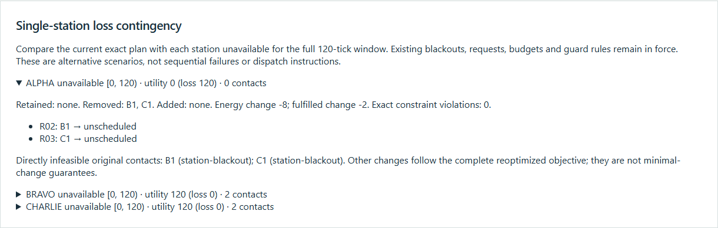
Figure 1 Actual installed application showing greedy trap and station loss. Captured during the accepted native user journey with prepared synthetic inputs.

A worked application journey
The worked example compares greedy trap and station loss with unreachable contact window. Interpret the results using the model assumptions and limits on the final page.
1. Open the application shortcut to start its local web interface and console. Select a prepared scenario or your own supported input; the examples require no external account or live hardware.
2. Solve greedy-trap and compare exact and greedy utility. Expand the station Alpha outage, inspect removed requests and export JSON. Compare the unreachable-window case.
3. Review the main case alongside the boundary case shown in Figure 2. The exact B1+C1 solution scored 120 against greedy 100; losing station Alpha removed both contacts. An unreachable contact window scored zero.
4. Download the supported evidence report and retain the input/configuration with it. Recompute after an input change; do not reuse a result under a different configuration.
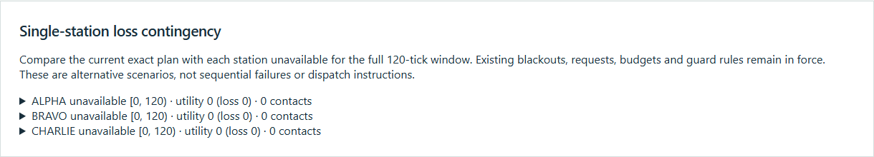
Figure 2 Actual installed application showing unreachable contact window. Captured during the accepted native user journey with prepared synthetic inputs.

Important implementation details

Station outages
The comparison removes only the lost station's options, calls the same exact solver, and derives retained/removed/added contacts and utility deltas from two sets. It reoptimizes utility rather than claiming minimum-change planning.
scheduler/replanning.py lines 25 to 44
25 before = set(baseline["selected"])
26 for station in STATIONS:
27 disrupted = replace(
28 case,
29 options=tuple(option for option in case.options if option.station != station),
30 )
31 exact, greedy = solve(disrupted, guard, policy)
32 after = set(exact["selected"])
33 comparisons.append(
34 {
35 "station": station,
36 "outage": {"start": 0, "end": case.horizon},
37 "exact": exact,
38 "greedy": greedy,
39 "retained": sorted(before & after),
40 "removed": sorted(before - after),
41 "added": sorted(after - before),
42 "utility_loss": baseline["utility"] - exact["utility"],
43 "fulfilled_delta": exact["fulfilled"] - baseline["fulfilled"],
44 "energy_delta": exact["energy"] - baseline["energy"],
Source file SHA256 01b12bb2982c41e2d2b31ab087d657b4615a52219c01d7e583088192a55feec2

Validation results and operating limits
Runtime source 4e5c7ecf87d8ac372a3a45cafc9b539a4fc660f3
Check | Observed evidence | Result
Published package | Exact public release, provider/sidecar hashes and installed resources verified; installed bytes unchanged. | Passed
Actual native core | The existing packaged CLI/API and native feature acceptance helper passed on the installed executable. | Passed
Scenario evidence | The exact B1+C1 solution scored 120 against greedy 100; losing station Alpha removed both contacts. An unreachable contact window scored zero. | Passed
UI and cleanup | Actual compiled-application browser journey passed. Both images were individually inspected; cleanup left no owned child process. | Passed

Installation and private data
Use the complete matching Windows portable folder from Releases, including all companion files; verify the SHA256 sidecar before extracting it. Keep application files separate from your inputs, downloaded reports and optional CLI history.
Return to this app's own console and press Ctrl+C. Closing its browser tab alone does not stop the service.

Limits and help
Finite fictional offline allocation, not operational antenna/radio scheduling, trajectory or command planning.
These Windows portable checks used isolated synthetic inputs. System-wide installation, default-browser opening, desktop shortcuts and mobile installation were outside this test. Additional shortcut checks are recorded separately. No user data or Docker configuration changed.
Release and checksums | Runtime source | Project usage and limits

