Mission Verification Evidence Kit Application Guide
Windows use and validation
By Jason Stys Version 1.1.0 10 November 2026
Inspect stale/missing requirement evidence and a dependency-aware revalidation queue. Prepared scenarios use the full Windows application and its existing model and report exports.
The published Windows portable application was installed and tested using isolated synthetic inputs. Provider and sidecar digests, release metadata and installed resource identities were checked. The installed file set remained unchanged after testing.

Capabilities and previous improvements
Build a metadata-bound revalidation and freshness queue with exact requirement/component scope and source work references. Helps reviewers identify stale or missing verification without weakening release gates.
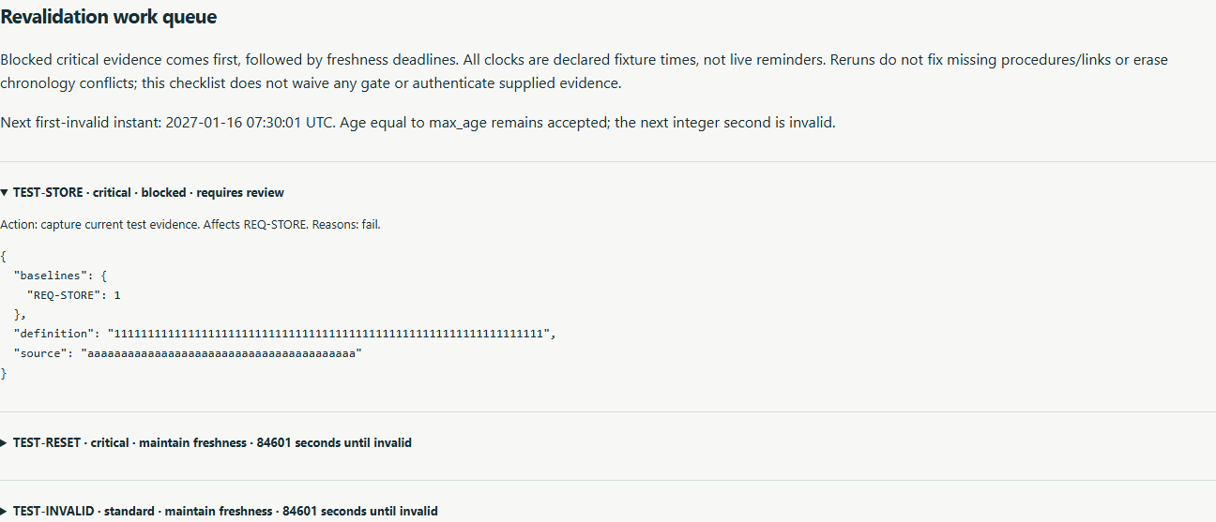
Figure 1 Actual installed application showing failed and expiring test queue. Captured during the accepted native user journey with prepared synthetic inputs.

A worked application journey
The worked example compares failed and expiring test queue with missing procedure baseline. Interpret the results using the model assumptions and limits on the final page.
1. Open the application shortcut to start its local web interface and console. Select a prepared scenario or your own supported input; the examples require no external account or live hardware.
2. Evaluate regression and expand the failed requirement and expiry queue. Inspect expected source and baseline identities, download JSON, then compare missing evidence.
3. Review the main case alongside the boundary case shown in Figure 2. SQL and core results agreed; provenance_authenticated remained false. Failed, stale and missing baseline reasons retained separate source and expiry bindings.
4. Download the supported evidence report and retain the input/configuration with it. Recompute after an input change; do not reuse a result under a different configuration.
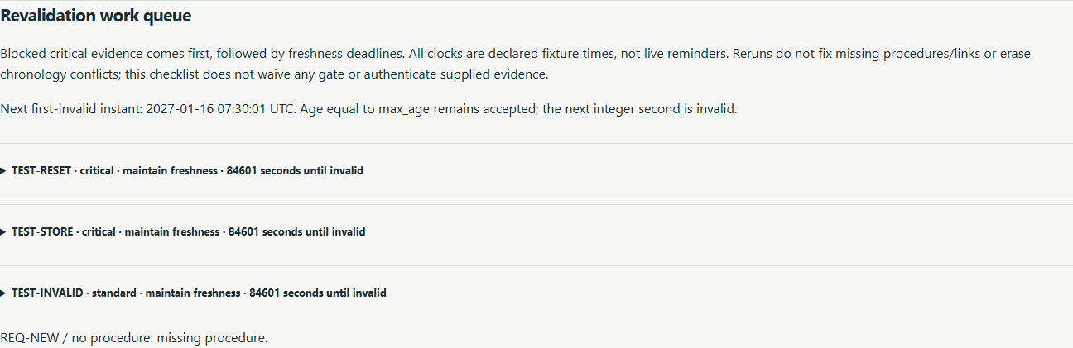
Figure 2 Actual installed application showing missing procedure baseline. Captured during the accepted native user journey with prepared synthetic inputs.

Important implementation details

Revalidation queue
The first invalid second is one after the inclusive age limit. Blocked, chronology-conflicting and accepted evidence get distinct actions, with expected source and baseline identities retained for human review.
evidencekit/revalidation.py lines 23 to 44
23 result = test["result"]
24 expires = result["completed"] + value["max_age"] + 1 if test["accepted"] else None
25 queue.append(
26 {
27 "test": test["id"],
28 "state": "maintain-freshness" if test["accepted"] else "blocked",
29 "critical": any(
30 baselines[req]["criticality"] == "critical" for req in test["requirements"]
31 ),
32 "requirements": test["requirements"],
33 "reasons": test["reasons"],
34 "first_invalid_second": expires,
35 "seconds_until_invalid": expires - value["as_of"] if expires is not None else None,
36 "action": "investigate-chronology-before-revalidation"
37 if "chronology-conflict" in test["reasons"]
38 else "capture-current-test-evidence"
39 if not test["accepted"]
40 else "schedule-revalidation-before-expiry",
41 "expected": {
42 "source": value["source"],
43 "definition": definitions[test["id"]]["definition"],
44 "baselines": {req: baselines[req]["revision"] for req in test["requirements"]},
Source file SHA256 b4f6bc06c131936e18e62e5439fcf37f1809f449be537d8d945f3baa9e591334

Validation results and operating limits
Runtime source 2743307a90da1621392fcafa138b6e103db751d5
Check | Observed evidence | Result
Published package | Exact public release, provider/sidecar hashes and installed resources verified; installed bytes unchanged. | Passed
Actual native core | The existing packaged CLI/API and native feature acceptance helper passed on the installed executable. | Passed
Scenario evidence | SQL and core results agreed; provenance_authenticated remained false. Failed, stale and missing baseline reasons retained separate source and expiry bindings. | Passed
UI and cleanup | Actual compiled-application browser journey passed. Both images were individually inspected; cleanup left no owned child process. | Passed

Installation and private data
Use the complete matching Windows portable folder from Releases, including all companion files; verify the SHA256 sidecar before extracting it. Keep application files separate from your inputs, downloaded reports and optional CLI history.
Return to this app's own console and press Ctrl+C. Closing its browser tab alone does not stop the service.

Limits and help
Declared evidence consistency, not certification, authenticated provenance or proof omitted requirements are complete.
These Windows portable checks used isolated synthetic inputs. System-wide installation, default-browser opening, desktop shortcuts and mobile installation were outside this test. Additional shortcut checks are recorded separately. No user data or Docker configuration changed.
Release and checksums | Runtime source | Project usage and limits

