ML Model Lifecycle Observatory Application Guide
Windows use and validation
By Jason Stys Version 1.1.0 10–11 November 2026
Author or import bounded JSONL datasets, train both real supported model algorithms, inspect verified evaluation dossiers, explicitly promote or roll back reviewed artifacts, run predictions and actual PSI drift analysis, and retain the dataset, registry and champion across restarts. Frozen profiles reject Windows junctions and installation/resource directories. This is an owner-local workbench, not a production deployment controller.
The downloaded Windows app passed its full workflow with synthetic data. Required main-branch checks and security scans passed for this source revision. Desktop and Start-menu shortcut targets were verified; the installed app was tested separately.

Capabilities and previous improvements
Build authenticated read-only release dossiers with verified bundle/registry agreement, recorded quality gates, bounded history and matching drift context. Fixed SQLite handle leaks. Gives model reviewers explicit evidence and uncertainty before an independent promotion or rollback decision.
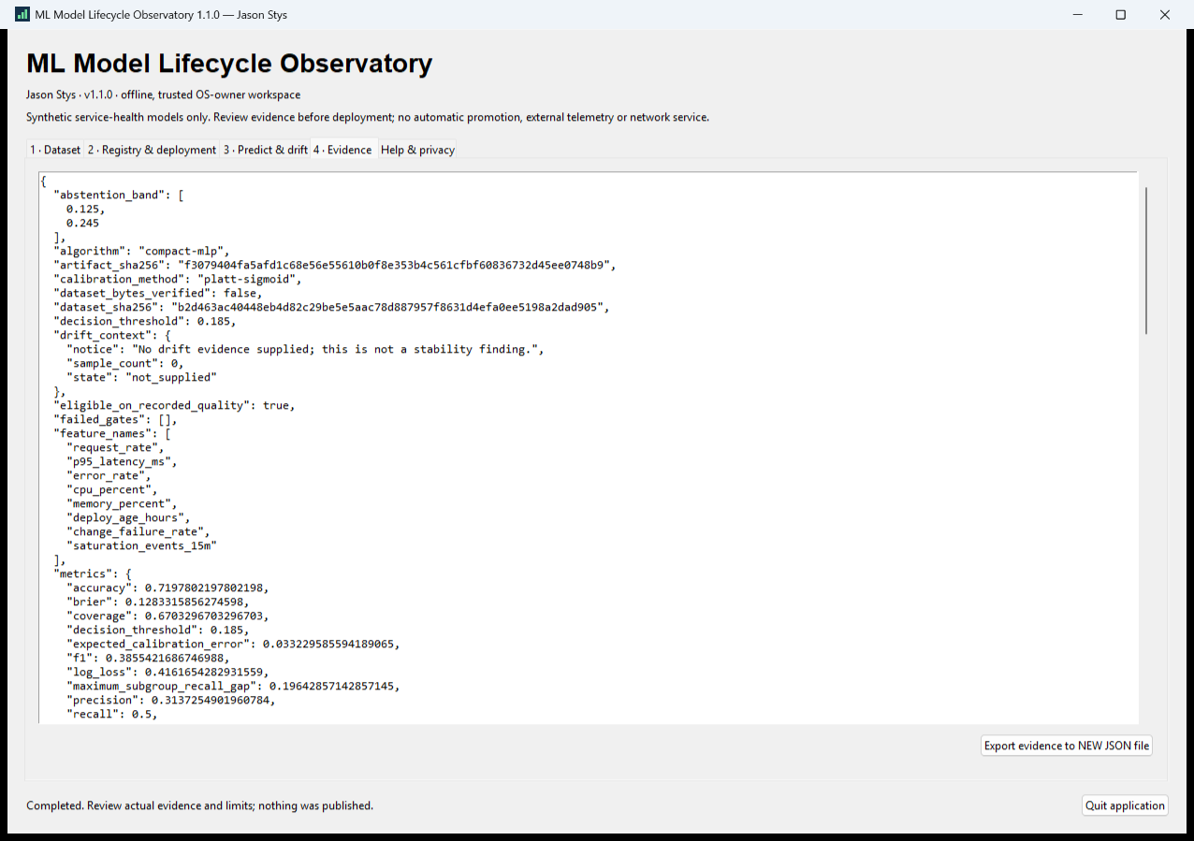
Figure 1 The installed model workbench displays a verified model dossier and recorded quality evidence before an explicit lifecycle decision.

A worked application journey
A fictional reliability analyst imports labeled service-health observations, trains both supported algorithms, reviews quality evidence, explicitly promotes a model and inspects predictions/drift.
1. Open an identified workspace and prepare or import 400–4,000 supported JSONL observations; inspect/edit the records before training.
2. Train the two real algorithms, inspect their verified dossiers and recorded quality gates, and review the candidate before any promotion.
3. Explicitly confirm or cancel promotion, configure shadow/canary routing, run an observation and inspect actual PSI drift evidence.
4. Export reviewed evidence, close normally and reopen the retained dataset, model registry and champion. A rollback rechecks the prior artifact.
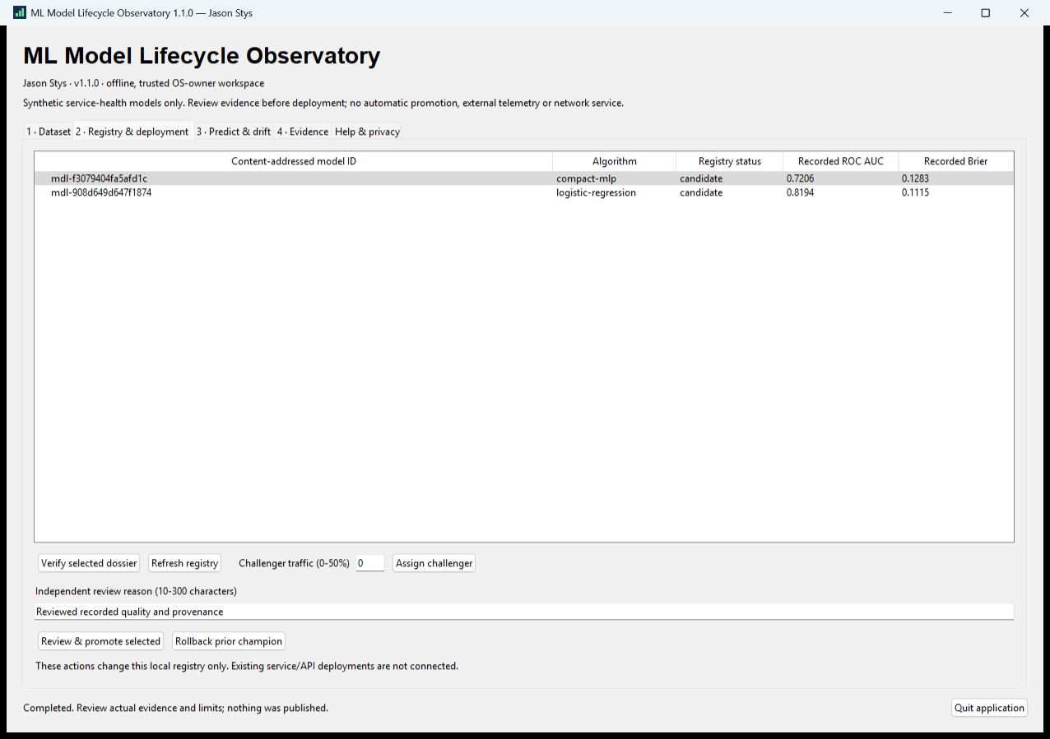
Figure 2 The real local registry displays retained model records. Reopening preserves the dataset and champion instead of training a substitute model.

Important implementation details

Reverify a model before explicit promotion
Promotion reopens the actual hash-verified dossier and checks recorded quality gates before the audited registry change. This does not silently rerun training metrics or deploy to production.
desktop/workspace.py lines 260 to 280
260 def promote(self, model_id: str, reason: str) -> dict[str, Any]:
261 """Reverify bundle and gates immediately before explicit audited promotion."""
262 self._open()
263 dossier = self.review(model_id)
264 if not all(dossier["quality_gates"].values()):
265 raise ValueError("Recorded quality gates failed; this native action cannot promote it")
266 self._reason(reason)
267 self.registry.promote(model_id, reason=reason.strip())
268 return self.review(model_id)
269
270 def challenger(self, model_id: str, traffic: int) -> dict[str, Any]:
271 """Verify the candidate before original shadow/canary assignment.
272
273 The returned dossier is actual registry state, not a deployment simulation.
274 """
275 self._open()
276 self.review(model_id)
277 if type(traffic) is not int or not 0 <= traffic <= MAX_TRAFFIC:
278 raise ValueError("Challenger traffic must be 0-50 percent; 0 means shadow only")
279 self.registry.assign_challenger(model_id, traffic)
280 return self.review(model_id)
Source file SHA256 b58d3d5b96ca93a34039fc08d1c08367993758ef435a4b83b5fff1db482cda89

Validation results and operating limits
Runtime source c23def449e9d1af1f9fbdce6438cf294cc2a4217
Check | Observed evidence | Result
Real native workflows | The installed two-launch workflow passed actual two-model training, canceled/confirmed promotion, shadow prediction, eight-feature PSI, export refusal and exact dataset/model/champion restart. | Passed
Source and security | All required main workflows for the runtime revision passed; processed CodeQL analyses reported zero open main alerts before release. | Passed
Distribution identity | All 2 assets matched provider/checksum identities; all 1301 installed files remained unchanged during acceptance. | Verified
PC scope | New per-user version folder and individual links verified. Synthetic profiles only; existing data and Docker were not used or changed. | Verified

Installation and private data
Keep the complete extracted ZIP together and launch MLModelLifecycleObservatory.exe. No system runtime or terminal setup is needed.
Open the verified Desktop icon. Help describes supported inputs and workflow limits; close through the app's owner controls and back up its external data directory after a normal exit.

Limits and help
Unsigned Windows x64 portable app; no signing, clean-machine or cross-OS certification. Its plaintext workspace belongs to one trusted OS user; it is not authenticated multiuser release authority.
Prepared inputs and acceptance used synthetic data only; normal profiles were not opened and Docker was unchanged. Local plaintext is trusted-OS-owner data, not protection against that OS user or administrator.
Release and checksums | Runtime source | Usage and limits

