MQTT Lifecycle Workbench Application Guide
Windows use and validation
By Jason Stys Version 1.1.0 11 November 2026
Author and replay bounded MQTT-style lifecycle event campaigns using the original deterministic broker, node, state consumer and recovery queue. Inspect exact event prefixes, queue loss, expiry, ordering and retained state in a real offline desktop workspace.
The independently downloaded installed application passed its original full native acceptance and retained-file checks. Current main source workflows and processed security analyses passed before publication; shortcut targets were verified separately.

Capabilities and previous improvements
The original lab retains seven reliability scenarios and explicit reconnect, retained-state, duplicate, ordering, backpressure and access-boundary evidence. The new editable campaign GUI adds cold-chain, factory and utility inputs, event inspection/search, complete report/checkpoint exports and current/previous project persistence.
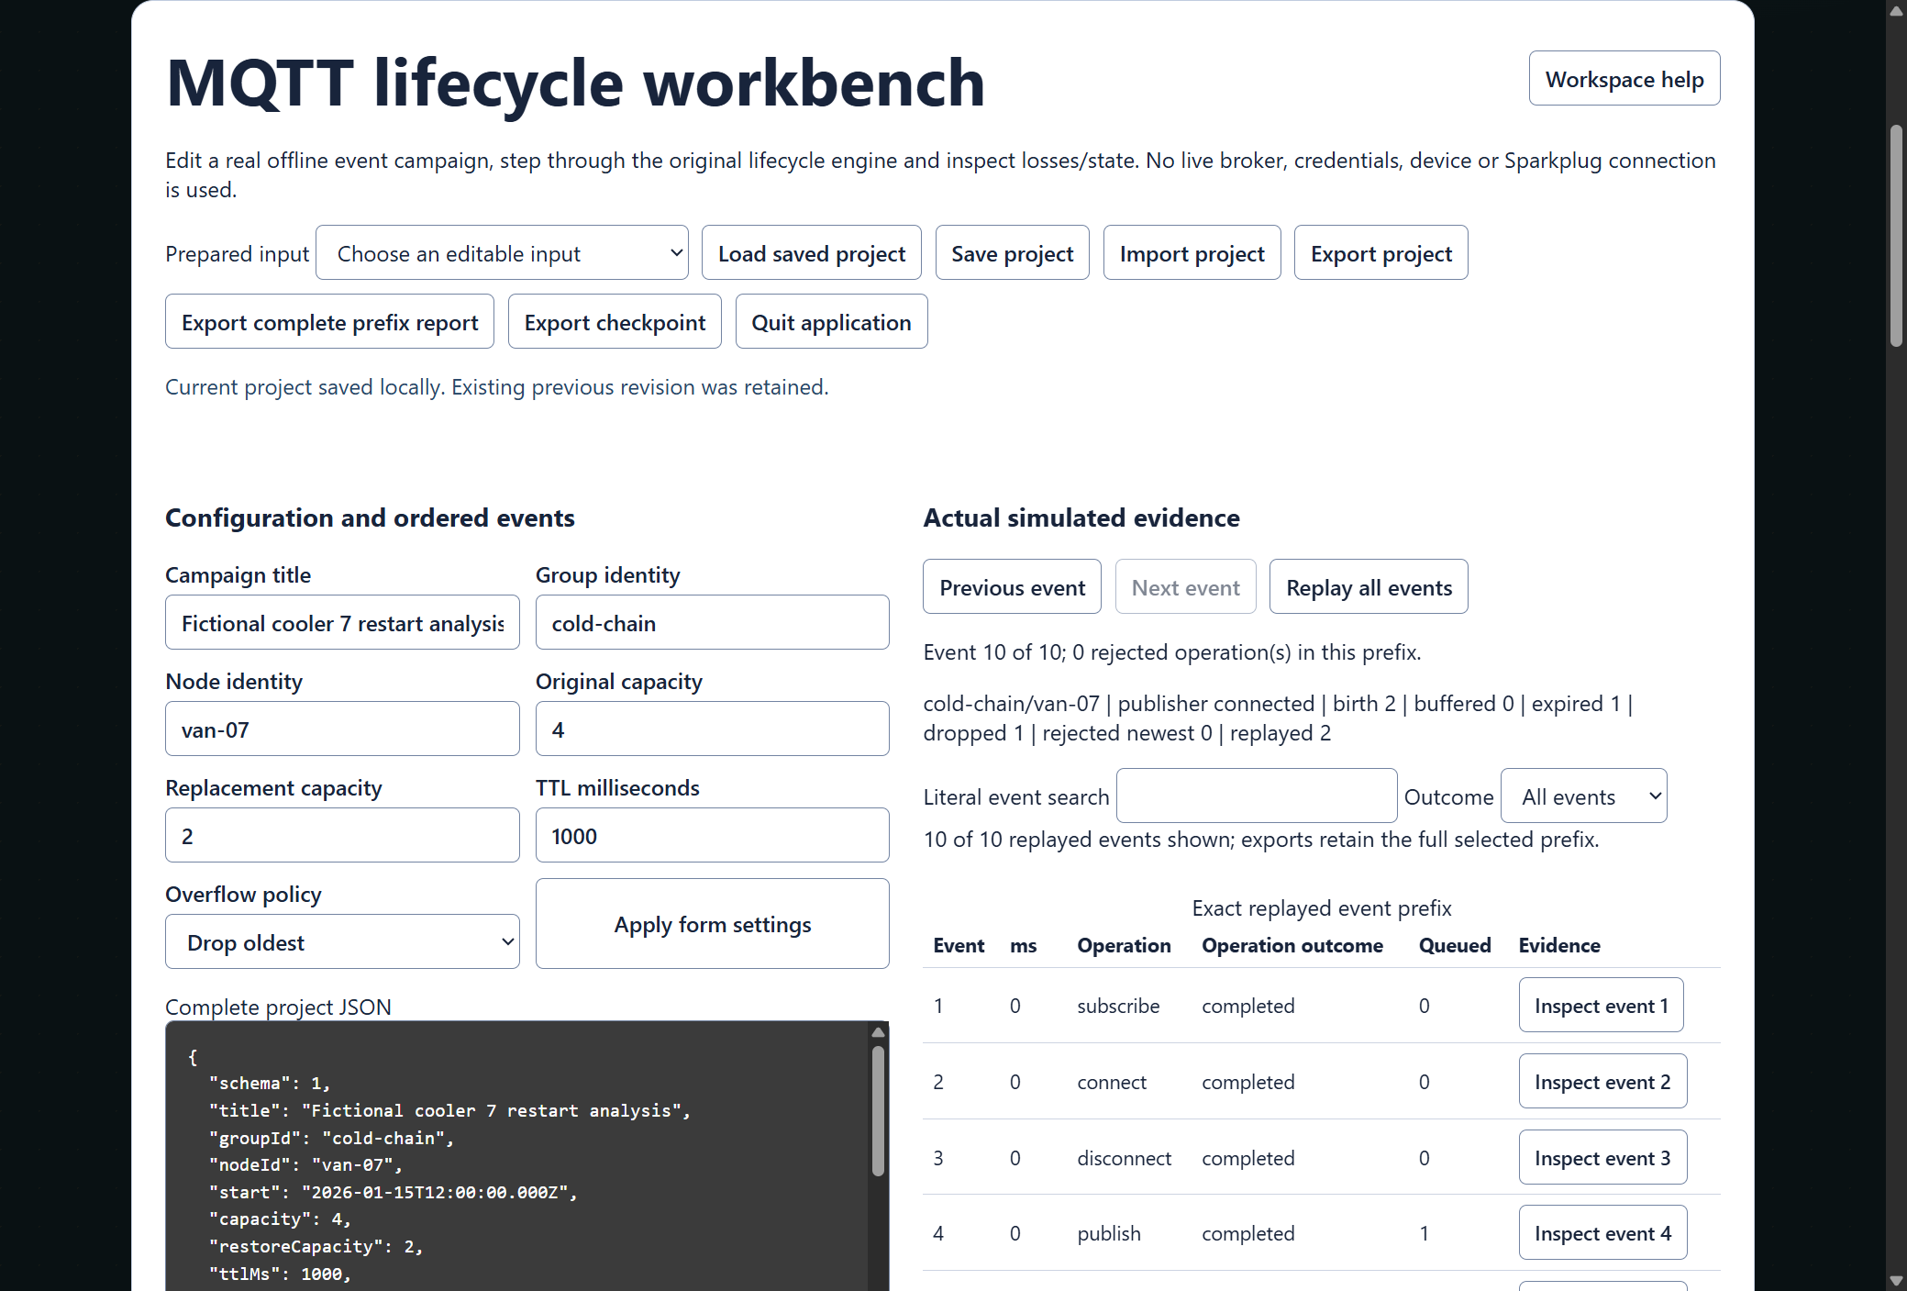
Figure 1 Actual installed cold-chain campaign after ten events: expired and dropped samples remain visible, with project settings and event inspection.

A worked application journey
A cold-chain engineer models a cooler outage and restart, inspects dropped and expired measurements and then compares a utility reject-newest policy. Both use the same actual offline engine and ordinary app controls.
1. Choose a prepared campaign or import supported project JSON, then edit identifiers, capacities, lifetime and ordered events.
2. Apply changes and step through an exact event prefix, or replay all events. Inspect real loss counters and selected event details.
3. Use literal search and outcome filters to investigate rows; export the complete selected prefix report, checkpoint and editable project.
4. Save and reopen the project with its previous revision retained. Quit application waits for an already accepted export to finish.
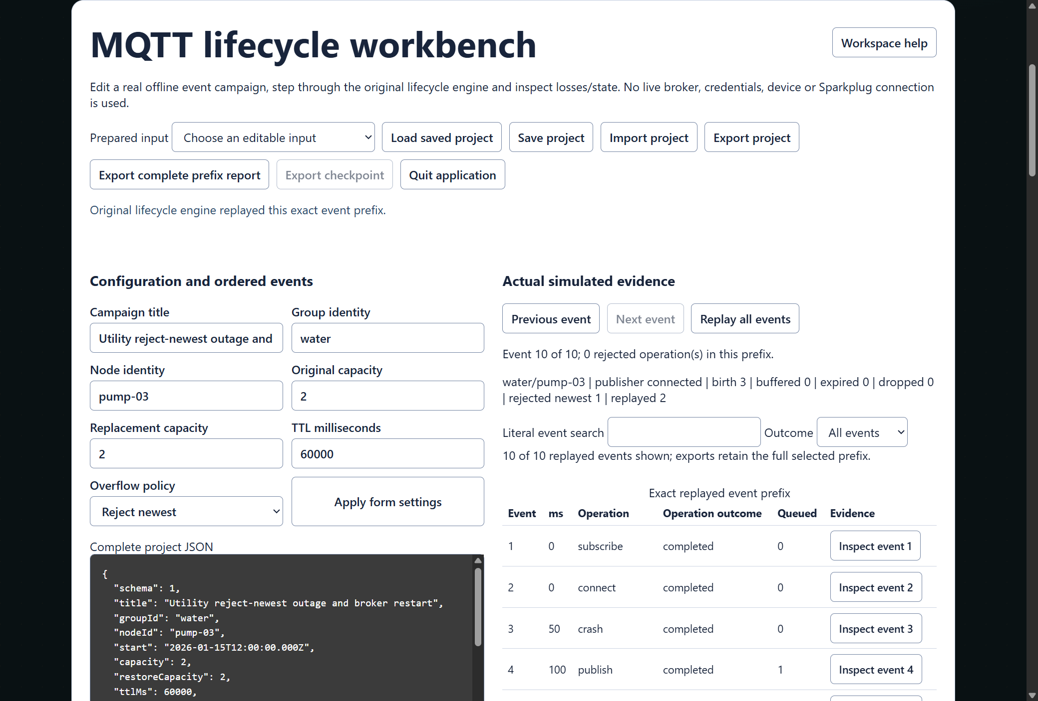
Figure 2 Actual installed utility campaign retains the selected replay prefix and export controls. The complete ordered evidence remains in the report below this viewport.

Important implementation details

Rebuild an exact replay from validated project data
Replay validates the closed project schema and cursor, then creates the original in-memory broker and deterministic clock. The fixed credentials are isolated simulation inputs, never a real account.
src/workbench/campaign.ts lines 175 to 193
175 export function replayProject(input: CampaignProject, count = input.events.length) {
176 const project = parseProject(JSON.stringify(input));
177 if (!Number.isSafeInteger(count) || count < 0 || count > project.events.length)
178 throw new Error('Replay cursor must select an exact event prefix.');
179 const broker = new InMemoryBroker();
180 // These fixed credentials exist only inside this isolated deterministic broker; never connect a real adapter.
181 const password = 'offline-simulation-only';
182 broker.registerCredential('simulation-node', password, {
183 role: 'node',
184 groupId: project.groupId,
185 nodeId: project.nodeId,
186 });
187 broker.registerCredential('simulation-consumer', password, {
188 role: 'consumer',
189 groupId: project.groupId,
190 });
191 let now = Date.parse(project.start);
192 const clock = () => new Date(now);
193 const ids = createDeterministicIdFactory();
Source file SHA256 b56fb0f96d09c5e811d04945949e711fec4b01204d95d67a10e2b1b875a4a934

Validation results and operating limits
Runtime source 8eeaa006201f9173d0454d0ca975f11b10a860a2
Check | Observed evidence | Result
Independent distribution | Downloaded provider assets, sidecar and installed file identities matched. The complete installed app was used; installation resources remained byte-identical. | Passed
Actual app use and restart | The complete installed consumer exercised all three industries, all seven original scenarios, exact prefix counters, inspection/search, project/report/checkpoint bytes, invalid input preservation, current/previous revisions and two normal exits. | Passed
Source and security | All current main workflows passed before publication. All configured exact-source processed CodeQL categories had zero raw findings and zero open alerts. | Passed
Individual shortcut | Desktop and Start-menu targets were read back against the installed version. Normal default-profile shortcut activation is separate from full installed executable acceptance. | Verified

Installation and private data
Download the matching version and checksum from Releases. This is an unsigned per-user portable Windows x64 app; keep its complete accompanying files together. No system Python installation or Docker change is needed.
Use the individual Desktop icon and in-app help. Inputs, saved evidence and exports stay outside the installation. Preserve older versions and your own profiles; tests used only separate synthetic inputs.

Limits and help
This is an offline deterministic lifecycle model. No live broker, device, wire-protocol conformance, multiuser account or external credential integration is asserted.
Projects and exports are plaintext owner-local data outside the app bundle. Do not put actual secrets in a campaign. Untrusted project input is validated as data, not executed.
Release and checksums | Exact runtime source | Usage and limits

